Before Using Database, Flat Files were used to store data. Example of flat files used in excel sheets:

Accounting Department >> employee files >>

* Name
* Address
* Salary
* Overtimes
* Taxes
* Attendance

Same data would be redundant for employees in Human Resource Department

Human Resource Department >> Employee file

* Name
* Address
* Birthdate
* mobile
* Telephone
* HireDate

And same data may exist in Sales Department

## Such restructure leads to (File disadvantages):

* Redundancy
  + Different format
  + waste of storage
  + Slow Update speed
  + Lack of Consistency
  + Sequential access
  + Lack of security
* No Relation Between Data
* No available Meta data

Advantages: in case of small amount of data and no much operations to be done on data, flat files are faster.

# Evolving to Database:

What is SQL?

* SQL stands for Structured Query Language
* SQL lets you access and manipulate databases
* SQL is an ANSI (American National Standards Institute) standard
* Although SQL is an ANSI (American National Standards Institute) standard, there are different versions of the SQL language.
* However, to be compliant with the ANSI standard, they all support at least the major commands (such as SELECT, UPDATE, DELETE, INSERT, WHERE) in a similar manner.

RDBMS:

* RDBMS stands for Relational Database Management System. RDBMS is the basis for SQL, and for all modern database systems such as MS SQL Server, IBM DB2, Oracle, MySQL, and Microsoft Access.

Columns/Fields

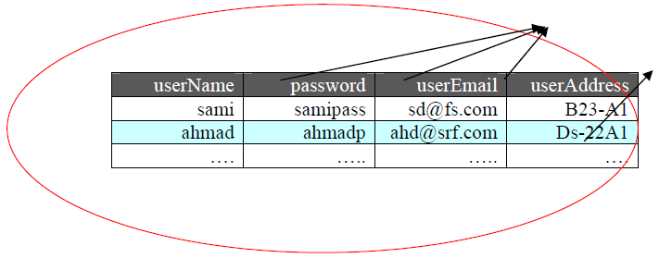

Row/Record

Table/Relation

Microsoft SQL Server: is a client server Architecture

Client

Application Program

DB system Environment

SW to process Queries

DBMS SW

SW to Access Stored Data

Server

DB

Meta Data

Sql Server Handel two types of DBs

* OLTP >> normal Database
* OLAP>> Warehousing DB and Historical Data

Sql Server Handles two types of Database within OLTP:

1. System Database (Master, Model, TempDB, MSDB)
2. User Database

## SQL Commands

DDL - Data Definition Language (Create, Alter, Drop)

DML - Data Manipulation Language (Select, Insert, Update, Delete)

DCL - Data Control Language (Grant, Revoke)

## Download

Microsoft SQL Server 2016 Express Edition : https://www.microsoft.com/en-us/sql-server/sql-server-downloads

[**Download SQL Server Management Studio 17.2**](https://go.microsoft.com/fwlink/?linkid=854085)