**CSE 431 – Documentation Report**

Name: Ahmed Sameh Mohamed Mourad

ID: 19P5861

-------------------------------------------------------------------------------------------------------------

# Extra Functionalities:

1. **Dark Mode:** Implemented a visually comfortable and straightforward dark mode for improved user experience.
2. **Flutter Best Practices:** Applied Flutter best practices consistently across the entire app to ensure efficiency and maintainability, such as managing the state.
3. **Functional Programming for Error Handling:** Utilized functional programming principles for error handling to enhance modularity and code readability.
4. **Flexible Reservation:** Allowed users to make reservations for any day within the current week, providing flexibility beyond restricting it to today only.
5. **Real-Time Date:** Both apps don’t dependent on the devices’ date to operate (DateTime.now), it operates on the correct time of Google’s server, so that no user can bypass the time constraints.
6. **Route Sorting:** Enable users to easily sort and organize routes according to their preferences, offering options for alphabetical sorting and sorting by price.
7. TDD Architecture: .

-------------------------------------------------------------------------------------------------------------

# Test Credentials (for both apps):

Email: [test@eng.asu.edu.eg](mailto:test@eng.asu.edu.eg)

Password: 123456

-------------------------------------------------------------------------------------------------------------

# Database Structure

I’ve used the Realtime database provided by firebase, for its speed and real-time read/write operation.

The database consists of 5 main nodes, and 2 attributes.

## Database View:

1. The 2 attributes are the “disable_user_validation” and “disable_driver_validation”, they are 2 bool attributes which controls the validation of the time constraints on both the user and driver apps; and can be set through each app respectively.

## Attributes View:

1. One of the main nodes is the “routes” node, it contains all the static routes that the driver can create a trip upon or a user can book a trip accordingly. It contains the route name, its address, its price, and its location on google maps which can be opened from both apps.

It contains 10 routes across all over Egypt, each one is represented by a photo from that place

## Routes View:

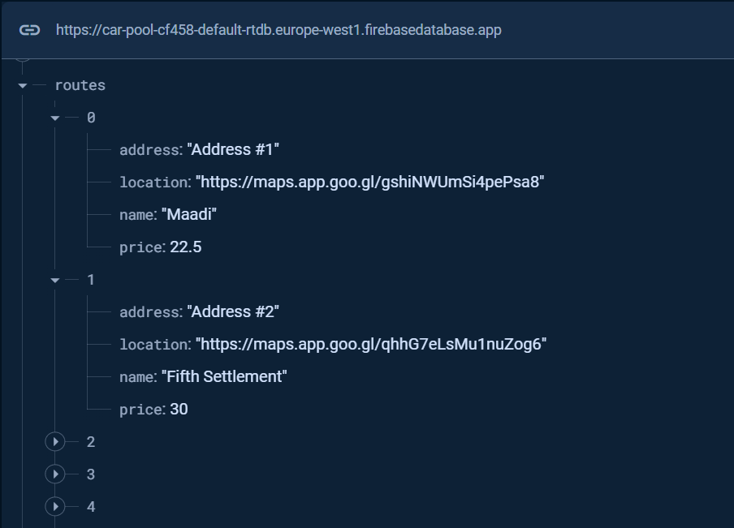

1. There is the “drivers” node which contains all the data about the registered drivers in the drivers app. It contains the name of the driver, his unique id, his trip count, his bonus points, and his raw email address.

Each entry has the unique id as its key and the value is the drivers’ data.

Each driver gets awarded 5 points when he successfully completes a trip, and the trip count increases by 1.

## Drivers View:

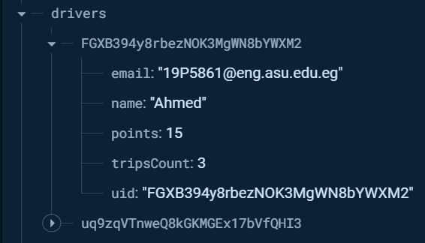

1. The “users” node contains all the data about the registered users in the users app. It contains the name of the user, his unique id, his trip count, his bonus points, and his raw email address.

Each entry has the unique id as its key and the value is the users’ data.

Each user gets awarded 5 points when he successfully completes a trip, and the trip count increases by 1.

## Users View:

1. The user trips node contains all the trips that a certain user has subscribed to.

## User Trips View:

