**Variable Length Subnet Mask (VLSM)**

**VLSM Design and Implementation Practice**

**Design the VLSM Addressing Scheme**

**• 10.0.0.0/8    255.255.255.0  
• VLAN 110 will require 62 host IP addresses  
• VLAN 170 LAN will require 62 host IP addresses  
• VLAN 150 LAN will require 30 host IP addresses  
• VLAN 160 LAN will require 30 host IP addresses  
• VLAN 180 LAN will require 30 host IP addresses  
• VLAN 140 LAN will require 30 host IP addresses  
• VLAN 120 LAN will require 30 host IP addresses  
• Server site will require 14 host IP addresses  
• Each Layer 3 switch will require 2 IPs to connect the GW router**

**Solution**

**10.00000000.00000000.00000000/8**

|  |  |  |  |  |  |  |  |
| --- | --- | --- | --- | --- | --- | --- | --- |
| x | x | x | x | x | x | x | x |
| 27 | 26 | 25 | 24 | 23 | 22 | 21 | 20 |
| 128 | 64 | 32 | 16 | 8 | 4 | 2 | 1 |

**Reorder**

1. • VLAN 110 will require 62 host IP addresses → Number of Hosts = 2^6 - 2 = 62 → /26 → 10.0.0.0/26
2. • VLAN 170 LAN will require 62 host IP addresses → Number of Hosts = 2^6 - 2 = 62 → /26 → 10.0.0.64/26
3. • VLAN 150 LAN will require 30 host IP addresses → Number of Hosts = 2^5 - 2 = 30 → /27 → 10.0.1.0/27
4. • VLAN 160 LAN will require 30 host IP addresses → Number of Hosts = 2^5 - 2 = 30 → /27 → 10.0.0.160/27
5. • VLAN 180 LAN will require 30 host IP addresses → Number of Hosts = 2^5 - 2 = 30 → /27 → 10.0.0.192/27
6. • VLAN 140 LAN will require 30 host IP addresses → Number of Hosts = 2^5 - 2 = 30 → /27 → 10.0.0.224/27
7. • VLAN 120 LAN will require 30 host IP addresses → Number of Hosts = 2^5 - 2 = 30 → /27 → 10.0.0.128/27
8. • Server site will require 14 host IP addresses → Number of Hosts = 2^4 - 2 = 14 → /28 → 10.0.1.32/28
9. • GW-MAIN-MLS will require 2 host IPs → Number of Hosts = 2^2 - 2 = 2 → /30 → 10.0.1.64/30
10. • GW-N-MLS will require 2 host IPs → Number of Hosts = 2^2 - 2 = 2 → /30 → 10.0.1.68/30
11. • GW-S-MLS will require 2 host IPs → Number of Hosts = 2^2 - 2 = 2 → /30 → 10.0.1.72/30
12. • GW-R-MLS will require 2 host IPs → Number of Hosts = 2^2 - 2 = 2 → /30 → 10.0.1.76/30

# Subnet Allocation Table

|  |  |  |  |  |  |
| --- | --- | --- | --- | --- | --- |
| Subnet Name | Network Address | Subnet Mask | First Host | Last Host | Broadcast Address |
| VLAN 110 | 10.0.0.0 | /26 | 10.0.0.1 | 10.0.0.62 | 10.0.0.63 |
| VLAN 170 | 10.0.0.64 | /26 | 10.0.0.65 | 10.0.0.126 | 10.0.0.127 |
| VLAN 120 | 10.0.0.128 | /27 | 10.0.0.129 | 10.0.0.158 | 10.0.0.159 |
| VLAN 160 | 10.0.0.160 | /27 | 10.0.0.161 | 10.0.0.190 | 10.0.0.191 |
| VLAN 180 | 10.0.0.192 | /27 | 10.0.0.193 | 10.0.0.222 | 10.0.0.223 |
| VLAN 140 | 10.0.0.224 | /27 | 10.0.0.225 | 10.0.0.254 | 10.0.0.255 |
| VLAN 150 | 10.0.1.0 | /27 | 10.0.1.1 | 10.0.1.30 | 10.0.1.31 |
| VLAN 300 | 10.0.1.32 | /28 | 10.0.1.33 | 10.0.1.46 | 10.0.1.47 |
| SW-S to MIU-MIU-GW | 10.0.1.48 | /28 | 10.0.1.49 | 10.0.1.62 | 10.0.1.63 |
| Main-MLS to MIU-MIU-GW | 10.0.1.64 | /30 | 10.0.1.65 | 10.0.1.66 | 10.0.1.67 |
| N-MLS to MIU-MIU-GW | 10.0.1.68 | /30 | 10.0.1.69 | 10.0.1.70 | 10.0.1.71 |
| S-MLS to MIU-MIU-GW | 10.0.1.72 | /30 | 10.0.1.73 | 10.0.1.74 | 10.0.1.75 |
| R-MLS to MIU-MIU-GW | 10.0.1.76 | /30 | 10.0.1.77 | 10.0.1.78 | 10.0.1.79 |

Addressing Table

|  |  |  |  |  |  |
| --- | --- | --- | --- | --- | --- |
| Device | Interface | Address | Subnet Mask | Default Gateway | VLAN ID |
| Main-MLS | G1/1/1 | 10.0.1.65 | 255.255.255.252 |  | VLAN 110 |
|  | VLAN 110 | 10.0.0.1 | 255.255.255.192 | 10.0.0.1 |  |
|  | VLAN 120 | 10.0.0.129 | 255.255.255.224 | 10.0.0.129 |  |
| S-MLS | G1/1/1 | 10.0.1.73 | 255.255.255.252 |  | VLAN 140 |
|  | VLAN 300 | 10.0.1.33 | 255.255.255.240 | 10.0.1.33 |  |
|  | VLAN 140 | 10.0.0.225 | 255.255.255.224 | 10.0.0.225 |  |
| N-MLS | G1/1/1 | 10.0.1.69 | 255.255.255.252 |  | VLAN 150 |
|  | VLAN 150 | 10.0.1.1 | 255.255.255.224 | 10.0.1.1 |  |
|  | VLAN 160 | 10.0.0.161 | 255.255.255.224 | 10.0.0.161 |  |
| R-MLS | G1/0/5 | 10.0.1.77 | 255.255.255.252 |  | VLAN 170 |
|  | VLAN 170 | 10.0.0.65 | 255.255.255.192 | 10.0.0.65 |  |
|  | VLAN 180 | 10.0.0.193 | 255.255.255.224 | 10.0.0.193 |  |
| MIU-MIU-GW | Gig0/0(ISP) | 209.165.200.226 | 255.255.255.252 |  |  |
|  | Gig0/1(R) | 10.0.1.78 | 255.255.255.252 |  |  |
|  | Gig0/0/0(Server) | 10.0.1.49 | 255.255.255.240 |  |  |
|  | Gig0/1/0(Main) | 10.0.1.66 | 255.255.255.252 |  |  |
|  | Gig0/2/0(S) | 10.0.1.74 | 255.255.255.252 |  |  |
|  | Gig0/3/0(N) | 10.0.1.70 | 255.255.255.252 |  |  |
| ISP | Gig0/0 | 209.165.200.225 | 255.255.255.240 |  |  |
|  | Gig0/1 | 64.100.1.1 | 255.255.255.224 |  |  |
|  | Gig0/2 | 64.100.2.1 | 255.255.255.224 |  |  |
| Branch-GW | Gig0/0.2 | 192.168.2.1 | 255.255.255.0 |  |  |
|  | Gig0/0.3 | 192.168.3.1 | 255.255.255.0 |  |  |
|  | Gig0/1 | 64.100.1.2 | 255.255.255.224 |  |  |
| Wireless Home Router | Gig0/1 | 64.100.2.2 | 255.255.255.224 |  |  |
|  | Router IP | 192.168.10.1 | 255.255.255.128 |  |  |

|  |  |  |  |  |
| --- | --- | --- | --- | --- |
| **PC-number** | **VLAN ID** | **IP Address** | **Subnet Mask** | **Default Gateway** |
| **MIU** | | | | |
| **PC-1** | VLAN 110 | 10.0.0.4  From DHCP Server | 255.255.255.192  From DHCP Server | 10.0.0.1 |
| **PC-2** | VLAN 110 | 10.0.0.5  From DHCP Server | 255.255.255.192  From DHCP Server | 10.0.0.1 |
| **PC-3** | VLAN 120 | 10.0.0.132  From DHCP Server | 255.255.255.224  From DHCP Server | 10.0.0.129 |
| **PC-4** | VLAN 300 | 10.0.1.37  From DHCP Server | 255.255.255.240  From DHCP Server | 10.0.1.33 |
| **PC-5** | VLAN 300 | 10.0.1.36  From DHCP Server | 255.255.255.240  From DHCP Server | 10.0.1.33 |
| **PC-6** | VLAN 140 | 10.0.0.229  From DHCP Server | 255.255.255.224  From DHCP Server | 10.0.0.225 |
| **PC-7** | VLAN 150 | 10.0.1.30 | 255.255.255.224 | 10.0.1.1 |
| **PC-8** | VLAN 160 | 10.0.0.190 | 255.255.255.224 | 10.0.0.161 |
| **PC-9** | VLAN 170 | 10.0.0.126 | 255.255.255.192 | 10.0.0.65 |
| **PC-10** | VLAN 180 | 10.0.0.222 | 255.255.255.224 | 10.0.0.193 |
| **MIU_ Branch 1** | | | | |
| **PC-11** | VLAN 2 | From DHCP Server | From DHCP Server | 192.168.2.1 |
| **PC-12** | VLAN 3 | From DHCP Server | From DHCP Server | 192.168.3.1 |
| **Wireless Home Network** | | | | |
| **Laptop** |  | 192.168.10.10 | 255.255.255.128 | 192.168.10.1 |
| **Tablet** |  | 192.168.10.30 | 255.255.255.128 | 192.168.10.1 |
| **Smartphone** |  | 192.168.10.20 | 255.255.255.128 | 192.168.10.1 |
| **Servers** | | | | |
| **DHCP Server** |  | 10.0.1.50 | 255.255.255.240 | 10.0.1.49 |
| **Email Server** |  | 10.0.1.51 | 255.255.255.240 | 10.0.1.49 |
| **Web server** |  | 10.0.1.52 | 255.255.255.240 | 10.0.1.49 |
| **DNS server** |  | 10.0.1.53 | 255.255.255.240 | 10.0.1.49 |
| **NTP and Syslog server** |  | 10.0.1.54 | 255.255.255.240 | 10.0.1.49 |

Part 3

On layer-3 switches:

1)int range g1/0/1-2 (and make the same for g1/0/3-4)

2)channel-group 2 mode active (it will be 3 for g1/0/3-4)

3)int port channel 2

4)switchport mode trunk

5)int g1/1/1

6)no switchport

7)ip address (ip) (subnet)

8)int vlan (no) (do the same for the second vlan)

9)ip address (ip) (subnet)

10)vlan (no)

11) name VLAN_no (do the same for the second vlan)

12)ip routing

On switch layer-2:

1)int range g0/1-2 (and make the same for f0/1-2)

2)channel-group 2 mode active (it will be 3 for f0/1-2)

3)int port channel 2

4)switchport mode trunk

5)int f0/3 (do the same f0/4 if exist)

6)switchport mode access

7)switchport access vlan no

8)vlan (no)

9) name VLAN_no (do the same for the second vlan)

Part 4

On MIU-GW:

1)router ospf 100

2)router-id 1.1.1.1

3)network between (Main,S,SW-S)->MIU-GW (wild card)(area 0)

4)redistribute eigrb 10 subnets

5)passive-interface default

6)no passive interface (on interfaces that need ospf)

7)router eigrb 10

8) network between (N,R)->MIU-GW (wild card)(area 0)

9) redistribute OSPF 100 metric 10000 100 255 1 1 1500

10)ip route 0.0.0.0 0.0.0.0 (next hop)

On Main,S:

1)router ospf 100

2)router id 2.2.2.2 (will be 3.3.3.3 in S)

3)network between (MIU,S,Main)

4)network between (Main,S)->VLAN_no

5)passive interface default

6) no passive interface (on interfaces that need ospf)

On N,R:

1)router eigrb 10

2)network between (N,R,Main)

3)network between (N,R)->vlans

4)passive interface default

5) no passive interface (on interfaces that need ospf)

On isp:

1)ip route 10.0.0.0 255.255.0.0 209.165.200.226

2)ip route 192.168.2.0 255.255.0.0 64.100.1.2

3) ip route 192.168.3.0 255.255.0.0 64.100.1.2

4) ip route 192.168.10.0 255.255.0.0 64.100.2.2

On branch:

Ip route 0.0.0.0 0.0.0.0 64.100.1.1

On wireless:

Ip route 0.0.0.0 0.0.0.0 64.100.2.1

Part 5

On DHCP server :

1)services->DHCP

2)check if it is on

3)fill inputs of the poll name, default gateway, DNS server, start ip address, subnet mask

4)press add after finish

On switch layer-3 :

1)int vlan (no)

2)ip helper-address (DHCP ip)

Branch-GW:

1)ip dhcp execlude-address (start ip)(end ip)->(for each vlan)

2)ip dhcp poll (name)

3)network (ip)(subnet)

4)default-router(ip)

5)dns-server (dns ip)

Show running-config on all devices

**Main-MLS**

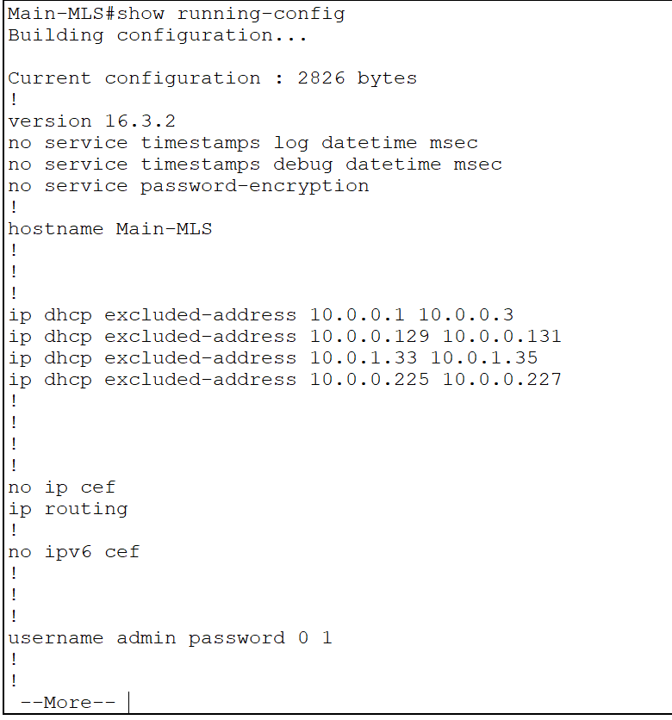

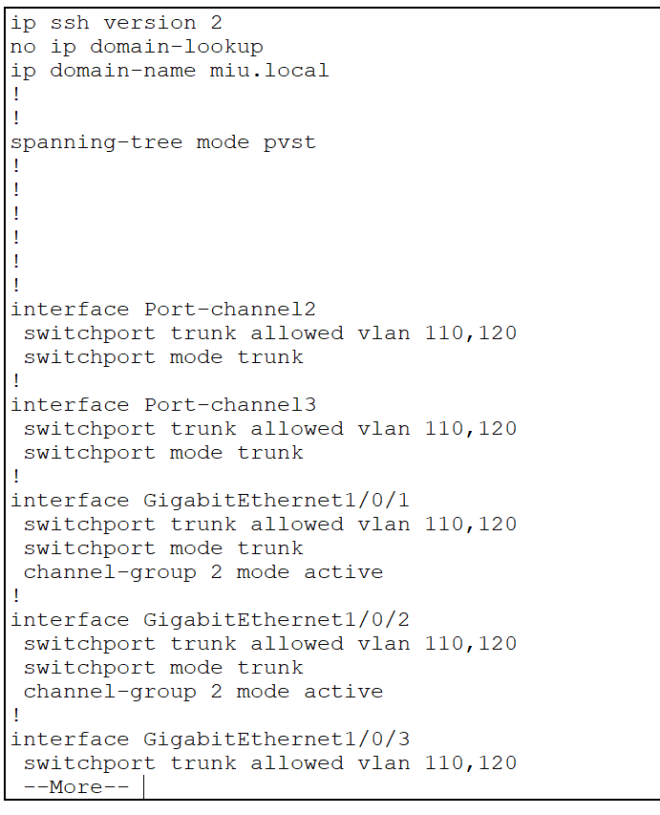

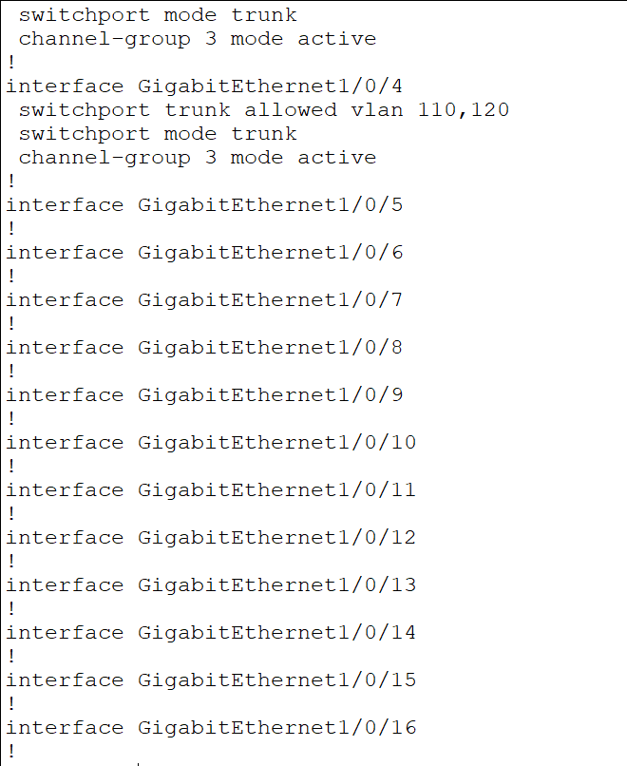

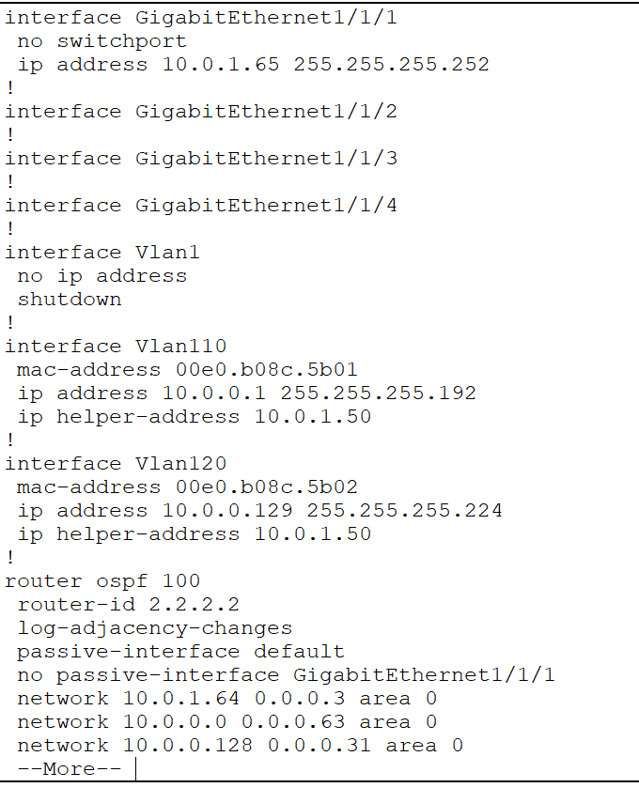

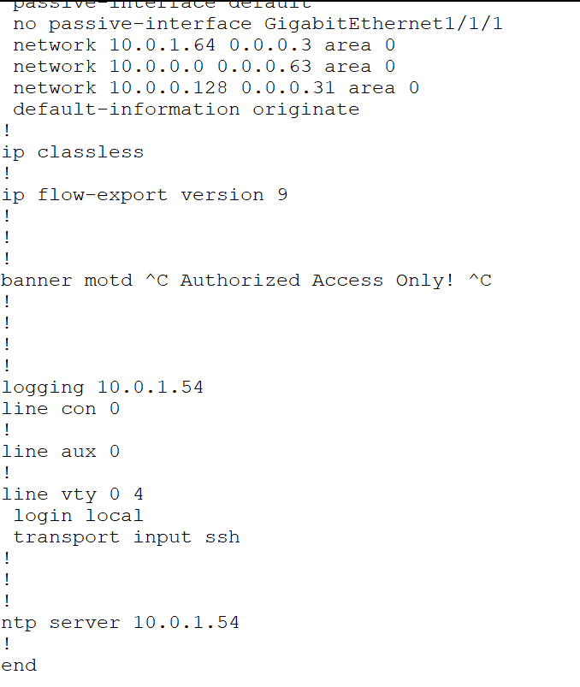

**MIU-GW**

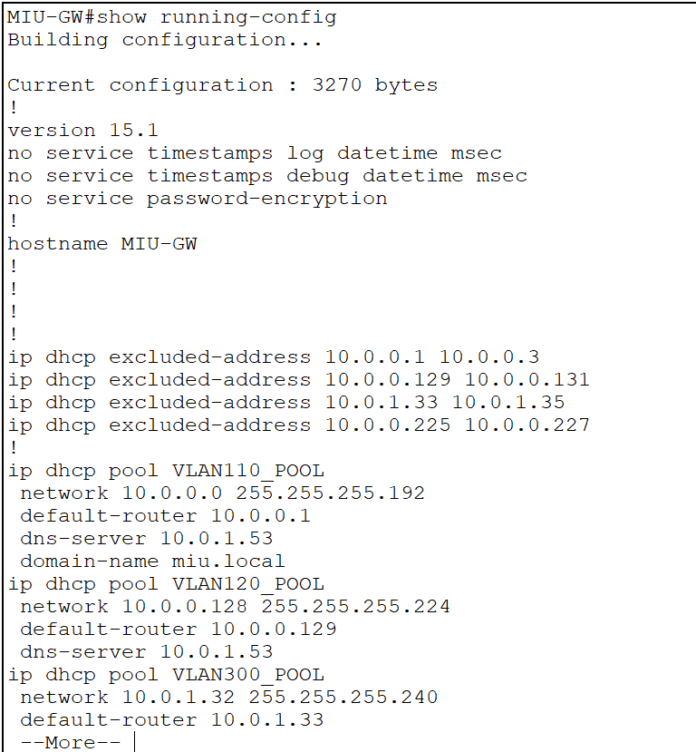

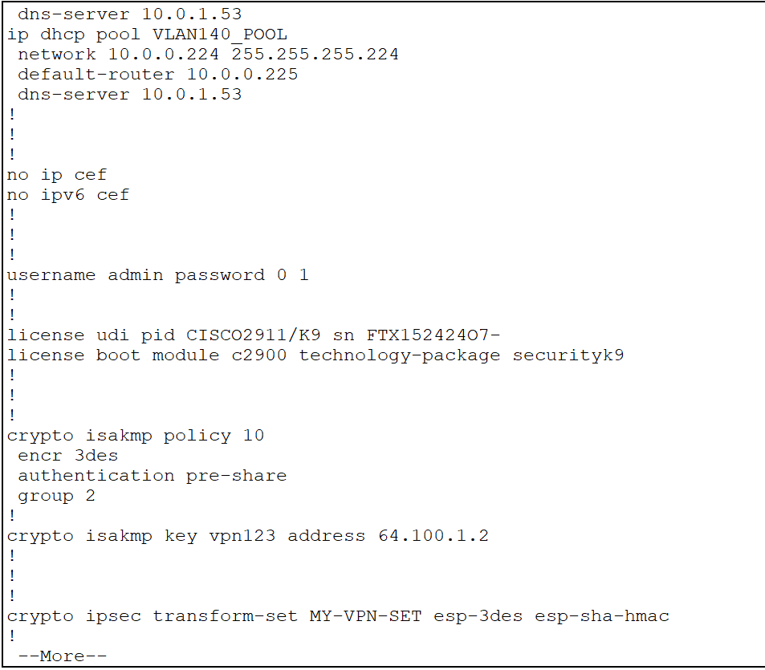

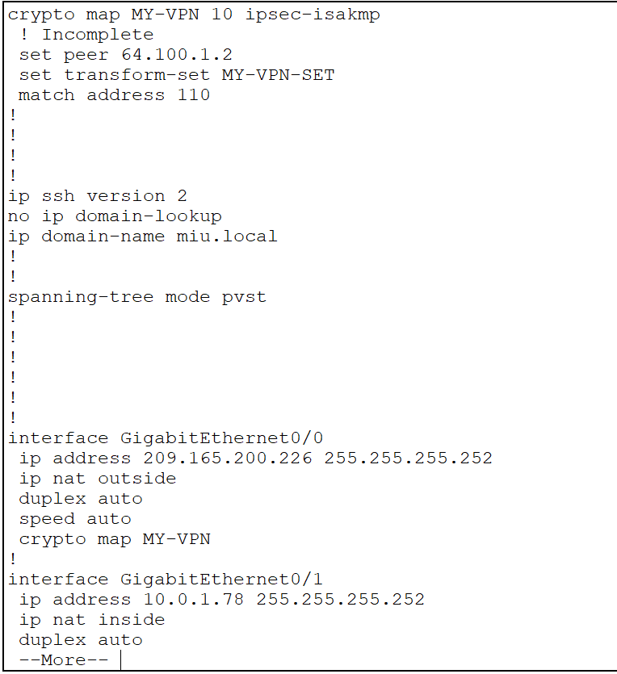

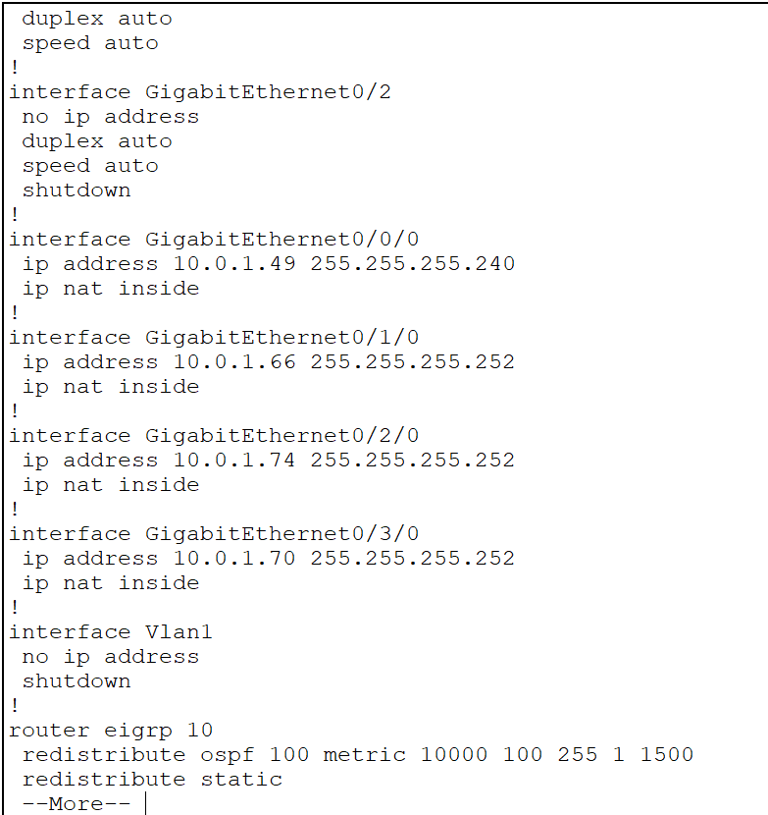

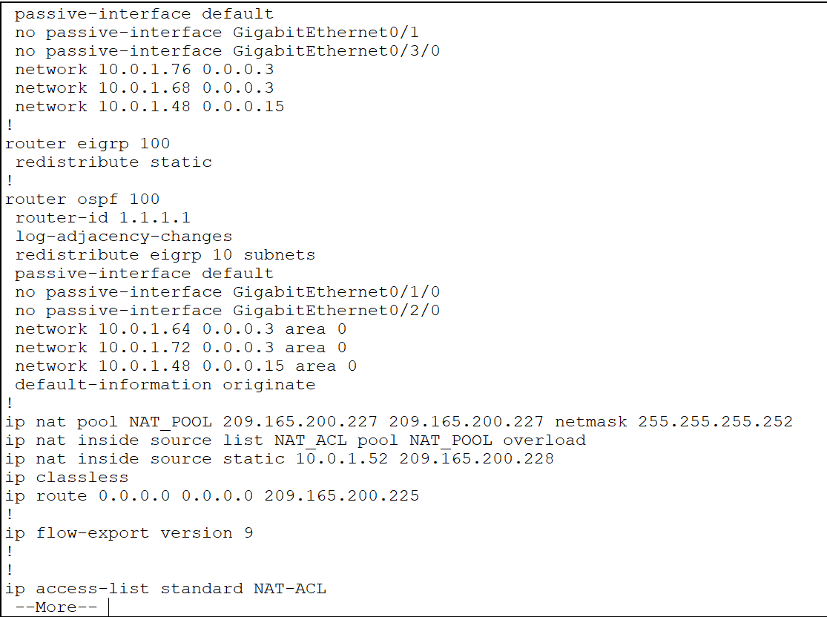

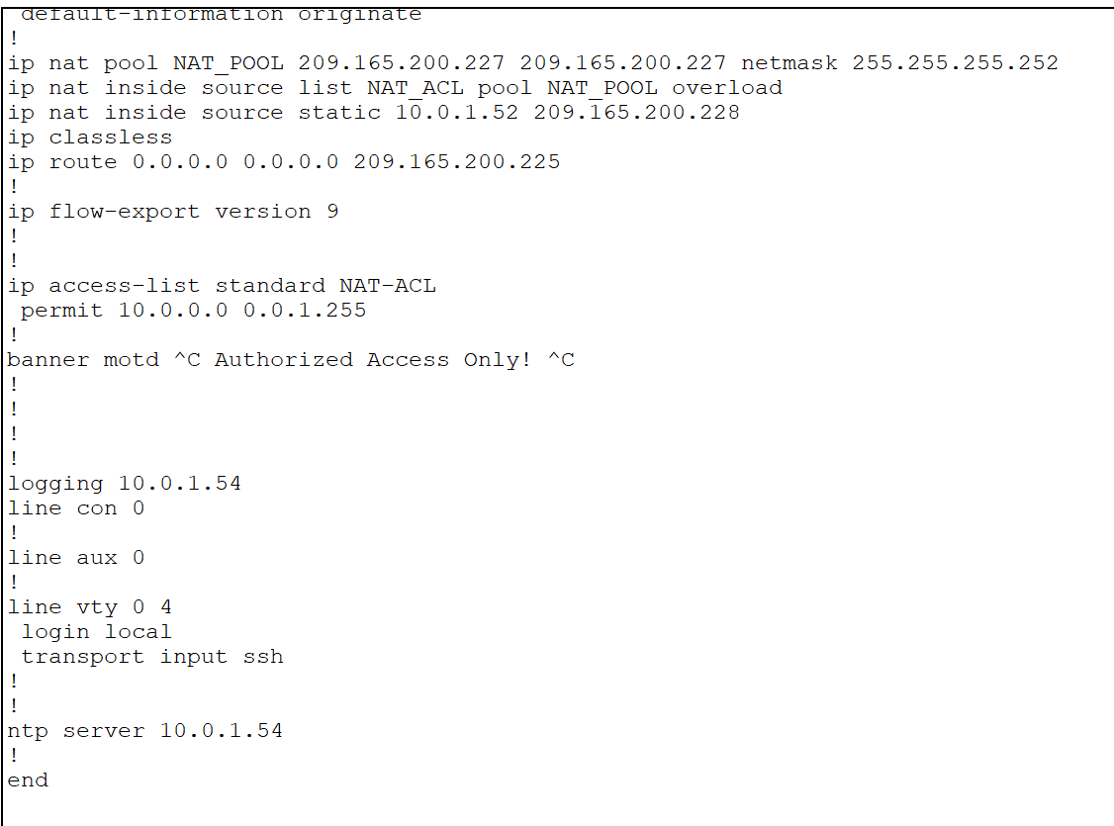

**ISP**

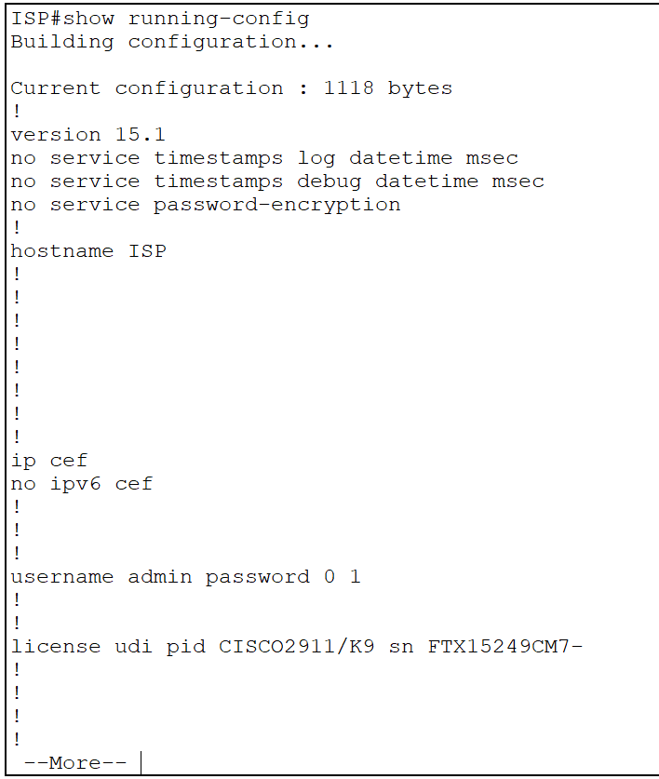

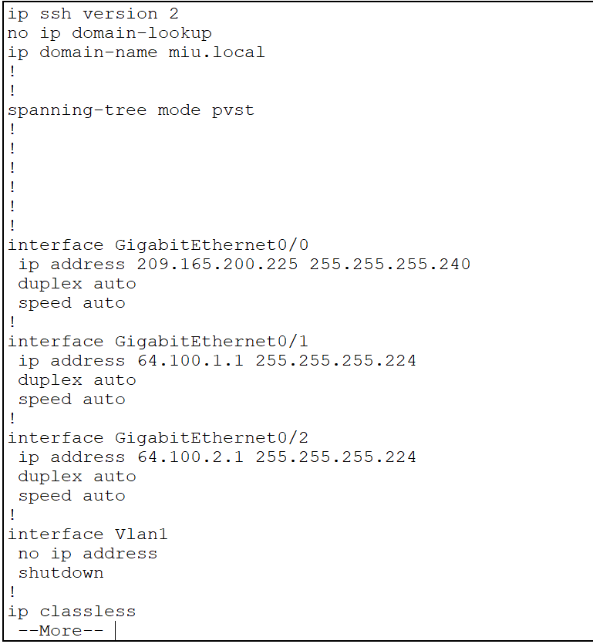

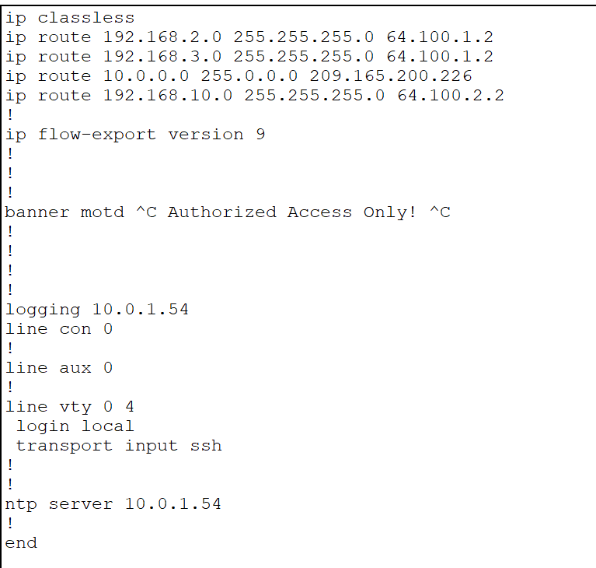

**Branch-GW**

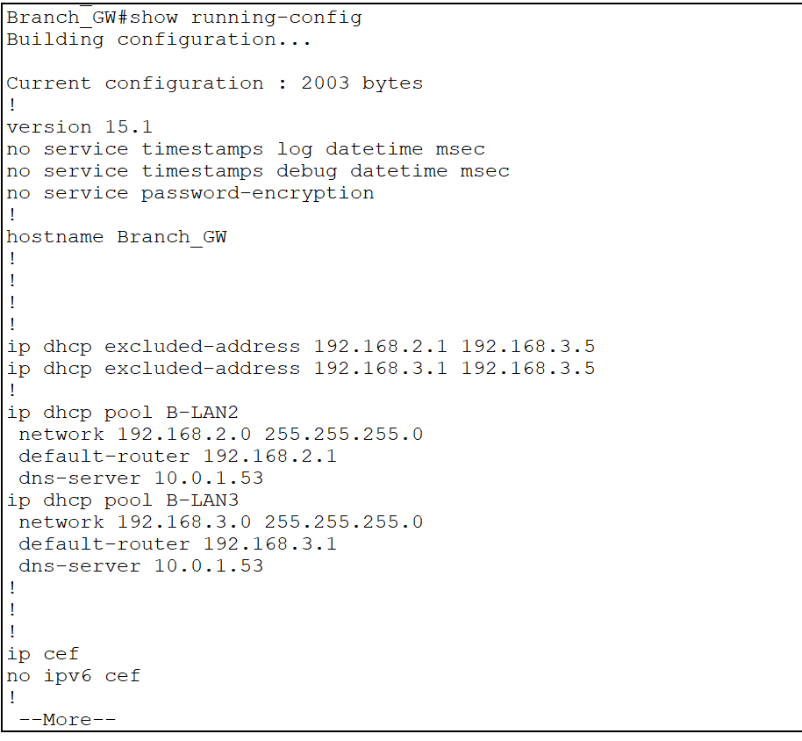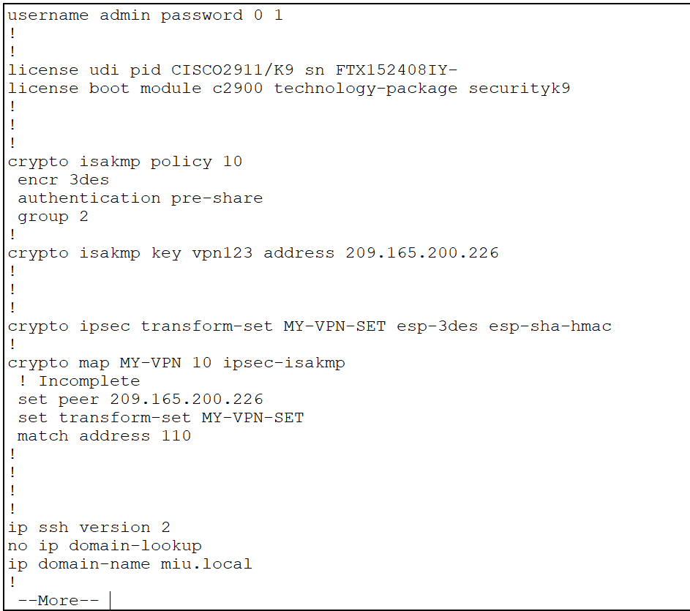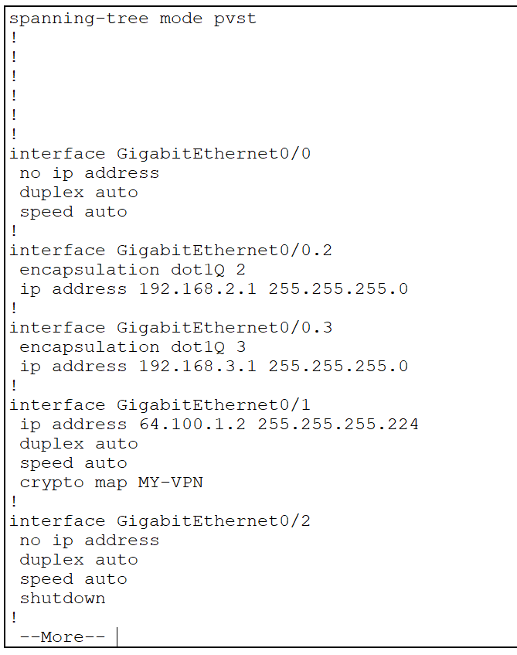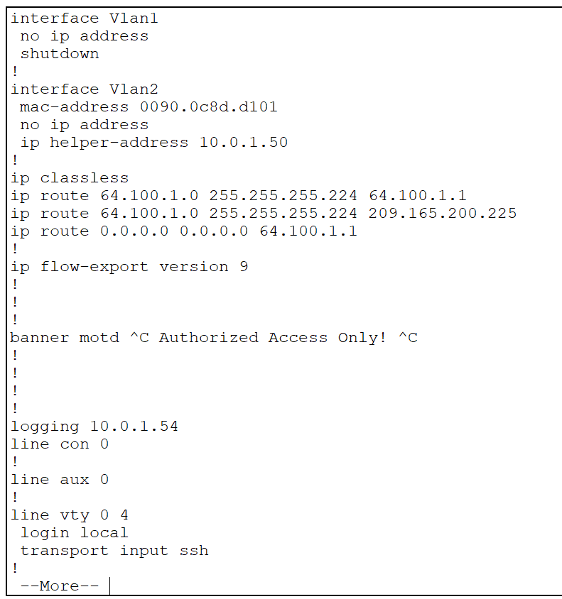

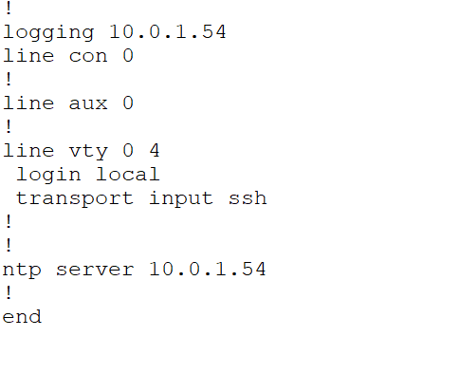

**Part 10: Verify Connectivity.**

**Perform a ping test between all devices connected to the network.**

**Take a screenshot of each ping operation.**

For example, pc1

Pc1 ping to pc2(same subnet same vlan)

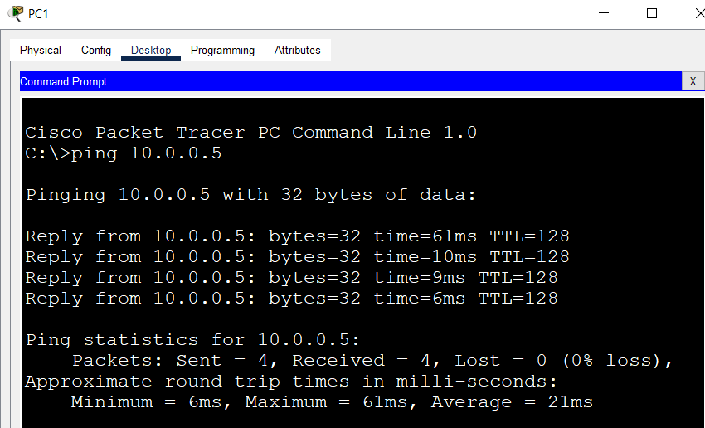

Pc1 to pc3 (same subnet diff vlan)

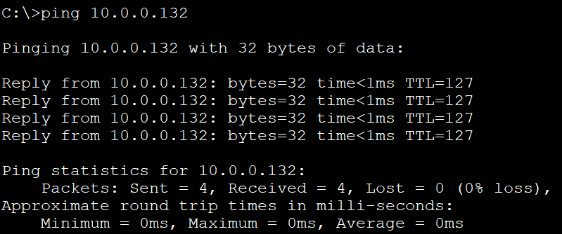

Pc1 to pc4(diff subnet diff vlan)

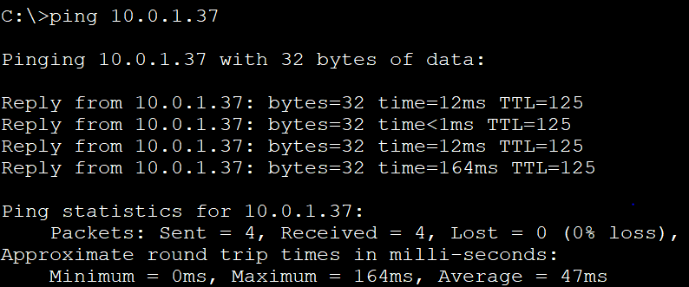

Pc1 ping pc6

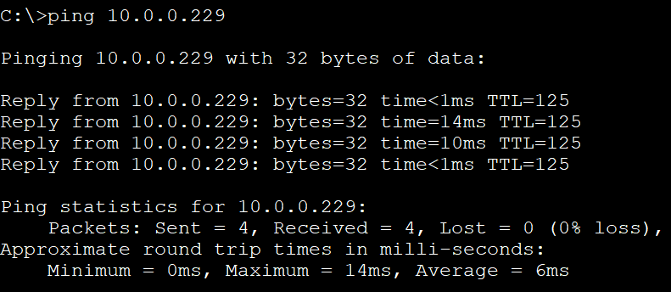

Pc1 ping pc7

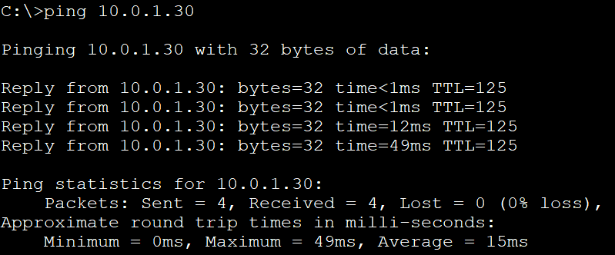

Pc1 ping pc8

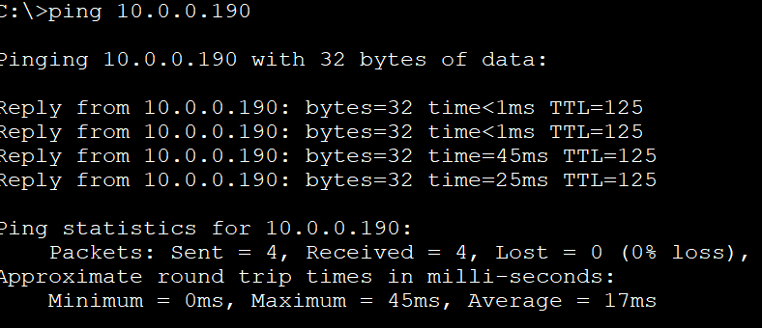

Pc1 ping pc9

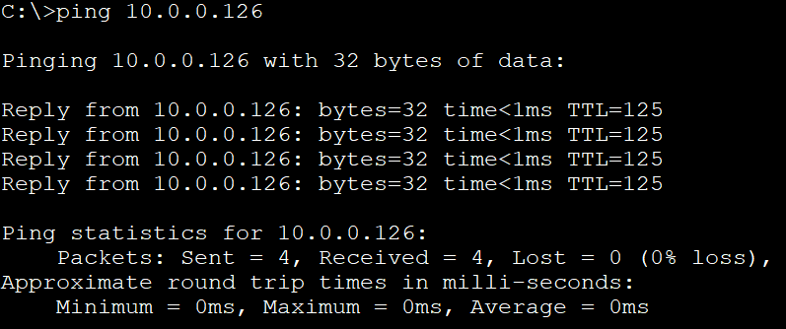

Pc1 ping pc10

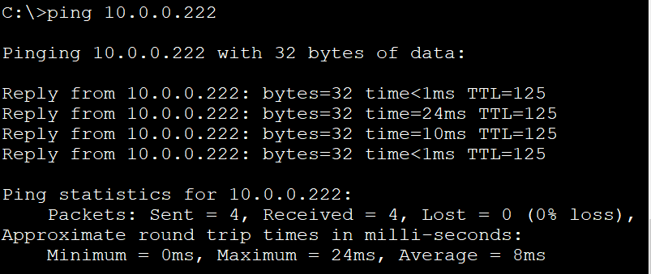

Pc1 ping pc11

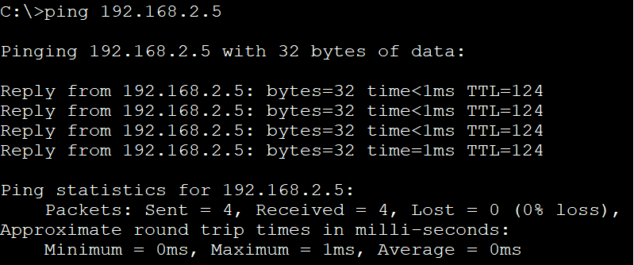

Pc1 ping pc12

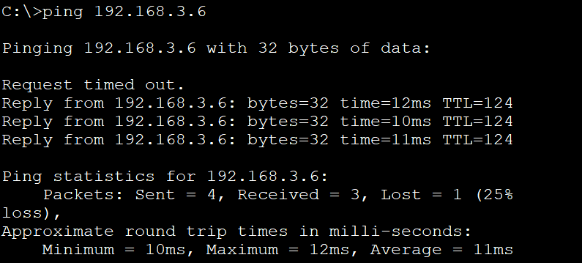

Pc1 ping its default-gateway(interface-SVI: vlan main-mls)

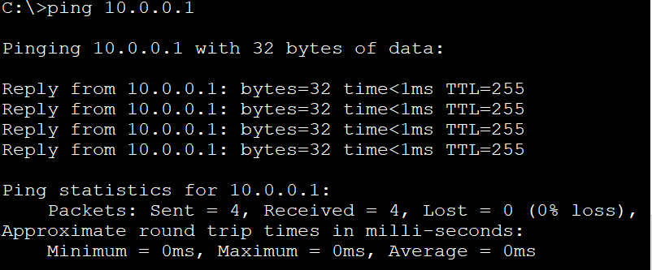

Pc1 ping DHCP Server in SW-S

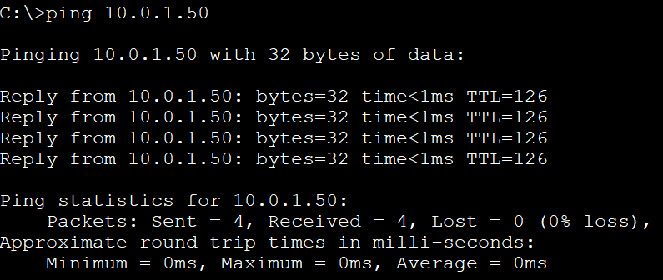

MIU-GW ping ISP

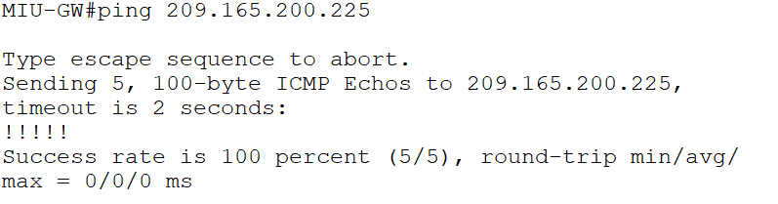

**MIU-GW ping Branch_GW**

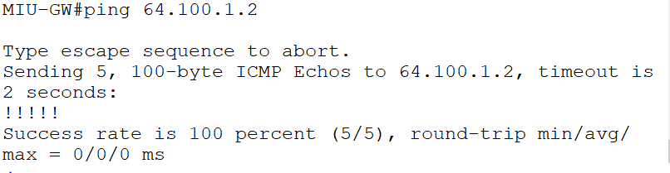

**ISP ping MIU-GW**

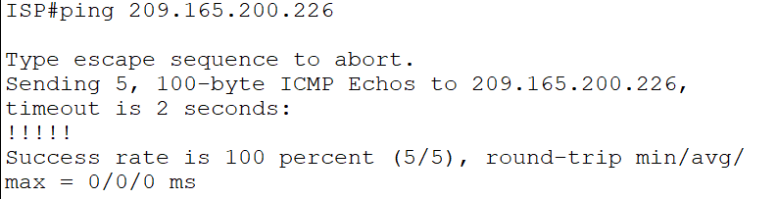

**ISP ping Branch_GW**

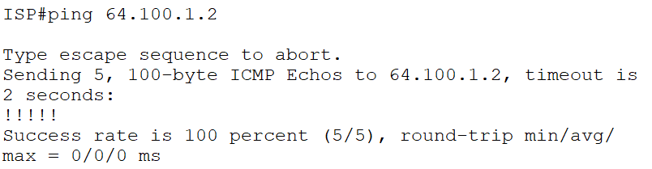

In wireless network

Smartphone ping tablet

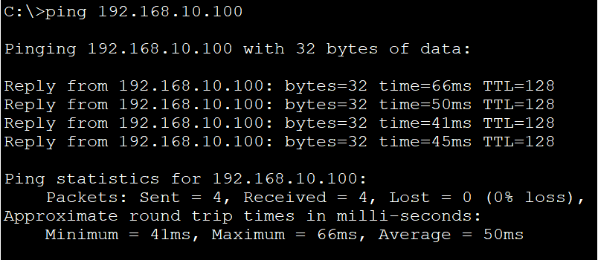

Display the IP address of each interface (IP Interface) on each device.

Show ip interface brief:

**Main-MLS**

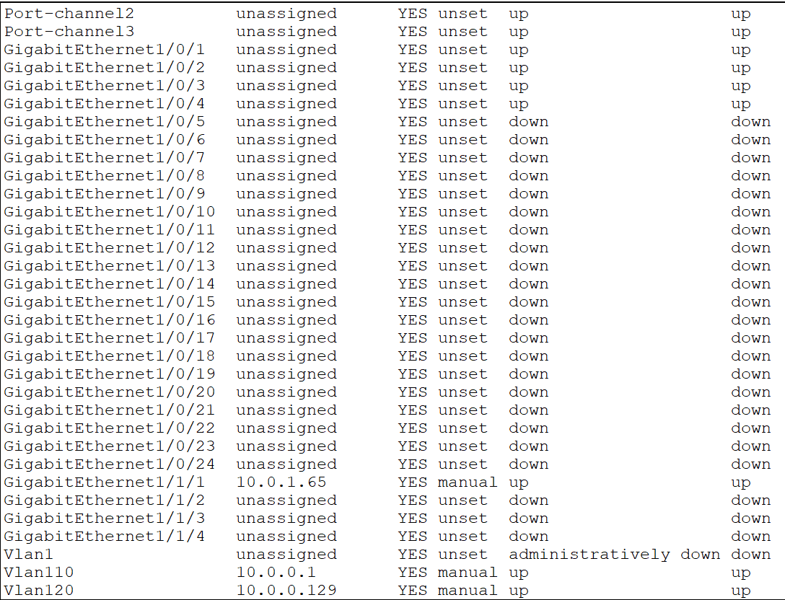

**S-MLS**

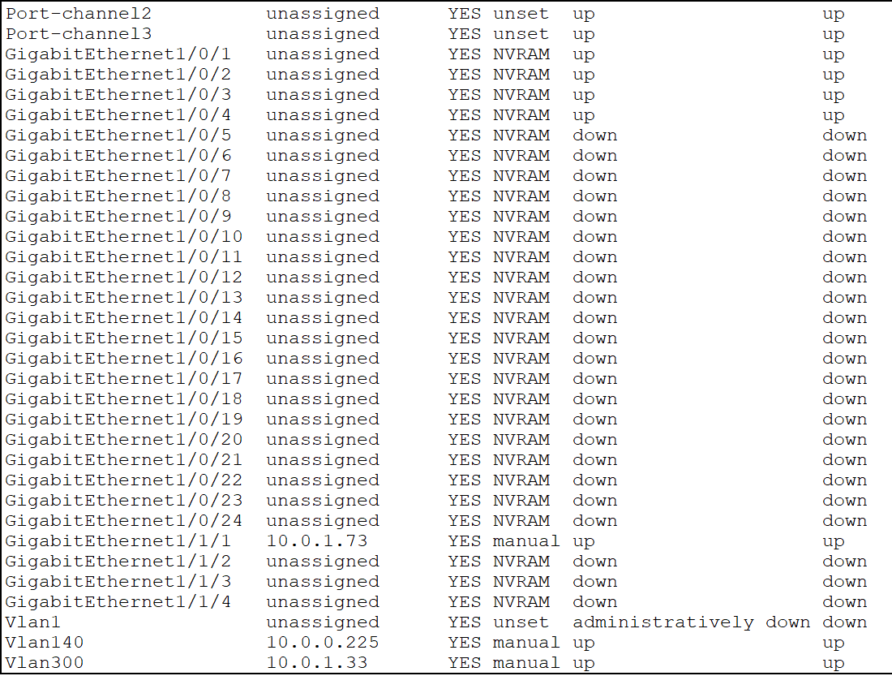

**N-MLS**

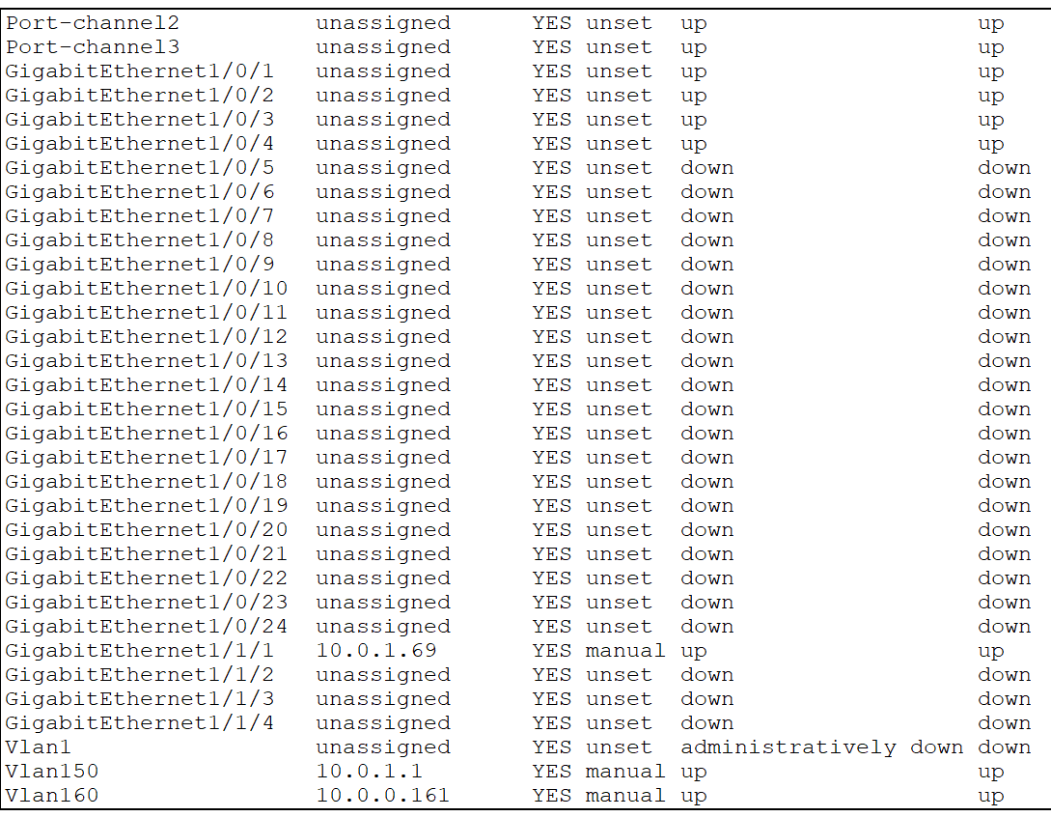

**R-MLS**

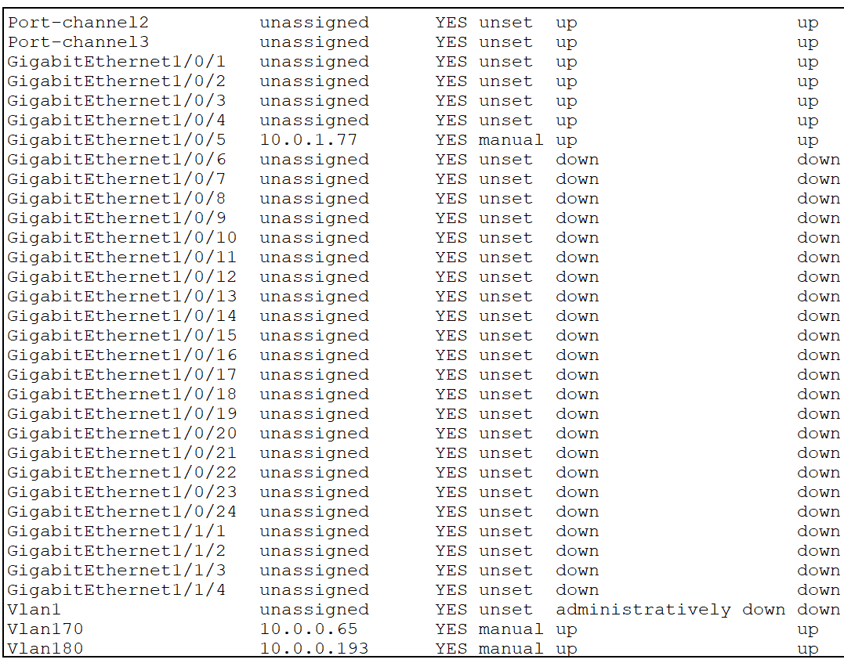

**MIU-GW**

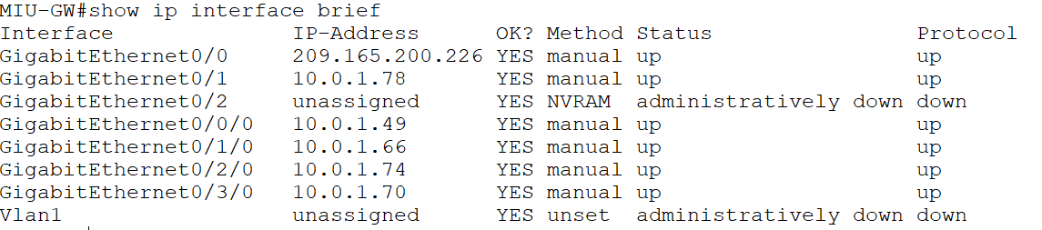

**Branch-GW**

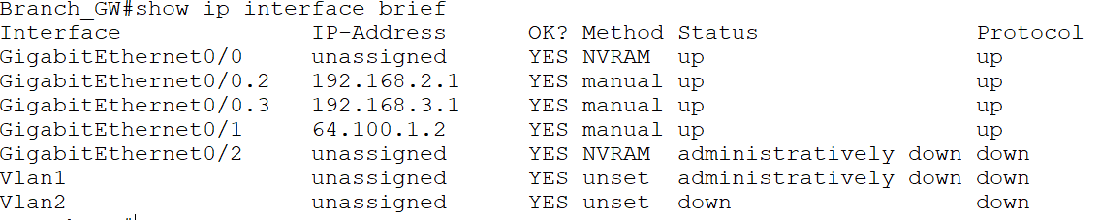

**ISP Router**

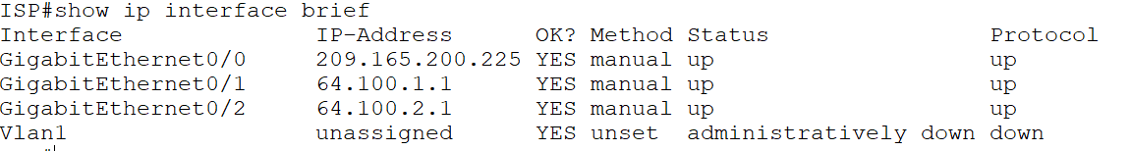

-Display the routing table for each router in the network.

Show ip route

**Main-MLS**

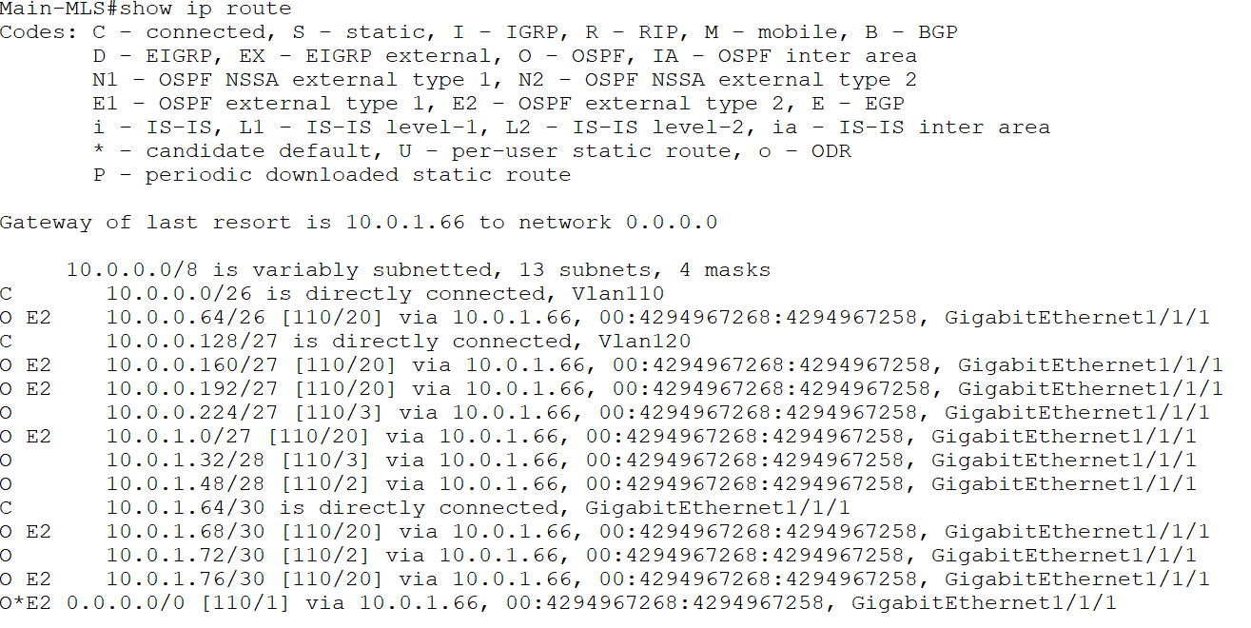

**S-MLS**

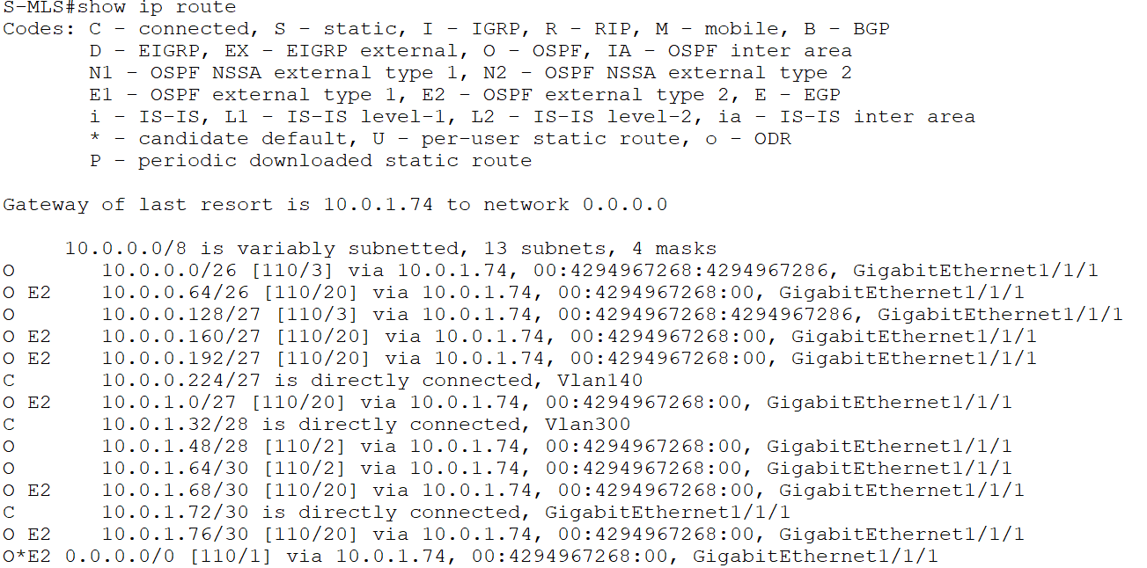

**N-MLS**

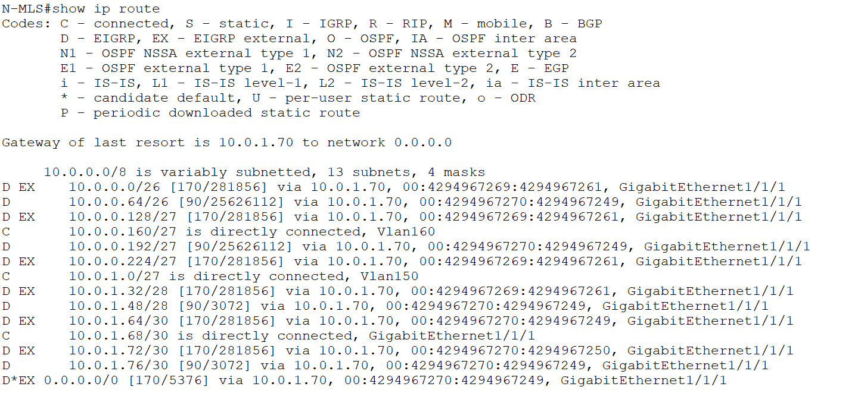

**R-MLS**

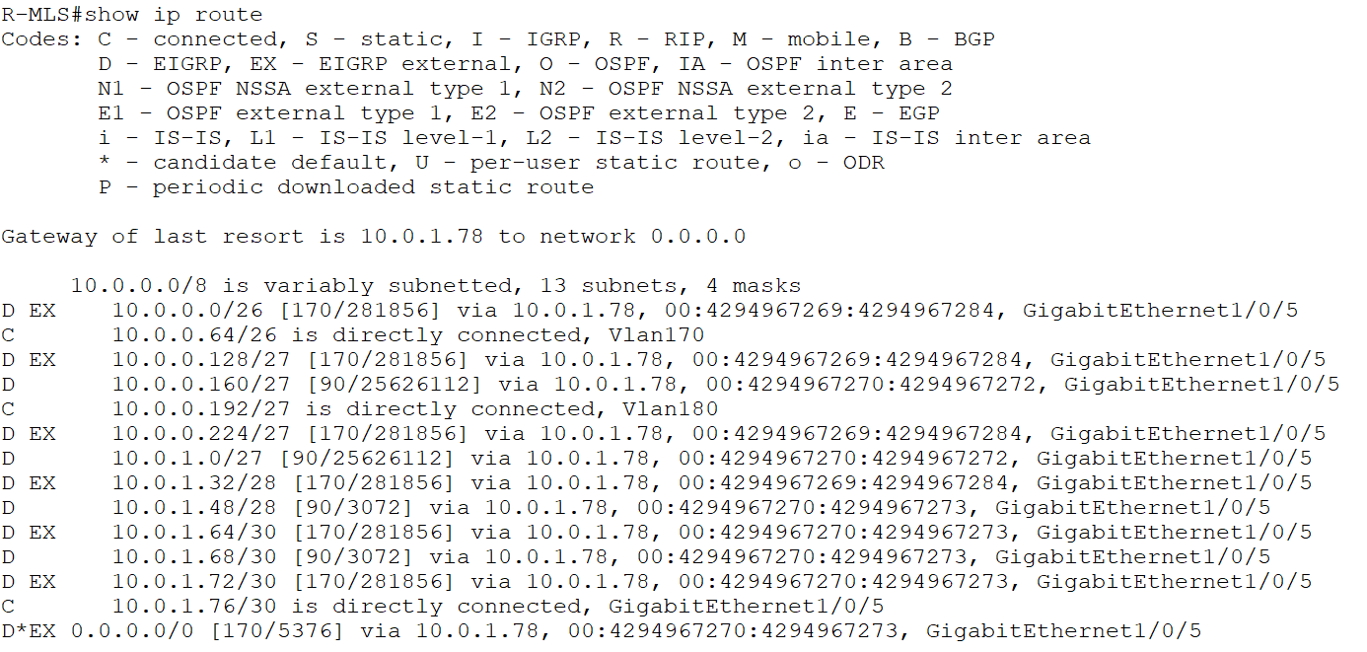

**MIU-GW**

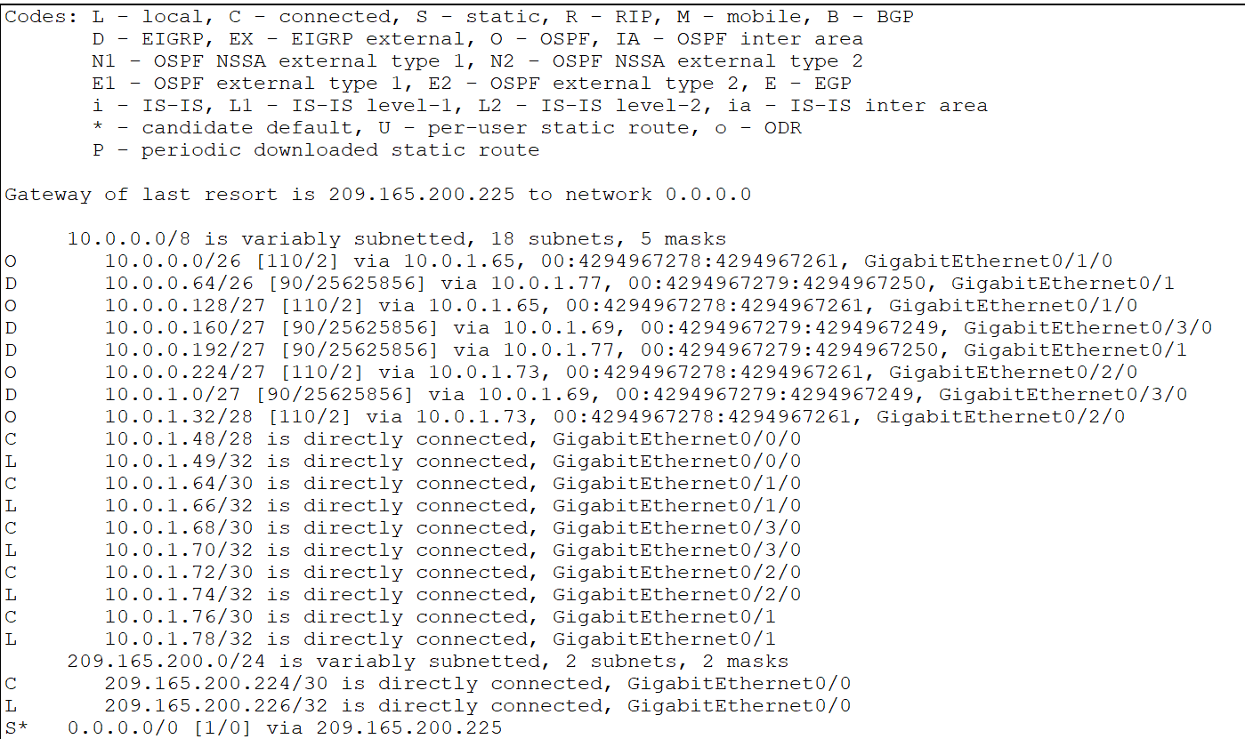

**Branch-GW**

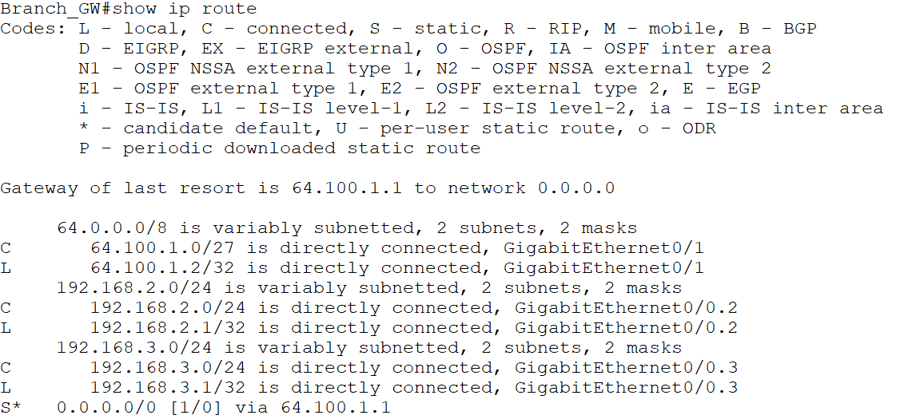

**ISP Router**

