# Contacts Book:

## Description:

Python script used to create contact book, add, delete, update, backup and show it’s content

## Prerequisites:

* Install python (pip install python)
* Install csv module (pip install python-csv)
* Install boto3 module (pip install boto3)

## Code Blocks:

1-importing libraries

* CSV
* OS

2- Define global variables

* Today (define today’s date in the format if year-month-day)
* 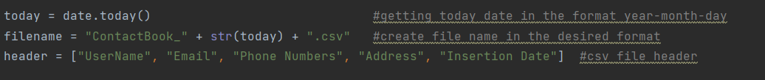Filename (create a variable with a name depends on today’s date )

3-code functions

4-Functions call and code execution:

## Functions description:

1. def input_in_valid_format():

Used in the functions that let the user enter data manually to make sure he enters it in the right format like in functions (create and update)

How it works?

1-Create a forever loop

1.1-take user input and turn it to a list to deal with it easily

1.2-create if condition that checks if the input meets the conditions

1st condition: entered 4 elements separated with comma

2nd condition: the second element contains @ as it must be an email

3rd condition: the third element is all digit as it must be a phone number

1.3-if conditions work break from the loop and go to step -2-

1.4-if conditions were not met print a message to show the problem and go to step -1.1-

2-add today date to the new line

3-return the new line from the function

1. def todays_file_exist():

check whether there is a contacts book with today’s date created or not using two libraries

1-os to check file existence on the computer

2-CSV to create one if it didn’t exist

How It Works?

1. After running the script isExist variable created it returns True or False



1. If True print file name and continue in other script functions
2. If False use CSV module to create a new file.csv with the right name then continue in the rest of the script functions
3. def list_of_users_in_csvFile(file):

It helps in listing the csv file user names and add them into a list instead of writing it every time we need it

Takes one argument (the file we want to list its users)

How it works?

1. Create empty list called names
2. With CSV module open file.csv in read mode

2.1- Skip the first row (header) next(read)

3.1- Loop over the rest of the rows and add the first index in names list

3- return names list from the function

1. def welcome():

1-print some welcome messages and take input from user about which command he wants to execute

2-return the command number

1. def cases(cmd_num):

take the input from welcome function and direct it to one of the 5 cases in this function

1. def create():

let the user choose how to create data from two options

* A picture containing graphical user interface

  Description automatically generatedManual data entry:

1. take input from user and make sure it’s in the right format using input_in_valid_format():
2. Graphical user interface, text

   Description automatically generatedOpen file.csv and add that row and show the added contact

* Importing data from another file:

1. The user input the imported file name
2. Using try except

In try :

* With csv module open the imported file then add it’s content to list called date
* Open the original file then copy list data to it

In except:

If any thing went wrong

* print(file,"DOESN'T EXISTS")

1. def update():

Takes the username which to update it’s contact from the user and the full update line then update it

How It Works?

1. print list with usernames with def list_of_users_in_csvFile(file): and ask the user to enter one of them
2. A computer screen capture

   Description automatically generated with medium confidencethere is a if condition to make sure the user exists if not return a message and ask user to enter a valid one again
3. After entering a valid user name ask the user to enter the new data in full and valid format by passing it to input_in_valid_format():
4. Define which row was the user name in by looping over the users list and getting the user’s index
5. Add the rows to the file.csv
6. def delete():
7. print list with usernames with def list_of_users_in_csvFile(file): and ask the user to enter one of them to delete
8. open the original file
   1. make sure the input username exists in the users list if not repeat until the user enters a valid one
   2. add all the rows except the one we want to delete to anew list called updatedlist
9. write updated list in file.csv

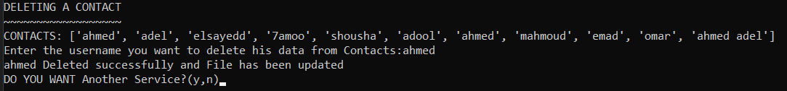

1. def show():

1. def backup(file_name, bucket, object name=None, folder name=None)

had a problem in this function:

it works in PyCharm but

import boto3 add the beginning of the code make the exe closes immediately couldn’t fix it