DOCKER
Slide 1: High-Level Docker Architecture
This diagram shows the relationship between the client (your command prompt), the Docker Daemon (the background engine on your computer), and Docker Hub (the "App Store" for images).
Use this to explain The Flow of a docker pull nginx command:
- Client: You type docker pull nginx in your terminal.
- Daemon: The Docker Daemon receives the request.
- Registry: The Daemon connects to Docker Hub and asks, "Do you have an image called nginx?"
- Pull: Docker Hub sends the image data back to the Daemon.
- Run: When you type docker run nginx, the Daemon creates a new container from that stored image.
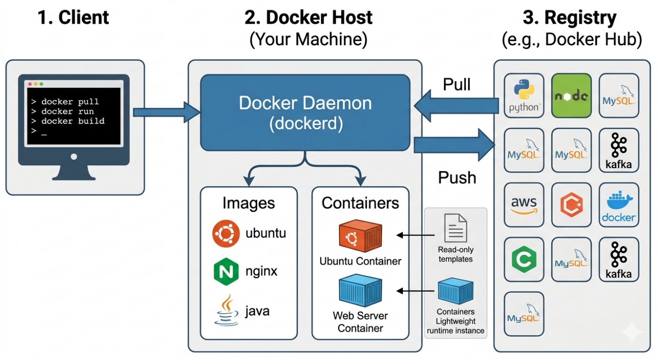
Slide 2: From Concept to Reality: A Running Nginx Server
This diagram translates the architecture into a concrete example. Show this when demonstrating how an official image like nginx gets turned into a usable web server.
Teaching Flow:
- Image Layer (The Stack): This is a read-only template containing Linux basics, plus Nginx configurations.
- Container Layer (The Top): When you run it, Docker adds a thin, writable "Container Layer" at the top where new files or logs are stored.
- Port Mapping (The Connection): Crucial concept! The container listens internally on Port 80. But students access it from outside using Port 8080. The diagram shows how this port mapping (-p 8080:80) creates the bridge.
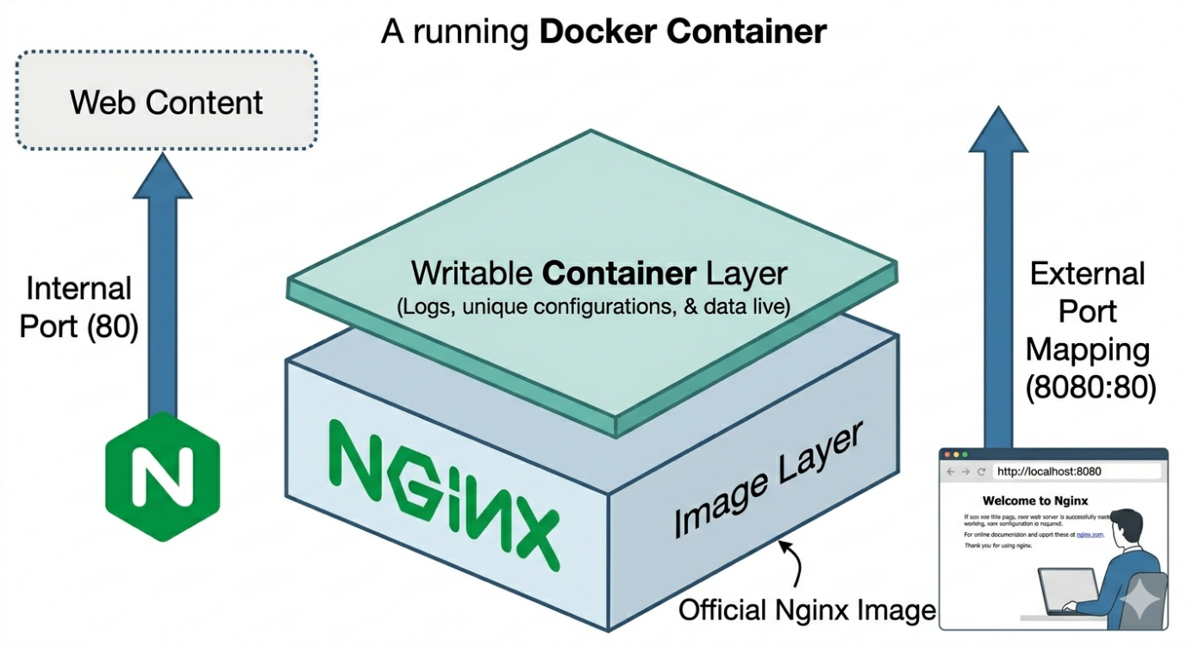
Slide 3: The Custom Journey: Dockerfile to Container
This diagram is perfect for showing How you create your own software. Tell the story of a developer who has code (app.js) and wants to make it a Docker Image.
Teaching Flow:
- Dockerfile (The Recipe): The code file (FROM alpine..., COPY...) is the master instruction list.
- Build (The Bakery): You run docker build. The Docker Daemon executes the commands.
- Image (The Product): This creates a multi-layered image (OS, Node.js, your code) that is stored on the local host.
- Run (The Serving): When you type docker run -d -p 3000:3000, the Daemon finally spins it up as a fully-fledged, accessible container.
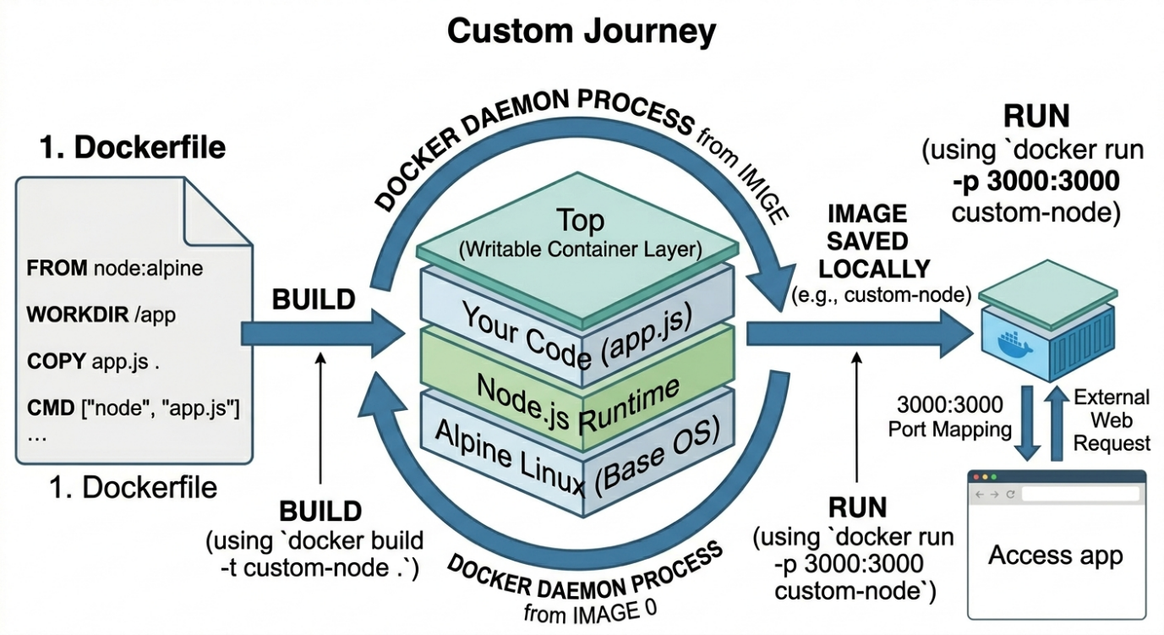
Part 1: The "Why" (The Problem Docker Solves)
Start with a story your students will recognize:
- The Scenario: A developer writes code on a Mac. It works perfectly. They send it to a student using Windows (like you just did with Kafka). It fails because of a missing Java version, a wmic error, or a wrong environment variable.
- The Solution: Docker "packages" the code, the tools (Java, Python), and the settings into a single Image. If it runs on the developer's laptop, it will run exactly the same on the student's laptop or a cloud server.

Part 2: Core Concepts (The Three Pillars)
Teach these three terms as the "Life Cycle" of a container:
- Dockerfile: The "Recipe." A text file with instructions (e.g., "Install Linux," "Install Java," "Copy my Kafka files").
- Image: The "Cake." A read-only snapshot created from the Dockerfile. You can share this on Docker Hub.
- Container: The "Slice." A running instance of an image. You can start, stop, and delete containers without affecting your actual computer.

Part 3: Hands-on Lab (The "Hello World")
Have your students install Docker Desktop and run these commands to understand the flow:
1. Pull and Run a pre-made image
docker run hello-world
Explanation: Docker looks for the image locally. If it’s not there, it "pulls" it from Docker Hub and runs it.
2. Run an Interactive Linux Terminal
docker run -it ubuntu bash
Explanation: This gives the student a full Ubuntu Linux terminal inside their Windows/Mac machine instantly.
Part 4: Building Their First Custom Image
Create a simple "Web Server" lesson. Have them create a file named Dockerfile (no extension) with this content:
# Step 1: Use an existing base image
FROM nginx:alpine

# Step 2: Copy a custom HTML file into the container
# (Assume they have an index.html in the same folder)
COPY index.html /usr/share/nginx/html/index.html

# Step 3: Tell the container to listen on port 80
EXPOSE 80

The Build & Run Commands:
- docker build -t my-first-webpage .
- docker run -d -p 8080:80 my-first-webpage
Teaching Tip: Explain Port Mapping (-p 8080:80). Port 80 is the container's "internal door," and 8080 is the "outside door" on the student's laptop.

