# ICS202

# Assignment1

##### Name: Ahmed Al-Makhlooq

##### ID: 202017740

##### Sec: 02

### Question i:

The array is [51, 52, 53, 54, 55, 56, 57, 58, 59, 60, …, 120]

1. 20: since 20 is not in the array, the worst case will be performed.

Which is "log n + 1" and the "+ 1" is to come out from loop.

→ = log 70 + 1 comparisons.

1. 57: firstly, we will compare 57 with the mid which is 85, so we will delete the right side

Secondly, we will compare 57 with the 2nd mid with is 67, so we will delete right side

Next, we will compare 57 with mid = 58, and we will also delete the right side.

Next, we will compare 57 with mid = 54, and we will delete the left side.

Next, we will compare 57 with mid = 56, and we will delete the left side.

Next, we will compare 57 with the last mid = 57, and return it.

So, the total comparison is 6.

1. 150: since 150 is not in the array, the worst case will be performed.

Which is "log n + 1" and the "+ 1" is to come out from loop.

→ = log 70 + 1 comparisons.

### Question ii:

1)

1. Firstly, we must find another iterator for j:

J = I + 1 → I + 3 → I + 5 → I + 7 → I + 9 → 2k + 1, for Ɐk >= 0.

We can assume 2k + 1 = n – 1 → k = (n – 2) / 2.

1. Now we can write the summations: $\sum_{i=0}^{n-1}{\sum_{z=0}^{k}{1}}$ = $\sum_{i=0}^{n-1}{\frac{n-2}{2}+1}$ = $\sum_{i=0}^{n-1}{\frac{n}{2}}$

= (n-1) + n/2 = $\frac{3n}{2}-1$ times

2)

a. the cost is O(n).

### Question iii:

1. $n^{2}-20n+1 ≤ Cn^{2}$ → $1-\frac{20}{n}+\frac{1}{n^{2}} ≤ C$ → C = 1, for all n >= 1.

→ c = 1, g(n) = n2 so, f(n) is in O(n2).

1. → → C = , for all n >= 20.

→ c = , g(n) = n2 so, f(n) is in Ω(n2).

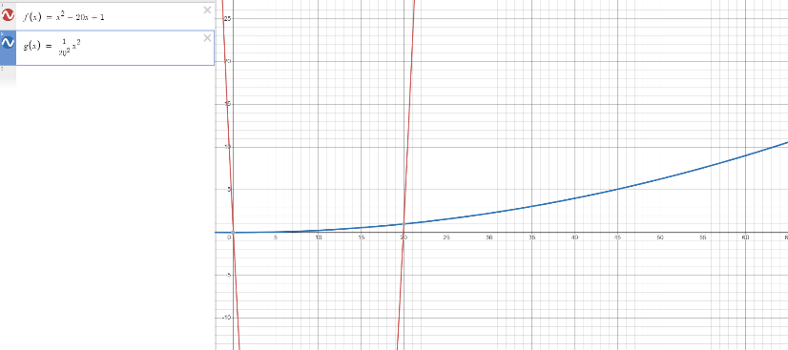

### Question iv:

1. Best case is when the two arrays have different sizes, and the time complexity is O(1).
2. Worst case is when the two arrays are equal, because in this case the time complexity will be $\sum_{k=0}^{n-1}{1}$ = n – 1 + 1 = n = O(n).
3. O (1), the space that the method allocates in the memory does not depend on the input. Because two "int" spaces will be allocated no matter what the input is.

### Question V:

1. f1 = n

f2 = n log n

They are both Ω (log n).

"n" is not Ω (n log n).

1. True or false:
   1. False.

Let us assume that f(n) = 4n, then g(n) = n → θ(g(n)) = θ(n).

Thus, 2f(n) = 24n = 16n ≠ θ(2n).

* 1. False.

Let f(n) = n2 and g(n) = n.

n2 + n ≠ θ(n).

* 1. False.

Let us assume that f(n) = 23n = 8n.

8n ≠ O(2n).

### Question VI:

|  |  |  |  |  |
| --- | --- | --- | --- | --- |
| F(n) | g(n) | F = O(g) | F = Ω(g) | F = θ(g) |
| n3 + 45n | 400n4 + 20n2 + 99 | True | False | False |
| 4n2 + 9log2n | 10n2 + 7log log n | True | True | True |
| 5n log n | 30n log log n | False | True | False |
| 5 log n | 3 log2 n | True | False | False |

### Question VII:

B:

A:

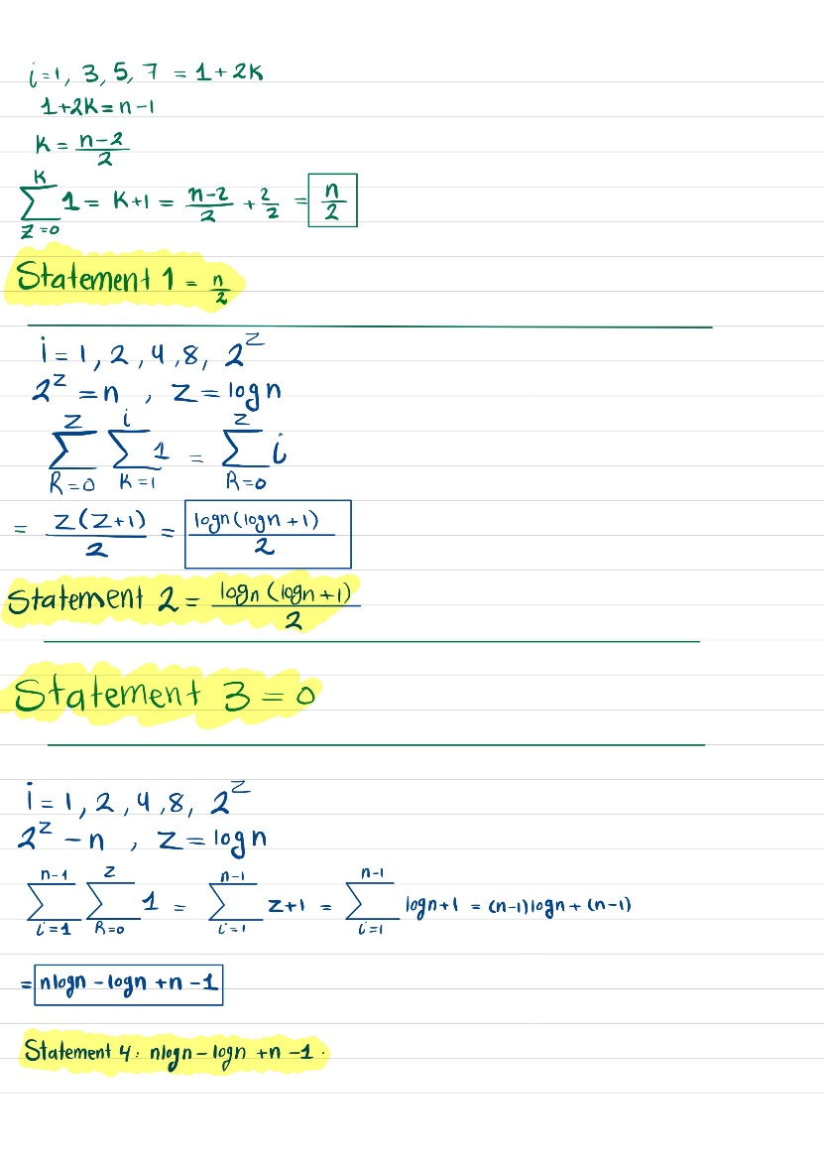

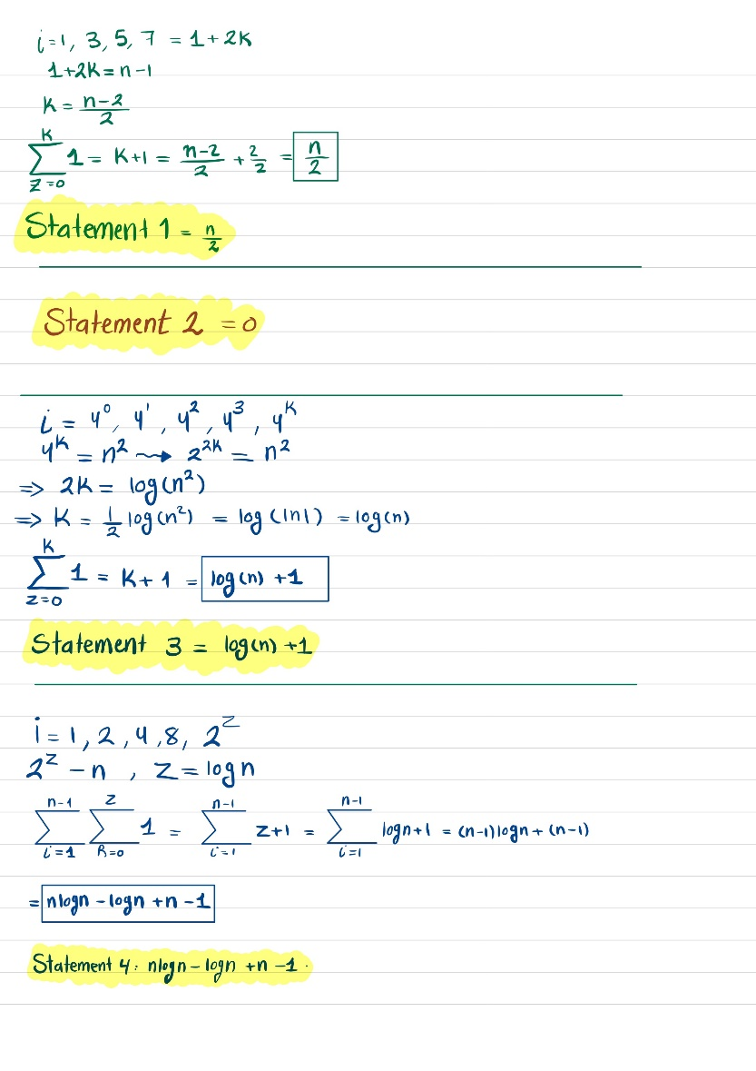

1. Best case: O (n log n).
2. Worst case: O (n log n).