**King Fahd University of Petroleum & Minerals**

**College of Computer Science and Engineering**

**Information and Computer Science Department**

**ICS 202 – Data Structures**

# Exercises for OO Concepts Review Lab

**Objectives**

The objective of this lab is to review object oriented concepts

**Outcomes**

After completing this Lab, students are expected to:

• Use inheritance when designing classes.

• Use polymorphism when designing classes.

• Design abstract classes and interfaces.

**Practice Exercise**

Write a class called **Book** in java that has the following instance variables: String **title**, int **pages** with the required accessor and **toString**() methods.

Now write a subclass “Textbook” of this class “Book” that has the following additional instance variable: String **course**. Override the **toString()** method of the “**Book**” class by printing the type of the book (**TextBook**), the title of the book, the number of pages and the course. Use another accessor method **getCourse().**

Now in a main class, create an array of 10 books with some of them being textbooks. Using a for-loop print their titles, number of pages and if it is a textbook, then its course. Finally, count the number of textbooks, the number of books and print their quantities.

SAMPLE OUTPUT: The following is a sample output>>

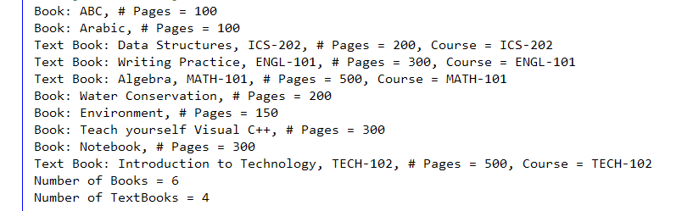

**Lab Exercise**

Design an abstract class **Student**. A student has the following information: **ID** and **GPA**. The student class has an abstract method **getStatus** that returns the status as a string and a non-abstract final method **displayStudent** that returns the details of a student (ID, GPA and status).

Design two subclasses **Undergraduate** and **Graduate**. The **status** of the graduate student is **good** if his GPA is 3.0 or above otherwise it is **probation**. The undergraduate's **status** is **honor** if his GPA is 3.0 or above, **good** if his GPA is 2.0 or above, **probation** otherwise. Write a test class that randomly generates 10 students and prints their type “Undergraduate or Graduate”, ID, GPA and status.

A sample output is shown below:

