hw_06

Ahmed Al-Tohamy

11/15/2021

#creat the data which is plant height (predictor variable x) and grain yield (response variable y)  
  
data <- data.frame (x=c(110.5, 105.4, 118.1, 104.5, 93.6, 84.1, 77.8, 75.6),  
y = c(5.755, 5.939, 6.010, 6.545, 6.730, 6.750, 6.899, 7.862))  
  
#first of all we should plot our data  
plot(data$x, data$y, xlab="plant height", ylab="grain yield", col ="blue", pch = 16)  
  
  
#creat the linear regression   
fit_data <- lm(y ~ x, data = data)  
  
#calculate Pearson correlation coefficient  
cor(data$y, data$x)

## [1] -0.868707

#we can see there is a negative correlation between plant height and grain yield  
  
#Add a regression line  
  
abline(fit_data, col="red", lwd=2)

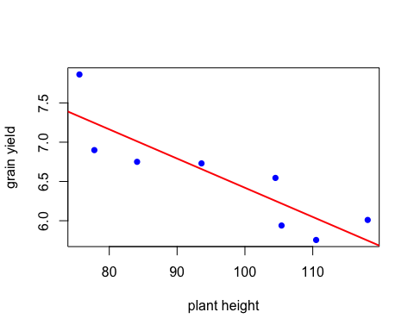

#Q1  
#a.the least squares estimate (^β1) of the slope β1  
coef(fit_data)["x"]

## x   
## -0.03717469

#^β1 is the estimate of the measure of the steepness of the line that best fit the data  
#you have (best estimate of expected change in Y for unit increase in X), ^β is using the least squares method

#b  
#We can do that by different methods, one of them is to call summary function and anova  
summary(fit_data)

##   
## Call:  
## lm(formula = y ~ x, data = data)  
##   
## Residuals:  
## Min 1Q Median 3Q Max   
## -0.34626 -0.27605 -0.09448 0.27023 0.53495   
##   
## Coefficients:  
## Estimate Std. Error t value Pr(>|t|)   
## (Intercept) 10.137455 0.842265 12.036 2e-05 ***  
## x -0.037175 0.008653 -4.296 0.00512 **   
## ---  
## Signif. codes: 0 '***' 0.001 '**' 0.01 '*' 0.05 '.' 0.1 ' ' 1  
##   
## Residual standard error: 0.3624 on 6 degrees of freedom  
## Multiple R-squared: 0.7547, Adjusted R-squared: 0.7138   
## F-statistic: 18.46 on 1 and 6 DF, p-value: 0.005116

anova(fit_data)

## Analysis of Variance Table  
##   
## Response: y  
## Df Sum Sq Mean Sq F value Pr(>F)   
## x 1 2.42357 2.42357 18.455 0.005116 **  
## Residuals 6 0.78794 0.13132   
## ---  
## Signif. codes: 0 '***' 0.001 '**' 0.01 '*' 0.05 '.' 0.1 ' ' 1

# from the tables we can conclude that  
#T-test = 12.036  
#F-test = 18.46   
#So we can say that, we reject H0 and there is a strong evidence of a relationship between  
#grain yield and plant height.

#c  
#by hand from the equation ^β1 ± tn−2,α/2 × s.e.(^β1)  
#^β1= -0.037175  
#tn−2,α/2 = 2.44691  
#s.e.(^β1) = 0.008653  
  
#When we add all of them --> -0.037175 ± 0.0211  
  
#The 95% confidence interval is a range of values that   
#you can be 95% confident contains the true mean of the population  
qt(0.05/2, 6)

## [1] -2.446912

#d

#equation #y^=a+bx #^y = 10.13745532 + -0.03717469 x

#e  
#from the summary table  
summary(fit_data)

##   
## Call:  
## lm(formula = y ~ x, data = data)  
##   
## Residuals:  
## Min 1Q Median 3Q Max   
## -0.34626 -0.27605 -0.09448 0.27023 0.53495   
##   
## Coefficients:  
## Estimate Std. Error t value Pr(>|t|)   
## (Intercept) 10.137455 0.842265 12.036 2e-05 ***  
## x -0.037175 0.008653 -4.296 0.00512 **   
## ---  
## Signif. codes: 0 '***' 0.001 '**' 0.01 '*' 0.05 '.' 0.1 ' ' 1  
##   
## Residual standard error: 0.3624 on 6 degrees of freedom  
## Multiple R-squared: 0.7547, Adjusted R-squared: 0.7138   
## F-statistic: 18.46 on 1 and 6 DF, p-value: 0.005116

#Residual standard error: 0.3624

#f  
#Estimate the expected yield of a rice variety when x=100  
predict(fit_data, newdata = data.frame(x = 100), interval = "confidence", levels=0.95)

## fit lwr upr  
## 1 6.419986 6.096321 6.743651

#g  
#predeict the expected yield of a rice variety when x=100  
predict(fit_data, newdata = data.frame(x = 100), interval = "prediction", levels=0.95)

## fit lwr upr  
## 1 6.419986 5.476038 7.363934

#clearly g is wider as it has lower value (5.476038) and upper value (5.476038)  
#in comparsion to f which has lower value (6.096321) and upper value (6.743651)  
# # confint(fit_data, level = 0.95)

#h  
#again we can get the coefficient of determination R2 by using the summary function   
summary(fit_data)

##   
## Call:  
## lm(formula = y ~ x, data = data)  
##   
## Residuals:  
## Min 1Q Median 3Q Max   
## -0.34626 -0.27605 -0.09448 0.27023 0.53495   
##   
## Coefficients:  
## Estimate Std. Error t value Pr(>|t|)   
## (Intercept) 10.137455 0.842265 12.036 2e-05 ***  
## x -0.037175 0.008653 -4.296 0.00512 **   
## ---  
## Signif. codes: 0 '***' 0.001 '**' 0.01 '*' 0.05 '.' 0.1 ' ' 1  
##   
## Residual standard error: 0.3624 on 6 degrees of freedom  
## Multiple R-squared: 0.7547, Adjusted R-squared: 0.7138   
## F-statistic: 18.46 on 1 and 6 DF, p-value: 0.005116

#coefficient of determination R2 --> 0.7  
#That means 70% of the variation in grain yield can be predictable from the plant height

#—————————————————————————–

#Q2  
d <- data.frame(x = c(1, 2, 3, 4, 5, 6, 7, 8, 9),  
 y = c(-2.08, -0.72, 0.28, 0.92, 1.20, 1.12, 0.68, -0.12, -1.28))  
  
#creat the linear regression   
fit_d = lm(y ~ x, data = d)  
  
#a  
#Plot y vs. x  
plot(d$x, d$y, xlab="X", ylab="Y", main="a")

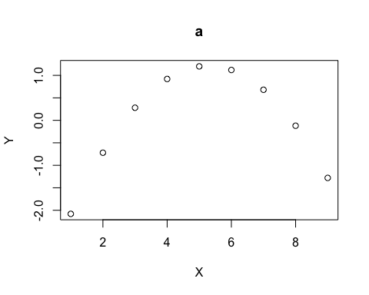

#b  
#plot   
d.res <- resid(fit_d)  
plot(d$y,d.res, xlab="Y", ylab="raw residuals", main="b")

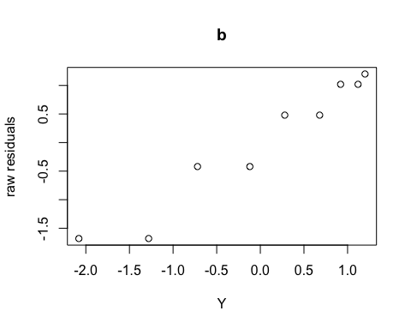

#c  
#Plot the raw residuals vs. x  
plot(d$x,d.res, xlab="x", ylab="raw residuals", main="c")

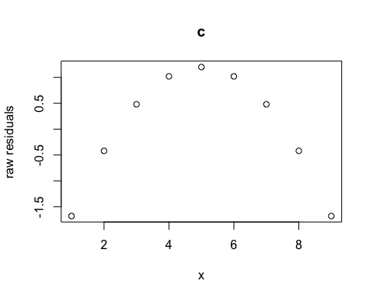

#d  
#Plot the raw residuals vs. y^  
plot(fitted(fit_d),d.res, xlab="Y^", ylab="raw residuals", main="d")

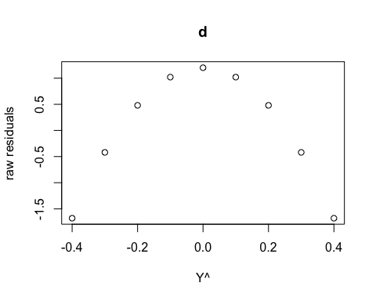

#e #I cant see any meaningful difference between (c) and (d) #they both represent quadratic equation # d) gives a better indication of the lack of fit as it is obvious it does not #fit into a line(it is a quadratic equation)