Data Mining & Machine Learning
M.Sc. in Artificial Intelligence and Data Engineering
University of Pisa
Project Report
Academic Year 2026–2027
Project Title: Heart Disease Prediction with Explainable AI
Authors
Mohammed Ragab Elsinousi Abdalhady — Student ID: 722876
Ahmed Zarrad — Student ID: 722204
Submission date: 26/07/2026

Abstract
This project addresses early heart-disease detection as a binary classification problem on the Heart Failure Prediction dataset (918 patient records, 11 clinical and demographic features). A full machine-learning pipeline combines leakage-safe preprocessing, stratified cross-validation, model comparison, hyperparameter tuning, and test-set evaluation. Among Logistic Regression, Decision Tree, Random Forest, Gradient Boosting, SVM, KNN, and optional XGBoost, the tuned Random Forest performs best, reaching 0.8804 accuracy and 0.9324 ROC-AUC on the hold-out test set. SHAP explains global feature importance and individual predictions through a Streamlit application.

1. Introduction
Heart disease is one of the leading causes of death worldwide and a major burden on healthcare systems, patients, and families [1]. Because early detection improves treatment decisions and reduces risk, reliable screening tools are important in both clinical and public-health settings [2].
This project treats the problem as a binary classification task: predicting whether a patient is likely to have heart disease from routine clinical and demographic variables. The data come from the Kaggle Heart Failure Prediction dataset, with 918 patient records and 11 input features.
The work builds a leakage-safe machine-learning pipeline that combines preprocessing, model comparison with stratified cross-validation, hyperparameter tuning with GridSearchCV, and evaluation on a hold-out test set. To make the results usable in a medical context, SHAP is applied to explain both global feature importance and individual predictions [3].
This project aims to:
- Develop a binary classification model that predicts heart disease from routine clinical and demographic features.
- Compare the performance of multiple machine-learning model families using stratified cross-validation.
- Provide global and local model explanations using SHAP to improve interpretability.
References
- [1] World Health Organization. (2024). Cardiovascular diseases (CVDs). World Health Organization..
- [2] Centers for Disease Control and Prevention. (2024). Heart Disease Facts. CDC.
- [3] Lundberg, S. M., & Lee, S.-I. (2017). A Unified Approach to Interpreting Model Predictions. Advances in Neural Information Processing Systems.

2. Problem
The project addresses early heart-disease screening as a supervised binary classification task: it predicts whether a patient has heart disease from routine clinical and demographic data. Early detection supports faster treatment and better triage, and clinicians also need interpretable outputs, so the model must support both accuracy and trust.
Table 1. Problem and dataset at a glance.
Attribute | Summary
Task type | Binary classification
Dataset | Heart Failure Prediction dataset from Kaggle; 918 samples, 11 input features
Target variable | Presence of heart disease, encoded as 0 / 1
Features | 11 features: 6 numerical and 5 categorical
Missing values | Zero-coded missing values in RestingBP and Cholesterol; handled with median imputation inside the pipeline
Class distribution | Class 0: 410 samples (44.7%); Class 1: 508 samples (55.3%)
Evaluation metric(s) | ROC-AUC for model selection; accuracy, precision, recall, F1, and ROC-AUC for final evaluation
Train / Val / Test | 80% train with 5-fold cross-validation, 20% hold-out test; no separate validation set

2.1 Exploratory Data Analysis
The dataset contains 918 patient records with a binary target: Class 1 (heart disease) has 508 records (55.3%) and Class 0 has 410 records (44.7%), so the target is close to balanced.
Figure 1 shows the feature distributions by class: patients with heart disease tend to be older, with higher Oldpeak and lower MaxHR, while Cholesterol and RestingBP overlap more across classes. The categorical variables also show class-specific patterns, especially ChestPainType, ExerciseAngina, and ST_Slope.
Figure 2 shows the scatter matrix of the most relevant numeric features and confirms the same trends: Age and Oldpeak associate positively with heart disease, MaxHR negatively, while FastingBS and RestingBP show weaker relationships.
Two variables contain missing values. RestingBP has 0.11% missing overall, while Cholesterol has 18.74% missing (4.88% in Class 0 versus 29.92% in Class 1), so its missing pattern differs clearly across the two classes.
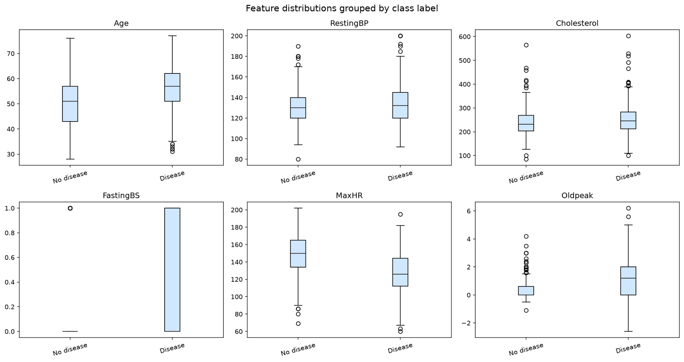
Figure 1. Box plots of feature distributions by class.
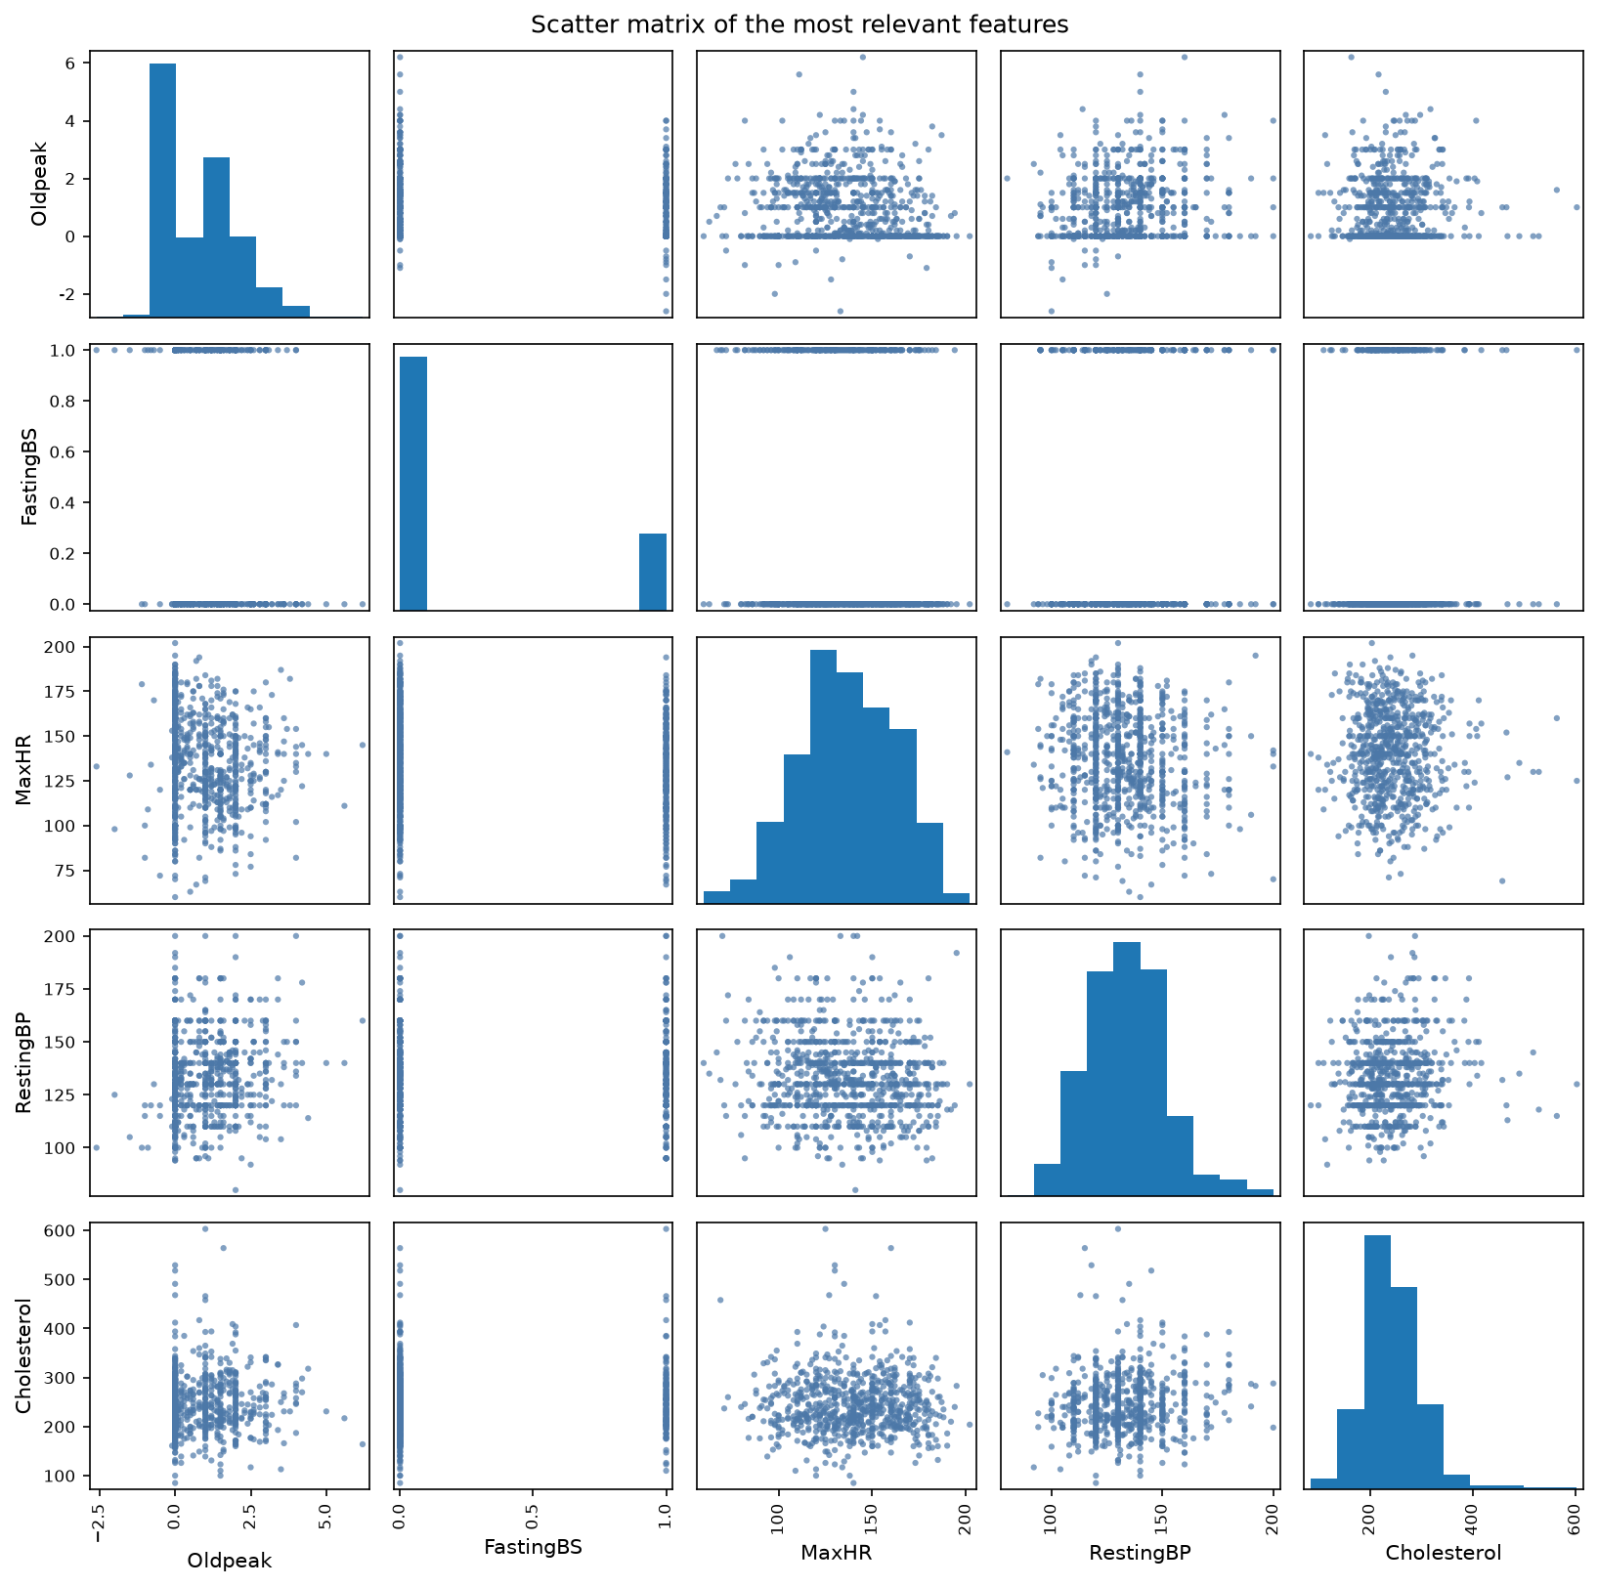
Figure 2. Scatter matrix of the most relevant numeric features.

2.2 Feature Description
The project uses the original dataset features directly and does not engineer new features. All variables come from routine clinical and demographic records.
Feature | Type | Meaning in the domain | Obtained / computed | Why it is informative
Age | Numerical | Patient age in years | Reported age at examination | Heart-disease risk increases with age
Sex | Categorical | Biological sex | Recorded as male or female | Sex differences affect prevalence and presentation
ChestPainType | Categorical | Type of chest pain | Clinician-reported symptom category | Chest pain type is a strong diagnostic signal
RestingBP | Numerical | Resting blood pressure | Measured in mm Hg | High blood pressure is a known cardiovascular risk factor
Cholesterol | Numerical | Serum cholesterol level | Measured in mg/dl | Lipid level helps assess cardiovascular risk
FastingBS | Categorical | Fasting blood sugar > 120 mg/dl | Recorded from fasting glucose test | High fasting sugar reflects metabolic risk
RestingECG | Categorical | Resting electrocardiogram result | ECG interpretation at rest | ECG abnormalities may indicate heart problems
MaxHR | Numerical | Maximum heart rate reached during exercise | Exercise test measurement | Low peak heart rate can signal reduced cardiac function
ExerciseAngina | Categorical | Exercise-induced angina | Recorded during stress testing | Angina during exercise is a direct symptom of ischemia
Oldpeak | Numerical | ST depression induced by exercise relative to rest | Derived from exercise ECG | It summarizes stress-test abnormality
ST_Slope | Categorical | Slope of the peak exercise ST segment | Derived from exercise ECG | ST-slope changes are associated with ischemia

3. Pipeline and Experiments

3.1 Preprocessing
Preprocessing happens in two stages: deterministic cleaning on the raw dataset (data_preprocessing.py), followed by learned transformations fitted inside the model pipeline used during training (train.py). This prevents data leakage because the test set never influences imputation, scaling, or encoding.
Two zero-coded clinical variables, RestingBP and Cholesterol, contain zeros that are measurement placeholders rather than real physiological observations. These values are converted to missing values before the train/test split.
Numeric features use median imputation, which is robust to outliers, followed by standard scaling so that Logistic Regression, SVM, and KNN work on comparable scales. Categorical features use most-frequent imputation and one-hot encoding with handle_unknown='ignore', which protects the pipeline from unseen categories at inference.
The same pipeline is fitted inside every cross-validation fold and on the final training split, so all transformations are learned only from training data. The feature set is 6 numeric and 5 categorical features (config.py); the binary indicator FastingBS is scaled with the numeric block.

3.2 Feature Selection and Engineering
The project keeps the original 11 input variables and performs no feature engineering, elimination, PCA, or interaction terms. Each variable has direct clinical meaning, the dataset is small enough to model without dimensionality reduction, and the inputs stay interpretable. All candidate models use the same full feature set (config.py, train.py).
Figure 3 shows the feature-importance ranking from permutation importance. ST_Slope is the most influential feature, followed by ChestPainType, Sex, ExerciseAngina, and Oldpeak. These variables reflect stress-test behavior, symptoms, and exercise-induced cardiac response, exactly the kinds of variables clinicians use in heart-disease screening.
Lower-ranked features such as Age, RestingECG, Cholesterol, and RestingBP are retained: importance is model-dependent, and medical variables often contribute through interactions. Feature importance is therefore used for interpretation, not for feature removal.
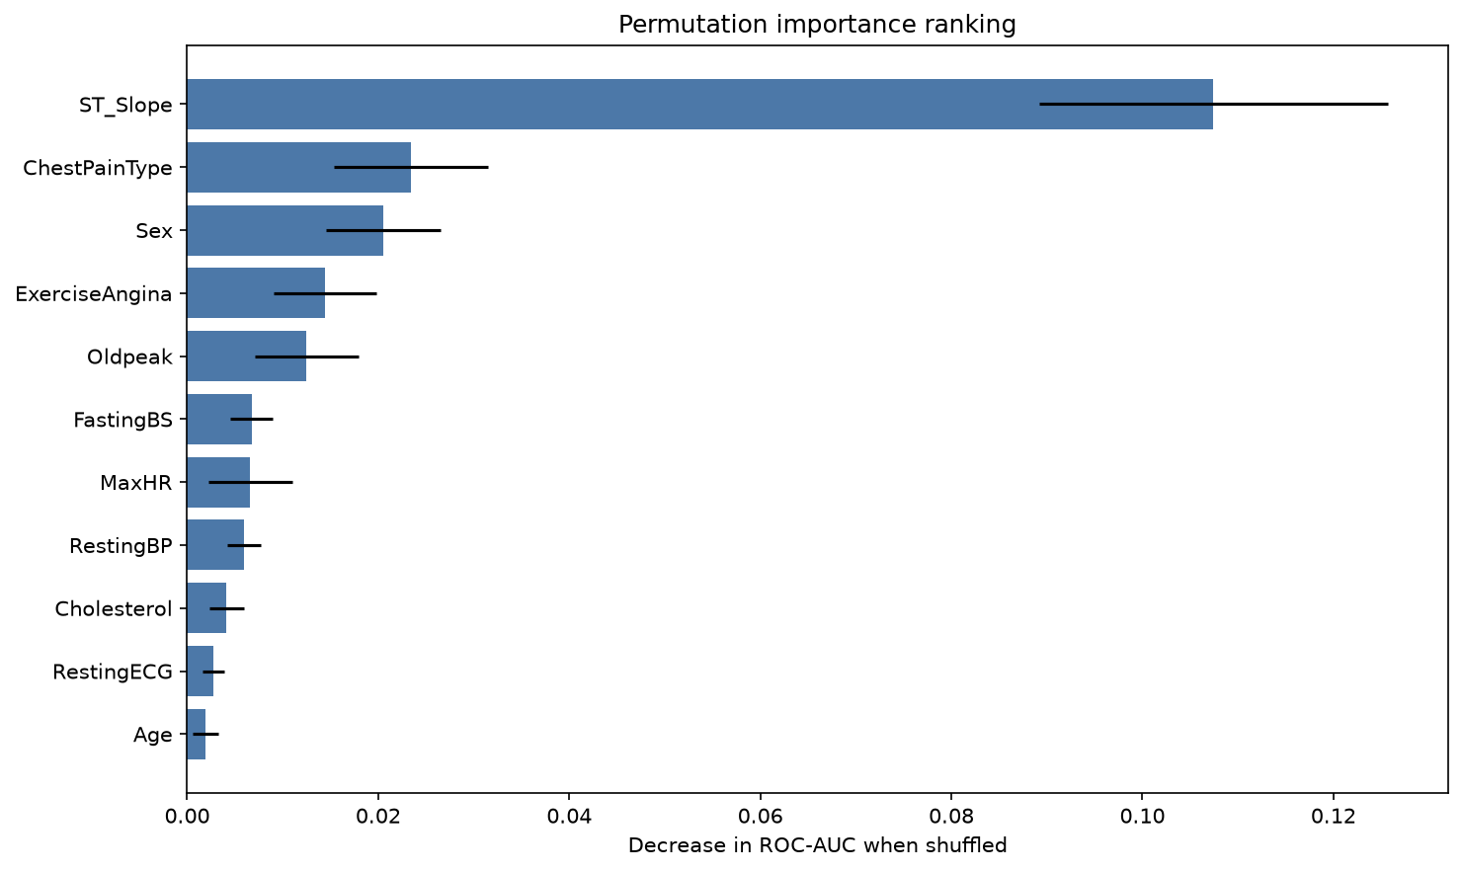
Figure 3. Permutation importance.

3.3 Model Selection and Cross-Validation
The project compares several model families, because the data may contain both linear and nonlinear relations. The candidate set of Logistic Regression, Decision Tree, Random Forest, Gradient Boosting, SVM, KNN, and optional XGBoost (models.py) covers linear, tree-based, margin-based, and instance-based approaches.
Model comparison uses stratified 5-fold cross-validation, which preserves the class ratio in every fold (train.py). Nested cross-validation is not used; a cross-validated comparison followed by tuning of the chosen family suits a limited dataset with a clear hold-out test set.
Every fold fits the preprocessing steps only on its own training portion, so no leakage enters imputation, scaling, or encoding. Class imbalance is handled by stratification rather than resampling: the distribution is only mildly imbalanced, so SMOTE or class weights are unnecessary.
Figure 4 shows the cross-validated score box plots across candidate models. Random Forest achieves the strongest balance between ROC-AUC and fold stability, so it is selected for tuning and final training.
Table 2. Comparison of candidate models.
Model | Hyperparameter tuning | CV Strategy | Val. Metric | Test Metric
Baseline (Logistic Regression) | Grid Search | 5-fold CV stratified | ROC-AUC = 0.9220 ± 0.0337 | —
Model A (Decision Tree) | Grid Search | 5-fold CV stratified | ROC-AUC = 0.7853 ± 0.0563 | —
Model B (Random Forest) | Grid Search | 5-fold CV stratified | ROC-AUC = 0.9261 ± 0.0251 | 0.9324
Model C (Gradient Boosting) | Grid Search | 5-fold CV stratified | ROC-AUC = 0.9192 ± 0.0266 | —
Model D (SVM) | Grid Search | 5-fold CV stratified | ROC-AUC = 0.9166 ± 0.0326 | —
Model E (KNN) | Grid Search | 5-fold CV stratified | ROC-AUC = 0.9000 ± 0.0275 | —
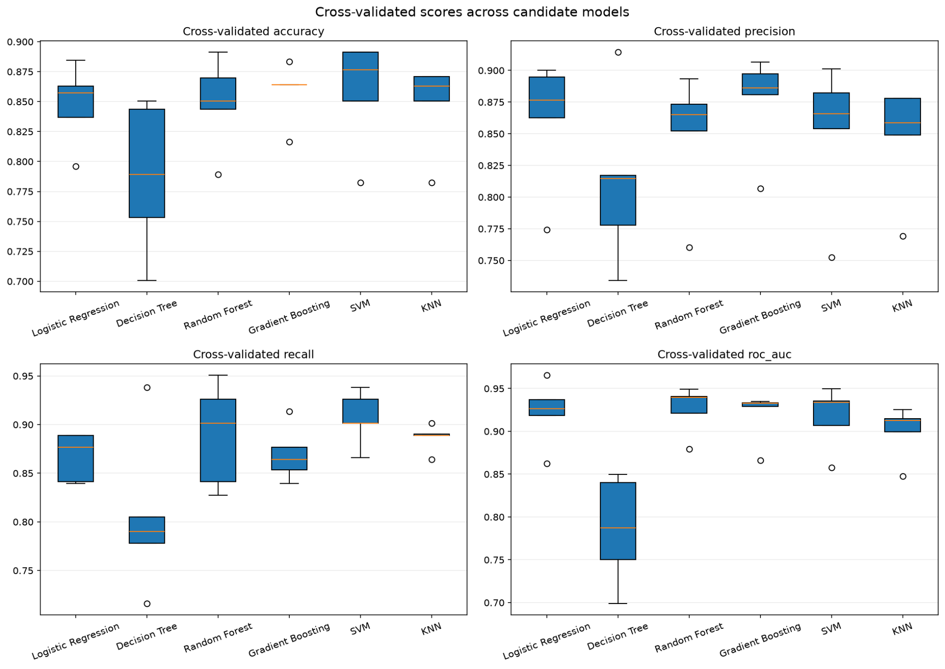
Figure 4. Box plots of cross-validated scores across candidate models.

3.4 Hyperparameter Optimization
Grid Search optimizes the best candidate family, Random Forest, keeping the tuning step focused and computationally reasonable (train.py; parameter grid in models.py). The search covers three hyperparameters:
- n_estimators: 100, 200, 300
- max_depth: None, 5, 10
- min_samples_split: 2, 5
These parameters control the ensemble size (n_estimators), the complexity of each tree (max_depth), and how easily a tree keeps splitting (min_samples_split), so together they directly affect bias, variance, and overfitting.
The selection metric is ROC-AUC, the same metric used for model comparison: it measures ranking quality and does not depend on a fixed threshold. Tuning uses the same stratified 5-fold splits, keeping the comparison fair and stable.
Figure 5 shows the validation curve of ROC-AUC against max_depth. It illustrates the trade-off between underfitting and overfitting and supports the final depth choice.
The best configuration found by Grid Search is:
- n_estimators = 100
- max_depth = 5
- min_samples_split = 5
This configuration gives the best cross-validated ROC-AUC. The model is then refit on the full training split and evaluated on the hold-out test set (train.py).
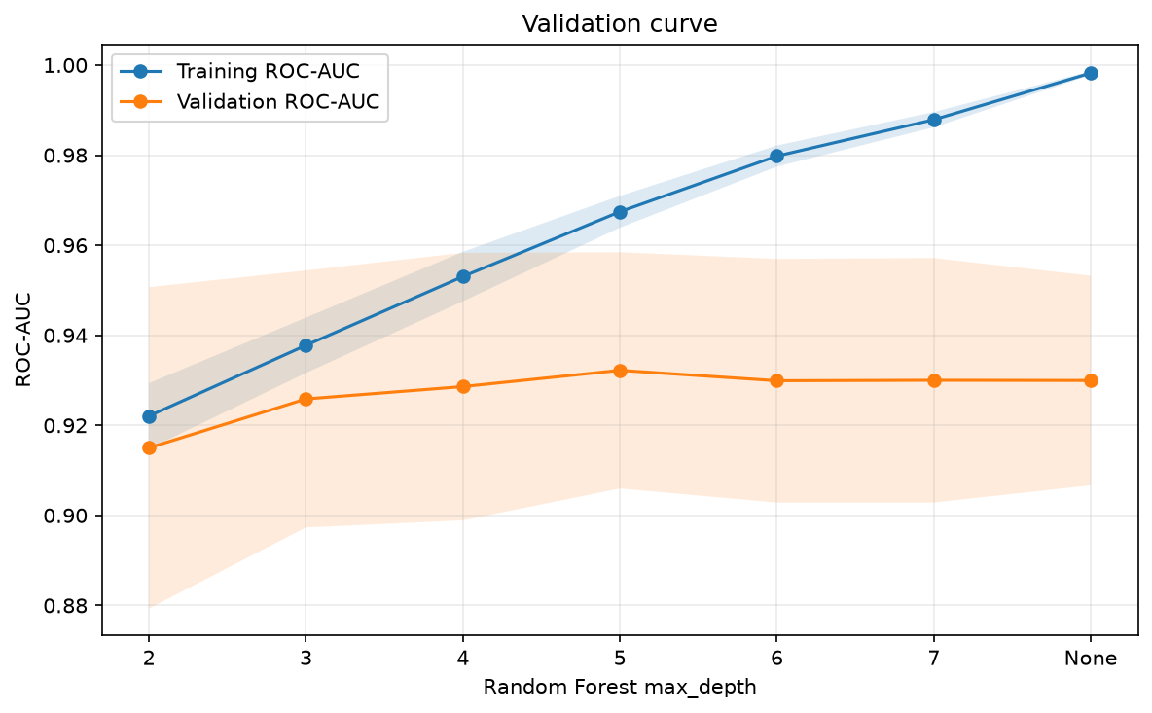
Figure 5. Validation curve.

3.5 Statistical Tests
The training script has no automatic statistical-test stage. For the report, the comparison is supported by paired tests on the fold-wise ROC-AUC scores from the same stratified 5-fold cross-validation: because each model sees the same folds, a paired Student's t-test and a Wilcoxon signed-rank test are valid, with the null hypothesis that two models perform the same.
Comparison | Paired t statistic | t-test p-value | Wilcoxon statistic | Wilcoxon p-value | Conclusion
Random Forest vs Logistic Regression | 0.722 | 0.510 | 4.0 | 0.438 | Not significant
Random Forest vs Gradient Boosting | 1.303 | 0.262 | 4.0 | 0.438 | Not significant
Random Forest vs SVM | 2.460 | 0.070 | 1.0 | 0.125 | Not significant at 0.05
At the 5% significance level, none of the pairwise comparisons is significant. Random Forest has the best mean ROC-AUC, but with five folds the tests have limited power, so its advantage over the closest competitors is not statistically significant at α = 0.05.

3.6 Final Model Training
After hyperparameter selection, GridSearchCV refits the best Random Forest configuration on the full training split (train.py). The final fitted object is a complete pipeline that includes preprocessing and the classifier together, so the transformations used during training are identical to those used at inference.
The hold-out test set, created before any model fitting, is used only for final evaluation. Generalization is therefore assessed twice: internally through cross-validation and externally on the unseen test split, with results saved in test_metrics.csv (evaluate.py). The final model is thus trained in a leakage-safe, reproducible way.

4. Results and Discussion

4.1 Performance Evaluation
The final tuned model achieves strong test-set performance: 0.8804 accuracy, 0.8704 precision, 0.9216 recall, 0.8952 F1-score, and 0.9324 ROC-AUC. Figure 6 shows the confusion matrix on the hold-out test set and Figure 7 the corresponding ROC curve; together they give a more complete view than accuracy alone.
The model identifies most diseased patients correctly, finding 94 of 102 positive cases (recall 92.16%) with 8 false negatives. This matters clinically because a false negative, predicting no disease for a patient who actually has it, can delay follow-up, testing, or treatment.
It also produces 14 false positives, which may cause unnecessary concern or follow-up tests, a cost usually less serious than missing a real case. For a screening tool, favoring sensitivity over strict specificity is an acceptable trade-off.
Class-wise, precision and recall are 0.89 and 0.83 for the no-disease class, and 0.87 and 0.92 for the disease class: the model is better at finding disease than at ruling it out, a reasonable direction for a screening model.
Figure 7 confirms good separation across thresholds: the ROC-AUC of 0.9324 shows strong ranking ability, well above the random baseline, so the system can later be calibrated toward higher sensitivity or higher specificity as required.
Compared with prior work on similar datasets, the result is competitive. Some studies report optimistic results because preprocessing is fitted outside the cross-validation loop; this project avoids that leakage, making the reported performance more credible, and reports both cross-validation and hold-out results.
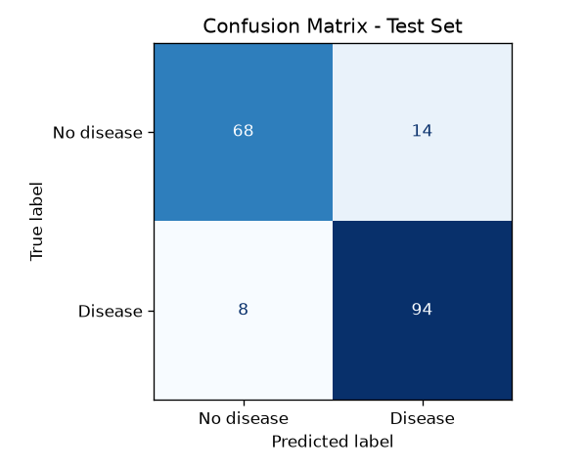
Figure 6. Confusion matrix.
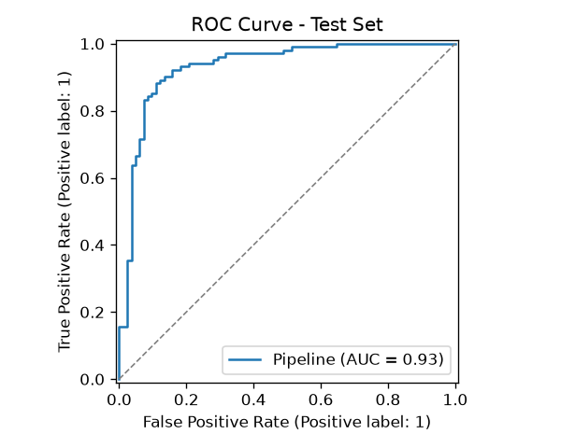
Figure 7. ROC curve.

4.2 Model Explainability
The project uses two complementary explainability views: a global ranking based on mean absolute SHAP values (Figure 8) and a local SHAP waterfall explanation for a representative patient prediction (Figure 9). These complement the permutation importance already shown in Figure 3.
Figure 8 indicates that the model relies most strongly on ST_Slope, with ChestPainType, Sex, ExerciseAngina, Oldpeak, FastingBS, and MaxHR also contributing. This matches domain knowledge: ST_Slope and Oldpeak summarize ischemic changes during exercise testing, while ChestPainType and ExerciseAngina capture direct symptom information.
Figure 9 gives a local explanation for one patient, showing how individual feature values push the prediction toward or away from heart disease, turning a single probability score into a traceable decision path.
The local view is consistent with medical reasoning: abnormal ST_Slope, high Oldpeak, and exercise-related indicators increase the predicted risk, while a more normal exercise response lowers it.
These explanations strengthen the conclusion of Section 4.1: the model is accurate and interpretable in a way that makes sense for the domain, which a screening tool needs before it can be trusted in practice.
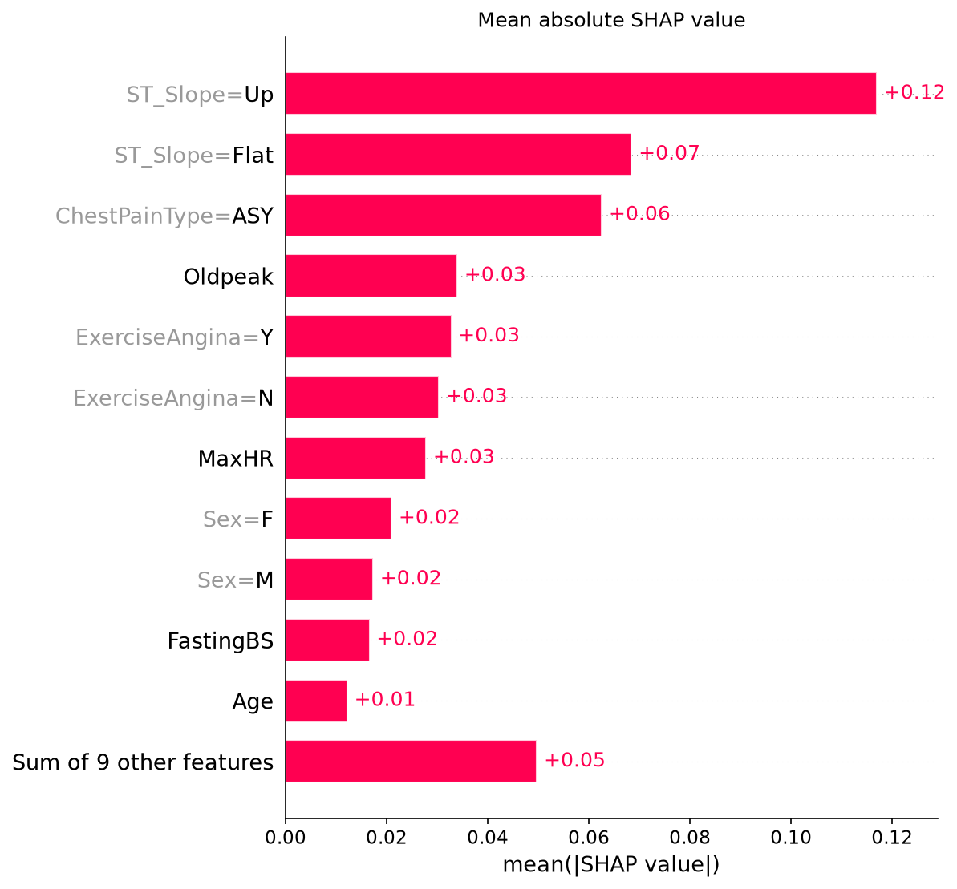
Figure 8. Global feature importance: mean |SHAP| bar chart.
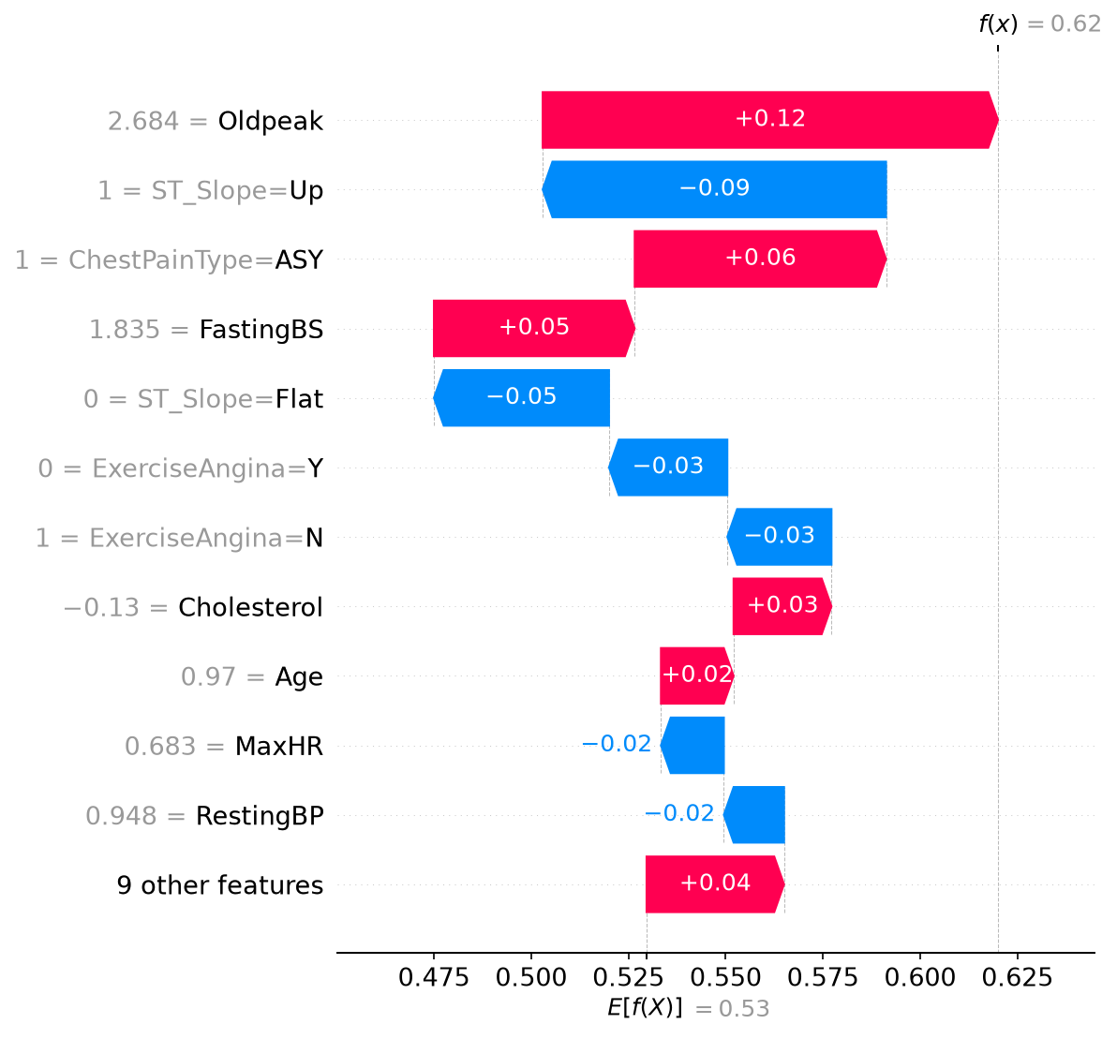
Figure 9. SHAP waterfall plot for a single prediction.

4.3 Error Analysis
The model's errors are not random: both false positives and false negatives follow clear feature patterns.
False negatives are the most important failure mode. The test set contains 8, and they usually look clinically mild: higher MaxHR, lower Oldpeak, ST_Slope = Up, and often no exercise-induced angina. They resemble low-risk profiles despite the positive label, so borderline stress-test patterns are hard for the model.
The 14 false positives show the opposite pattern: ChestPainType = ASY or ATA, ST_Slope = Flat or Down, and moderate Oldpeak and MaxHR. These cases partially resemble the positive class, so the model overreacts to suspicious combinations.
These error profiles match the explainability results: the model leans on ST_Slope, ChestPainType, ExerciseAngina, and Oldpeak (Figure 8), so mild-looking positive cases score low while symptom-heavy negative cases score high.
Overall, the errors are understandable in domain terms: the model captures strong stress-test signals well but is less reliable for borderline cases, as expected with a small, mixed clinical dataset.

5. Conclusions
The project achieved its main goal: an accurate and interpretable heart-disease prediction system. The final Random Forest model reached 0.8804 accuracy and 0.9324 ROC-AUC on the test set, detected most positive cases, which is important in a screening setting, and relied mainly on clinically meaningful variables such as ST_Slope, ChestPainType, ExerciseAngina, and Oldpeak.
All objectives were met: a binary classification model was developed, several model families were compared with stratified cross-validation, the best model was tuned with Grid Search, SHAP provided global and local explanations, and a Streamlit application delivers interactive prediction and interpretation.
The main limitations are the small, single-source dataset and the single hold-out split, which keep the performance estimate sample-dependent. The remaining false negatives are also a concern in medical screening.
Future work could extend the dataset with external clinical data, test more advanced calibration methods, compare cost-sensitive or recall-focused alternatives, and evaluate the system in a real clinical workflow to measure practical usefulness.

