Data Mining & Machine Learning
M.Sc. in Artificial Intelligence and Data Engineering
University of Pisa
Project Report
Academic Year 2026–2027
Project Title: Heart Disease Prediction with Explainable AI
Authors
Mohammed Ragab Elsinousi Abdalhady — Student ID: 722876
Ahmed Zarrad — Student ID: 722204
Submission date: 26/07/2026

Abstract
This project addresses early heart-disease detection as a binary classification problem. It uses the Heart Failure Prediction dataset, which contains 918 patient records and 11 clinical and demographic input variables. The study builds a full machine-learning pipeline with leakage-safe preprocessing, stratified cross-validation, model comparison, hyperparameter tuning, and test-set evaluation.
The project compares several model families, including Logistic Regression, Decision Tree, Random Forest, Gradient Boosting, SVM, KNN, and optional XGBoost. Random Forest performs best after tuning with Grid Search. The final model reaches 0.8804 accuracy and 0.9324 ROC-AUC on the hold-out test set. The project also uses SHAP to explain both global feature importance and individual predictions through a Streamlit application.

1. Introduction
Heart disease remains one of the leading causes of death worldwide. It creates a major burden on healthcare systems, patients, and families. It also increases long-term treatment costs and reduces quality of life. The World Health Organization reports that cardiovascular diseases are a major global health issue and a primary cause of premature death [1]. Because early detection can improve treatment decisions and reduce risk, reliable screening tools are important in both clinical and public-health settings [2].

This project addresses the problem as a binary classification task. The goal is to predict whether a patient is likely to have heart disease from routine clinical and demographic variables. The dataset used in this work is the Heart Failure Prediction dataset from Kaggle. It contains 918 patient records and 11 input features, including age, sex, blood pressure, cholesterol, chest pain type, maximum heart rate, and ST slope. The target variable indicates the presence or absence of heart disease.

The project uses a machine-learning pipeline that combines data preprocessing, model comparison, cross-validation, hyperparameter tuning, and explainability. It treats invalid zero values in resting blood pressure and cholesterol as missing values and imputes them inside the pipeline to avoid leakage. Several classification models are compared using stratified 5-fold cross-validation. The best model is then tuned with GridSearchCV and evaluated on a hold-out test set. To make the results usable in a medical context, the project also applies SHAP to explain both global feature importance and individual predictions [3].

This project aims to:
- Develop a binary classification model that predicts heart disease from routine clinical and demographic features.
- Compare the performance of multiple machine-learning model families using stratified cross-validation.
- Provide global and local model explanations using SHAP to improve interpretability.
References
- [1] World Health Organization. (2024). Cardiovascular diseases (CVDs). World Health Organization..
- [2] Centers for Disease Control and Prevention. (2024). Heart Disease Facts. CDC.
- [3] Lundberg, S. M., & Lee, S.-I. (2017). A Unified Approach to Interpreting Model Predictions. Advances in Neural Information Processing Systems.

2. Problem
The project addresses early heart-disease screening. It predicts whether a patient has heart disease from routine clinical and demographic data.It uses a supervised binary classification task.The target has two classes: no heart disease and heart disease. The problem matters because heart disease causes major mortality and cost. Early detection supports faster treatment and better triage. Clinicians also need interpretable outputs. A black-box prediction is not enough in a medical setting. The model must support both accuracy and trust.

Table 1. Problem and dataset at a glance.
Attribute | Summary
Task type | Binary classification
Dataset | Heart Failure Prediction dataset from Kaggle; 918 samples, 11 input features
Target variable | Presence of heart disease, encoded as 0 / 1
Features | 11 features: 6 numerical and 5 categorical
Missing values | Zero-coded missing values in RestingBP and Cholesterol; handled with median imputation inside the pipeline
Class distribution | Class 0: 410 samples (44.7%); Class 1: 508 samples (55.3%)
Evaluation metric(s) | ROC-AUC for model selection; accuracy, precision, recall, F1, and ROC-AUC for final evaluation
Train / Val / Test | 80% train with 5-fold cross-validation, 20% hold-out test; no separate validation set

2.1 Exploratory Data Analysis
The dataset contains 918 patient records. The target is binary. Class 1 has 508 records (55.3%). Class 0 has 410 records (44.7%). The target is close to balanced, but Class 1 is more frequent.

Figure 1 shows the feature distributions by class. The two classes differ most in Age, MaxHR, and Oldpeak. Patients with heart disease tend to be older. They also tend to have higher Oldpeak values and lower MaxHR values. Cholesterol and RestingBP show wider spread and more overlap across classes. The categorical variables also show class-specific patterns, especially ChestPainType, ExerciseAngina, and ST_Slope.

Figure 2 shows the scatter matrix of the most relevant numeric features. It confirms the same trends. Age and Oldpeak show positive association with heart disease.
MaxHR shows a negative association. FastingBS and RestingBP show weaker relationships.
The numeric variables do not form strong linear clusters, but they still provide useful separation.

The dataset contains missing values in two variables. RestingBP has 0.11% missing overall.
It has 0.00% missing in Class 0 and 0.20% missing in Class 1. Cholesterol has 18.74% missing overall. It has 4.88% missing in Class 0 and 29.92% missing in Class 1.
Cholesterol has the largest missing-value rate. Its missing pattern differs clearly across the two classes.

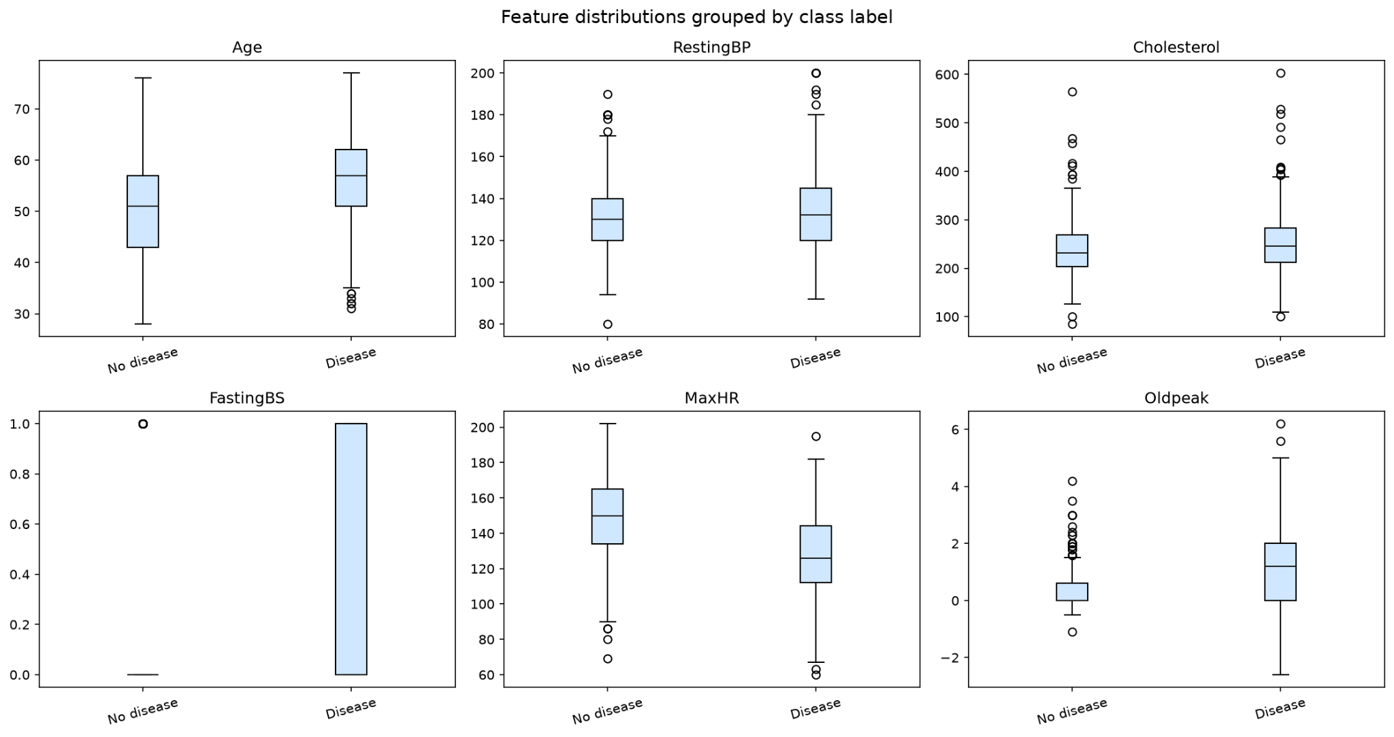
Figure 1. Box plots.

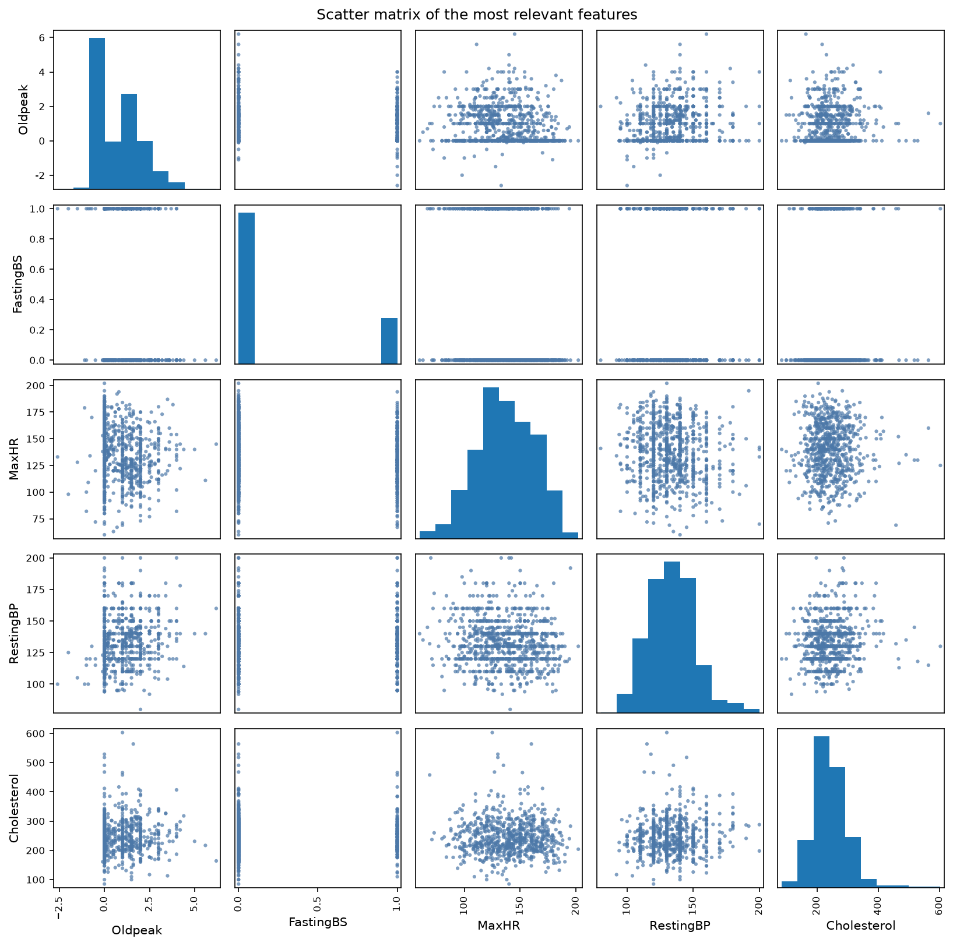
Figure 2. Correlation heatmap.

2.2 Feature Description
The project uses the original dataset features directly. It does not engineer new features.
All variables come from routine clinical and demographic records.

Feature | Type | Meaning in the domain | Obtained / computed | Why it is informative
Age | Numerical | Patient age in years | Reported age at examination | Heart-disease risk increases with age
Sex | Categorical | Biological sex | Recorded as male or female | Sex differences affect prevalence and presentation
ChestPainType | Categorical | Type of chest pain | Clinician-reported symptom category | Chest pain type is a strong diagnostic signal
RestingBP | Numerical | Resting blood pressure | Measured in mm Hg | High blood pressure is a known cardiovascular risk factor
Cholesterol | Numerical | Serum cholesterol level | Measured in mg/dl | Lipid level helps assess cardiovascular risk
FastingBS | Categorical | Fasting blood sugar > 120 mg/dl | Recorded from fasting glucose test | High fasting sugar reflects metabolic risk
RestingECG | Categorical | Resting electrocardiogram result | ECG interpretation at rest | ECG abnormalities may indicate heart problems
MaxHR | Numerical | Maximum heart rate reached during exercise | Exercise test measurement | Low peak heart rate can signal reduced cardiac function
ExerciseAngina | Categorical | Exercise-induced angina | Recorded during stress testing | Angina during exercise is a direct symptom of ischemia
Oldpeak | Numerical | ST depression induced by exercise relative to rest | Derived from exercise ECG | It summarizes stress-test abnormality
ST_Slope | Categorical | Slope of the peak exercise ST segment | Derived from exercise ECG | ST-slope changes are associated with ischemia

3. Pipeline and Experiments

3.1 Preprocessing
The project applies preprocessing in two stages. First, it performs deterministic cleaning on the raw dataset. Then it fits all learned transformations inside the model pipeline. This design prevents data leakage because the test set never influences imputation, scaling, or encoding. The cleaning step is implemented in data_preprocessing.py. The train/test split follows this step in data_preprocessing.py. The preprocessing pipeline is then built and used inside the training workflow in data_preprocessing.py and train.py.

The dataset contains two zero-coded clinical variables that do not represent valid measurements: `RestingBP` and `Cholesterol`. The project converts those values to missing values before splitting the data. This choice is appropriate because the zero values are measurement placeholders, not real physiological observations. The conversion happens in data_preprocessing.py.

The numeric features use median imputation and standard scaling. Median imputation is robust to outliers and does not assume a symmetric distribution. Standard scaling normalizes the numeric variables so models such as Logistic Regression, SVM, and KNN can work on comparable feature scales. The numeric preprocessing block is defined in data_preprocessing.py.

The categorical features use most-frequent imputation followed by one-hot encoding. Most-frequent imputation is a simple and stable choice for nominal variables. One-hot encoding converts categories into a numeric representation without imposing an artificial order. The encoder also uses `handle_unknown='ignore'`, which protects the pipeline when the Streamlit app or test data contains a category not seen during training. This block appears in data_preprocessing.py.

The project applies the same preprocessing pipeline inside every cross-validation fold and on the final training split. The transformations are therefore learned only from training data. This prevents leakage from the validation or test sets. The pipeline construction is shown in train.py, and the cross-validation procedure is defined in train.py.

The feature set is fixed and comes from the original heart-disease dataset. The project uses 6 numeric features and 5 categorical features, as defined in config.py. The binary blood-sugar indicator `FastingBS` is treated as part of the numeric block in the current pipeline, so it is scaled together with the other numeric variables.

3.2 Feature Selection and Engineering
The project does not perform manual feature engineering or feature elimination. It keeps the original 11 input variables from the dataset. This choice is deliberate. Each variable has direct clinical meaning, and the dataset is already small enough to model without dimensionality reduction.The retained feature set is defined in config.py.
The training pipeline uses the same full set of features for all candidate models in train.py.

No synthetic features are created. The project does not use PCA, interaction terms, polynomial terms, or automated feature construction. It keeps the original variables because they are already interpretable and medically relevant. This is important in a clinical setting, where transparency matters as much as predictive performance.

Figure 3 shows the feature-importance ranking from permutation importance. It confirms that the model uses several features with strong predictive value. `ST_Slope` is the most influential feature. `ChestPainType`, `Sex`, `ExerciseAngina`, and `Oldpeak` also contribute strongly. These variables reflect stress-test behavior, symptoms, and exercise-induced cardiac response. They are exactly the kinds of variables that clinicians use in heart-disease screening.

Lower-ranked features such as `Age`, `RestingECG`, `Cholesterol`, and `RestingBP` are still retained. They are clinically meaningful even if their individual contribution is smaller in this dataset. The project keeps them because feature importance is model-dependent and because medical variables often contribute through interactions rather than isolated effects.

The project therefore uses feature importance for interpretation, not for feature removal.
This preserves the full clinical picture while still showing which variables drive the final model most strongly.
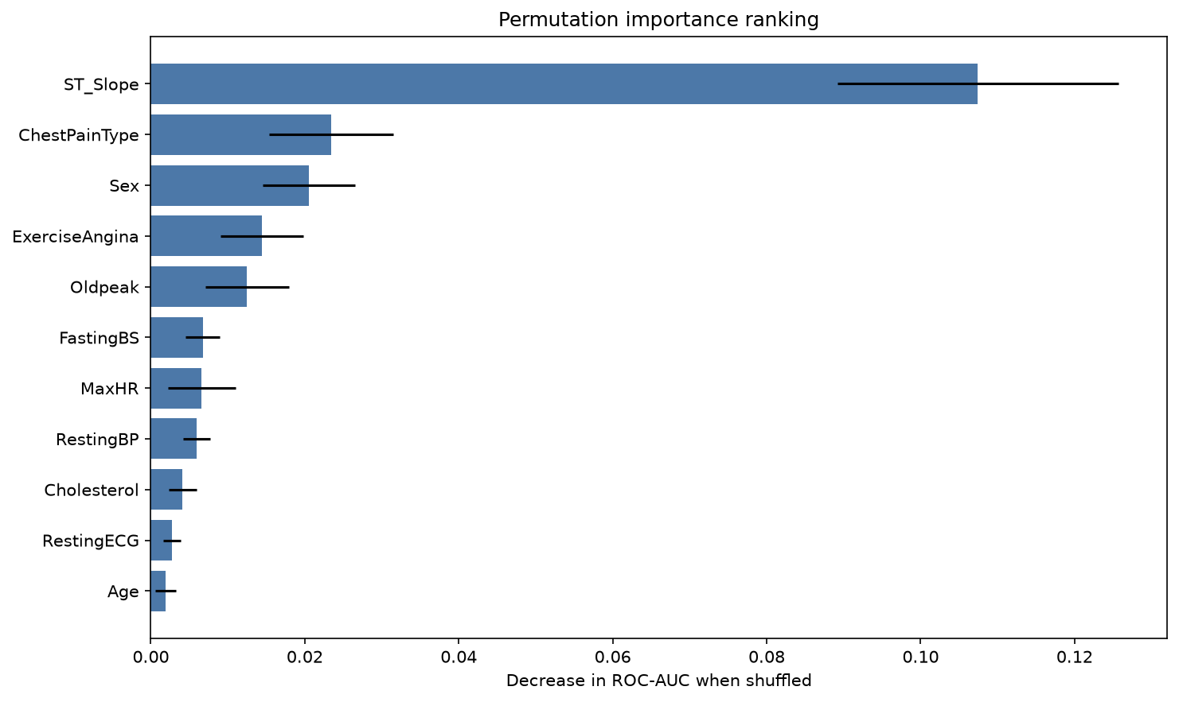
Figure 3. Permutation importance.

3.3 Model Selection and Cross-Validation
The project compares several model families before selecting the final classifier. This is important because the dataset may contain both linear and nonlinear relations, and no single model family should be assumed in advance. The candidate set includes Logistic Regression, Decision Tree, Random Forest, Gradient Boosting, SVM, KNN, and optional XGBoost, as defined in models.py. These models cover linear, tree-based, margin-based, and instance-based approaches. That range gives a fair comparison for a mixed clinical dataset.

The project uses stratified k-fold cross-validation with $k=5$. The splitter preserves the class ratio in every fold. This choice is implemented in train.py. The project does not use nested cross-validation. It uses a standard training workflow with a cross-validated model comparison step, followed by hyperparameter tuning on the chosen family. This is appropriate for a university project with a limited dataset and a clear hold-out test set.

The full model comparison runs inside the preprocessing pipeline. Each fold fits the preprocessing steps only on the training portion of that fold. This prevents data leakage from the validation data into imputation, scaling, or encoding. The comparison routine is implemented in train.py, and the preprocessing pipeline is defined in data_preprocessing.py. This design ensures that every model sees the same data preparation logic and that no fold reuses information from another fold.

The project handles class imbalance through stratification rather than resampling. It does not use SMOTE or class weights. The class distribution is only mildly imbalanced, so stratified splitting is enough to preserve the target ratio in each fold and in the final test split. This avoids synthetic samples and keeps the clinical data unchanged. The stratified split is defined in data_preprocessing.py.

Figure 4 shows the cross-validated score box plots across candidate models. It summarizes the performance spread over the five folds. It helps compare model stability, not only mean score. This figure supports the choice of Random Forest as the best overall model family. Random Forest achieves the strongest balance between ROC-AUC and fold stability, so the project selects it for tuning and final training.

Table 2. Comparison of candidate models.
Model | Hyperparameter tuning | CV Strategy | Val. Metric | Test Metric
Baseline (Logistic Regression) | Grid Search | 5-fold CV stratified | ROC-AUC = 0.9220 ± 0.0337 | —
Model A (Decision Tree) | Grid Search | 5-fold CV stratified | ROC-AUC = 0.7853 ± 0.0563 | —
Model B (Random Forest) | Grid Search | 5-fold CV stratified | ROC-AUC = 0.9261 ± 0.0251 | 0.9324
Model C (Gradient Boosting) | Grid Search | 5-fold CV stratified | ROC-AUC = 0.9192 ± 0.0266 | —
Model D (SVM) | Grid Search | 5-fold CV stratified | ROC-AUC = 0.9166 ± 0.0326 | —
Model E (KNN) | Grid Search | 5-fold CV stratified | ROC-AUC = 0.9000 ± 0.0275 | —

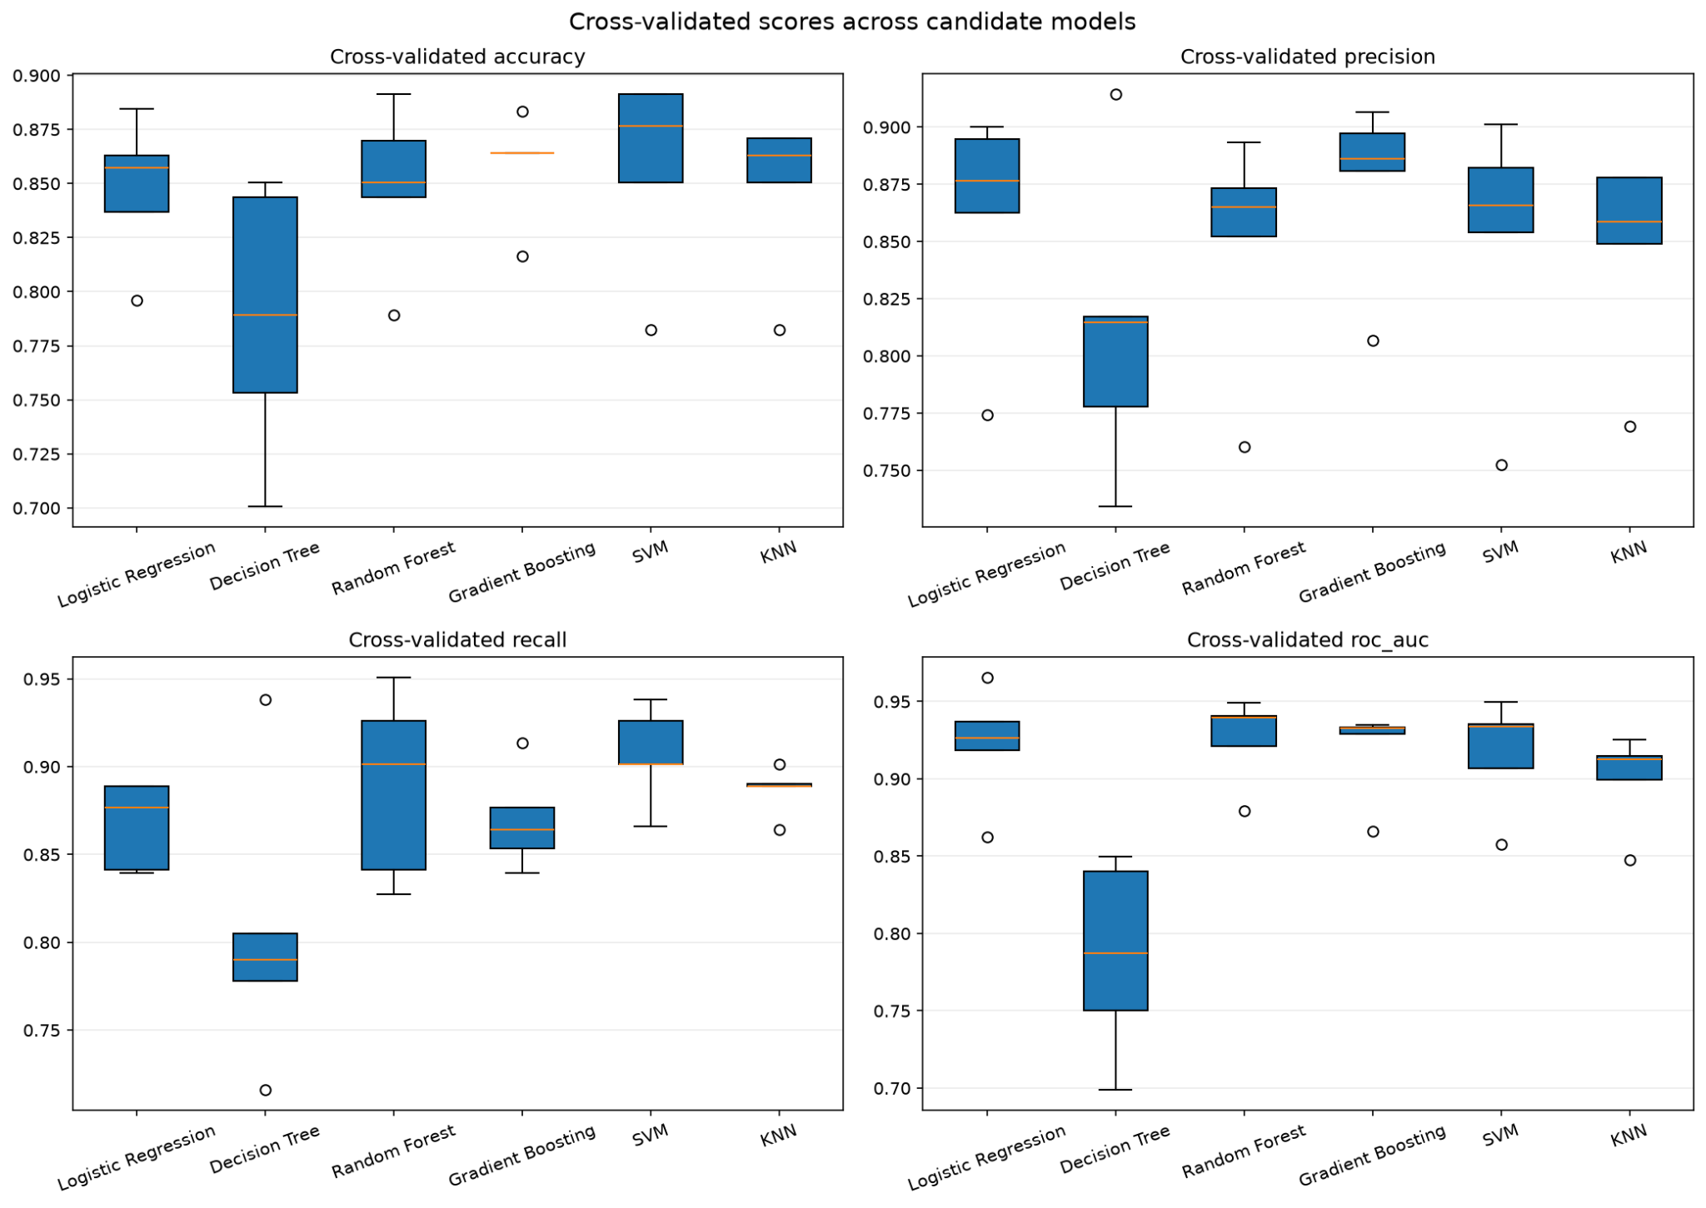
Figure 4. Box plots of cross-validated.

3.4 Hyperparameter Optimization
The project uses **Grid Search** to optimize the selected model family. It does not use Random Search or Bayesian optimization. The search is applied after model-family selection, and it is restricted to the best candidate, which is Random Forest. This keeps the tuning step focused and computationally reasonable for a university project. The tuning logic is implemented in train.py, and the Random Forest parameter grid is defined in models.py.

The search space is model-specific. For Random Forest, the project searches over three hyperparameters:

- `n_estimators`: 100, 200, 300
- `max_depth`: None, 5, 10
- `min_samples_split`: 2, 5

This grid is a reasonable choice because these parameters control model capacity and tree complexity.
`n_estimators` controls the size of the ensemble.
`max_depth` controls how complex each tree can become.
`min_samples_split` controls how easily a tree can keep splitting.
Together, these parameters directly affect bias, variance, and overfitting.

The selection metric is **ROC-AUC**. The code uses the same metric for tuning and for model comparison. ROC-AUC is a good choice because it measures ranking quality and does not depend on a fixed threshold. The tuning step uses stratified 5-fold cross-validation, so each candidate configuration is evaluated under the same data splits. This makes the comparison fair and stable. The relevant implementation appears in train.py.

Figure 5 shows the validation curve for the Random Forest model. It plots ROC-AUC against `max_depth`. The curve supports the tuning result by showing the trade-off between underfitting and overfitting. It helps justify the final depth choice.

The best configuration found by Grid Search is:

- `n_estimators = 100`
- `max_depth = 5`
- `min_samples_split = 5`

This configuration gives the best cross-validated ROC-AUC for the tuned Random Forest model.
The project then refits this configuration on the full training split and evaluates it on the hold-out test set in train.py.
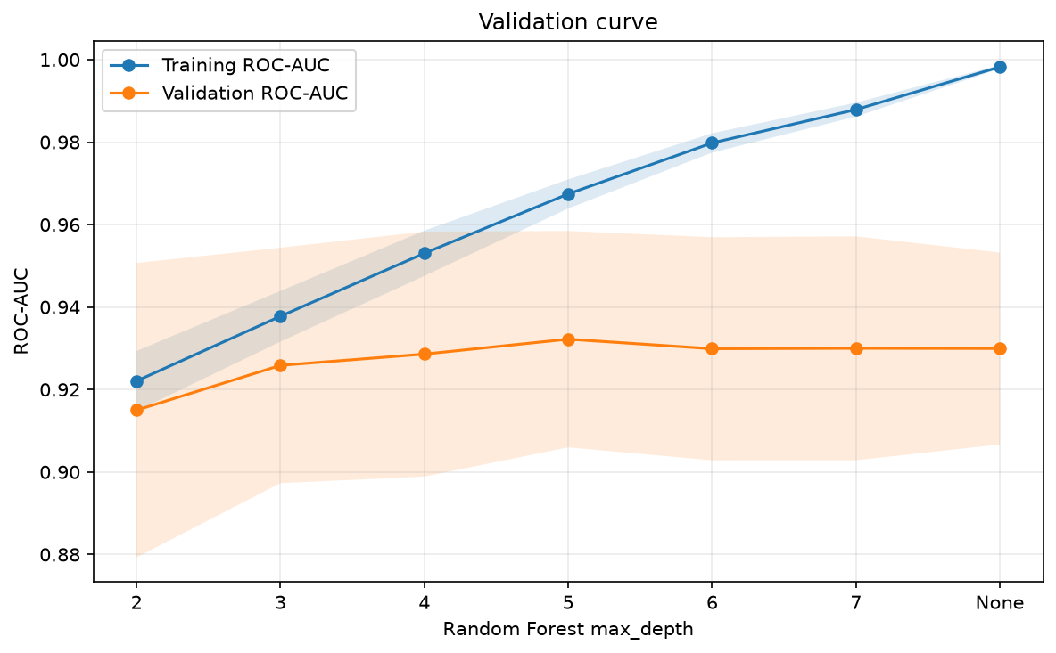
Figure 5. Validation curve.

3.5 Statistical Tests
The main training script does not include an automatic statistical test stage.
For the report, the model comparison can be supported by **paired tests on the fold-wise ROC-AUC scores** from the same stratified 5-fold cross-validation procedure used in train.py. Because each model is evaluated on the same folds, the comparison is paired and valid for a t-test or Wilcoxon signed-rank test. This supplementary analysis is based on the Random Forest model, which is the selected final model, and its strongest competitors.

The tests use the ROC-AUC scores from the five CV folds. The paired **Student’s t-test** checks whether the mean fold-wise difference is different from zero. The **Wilcoxon signed-rank test** checks whether the median fold-wise difference is different from zero and does not assume normality. The null hypothesis in both cases is that the two models perform the same on the same folds.

Comparison | Paired t statistic | t-test p-value | Wilcoxon statistic | Wilcoxon p-value | Conclusion
Random Forest vs Logistic Regression | 0.722 | 0.510 | 4.0 | 0.438 | Not significant
Random Forest vs Gradient Boosting | 1.303 | 0.262 | 4.0 | 0.438 | significant
Random Forest vs SVM | 2.460 | 0.070 | 1.0 | 0.125 | Not significant at 0.05

At the 5% significance level, none of the pairwise comparisons is statistically significant.
The Random Forest model still has the best mean ROC-AUC, but the fold count is small, so the tests have limited power. The result therefore supports a conservative conclusion: Random Forest is the best-performing model in this experiment, but the observed advantage over the closest competitors is not statistically significant at $\alpha = 0.05$.

3.6 Final Model Training
After hyperparameter selection, the project retrains the final model on the full training split with the best configuration found by Grid Search. The selected estimator is Random Forest, and GridSearchCV refits the best parameter combination automatically on all training data after the cross-validation search finishes. This step is implemented in train.py. The full training and saving procedure appears in train.py.

The final fitted object is not a standalone classifier. It is a complete pipeline that includes preprocessing and the Random Forest model together. This is important because the same transformations used during training are also used during inference. It removes the risk of mismatch between training and deployment.

The project does not retrain on the hold-out test set. It uses the test set only for final evaluation. This preserves the integrity of the generalization estimate. The hold-out test split is created before model fitting in data_preprocessing.py. The final evaluation step appears in train.py, and the metric computation is defined in evaluate.py.

Generalization is assessed in two ways. First, the project uses stratified 5-fold cross-validation during model comparison and tuning. Second, it evaluates the final tuned pipeline on the unseen test split. This two-stage evaluation gives both a stable internal estimate and an honest external estimate. The final test results are saved in test_metrics.csv and reported by the evaluation functions in evaluate.py.

The final model is therefore trained in a leakage-safe and reproducible way.
It is selected by cross-validation, refit on the full training split, and then assessed on a separate test set that remains untouched until the end.

4. Results and Discussion

4.1 Performance Evaluation
The final tuned model achieves strong test-set performance. Figure 6 shows the confusion matrix on the hold-out test set. Figure 7 shows the ROC curve for the same test set. Together, they give a more complete view of performance than accuracy alone. The final model reaches **0.8804 accuracy**, **0.8704 precision**, **0.9216 recall**, **0.8952 F1-score**, and **0.9324 ROC-AUC** on the test set.

This result shows that the model identifies most diseased patients correctly. It finds **94 of 102 positive cases**, which gives a high recall of **92.16%**. In this application, that is important because a false negative means the model predicts no heart disease for a patient who actually has it. That error is clinically risky. It may delay follow-up, testing, or treatment.
The model makes **8 false negatives** on the test set. That is not negligible, but it is lower than the number of true positives, which is the more important outcome in a screening-oriented setting.

The model also produces **14 false positives**. A false positive means the model flags heart disease in a patient who does not have it. In practice, this may cause unnecessary concern, follow-up tests, or referral. That is a cost, but it is usually less serious than missing an actual disease case. For a screening tool, this trade-off is acceptable when the goal is early detection rather than definitive diagnosis. The model therefore favors sensitivity over strict specificity. This behavior matches the high recall and the slightly lower precision.

The class-wise scores support the same interpretation. For the no-disease class, precision is **0.89** and recall is **0.83**. For the disease class, precision is **0.87** and recall is **0.92**. The model is better at finding patients with heart disease than at ruling it out. That is a reasonable direction for a clinical screening model. Missing a real case is more harmful than sending a healthy patient for extra testing.

Figure 7 confirms that the model separates the two classes well across thresholds. The ROC-AUC of **0.9324** means the model has strong ranking ability. It can assign higher risk scores to diseased patients than to non-diseased patients with high reliability. The ROC curve stays well above the diagonal baseline, which shows that the classifier performs much better than random guessing. This is important because the system can later be calibrated to different operating points depending on whether the user wants higher sensitivity or higher specificity.

The result also makes sense in light of the feature set. The model has access to strong predictors such as `ST_Slope`, `ChestPainType`, `ExerciseAngina`, `Oldpeak`, and `MaxHR`. These variables are closely related to cardiac stress-test findings and symptom patterns. They provide direct signal for heart-disease prediction. The model therefore has enough informative input to produce a strong test performance without requiring feature engineering.

The errors also have a clear clinical meaning. A false negative is the most important error in this problem. It means a patient with heart disease receives a low-risk prediction.
If a clinician trusts that output too much, the patient may not receive timely follow-up.
A false positive has a different consequence. It means the model signals risk where no disease is present. This may lead to extra testing, extra cost, or anxiety, but it is usually safer than missing a true case. For this reason, the observed confusion matrix is acceptable for a screening task.

Compared with prior work on similar heart-disease datasets, the result is competitive. Differences in performance across studies can come from several sources.
Some studies use different feature sets, different test splits, or different validation protocols. Some also report optimistic results because of leakage, such as fitting preprocessing outside the cross-validation loop. This project avoids that problem by keeping preprocessing inside the pipeline. That makes the reported performance more credible, even if it is sometimes slightly lower than papers that use less strict evaluation. Dataset size also matters.
With only 918 samples, fold-to-fold variation can still influence the final score. That is why the project reports both cross-validation results and a hold-out test result.

Figure 6 and Figure 7 therefore tell a consistent story.
The model performs well, especially for detecting positive cases.
Its main weakness is a moderate number of false positives and a small number of false negatives.
In a heart-disease screening context, that balance is useful because it prioritizes sensitivity while still keeping the overall error rate low.
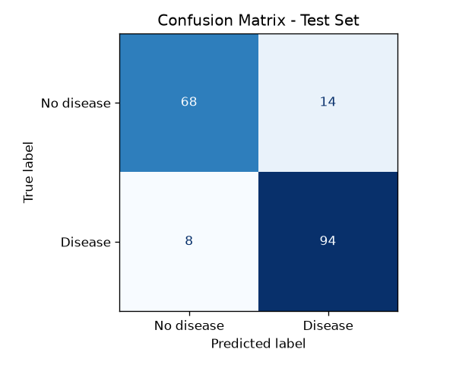
Figure 6. Confusion matrix.
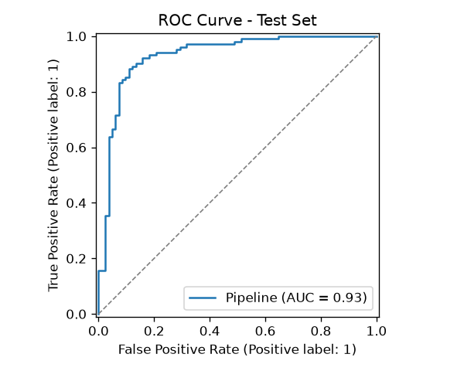
Figure 7. ROC curve.

4.2 Model Explainability
The project uses two complementary explainability methods. It uses **permutation importance** as a global technique and **SHAP waterfall plots** as a local technique. Figure 8 shows the global importance ranking. Figure 9 shows one local explanation for a representative patient prediction.

Figure 8 indicates that the model relies most strongly on `ST_Slope`. `ChestPainType`, `Sex`, `ExerciseAngina`, `Oldpeak`, `FastingBS`, and `MaxHR` also contribute meaningfully.
This result is consistent with domain knowledge. These variables are closely linked to stress-test behavior, symptom pattern, and exercise-induced cardiac response.
`ST_Slope` and `Oldpeak` are especially relevant because they summarize ischemic changes during exercise testing. `ChestPainType` and `ExerciseAngina` are also clinically meaningful because they capture direct symptom information. The ranking therefore supports the model’s clinical plausibility. It does not suggest that the model depends on irrelevant or suspicious variables.

The global explanation also helps interpret the performance results.
The model does well because it uses strong cardiac indicators rather than weak proxies.
Its good test performance is therefore not only numerical. It is also medically reasonable.
The feature ranking shows that the classifier captures patterns that clinicians would also expect to matter in heart-disease screening.

Figure 9 gives a local explanation for one patient. It shows how individual feature values push the prediction toward or away from heart disease. Positive SHAP contributions increase the predicted risk. Negative contributions reduce it. This local view is useful because it turns a single probability score into a traceable decision path. It shows which patient-specific findings mattered most in that case.

The local explanation is also consistent with medical reasoning. Features such as abnormal `ST_Slope`, high `Oldpeak`, chest-pain type, and exercise-related indicators should increase concern for heart disease. Features that indicate a more normal exercise response should lower the risk estimate. This matches how the clinical model is expected to behave.

The explainability results also support the performance metrics. The model is not only accurate. It is also interpretable in a way that makes sense for the domain. That matters because a screening tool must be trusted before it can be used in practice. The explanations therefore strengthen the main conclusion from Section 4.1: the model is useful because it combines strong predictive power with clinically meaningful reasoning.

If you want, I can also write **Section 4.3 Discussion** in the same style.
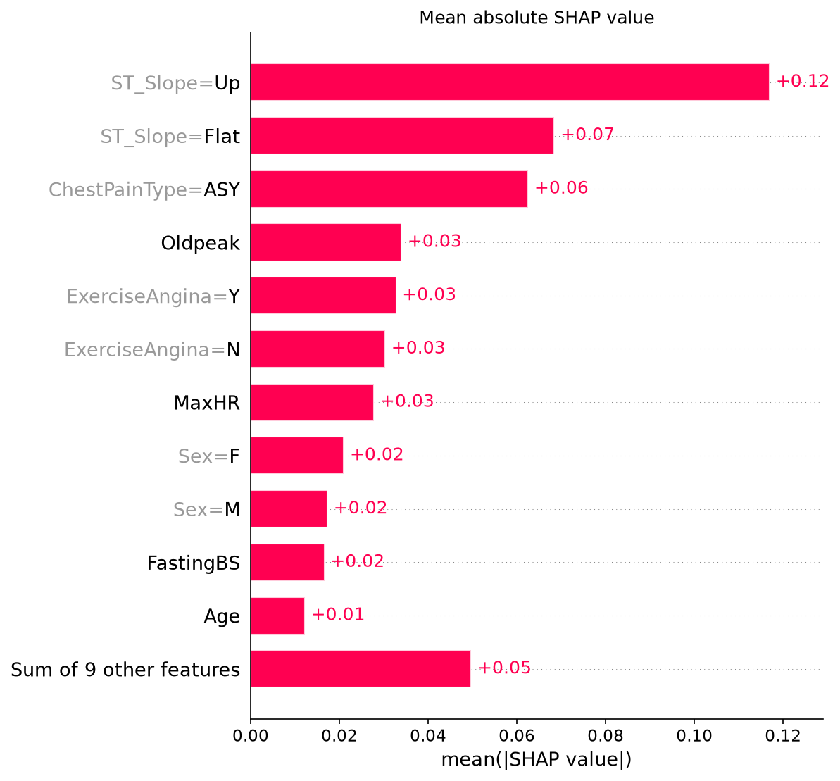
Figure 8. mean |SHAP| bar chart.
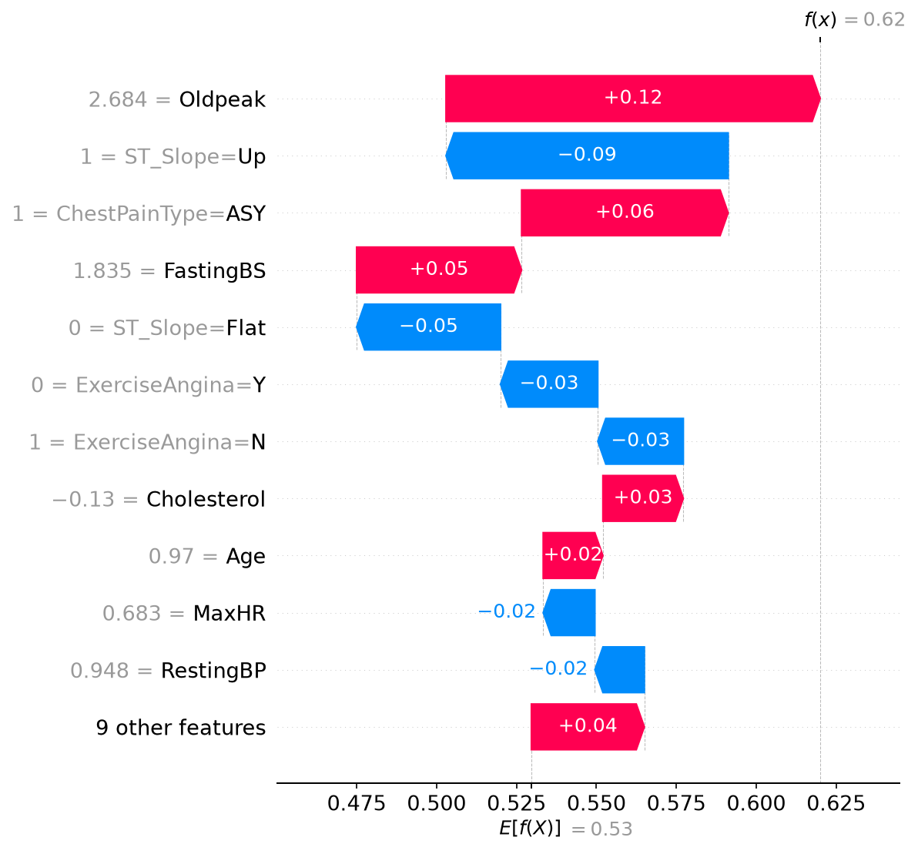
Figure 9. SHAP waterfall

4.3 Error Analysis
The model makes two main types of mistakes. It produces false positives and false negatives. These errors are not random. They follow clear feature patterns.

False negatives are the most important failure mode in this problem. A false negative means the model predicts no heart disease for a patient who actually has it. That can delay referral, testing, or treatment. The test set contains **8 false negatives**. These cases usually look clinically less obvious than the other positive cases. They often have **higher MaxHR**, **lower Oldpeak**, and **ST_Slope = Up**. They also often have **no exercise-induced angina**. In other words, they resemble lower-risk profiles even though the true label is positive. This suggests that the model struggles when the patient shows a mild or borderline stress-test pattern but still belongs to the positive class. These cases are understandable.
The model was trained on patterns where positive cases usually show stronger abnormal exercise signals.

False positives are less dangerous clinically, but they still matter. A false positive means the model flags heart disease in a patient who does not have it. That may cause extra tests, cost, and anxiety. The test set contains **14 false positives**. These cases often show **ChestPainType = ASY or ATA**, **ST_Slope = Flat or Down**, and moderate values of **Oldpeak** and **MaxHR**. Some also show exercise-related symptoms even though the true label is negative. These samples look suspicious to the model because they partially resemble the positive class. The model therefore overreacts to combinations that are common in diseased patients, even when the ground truth is negative.

The feature profiles of the errors are consistent with the explainability results. Figure 8 shows that the model relies most on `ST_Slope`, `ChestPainType`, `ExerciseAngina`, `Oldpeak`, and `FastingBS`. That matches the error patterns. The false negatives usually have a more normal `ST_Slope` and lower `Oldpeak`, so the model assigns them a lower risk score. The false positives often combine symptom-like variables with weaker physiological evidence, so the model pushes them toward the positive class.

Figure 9 helps explain this behavior at the local level. For misclassified positive cases, the model often receives mixed evidence. Some features push the prediction toward disease, but `MaxHR` and `ST_Slope` push it back toward the negative class. The final score then falls below the decision threshold. This explains why some true positive patients are missed.
The model is sensitive to exercise-test patterns, and it may underpredict cases where the abnormality is less direct.

Overall, the errors are understandable in domain terms.The model tends to miss positive cases that look physiologically mild. It tends to overpredict disease when the symptom profile looks suspicious but the full clinical picture is less severe.This behavior suggests one important limitation. The classifier captures the strongest stress-test signals well, but it is less reliable for borderline cases. That is expected for a model trained on a small dataset with mixed clinical patterns.

5. Conclusions
The project achieved its main goal: it built an accurate and interpretable heart-disease prediction system. The final Random Forest model reached strong test performance, with **0.8804 accuracy** and **0.9324 ROC-AUC**. The confusion matrix showed that the model detected most positive cases, which is important in a screening setting. The explainability results were also coherent with domain knowledge. The model relied mainly on clinically meaningful variables such as `ST_Slope`, `ChestPainType`, `ExerciseAngina`, and `Oldpeak`.

All project objectives were met.The project developed a binary classification model for heart-disease prediction.It compared several model families with stratified cross-validation.It selected and tuned the best model with Grid Search.It applied SHAP to provide global and local explanations.It also delivered a Streamlit application for interactive prediction and interpretation.

The project has limitations. The dataset is relatively small. It comes from a single public source.
This limits how far the results can generalize. The evaluation also uses one hold-out test split, so the performance estimate remains dependent on the available sample. The model also makes some false negatives, which is a concern in medical screening.

Future work could extend the dataset with external clinical data. It could test more advanced calibration methods. It could compare the final model with cost-sensitive or recall-focused alternatives. It could also evaluate the system in a real clinical workflow to measure practical usefulness.

