ModII Project Report
Ahmed Omar Zoher 34-2413
Omar Tarek 34-338
Mohamed Mamdouh 34-3185
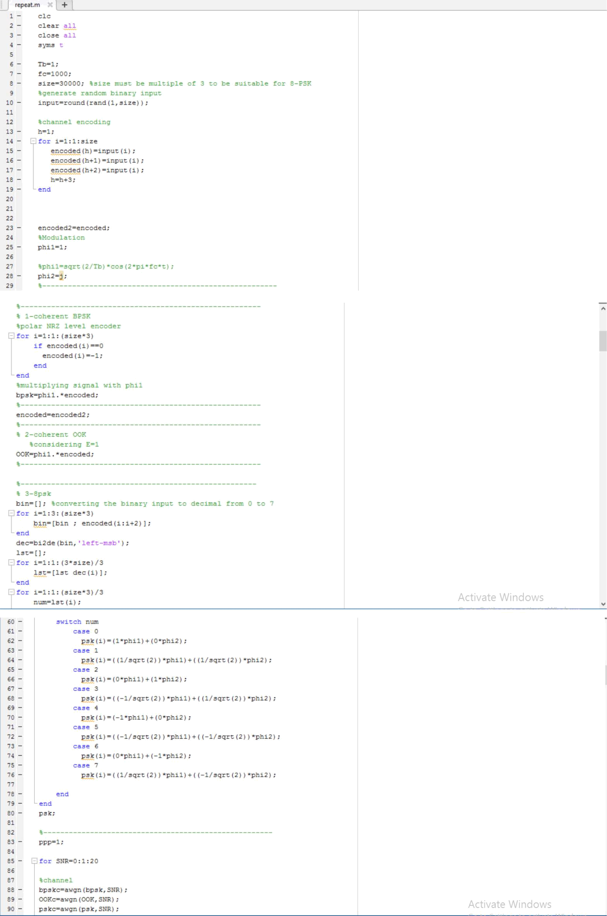
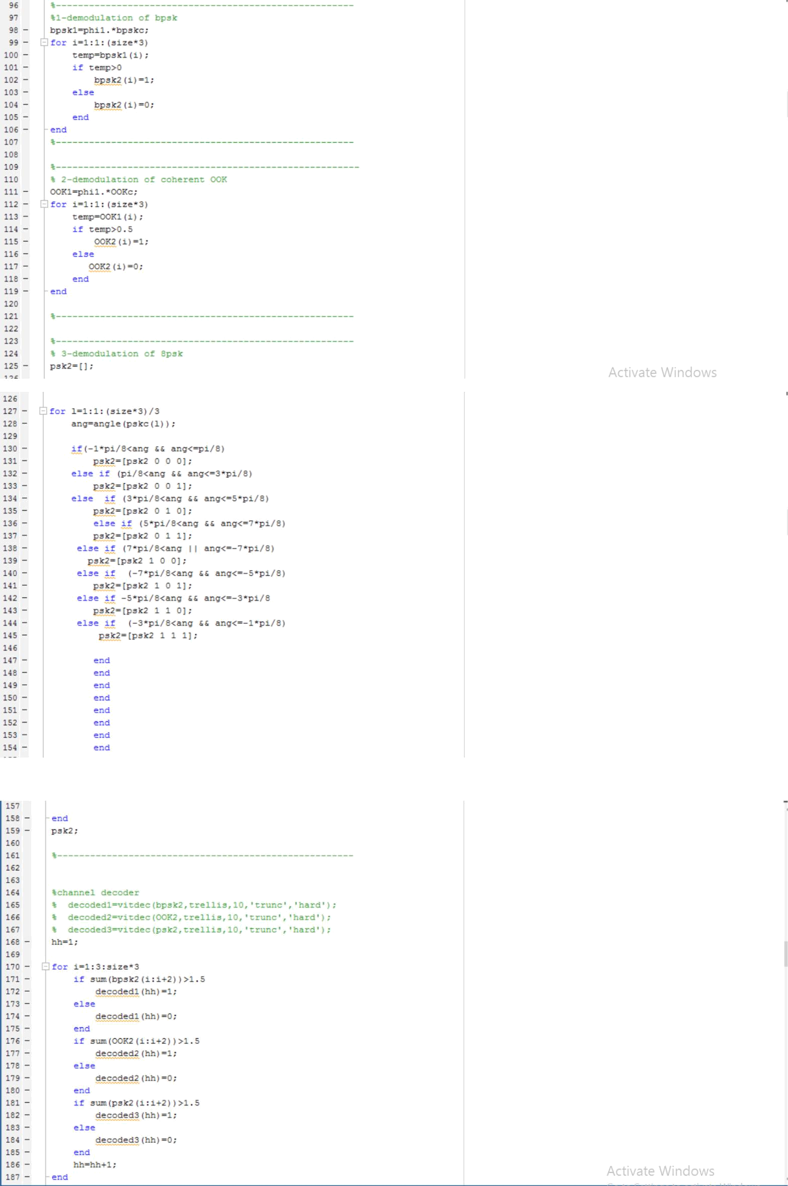
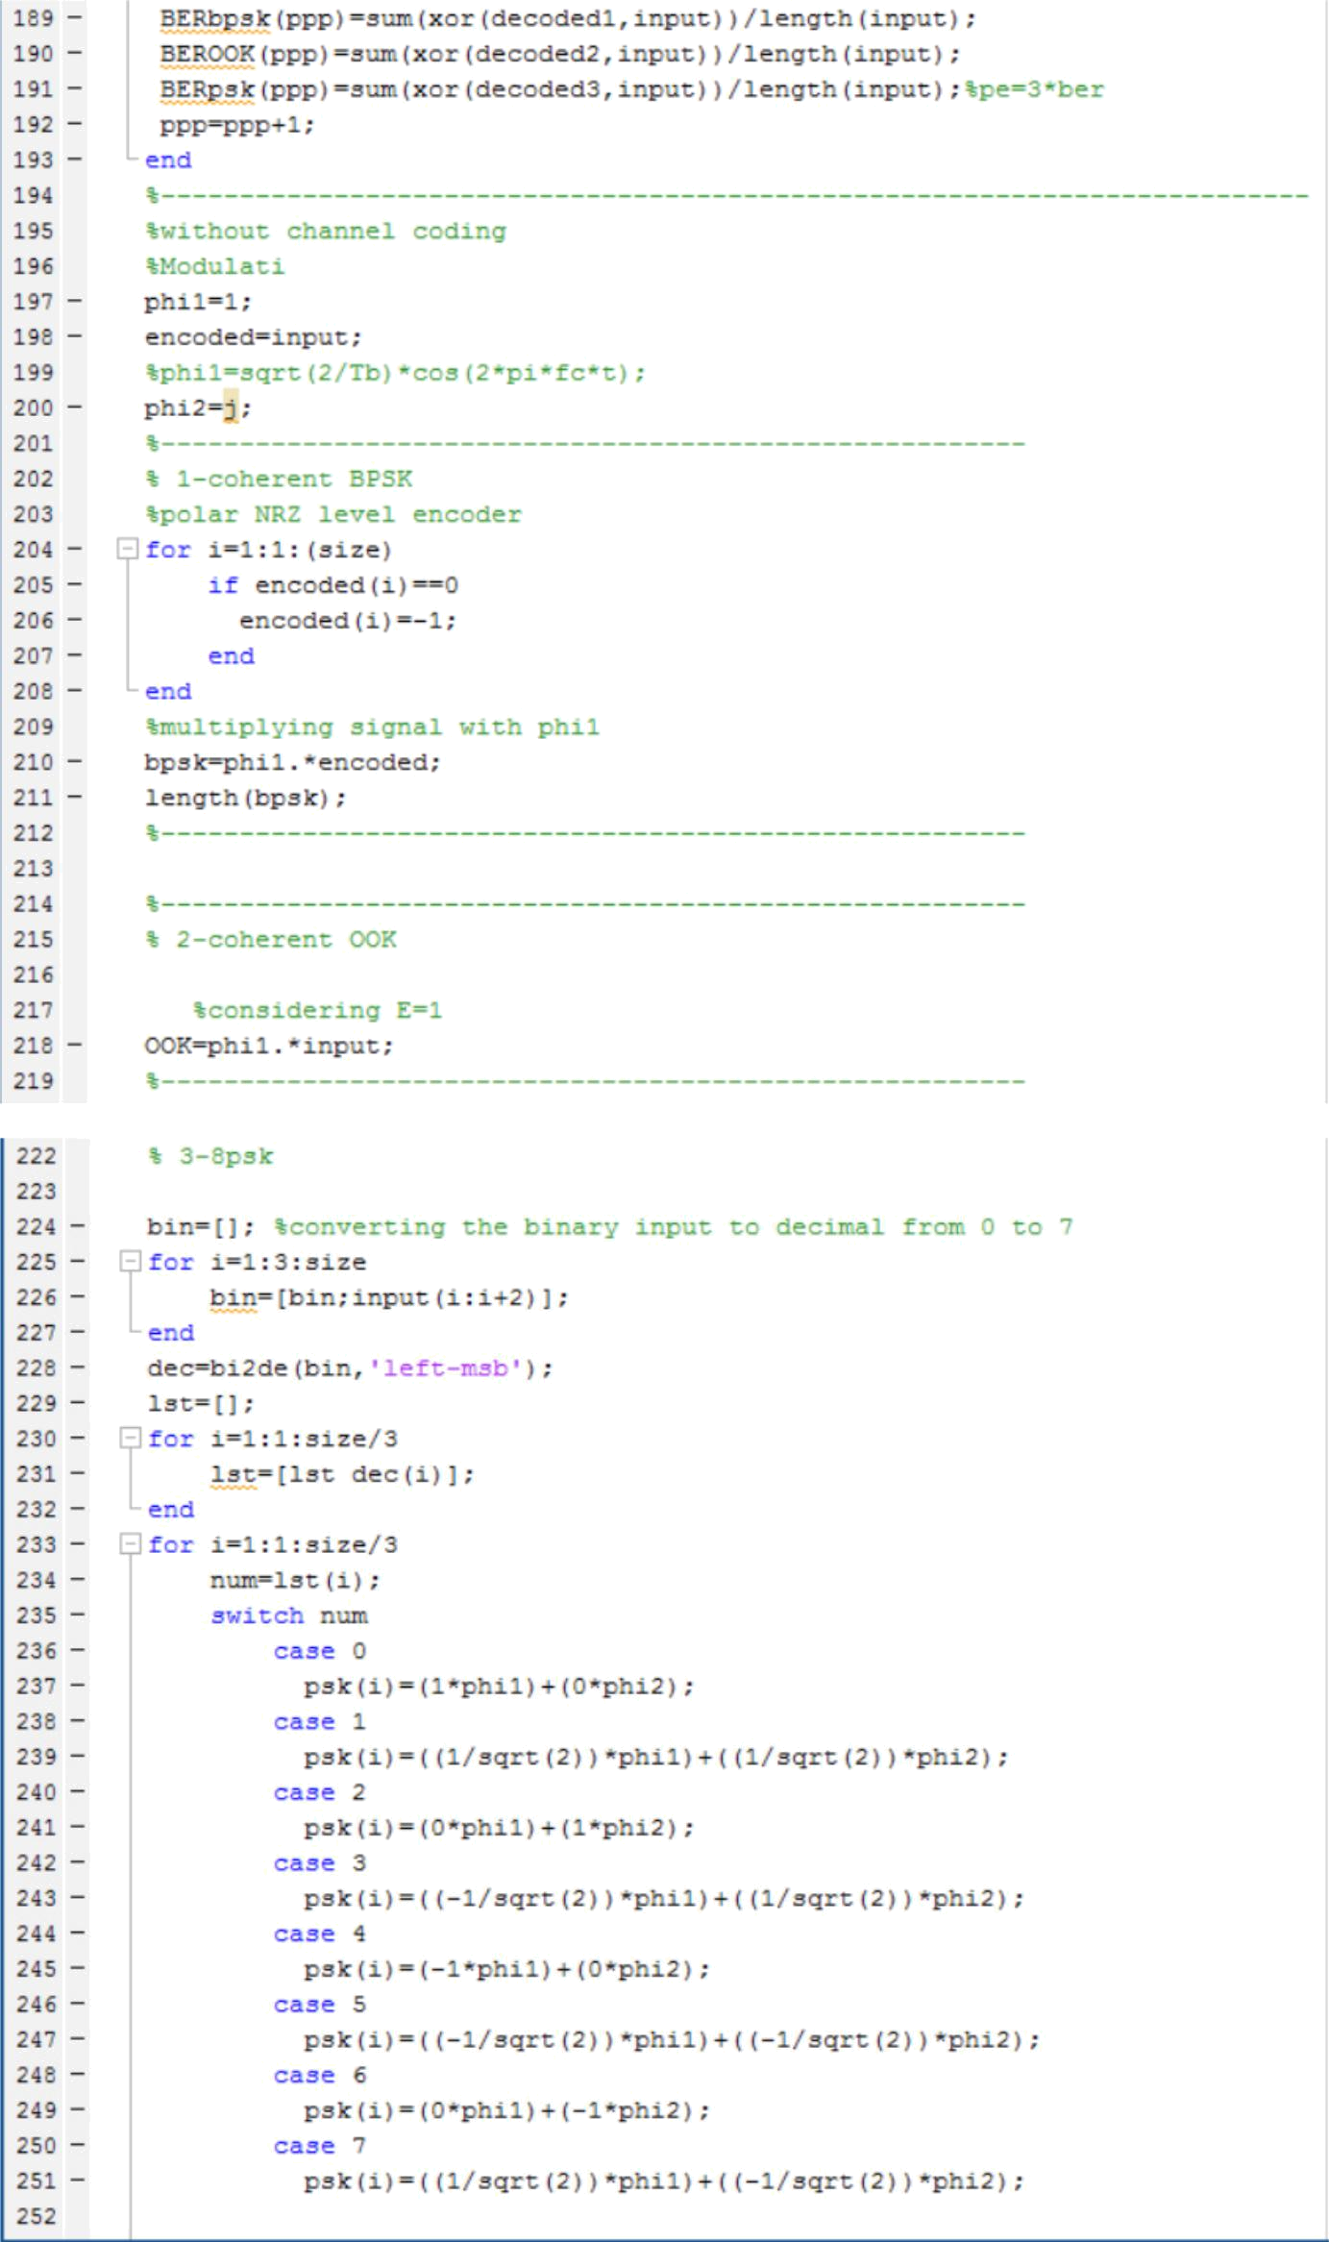
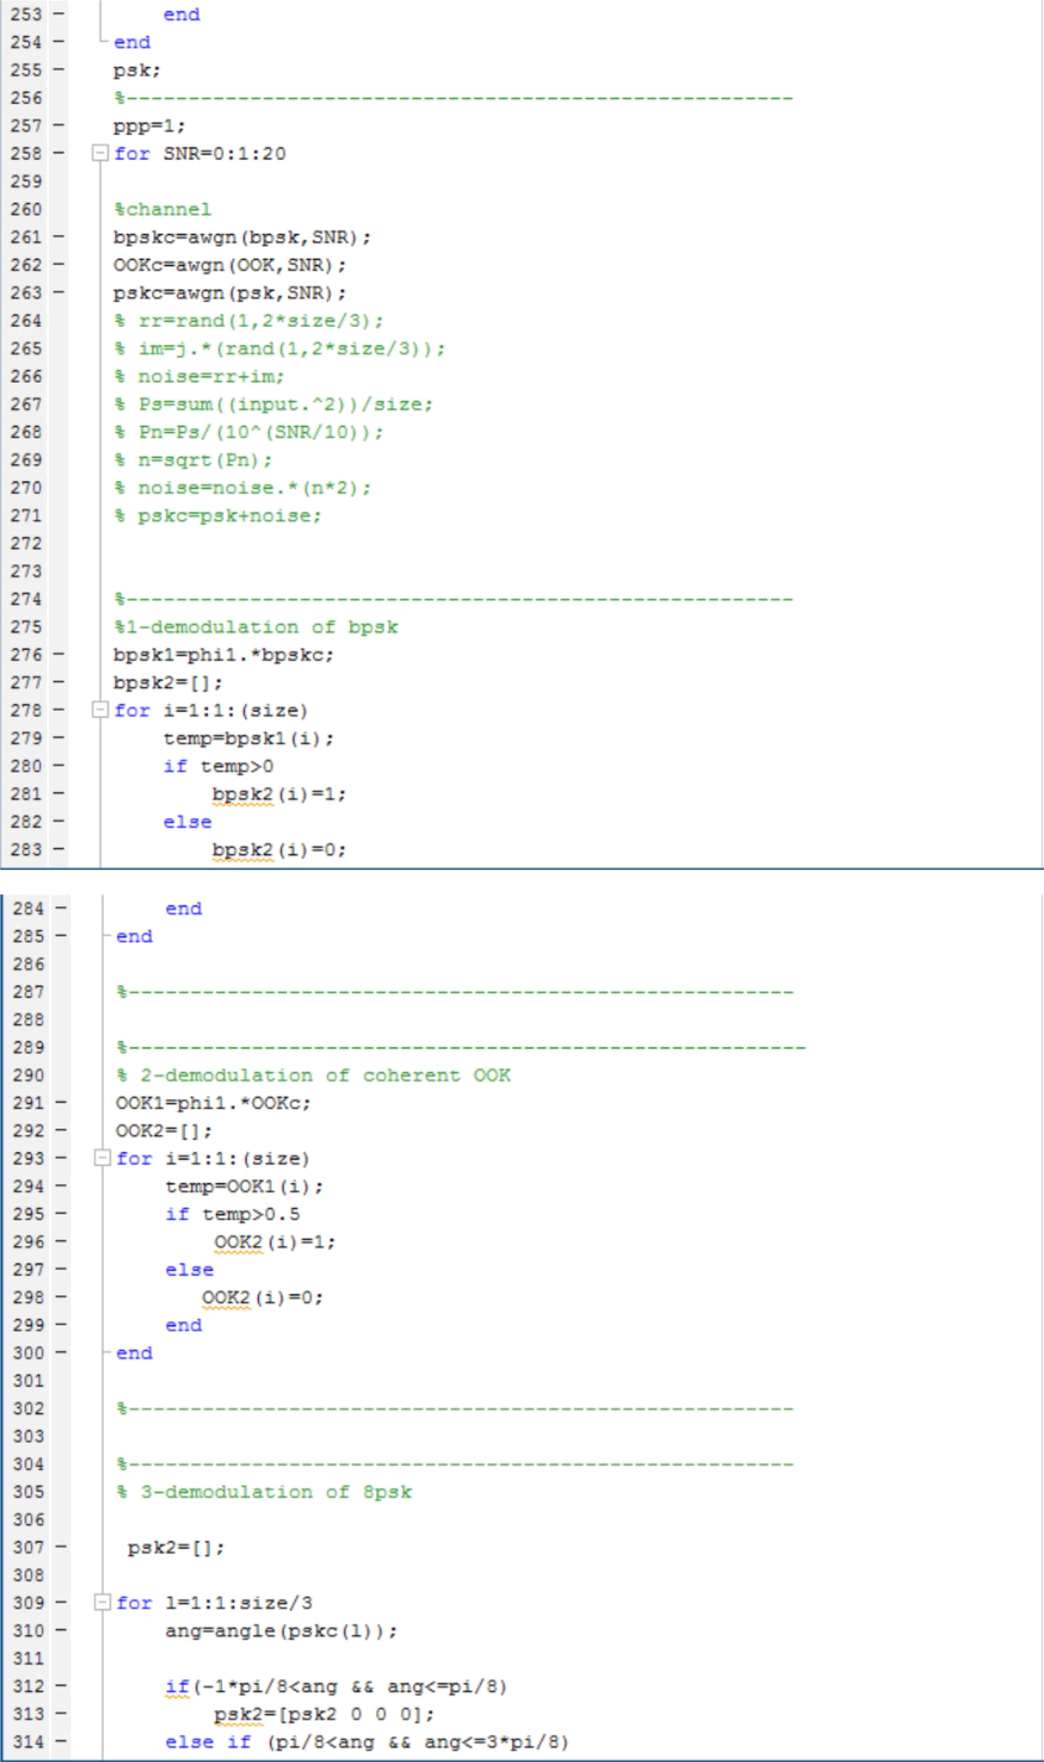
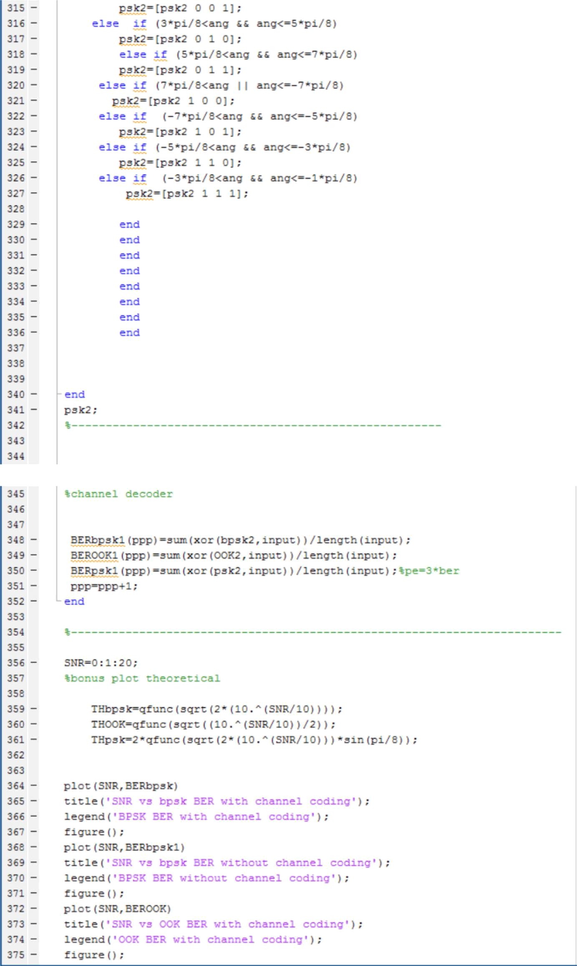
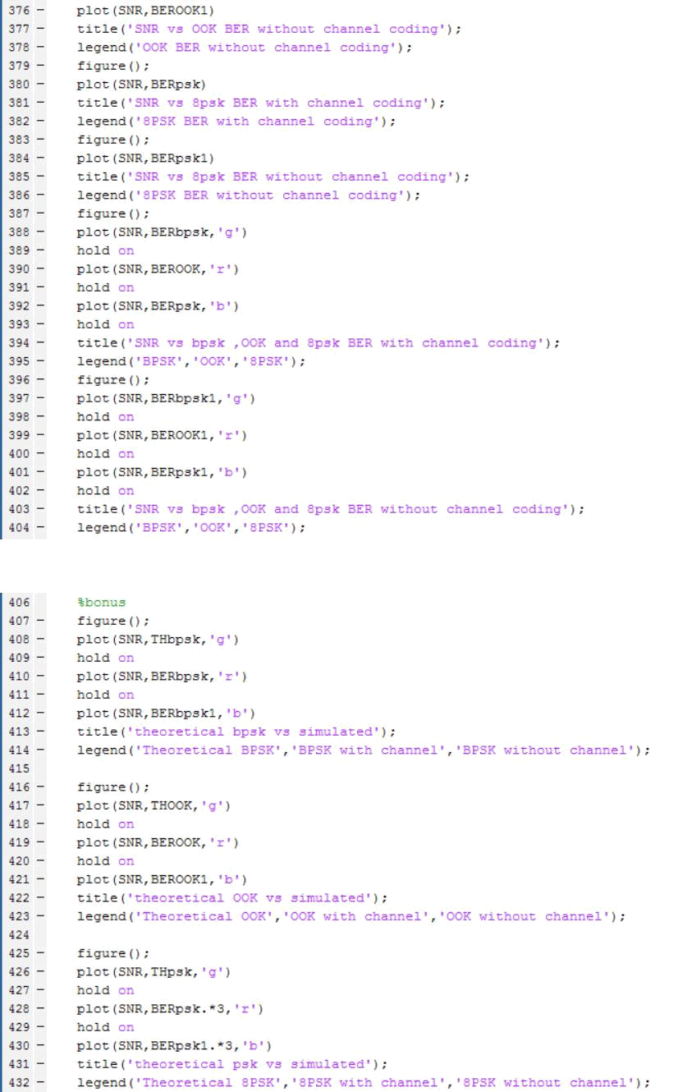
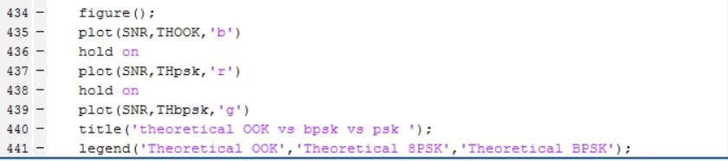
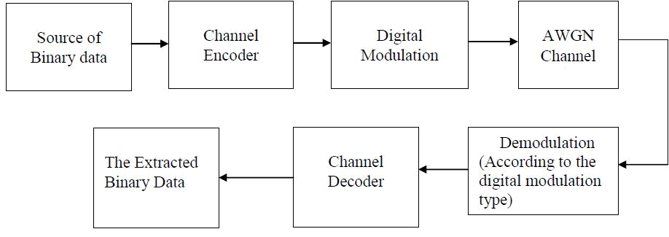
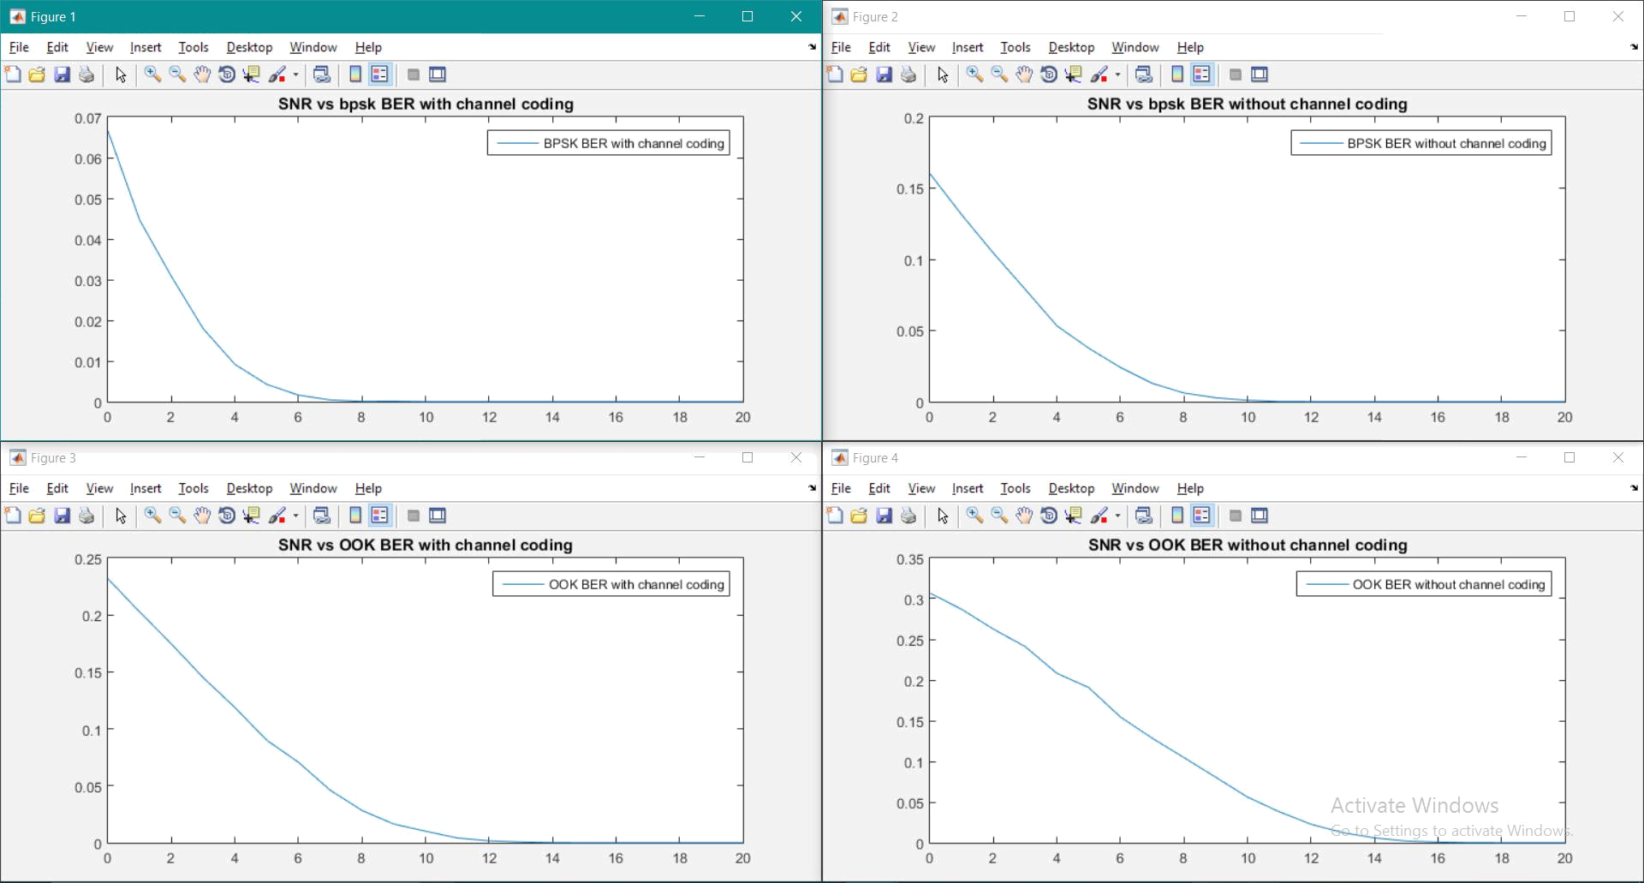
It is clear form the graphs below that the BER vs SNR with channel coding is better that without and that’s because we used repetition code which make the probability of the msg to be disturbed very low
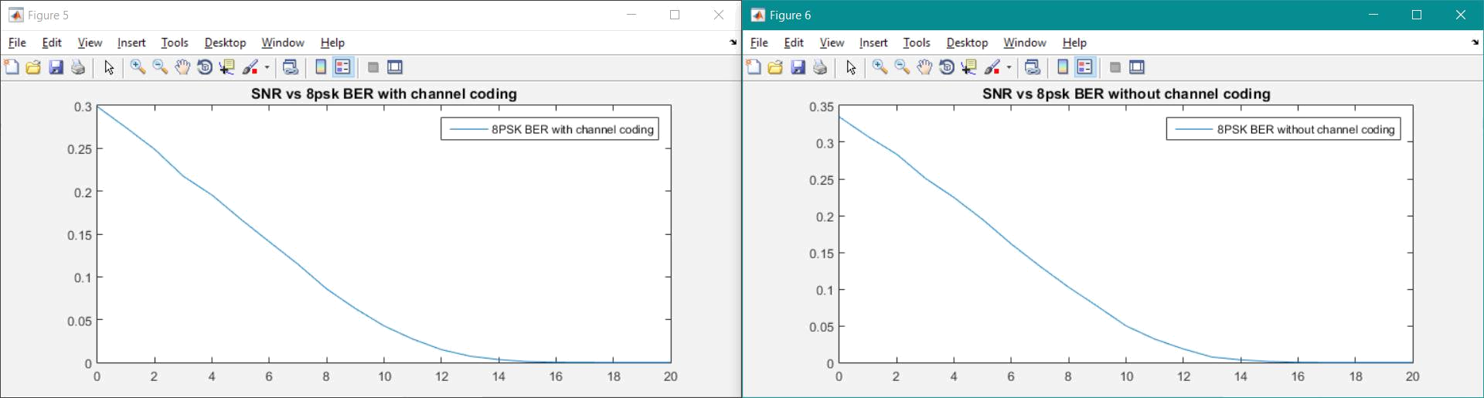
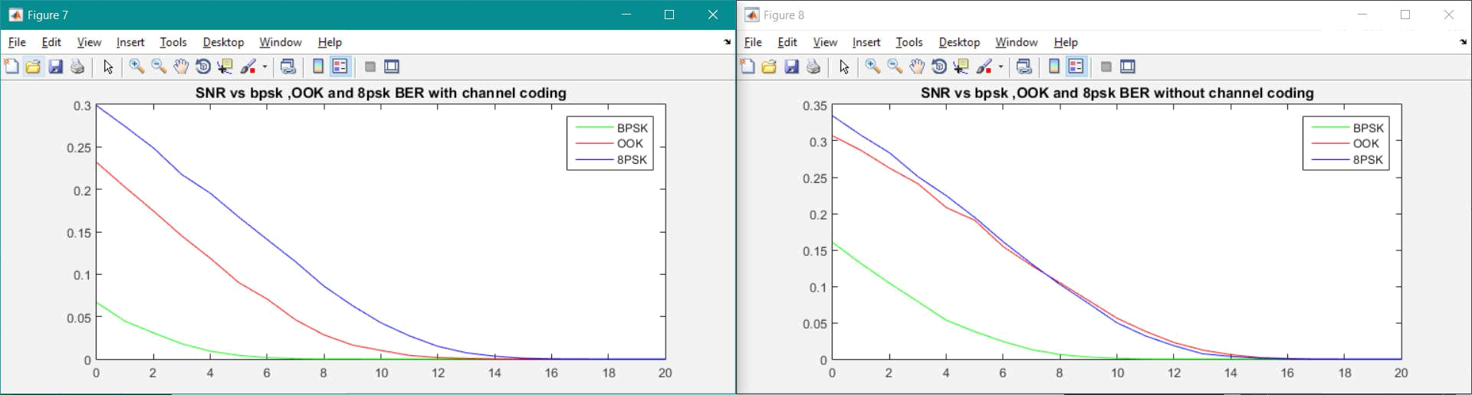
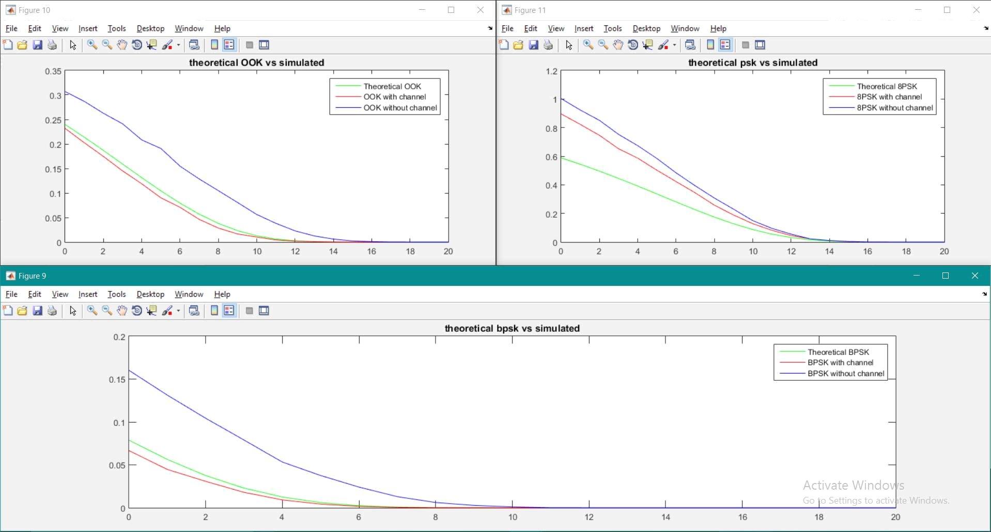
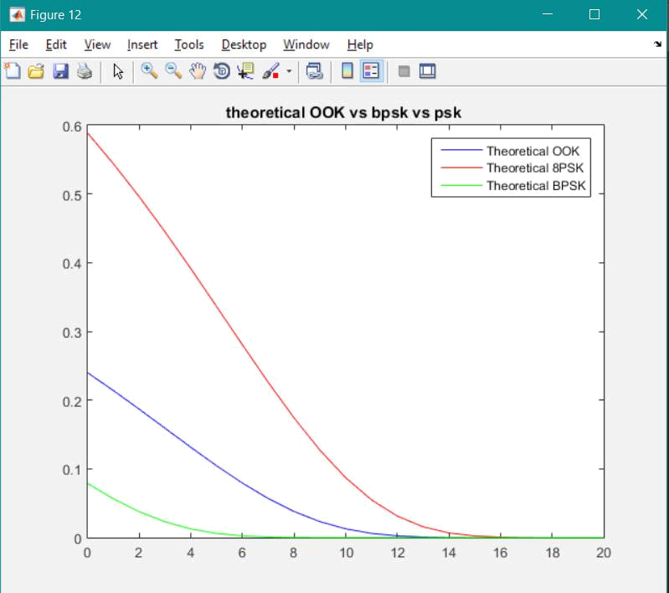
It is Clear from the below graphs that the bpsk is the best type concerning the BER while the OOK comes after it and of course 8-PSK is the worst of all whether we used channel coding or not
It Is clear that the theoretical pe is approximately equal the simulated one of course the with channel coding one is the best but that is because while deriving the theoretical probability we did not use channel coding so that is normal.

