Name: Ahmed Atta Abdullah Abdelhay

## Design FSM

* Consists of 2 FSM, one for the control unit and the other for the Resolver.

1- Control Unit

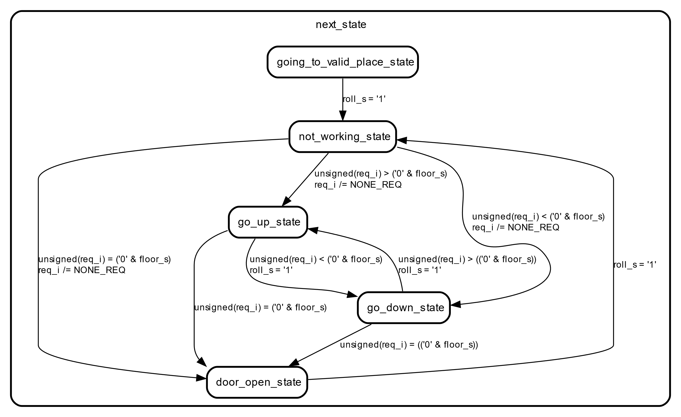

2- Resolver

