Total Marks: | 03
Obtained Marks:

Introduction To Blockchain
Assignment # 04

Last date of Submission: 25 May 2026

Submitted To: Mr. Shahab Khan
_________________________________________________________________________________________________________________________________________________________________________________________________________________________________
Student Name: Muhammad Ahmed Baig _________________________________________________________________________________________________________________________________________________________________________________________________________________________________

Reg Number: 2112389
__________________________________________________________________________________________________________________________________________________________________________________________________________________________________

(CLO-3)
Q: You are tasked with creating a Solidity smart contract to manage student information. The contract should store the details of a student, including their id, name, age, and department. Task:
- Define a struct called Student with the following properties:
  - id (uint)
  - name (string)
  - age (uint)
  - department (string)
- Implement the following functions:
  - A function to add a new student's data.
  - A function to update an existing student's data. Requirements:

- The functions should ensure data is only updated or accessed if the student exists.
- The contract should handle adding and updating data correctly.

Assignment Instructions:
- Compile and deploy the contract using an Ethereum development environment like Remix.
- Take a screenshot of your working contract (after successfully adding, updating, and retrieving student data).
- Upload your contract code and the screenshot to GCR and GitHub repository. Share the link to your repository in your assignment submission.

Compile:
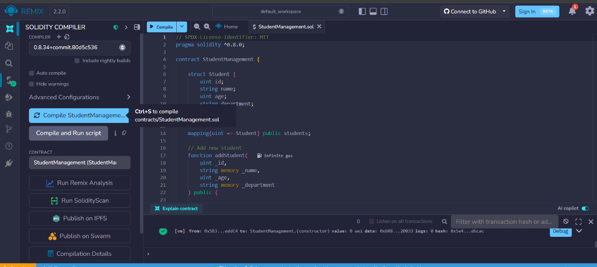

Deploy:
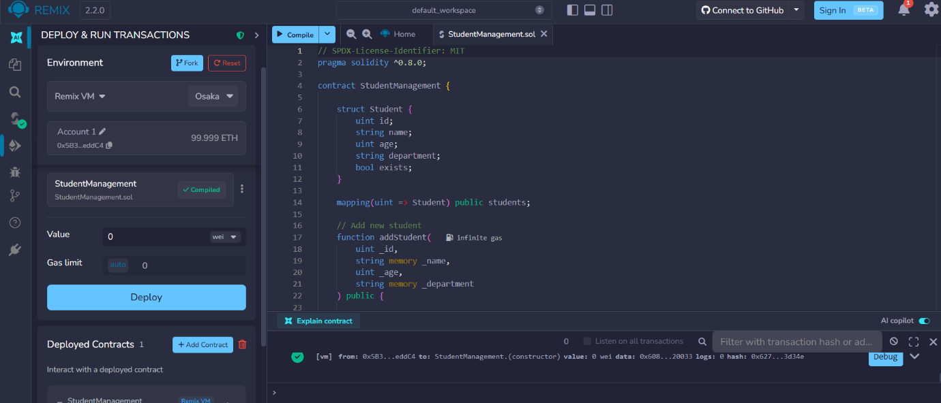

Addstudent success:
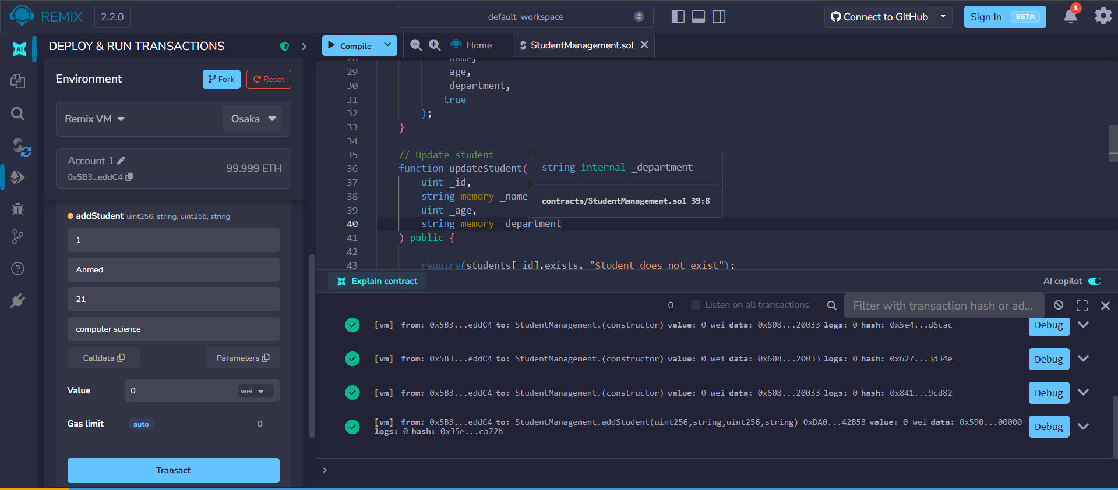

getStudent:
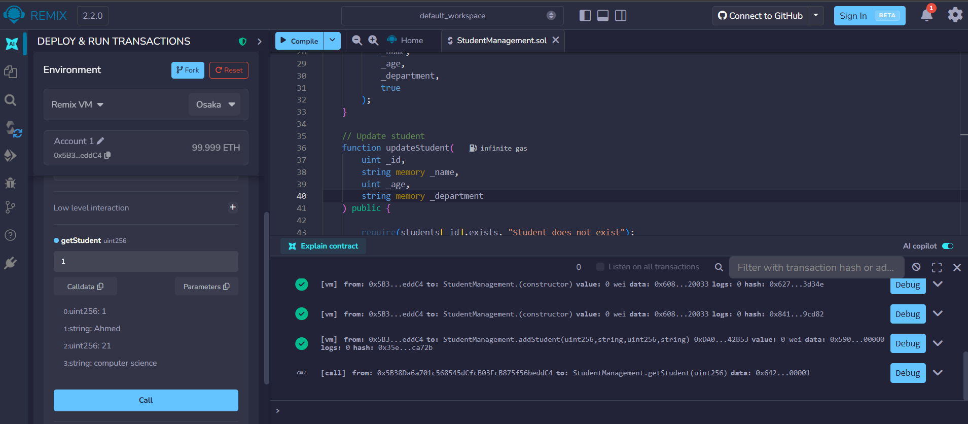

updateStudent success:

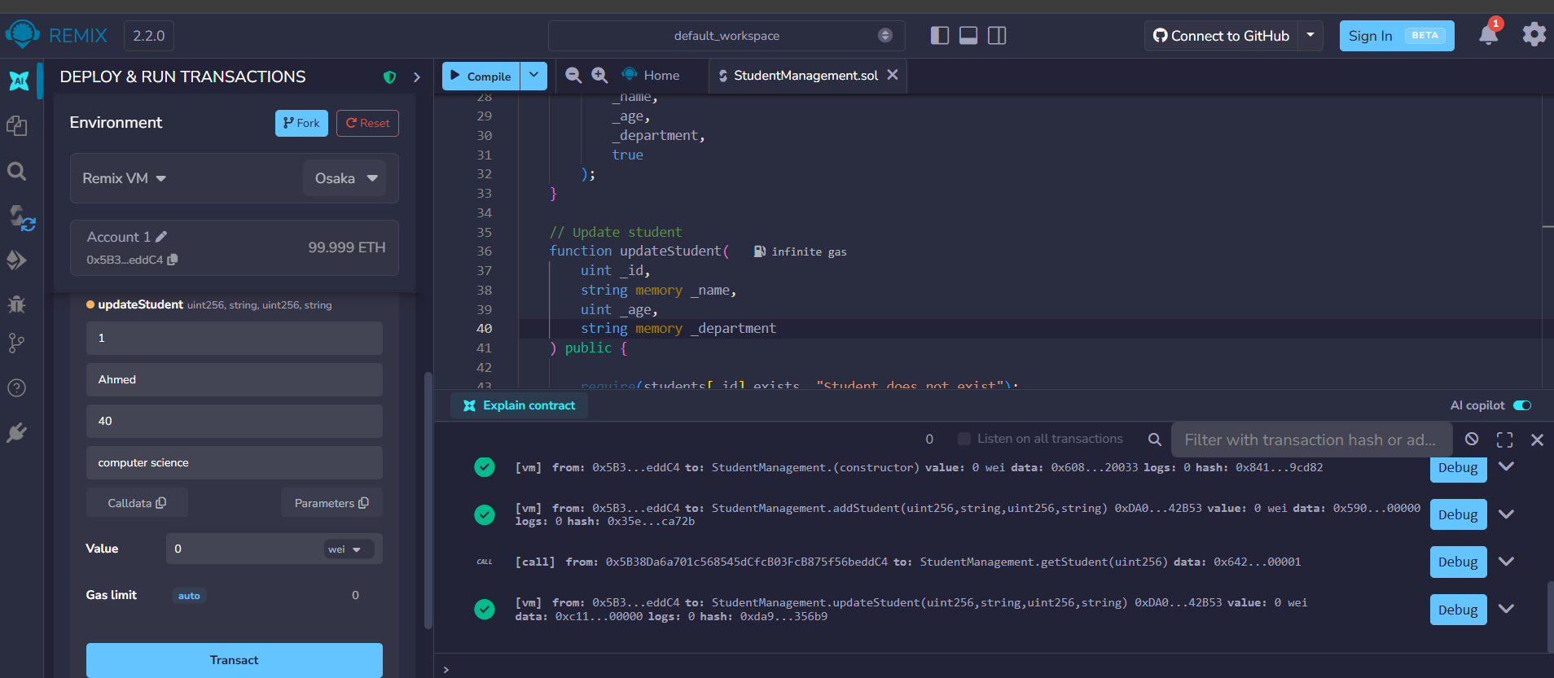

getStudent output:

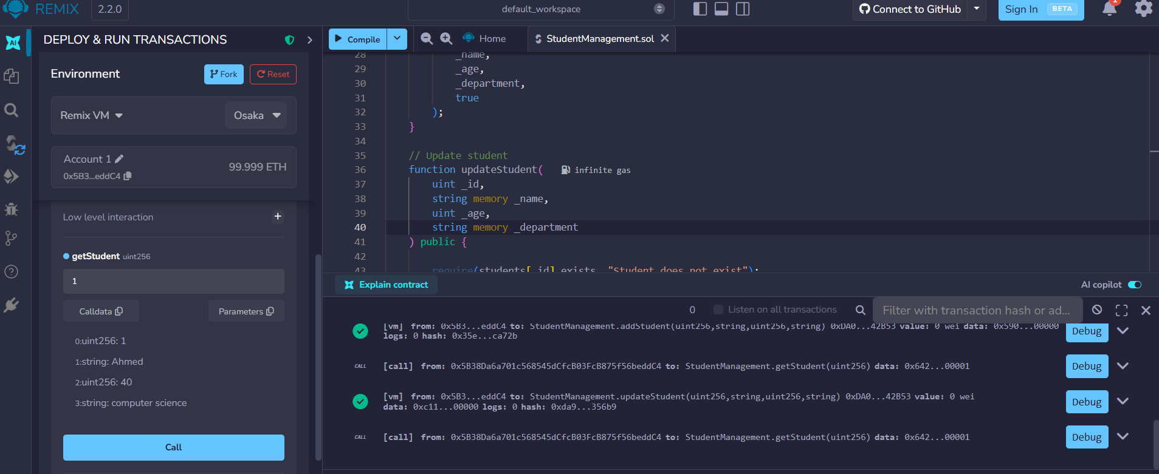

CODE

// SPDX-License-Identifier: MIT
pragma solidity ^0.8.0;

contract StudentManagement {

struct Student {
uint id;
string name;
uint age;
string department;
bool exists;
}

mapping(uint => Student) public students;

// Add new student
function addStudent(
uint _id,
string memory _name,
uint _age,
string memory _department
) public {

require(!students[_id].exists, "Student already exists");

students[_id] = Student(
_id,
_name,
_age,
_department,
true
);
}

// Update student
function updateStudent(
uint _id,
string memory _name,
uint _age,
string memory _department
) public {

require(students[_id].exists, "Student does not exist");

students[_id].name = _name;
students[_id].age = _age;
students[_id].department = _department;
}

// Retrieve student data
function getStudent(uint _id)
public
view
returns (
uint,
string memory,
uint,
string memory
)
{
require(students[_id].exists, "Student does not exist");

Student memory s = students[_id];

return (
s.id,
s.name,
s.age,
s.department
);
}
}

