AI-Assisted Diagnostics / TeethhXraiAi

Using Deep Learning model to detect caries, pathology from x-rays; enhancing image analysis. Helps speed up diagnosis, reduce oversight.
Dentists face the daily challenge of identifying early signs of dental disease from X-rays—tiny caries, periapical lesions, or impacted teeth that are easy to miss when reviewing dozens of images under time pressure. TeethXrayAI brings the power of artificial intelligence directly into the dental workflow, offering dentists an extra set of eyes that never tire and can spot subtle patterns with high consistency.
Built on modern deep learning (YOLOv8) and trained on specialized dental datasets, the system can automatically highlight areas of concern such as cavities, deep caries, impacted teeth, and periapical lesions. This helps dentists:
Save time by reducing manual effort in scanning every detail of each X-ray.
Increase accuracy through AI-assisted detection, minimizing missed diagnoses.
Improve patient communication by visually showing patients the highlighted problem areas.
Support clinical decisions by acting as a second opinion, especially in complex or ambiguous cases.

Model result on unseen data:
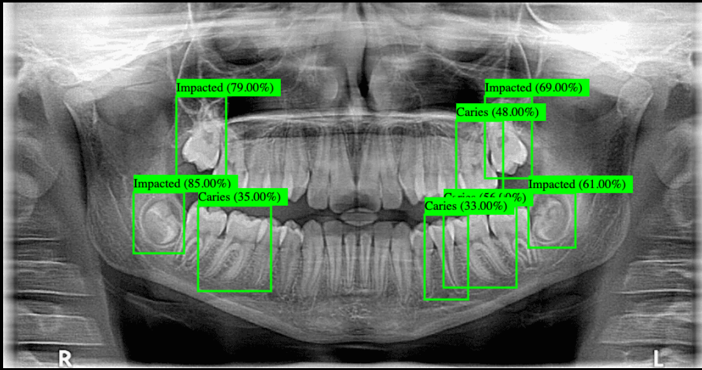
Some of the technical result
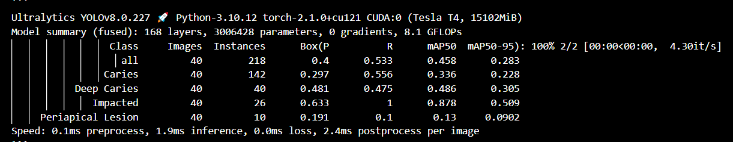
The model can detect “Caries”, “Deep Caries”, “Impacted”, “Periapical Lesion”

The model is implemented in a website so nontechnical can use it easily (simple UI) can be enhanced if needed
You just click on choose file and add your x ray image and it gives you instant processing of speed 0.3ms of the diagnosis
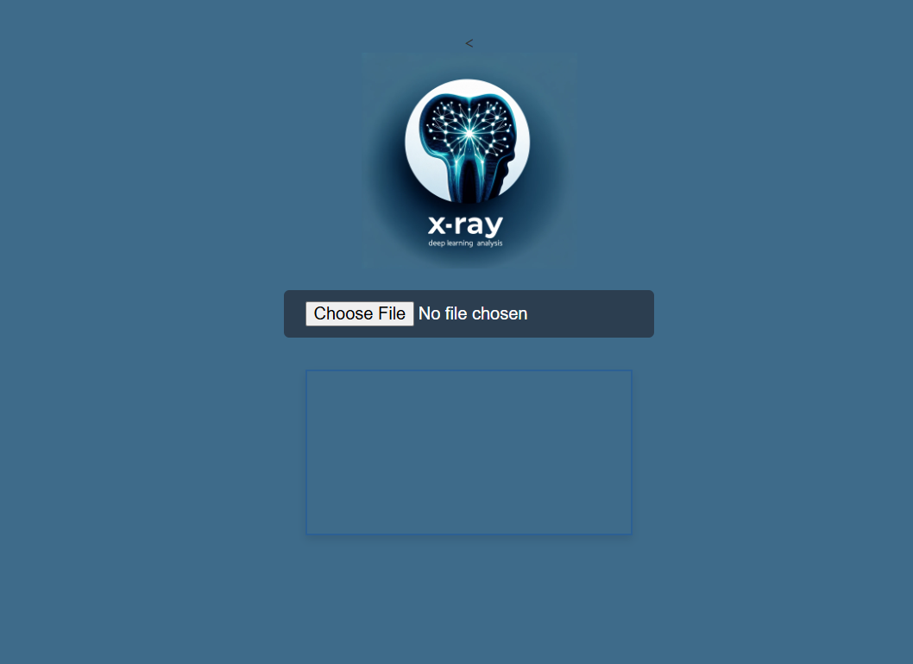
Finally, the project is just designed to make dentists work easier, fast and efficient

