**Name: Ahmed Hossam Kamal Hafez**

**B.N: 45**

**Topic: Artificial Intelligence**

**Github link:**

**Github pages:**

**Application brief**

* Artificial intelligence is the science which makes it possible machines to learn from the experience and to perform tasks like human. Artificial intelligence is mostly concerned to make machines and computer smart and able to think
* The most common explain in our life for artificial intelligence is self-driving cars

**Artificial intelligence has much application in many fields:-**

a) Power electronics

Power electronics converters which transmit system these converters are prone to failure and research use artificial intelligence to do the automated design process for reliable power electronic converter by calculating exact design parameters

b) Heavy industry

Robots are common in many industries and they are doing jobs which is considered dangerous to human and they prove their ability in this and they did less mistakes than human

c) Space exploration

Space expedition and discoveries always require analyzing huge data and artificial intelligence and machine learning is the best way to handle this information.

Astronomers use artificial intelligence to saft through years of data obtained by different telescopes

Artificial intelligence is used also in **NASA**.

**Types of artificial intelligence:-**

1) Reactive machines

2) Limited memory

3) Theory of mind

4) Self-awareness

5) Artificial narrow intelligence

6) Artificial general intelligence

7) Artificial super intelligence

**Screen Shots:-**

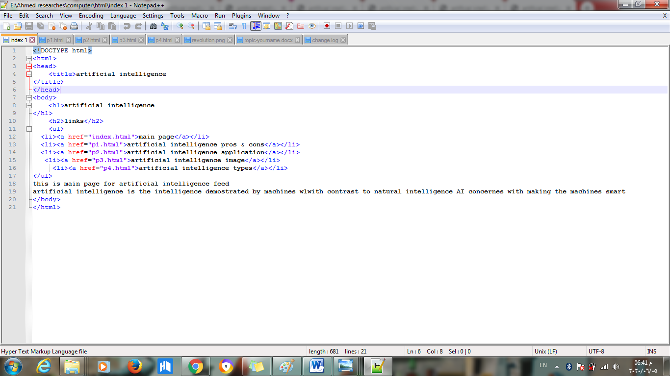

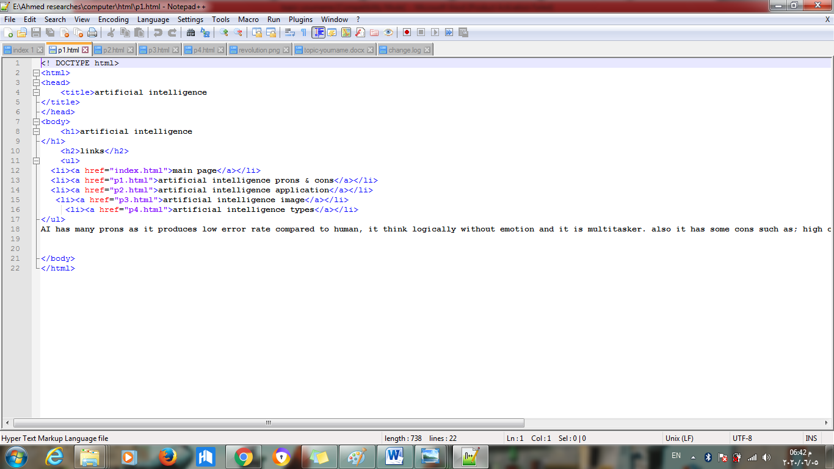

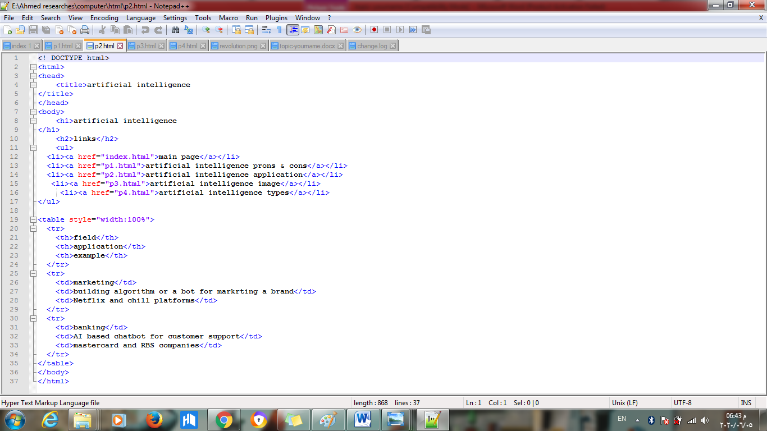

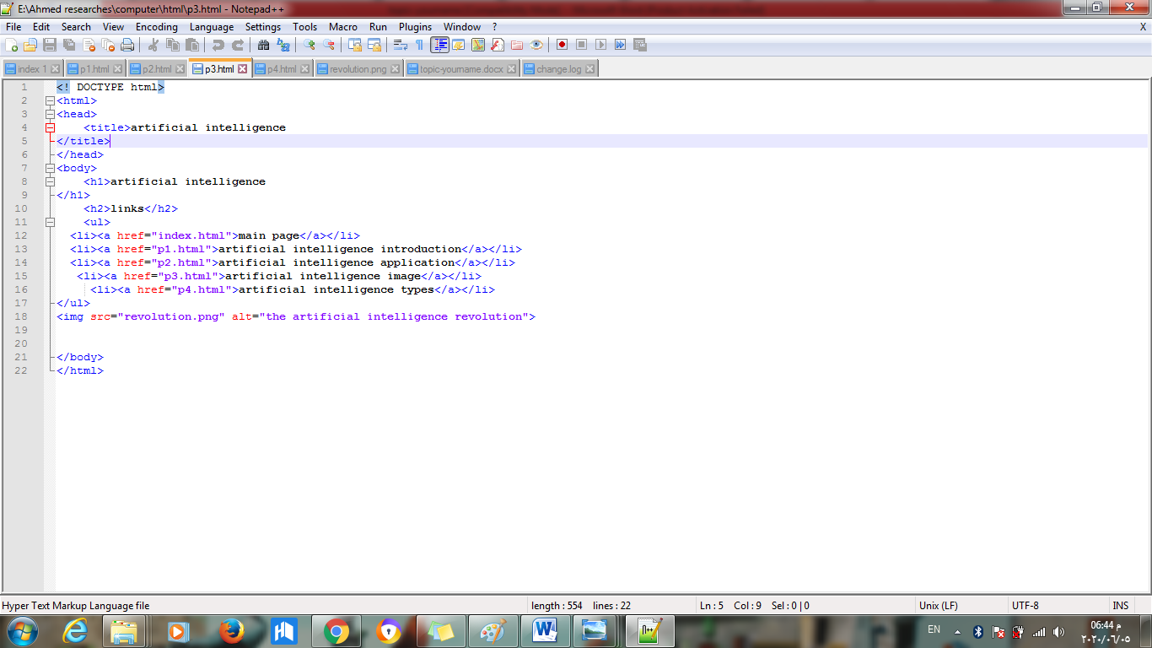

\

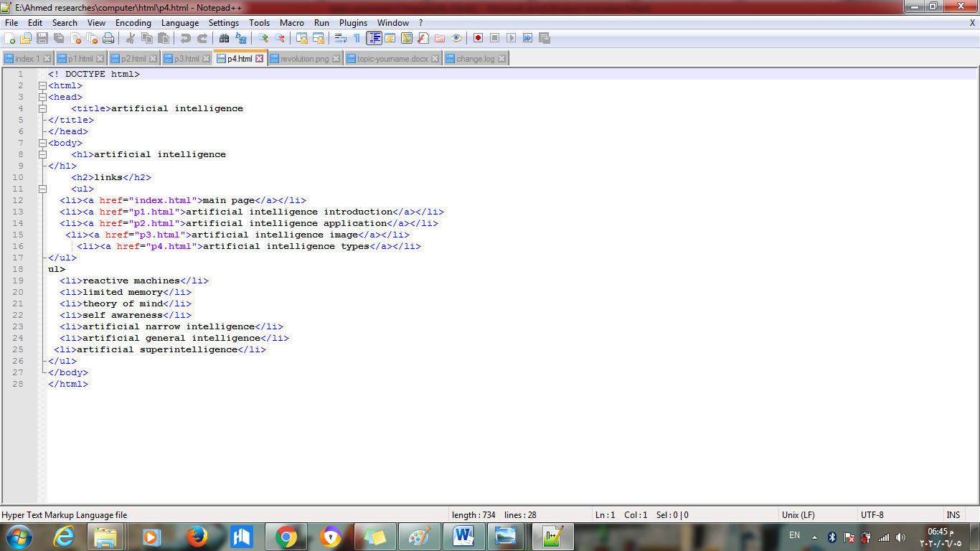

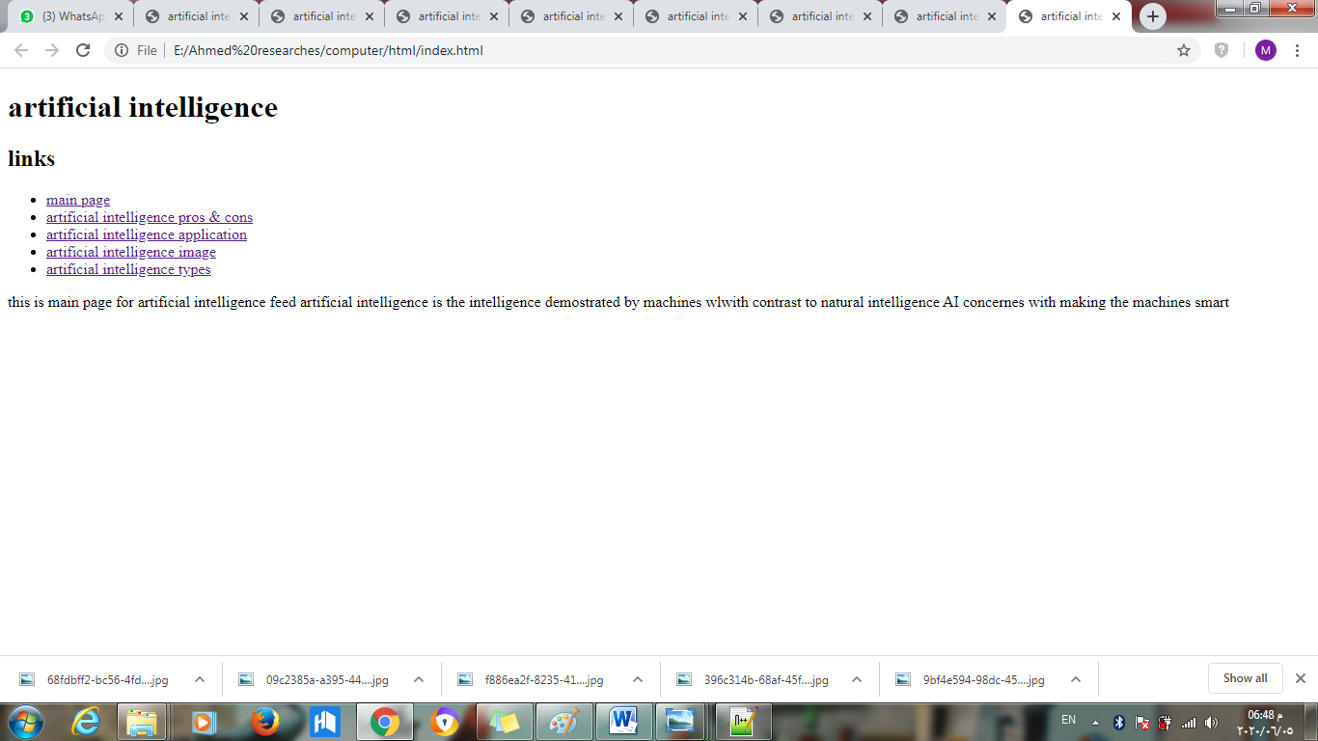

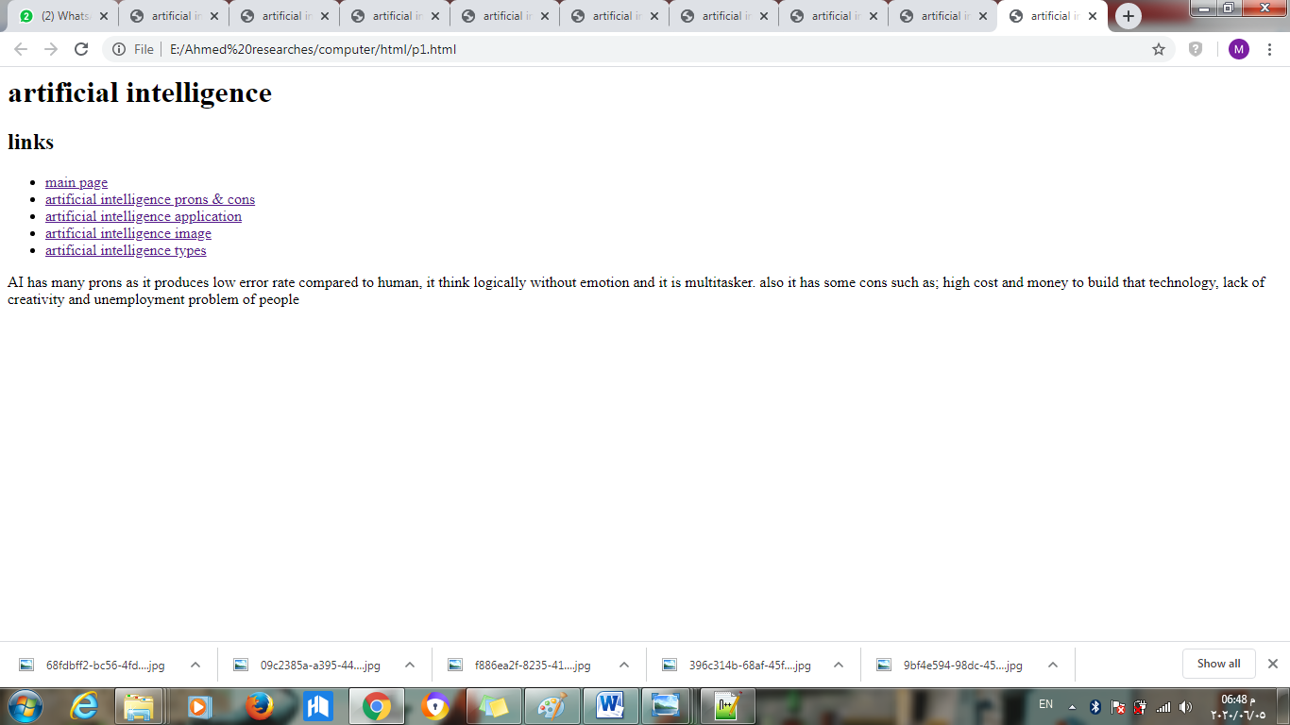

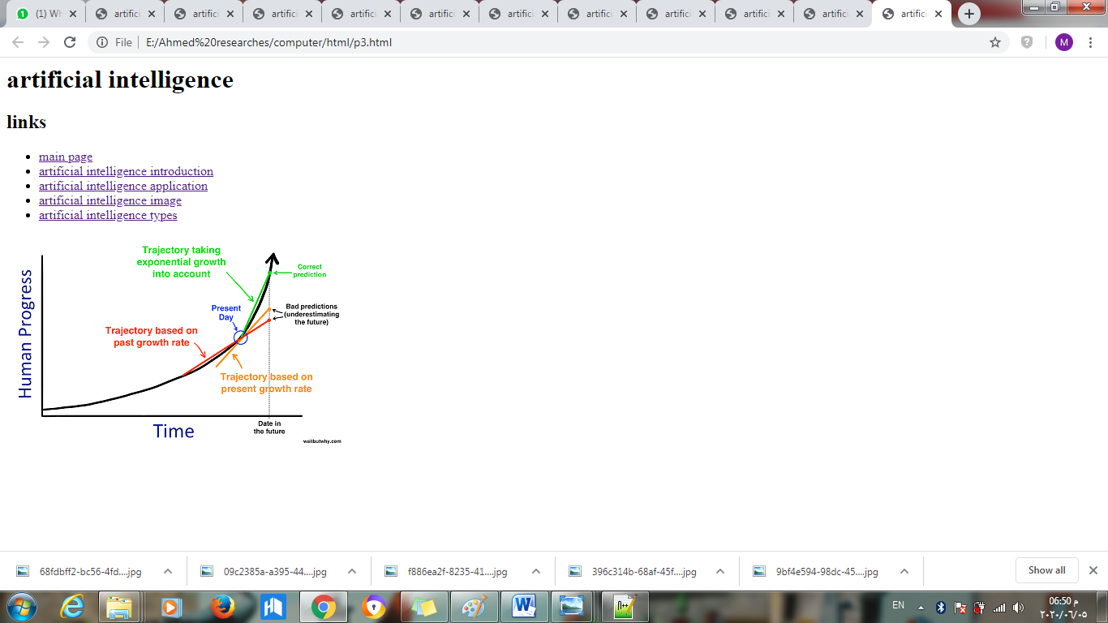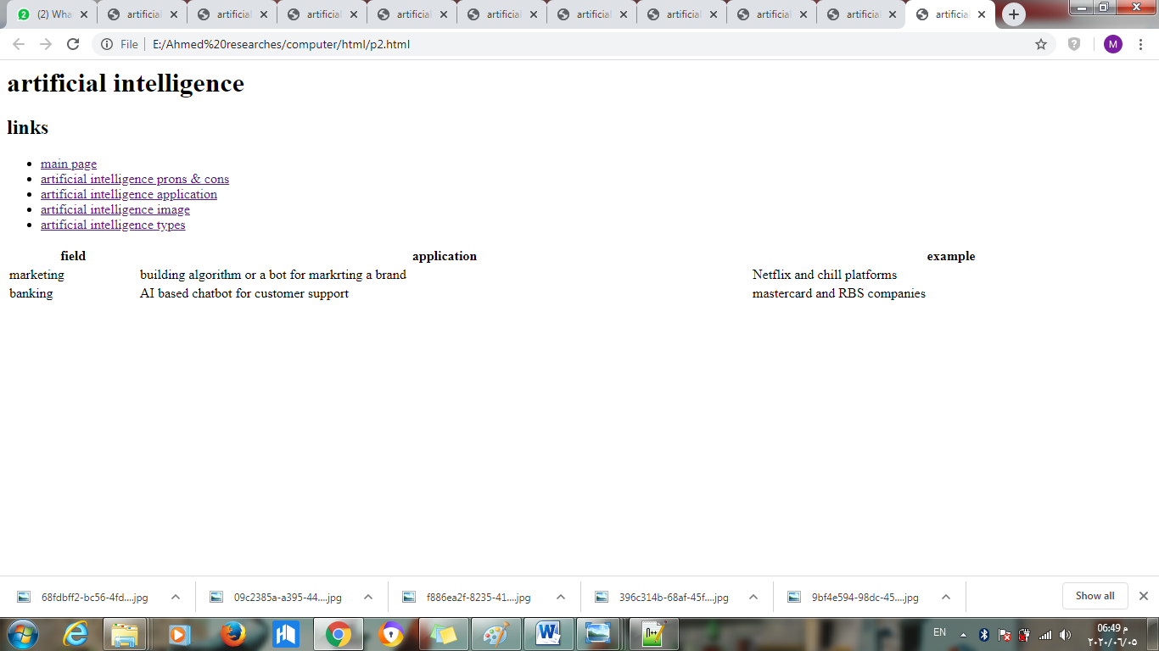

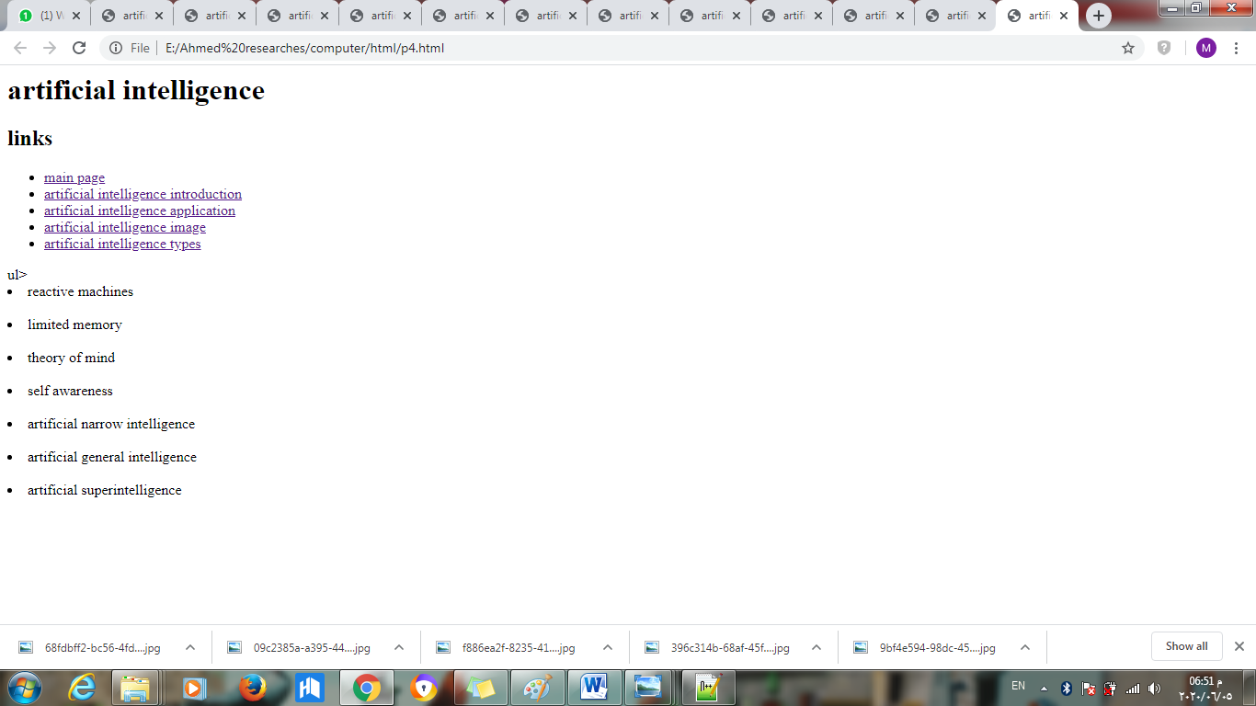

**References**

1. Bourbakis, N. G. (1992). Artificial intelligence methods and applications (Vol. 1). World Scientific.
2. Koutsojannis, C., & Sirmakessis, S. (Eds.). (2008). Tools and applications with artificial intelligence (Vol. 166). Springer.
3. Bundy, A. (2017). Preparing for the future of Artificial Intelligence.‏‏‏