### Prompt 1: initial setup and page suggestions
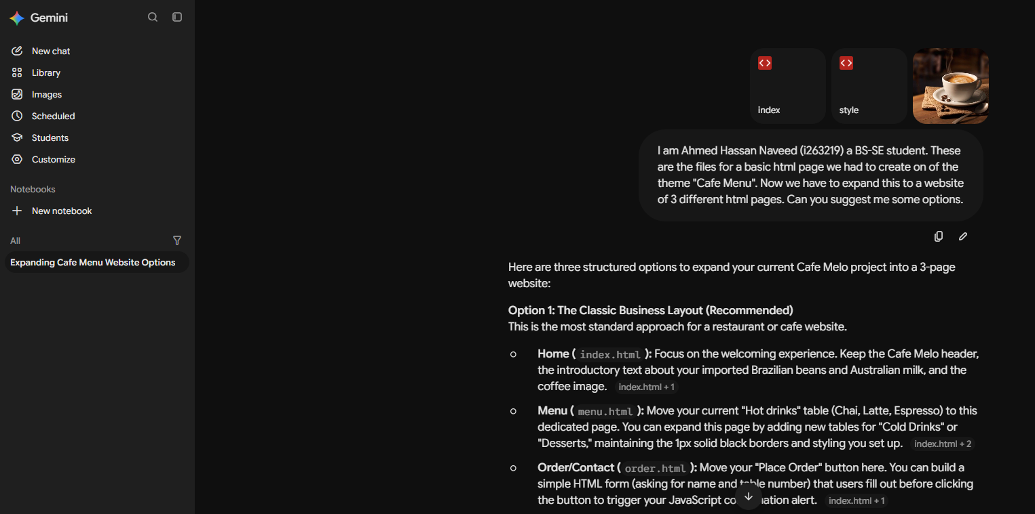
Prompt: I am Ahmed Hassan Naveed (i263219) a BS-SE student. These are the files for a basic html page we had to create on the theme "Cafe Menu". Now we have to expand this to a website of 3 different html pages. Can you suggest me some options.
Result: gave me some page suggestions

###Prompt 2: The home page
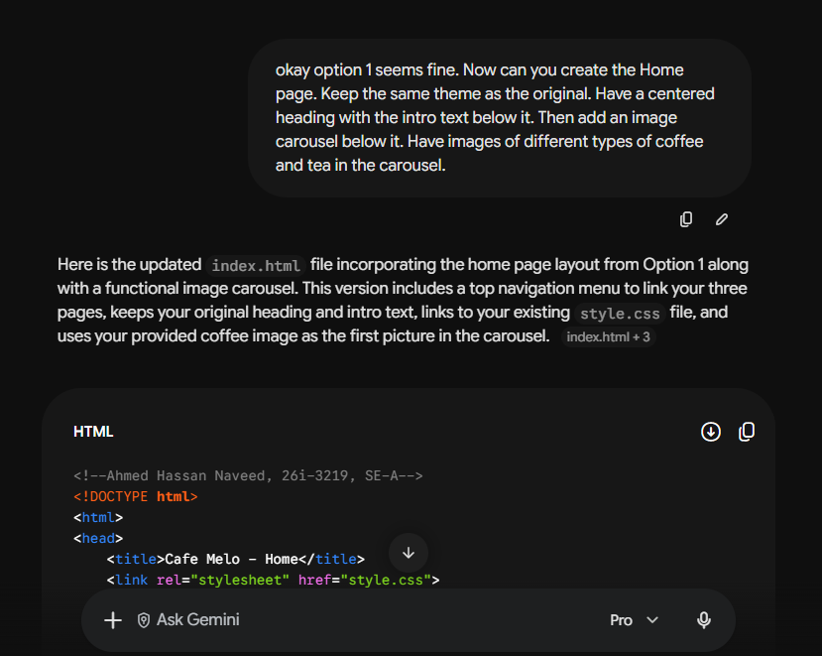
Prompt: okay option 1 seems fine. Now can you create the Home page. Keep the same theme as the original. Have a centered heading with the intro text below it. Then add an image carousel below it. Have images of different types of coffee and tea in the carousel.
Result: Generated the index.html file but used internal css to had to fix that

###Prompt 3: internal CSS fix
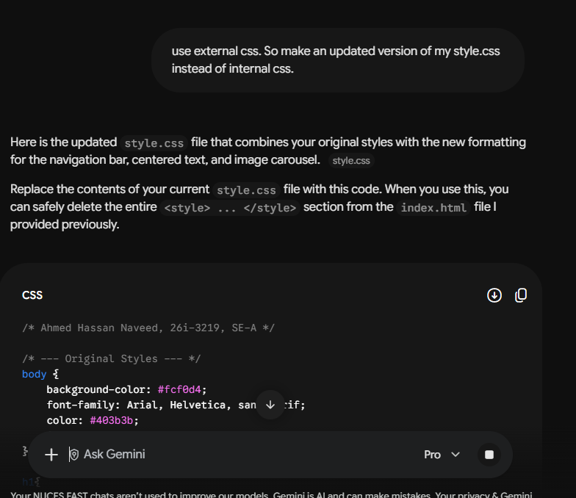
Prompt: use external css. So make an updated version of my style.css instead of internal css.
Result: new style.css generated.

##Prompt 4: image generation
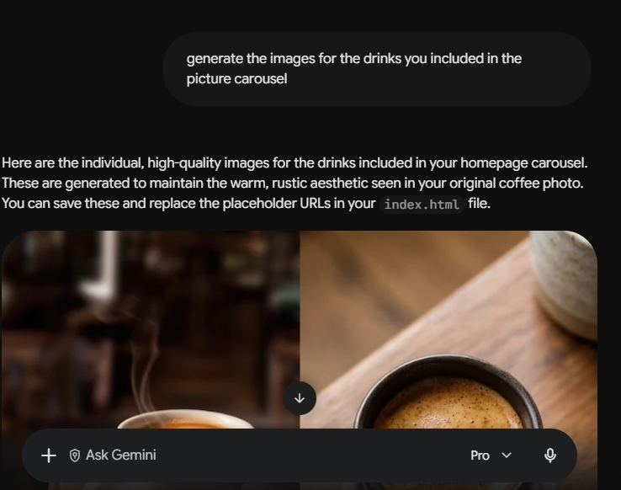
Prompt: generate the images for the drinks you included in the picture carousel
Result: images generated. But had to manually crop them

##Prompt 5: Menu page
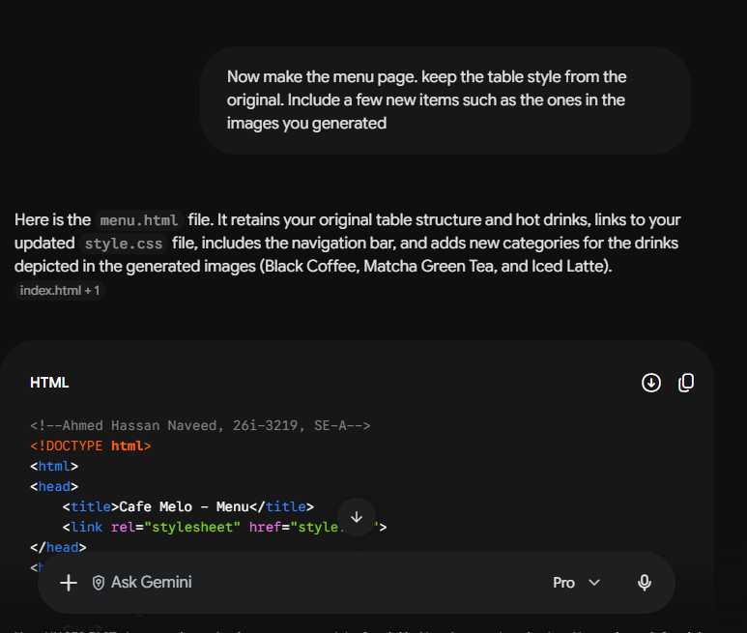
Prompt: Now make the menu page. keep the table style from the original. Include a few new items such as the ones in the images you generated
Result: menu page created correctly

##Prompt 5: contact us page
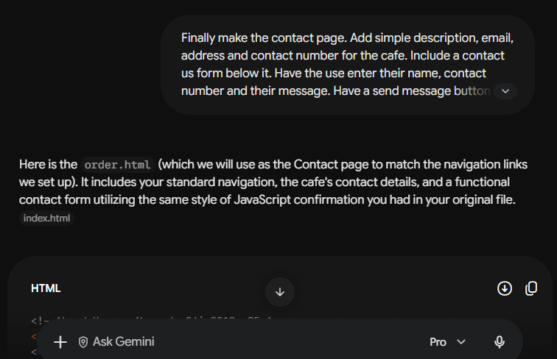

Prompt: Finally make the contact page. Add simple description, email, address and contact number for the cafe. Include a contact us form below it. Have the use enter their name, contact number and their message. Have a send message button below it which will utilize a javascript function to show a confirmation message using window alert and also add a console log
Result: contact page made with correct functionality.

