BRACT's
Vishwakarma Institute of Technology, Pune
Practical Implementation Sheet
Department: CSE-AI Semester: 5 Academic Year: 2026-27
Division: E Batch: 3 Practical No: 3
Roll no: 59 PRN No: 12413301 Name of Student: Shaikh Ahmed

Subject Name : Deep Learning
Problem Statement: Implement forward propagation and backpropagation using PyTorch. Analyze the effect of different learning rates and epochs on a Deep Neural Network classifying the CIFAR-10 dataset.
1. Course Objectives & Relevance
1. Build a deep feedforward network for RGB images.
2. Understand and compute backpropagation gradients.
3. Compare multiple learning rates (0.01, 0.001, 0.0001).
2. Theoretical Foundations & Mathematical Formulations
Backpropagation computes gradients using the chain rule across network layers. Gradient Descent then updates parameters: theta_new = theta_old - learning_rate * (dL/dtheta).
3. Algorithm / Step-by-Step Execution Plan
1. Load CIFAR-10 RGB dataset.
2. Define a 3-layer Deep Neural Network.
3. Initialize multiple models to train at different learning rates.
4. Record loss curves across epochs to analyze convergence speed.
4. Model Architecture & Visualizations
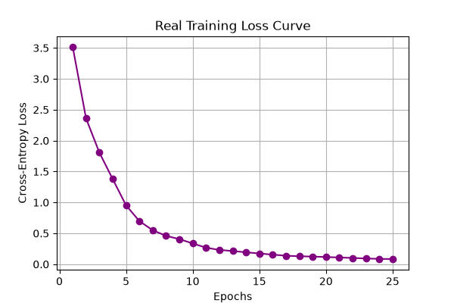
cifar10_real_loss_curve.png
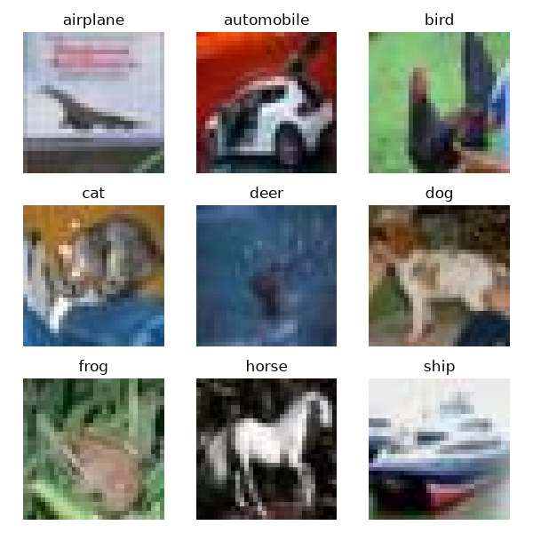
cifar10_real_samples.png
5. Conclusions & Summary
Learning rate significantly impacts training. Too high causes instability, while too low causes slow convergence. An optimal LR allows smooth minimization of the loss function.

