BRACT's
Vishwakarma Institute of Technology, Pune
Practical Implementation Sheet
Department: CSE-AI Semester: 5 Academic Year: 2026-27
Division: E Batch: 3 Practical No: 4
Roll no: 59 PRN No: 12413301 Name of Student: Shaikh Ahmed

Subject Name : Deep Learning
Problem Statement: Develop an LSTM-based model for time-series forecasting using historical Apple (AAPL) stock price data.
1. Course Objectives & Relevance
1. Understand Recurrent Neural Networks (RNN) and temporal sequences.
2. Implement LSTM gates to prevent vanishing gradients.
3. Forecast future continuous values based on historical time steps.
2. Theoretical Foundations & Mathematical Formulations
Long Short-Term Memory (LSTM) cells use Forget, Input, and Output gates to regulate information flow. This architecture preserves long-term dependencies in time-series data.
3. Algorithm / Step-by-Step Execution Plan
1. Load AAPL historical stock prices.
2. Scale numerical data to [0,1] for network stability.
3. Create rolling sequences of 60 days.
4. Define PyTorch LSTM regression model.
5. Train and overlay predictions on actual historical charts.
4. Model Architecture & Visualizations
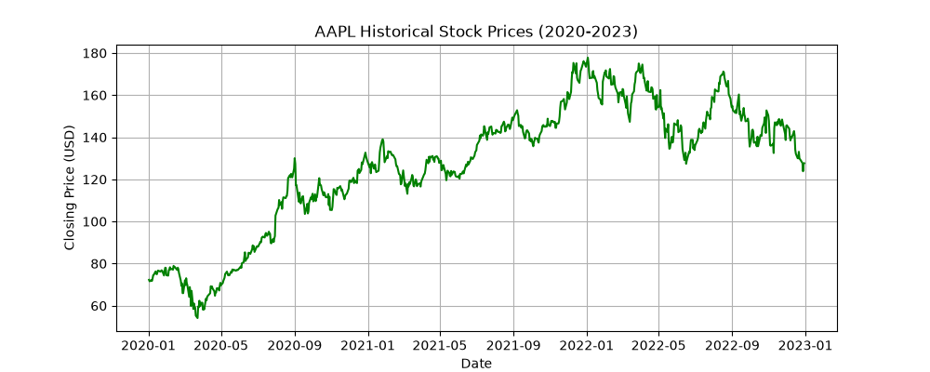
aapl_historical.png
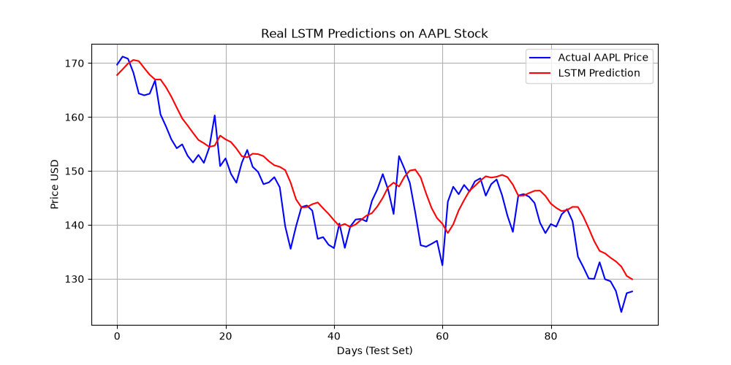
lstm_real_predictions.png
5. Conclusions & Summary
LSTMs successfully capture temporal dependencies and trends in time-series data, making them highly suitable for financial forecasting compared to standard feedforward networks.

