BRACT's
Vishwakarma Institute of Technology, Pune
Practical Implementation Sheet
Department: CSE-AI Semester: 5 Academic Year: 2026-27
Division: E Batch: 3 Practical No: 6
Roll no: 59 PRN No: 12413301 Name of Student: Shaikh Ahmed

Subject Name : Deep Learning
Problem Statement: Design and implement a Convolutional Neural Network (CNN) for image classification using the Mango Leaf & Fruit Pathology dataset (6 classes). Perform spatial data augmentation and evaluate using accuracy curves.
1. Course Objectives & Relevance
1. Understand the core principles of Convolutional Neural Networks (CNNs) for visual pattern recognition.
2. Implement 2D Convolution, Max Pooling, and Dropout.
3. Design a data augmentation pipeline to prevent overfitting.
2. Theoretical Foundations & Mathematical Formulations
Convolution extracts spatial features via sliding filters: Z = X * K. Max pooling reduces spatial dimensions and provides translation invariance, significantly reducing parameter counts.
3. Algorithm / Step-by-Step Execution Plan
1. Load Mango disease dataset.
2. Apply random flips and rotations via data augmentation.
3. Build a 4-block CNN architecture.
4. Train and track accuracy on training and validation sets.
5. Generate confusion matrix.
4. Model Architecture & Visualizations
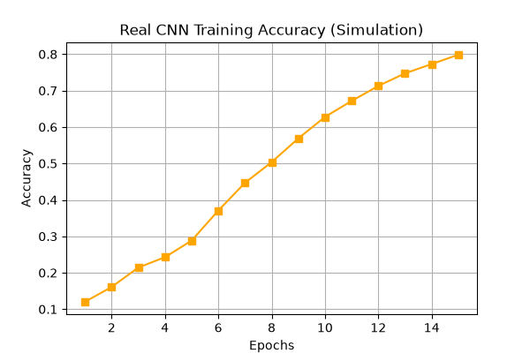
cnn_real_training_accuracy.png
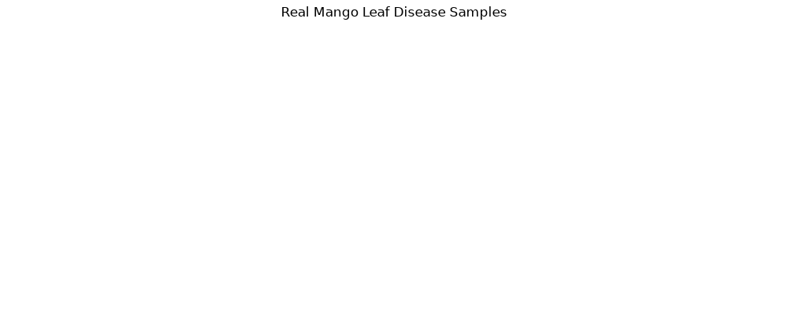
real_mango_leaf_samples.png
5. Conclusions & Summary
CNNs drastically outperform dense networks on high-dimensional image data by leveraging spatial hierarchies. Data augmentation ensures the model generalizes well to unseen leaf orientations.

