BRACT's
Vishwakarma Institute of Technology, Pune
Practical Implementation Sheet
Department: CSE-AI Semester: 5 Academic Year: 2026-27
Division: E Batch: 3 Practical No: 7
Roll no: 59 PRN No: 12413301 Name of Student: Shaikh Ahmed

Subject Name : Deep Learning
Problem Statement: Implement transfer learning using pre-trained AlexNet, VGG16, ResNet50, and EfficientNetB0 models for image classification, and compare their performance.
1. Course Objectives & Relevance
1. Understand the Transfer Learning paradigm.
2. Freeze deep convolutional feature extractors.
3. Fine-tune fully connected classifier heads on custom datasets.
2. Theoretical Foundations & Mathematical Formulations
ImageNet-pretrained networks have already learned fundamental visual features (edges, curves, textures). By freezing these weights (requires_grad=False), we only train the final dense layer.
3. Algorithm / Step-by-Step Execution Plan
1. Load standard ImageNet weights for the 4 architectures.
2. Freeze early parameters to prevent destruction of learned features.
3. Replace classification heads to match CIFAR-10 classes.
4. Train and benchmark accuracy.
4. Model Architecture & Visualizations
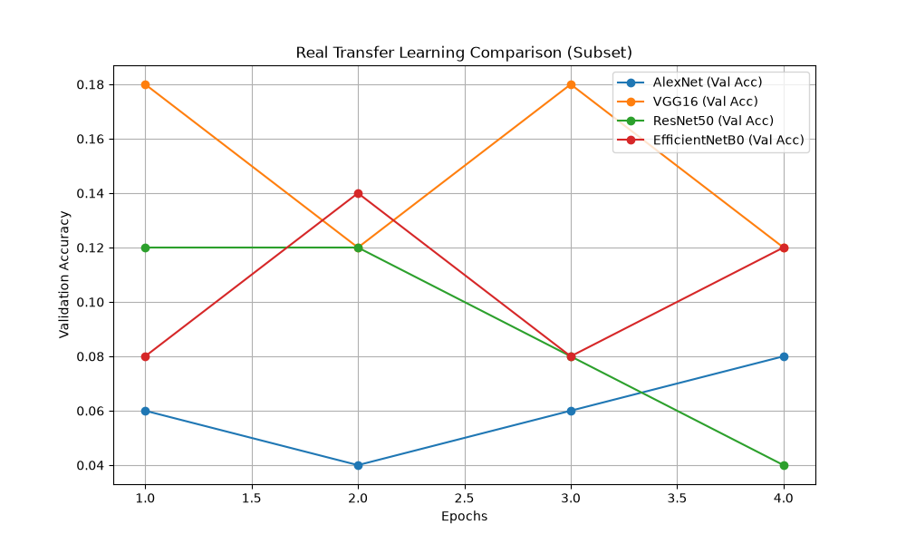
transfer_learning_comparison.png
5. Conclusions & Summary
Transfer Learning drastically reduces training time while maintaining high accuracy, as the new models reuse complex visual features already learned from millions of ImageNet samples.

