BUILD & DEPLOYMENT GUIDE
ArcGIS Web MCP
A remote MCP server for ArcGIS Online and ArcGIS Enterprise on Cloudflare Workers
How it was built, tested, deployed and connected — from the first line of code to a live server
Version 0.2.0 · October 2026
Live server: arcgis.web-mcp.workers.dev

DEVELOPED BY
Ahmed Salah Muhammed
Full Stack Developer · GIS Developer
ahmedsalah-portfolio.vercel.app

Contents
1. Introduction 4
1.1 What ArcGIS Web MCP is 4
1.2 Why a web version 4
1.3 At a glance 4
2. Architecture 5
2.1 Components 5
2.2 The sign-in flow 5
2.3 Tokens and where they live 7
3. Technology stack 8
4. Project structure 8
5. How it was built 10
5.1 Step 1: start from Cloudflare's remote MCP template 10
5.2 Step 2: register an ArcGIS OAuth 2.0 app 10
5.3 Step 3: sign in with ArcGIS (OAuth 2.0 + PKCE) 10
5.4 Step 4: the first tools (read-only, v0.1) 11
5.5 Step 5: write tools (v0.2), verified on ArcGIS Online first 11
5.6 Step 6: safety rails 11
5.7 Step 7: pages, branding and the server's identity 12
6. Tools reference 13
6.1 Things to ask 13
7. Running and testing locally 14
7.1 Prerequisites 14
7.2 Configure 14
7.3 Run the server 14
7.4 Automated tests 14
7.5 Try it by hand 14
7.6 Live end-to-end test 15
8. Deploying to Cloudflare 16
8.1 Log in to Cloudflare 16
8.2 Choose the URL 16
8.3 Prepare the secrets 16
8.4 Deploy 16
8.5 Register the production redirect URL 17
8.6 Verify the deployment 17
8.7 Updates, logs and rollback 17
8.8 Starting over 17
9. Connecting MCP clients 18
9.1 Claude (desktop and web) 18
9.2 Claude Code 18
9.3 VS Code, Cursor and other clients 18
9.4 What users see 18
10. Security model 20
11. Limits and quotas 20
12. Troubleshooting 21
13. Customizing 22
13.1 Developer credit 22
13.2 ArcGIS Enterprise 22
13.3 Running your own copy 22
14. Next steps 22
Appendix A. Command cheat sheet 23
Appendix B. Configuration reference 23
Appendix C. ArcGIS REST endpoints used 24
Appendix D. Glossary 25

1. Introduction

1.1 What ArcGIS Web MCP is
ArcGIS Web MCP is a remote Model Context Protocol (MCP) server for ArcGIS Online and ArcGIS Enterprise. It runs on Cloudflare Workers, so anyone can add it to Claude, Claude Code, VS Code, Cursor or any other MCP client with one HTTPS link. There is nothing to install.
Every user signs in with their own ArcGIS account through OAuth 2.0 with PKCE. The server has no shared account and never sees a password: each tool runs with the signed-in user's own permissions, so it can do exactly what that user could do in ArcGIS, and nothing more.
Version 0.2.0 has 12 tools: searching and reading content, publishing hosted feature layers, editing data and schemas, building web maps, managing folders, groups and sharing, plus a raw REST tool for everything else. Anything irreversible, bulk, public or credit-spending asks the user to confirm first.

1.2 Why a web version
It is the web companion of ArcGIS Pro Salah MCP, a local Python MCP server that drives ArcGIS Pro (ArcPy), the open Pro session (a .NET add-in), ArcGIS Online (the ArcGIS API for Python) and generates web apps. That server needs a Windows machine with ArcGIS Pro, so it cannot be hosted for other people.
ArcGIS Web MCP re-implements the portal tools over plain ArcGIS REST and keeps the same tool names, arguments and {"ok": ..., "data": ...} results, so prompts and habits carry over from one to the other.

1.3 At a glance
Item | Value
Live server | https://arcgis.web-mcp.workers.dev (home page)  https://arcgis.web-mcp.workers.dev/mcp (MCP endpoint)
Transport | Streamable HTTP
Sign-in | OAuth for MCP clients (dynamic client registration, PKCE S256)  ArcGIS OAuth 2.0 + PKCE as a public client (no client secret)
Hosting | Cloudflare Workers, free plan, with one KV namespace
Portals | ArcGIS Online by default; ArcGIS Enterprise with one setting
Tools | 12 tools, all named portal_*
Clients | Claude (desktop and web), Claude Code, VS Code, Cursor, MCP Inspector, and any client with Streamable HTTP and OAuth
Quality | 57 unit tests; 53 live checks against ArcGIS Online
Developer | Ahmed Salah Muhammed, Full Stack Developer · GIS Developer

2. Architecture

2.1 Components
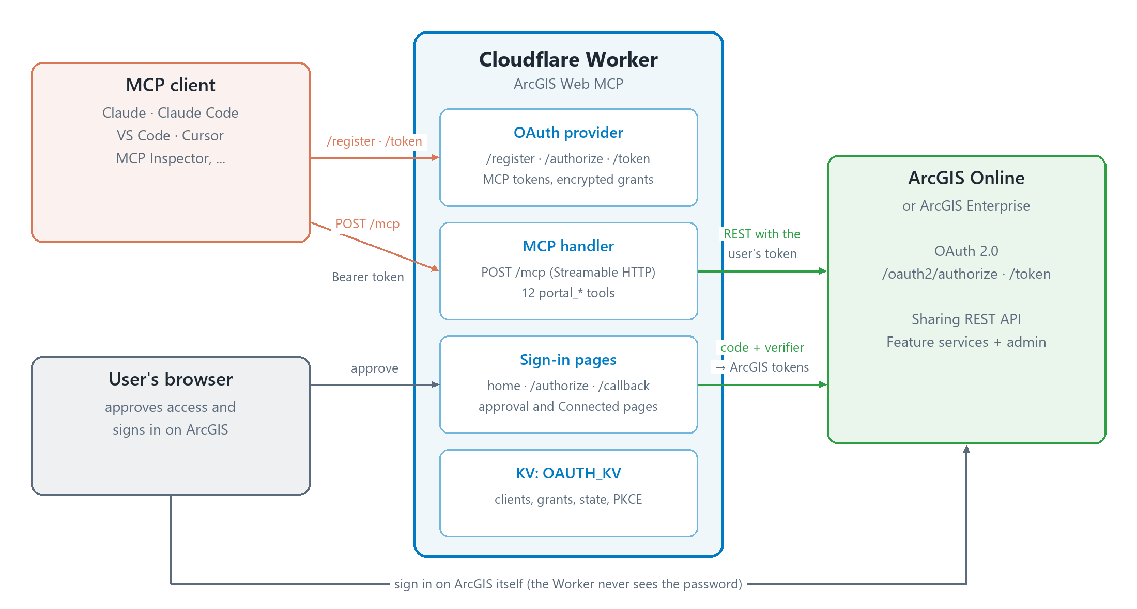
Figure 1 — Components and how they talk to each other
- MCP client (Claude, Claude Code, VS Code, Cursor, ...): finds the sign-in endpoints from the server, registers itself, opens the browser so the user can sign in, then calls /mcp with a Bearer token.
- Cloudflare Worker: one TypeScript Worker with four parts:
  - OAuth provider (@cloudflare/workers-oauth-provider): /register, /authorize and /token. It issues MCP tokens and keeps each user's grant, with the ArcGIS tokens encrypted inside it.
  - MCP handler (createMcpHandler from agents): serves MCP over Streamable HTTP on /mcp and registers the 12 tools for the signed-in user.
  - Sign-in pages (Hono): the home page, the approval page, the redirect to ArcGIS, /callback and the "Connected" page.
  - KV namespace OAUTH_KV: registered clients, grants, the short-lived sign-in state and the PKCE verifiers.
- ArcGIS Online or Enterprise: the OAuth 2.0 endpoints for the sign-in, the Sharing REST API for content, users and groups, and the feature services (and their admin endpoints) for data and schemas.

2.2 The sign-in flow
MCP clients sign in with OAuth. The Worker is the OAuth server for the client and, at the same time, an OAuth client of ArcGIS: the user approves the client on the Worker's page, then signs in on ArcGIS itself.
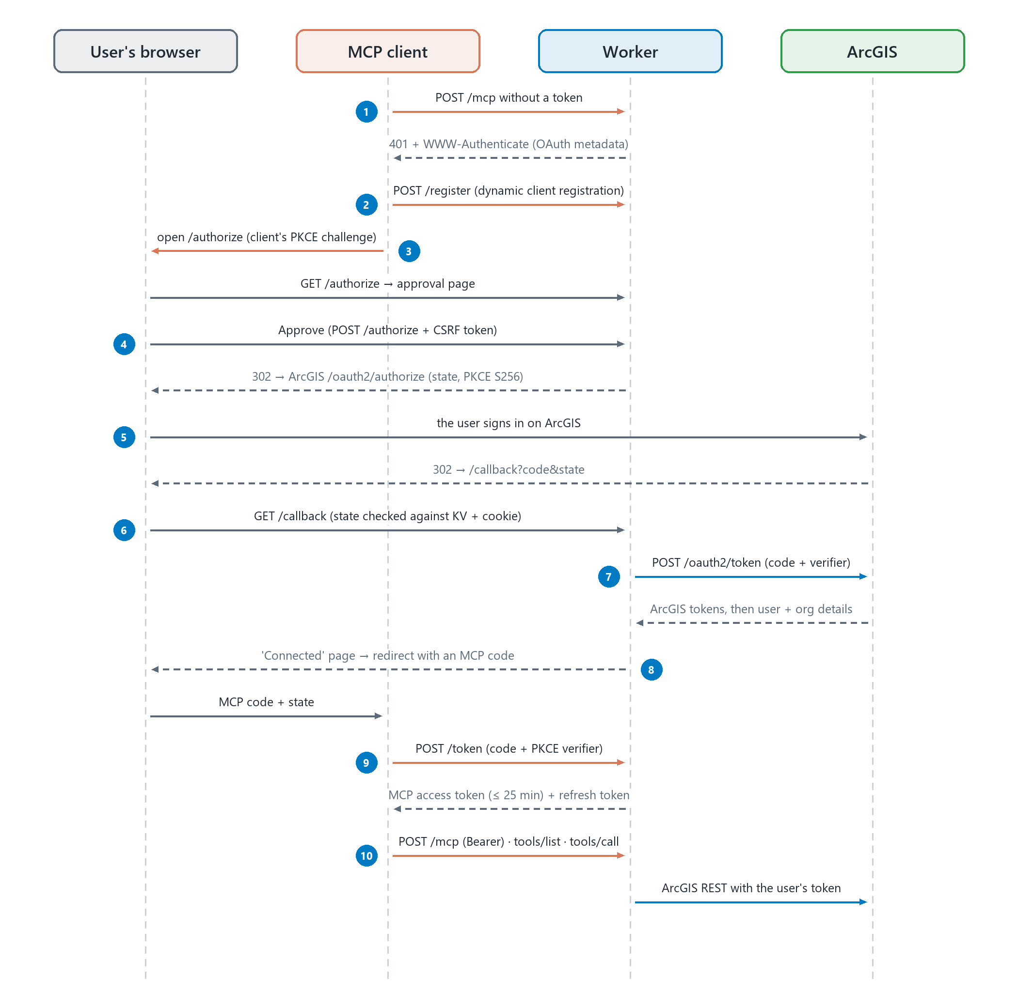
Figure 2 — Signing in from an MCP client (the numbers match the steps below)
- The client calls /mcp without a token and gets 401 with a WWW-Authenticate header that points to the OAuth metadata.
- The client registers itself at /register (dynamic client registration).
- The client opens /authorize in the user's browser with its own PKCE challenge; the Worker shows the approval page.
- The user clicks Approve (the form carries a CSRF token). The Worker stores the request in KV under a random state for 10 minutes, binds that state to the browser with a hashed cookie, keeps a PKCE verifier in KV, and redirects to ArcGIS /oauth2/authorize with code_challenge_method=S256 and expiration=20160 (a two-week refresh token). The approval is remembered for 30 days in a signed cookie.
- The user signs in on ArcGIS itself, and ArcGIS redirects to /callback with a code.
- /callback checks the state against KV and the browser cookie. State and verifier are deleted after use.
- The Worker exchanges the code with the verifier (no client secret), then reads community/self and portals/self for the user and the organization.
- The grant is stored with the ArcGIS tokens in its encrypted properties. The browser shows the "Connected to ArcGIS" page, which returns to the client with an MCP code after 2 seconds.
- The client exchanges that code at /token for an MCP access token (up to 25 minutes) and a refresh token.
- Every tool call is POST /mcp with the Bearer token; the Worker runs the tool with the user's own ArcGIS token.

2.3 Tokens and where they live
Token | Lifetime | Where it lives
ArcGIS access token | About 30 minutes | Encrypted inside the user's grant; never returned to the client and never logged
ArcGIS refresh token | Two weeks (expiration=20160 at sign-in) | Encrypted inside the grant; used by the Worker to renew the access token
MCP access token | Up to 25 minutes, always shorter than the ArcGIS token | Held by the MCP client and sent as Authorization: Bearer to /mcp
MCP refresh token | Until the ArcGIS sign-in expires or is revoked | Held by the MCP client; each refresh also lets the Worker renew the ArcGIS token

When the client refreshes and the ArcGIS token has less than 5 minutes left, tokenExchangeCallback in src/index.ts renews it with the ArcGIS refresh token. If ArcGIS refuses (the sign-in expired or was revoked), the client receives invalid_grant and asks the user to sign in again.

3. Technology stack
Component | Version | Role
Cloudflare Workers | free plan | Runtime: compatibility date 2026-10-19, flags nodejs_compat and global_fetch_strictly_public
Wrangler | 4.152 | CLI for local development, deployment, secrets and logs
TypeScript | 6.0.3 | Language
@cloudflare/workers-oauth-provider | 0.8.3 | OAuth server for MCP clients: registration, authorization, tokens, encrypted grant properties
agents | 0.29 | createMcpHandler and getMcpAuthContext: MCP over Streamable HTTP on /mcp
@modelcontextprotocol/server | 2.3.1 | McpServer and tool registration
Hono | 4.13 | Routes for the home page, /authorize and /callback
zod | 4.6 | Input schemas of the tools
Workers KV |  | OAUTH_KV: clients, grants, sign-in state, PKCE verifiers
Vitest | 3.2 | Unit tests (run in Node, with a fake ArcGIS)
MCP Inspector | 2.12 | Manual testing (development dependency)
Node.js / npm | 24 / 11 | Local tooling

4. Project structure
The project lives in E:\iti-9month\MCP\ArcGIS Web MCP.
File | Purpose
src/index.ts | Entry point: OAuth provider configuration (routes, 25-minute token lifetime), the MCP handler, and the ArcGIS token refresh
src/arcgis-handler.ts | Home page, approval page, redirect to ArcGIS with PKCE, /callback (code exchange, user and org lookup), Connected and error pages
src/arcgis.ts | ArcGIS REST and OAuth helpers: PKCE, authorize URL, token exchange and refresh, requests and uploads, error mapping, host allowlist, token scrubbing
src/portal.ts | Read tools: whoami, search, item, layer query
src/content.ts | Item writes, folders, sharing, publishing
src/layer-writes.ts | Feature edits (applyEdits, calculate, truncate), schema changes, renderers, labels, views
src/maps.ts | Web maps: create, describe, layers, popups, renderers, filters, basemaps
src/groups.ts | Groups: search, get, create, update, delete
src/rest.ts | Raw REST, with the host allowlist and confirmation for writes
src/safety.ts | Confirmation rail, audit lines, limits
src/tools.ts | Registers the 12 MCP tools (names, descriptions, zod schemas, annotations) and the result envelope
src/pages.ts | Developer credit (AUTHOR), MCP server info and instructions, home page, status pages, page security headers
src/avatar.ts | The developer's photo as an inline data URI
src/workers-oauth-utils.ts | From Cloudflare's demo: approval page, CSRF, sign-in state in KV, session and approval cookies
test/*.test.ts | 57 unit tests
wrangler.jsonc | Worker name, entry point, compatibility, KV binding, variables, required secrets, dev port
.dev.vars / .dev.vars.example | Local secrets (gitignored) and their template
worker-configuration.d.ts | Environment types generated by npx wrangler types
README.md | Project overview

5. How it was built
The project was built in small steps, each one tested before the next. This chapter follows that order.

5.1 Step 1: start from Cloudflare's remote MCP template
The Worker started from Cloudflare's official remote MCP server with GitHub OAuth demo (cloudflare/ai, folder demos/remote-mcp-github-oauth). It brings matching versions of the OAuth provider, the agents MCP handler and the MCP SDK, and a consent page with CSRF protection. The GitHub sign-in was then replaced with ArcGIS.
- npm create cloudflare ignored the template argument, so the demo was copied with a git sparse checkout instead.
- @cloudflare/workers-types conflicted with Wrangler's own type version (npm ERESOLVE). It was removed; the types are generated from wrangler.jsonc with npx wrangler types.
One way to fetch only the demo folder:
git clone --depth 1 --filter=blob:none --sparse https://github.com/cloudflare/ai.git
cd ai
git sparse-checkout set demos/remote-mcp-github-oauth

5.2 Step 2: register an ArcGIS OAuth 2.0 app
- In ArcGIS Online, open Content → New item → Developer credentials → OAuth 2.0 credentials (older Enterprise versions: Register application).
- Add the redirect URLs: http://localhost:8788/callback for local development and, after the first deploy, https://<worker>.<subdomain>.workers.dev/callback.
- Copy the Client ID. It is the only value the Worker needs from ArcGIS.
Note: The Worker is a public client and uses PKCE instead of a client secret. The client secret and temporary tokens are not needed; never paste them anywhere, and reset the secret in the item's settings if it was ever shared.

5.3 Step 3: sign in with ArcGIS (OAuth 2.0 + PKCE)
- src/arcgis.ts builds the PKCE pair (S256, checked against the RFC 7636 test vector), the authorize URL (response_type=code, code_challenge_method=S256, expiration=20160) and both token calls, authorization_code with the verifier and refresh_token, without a client secret.
- src/arcgis-handler.ts shows the approval page, keeps the sign-in state in KV for 10 minutes, binds it to the browser with a hashed cookie, stores the PKCE verifier in KV (deleted after use) and redirects to ArcGIS.
- /callback checks the state against KV and the cookie, exchanges the code, reads community/self and portals/self, and saves the user (username, full name, role, organization, portal) and the ArcGIS tokens in the grant.
- src/index.ts limits MCP access tokens to 25 minutes and renews the ArcGIS token when the client refreshes.
Bug found on the first real sign-in: /token answered 400 "Invalid authorization code format". The OAuth provider builds codes as userId:grantId:secret, and the user id contained a colon. grantUserId() now uses username@portal-host with colons replaced, and a unit test covers it.

5.4 Step 4: the first tools (read-only, v0.1)
Four read-only tools were ported from the Python MCP with the same names, arguments and result envelope: portal_whoami, portal_search, portal_item (get, data) and portal_layer_query (describe, query, count, stats). They were tested end to end through a real MCP client: OAuth sign-in in the browser, the four tools on real content, and a token refresh.

5.5 Step 5: write tools (v0.2), verified on ArcGIS Online first
Before any write tool was written in TypeScript, every ArcGIS REST call it needs was tried on ArcGIS Online with throwaway private items named mcp_test_*, deleted afterwards. What that showed shaped the code:
- A CSV added as item text cannot be analyzed or published; it has to be uploaded as a multipart file.
- Publishing returns a job: content/users/<me>/publish gives the new item and a job id, polled at items/<id>/status until it is completed (about 10 seconds for a small CSV).
- Renaming a folder (updateFolder) rejected every parameter tried, so the tool does not offer it.
- A layer that has views cannot be deleted ("has a related Service item"): the views go first.
- Field and capability changes go to the admin URL (/rest/admin/services/...): addToDefinition, deleteFromDefinition and updateDefinition.
- updateDefinition replaces drawingInfo as a whole, so renderers and labels are merged into the current one.
- A filtered view takes three calls: createService with isView, addToDefinition with the source layer, then updateDefinition with viewDefinitionQuery and field visibility.
The result was eight new tools, plus update, move, protect, unprotect, delete and dependencies on portal_item (chapter 6).

5.6 Step 6: safety rails
- Confirmation: irreversible, bulk, public or credit-spending calls return {"ok": false, "code": "confirm_required", "preview": ..., "hint": ...} and change nothing until they are called again with confirm: true. The client shows the preview and asks the user.
- Protected items are refused even with confirm; the user has to unprotect them first.
- Geocoding is confirmed before anything is uploaded, with an estimate of the credits (0.04 per address on ArcGIS Online), so a refusal never leaves an orphan CSV item behind.
- Audit log: every write prints one JSON line ({"audit": {time, user, portal, tool, action, target, ok}}) to the Worker logs, never a token.
- Limits keep each call inside the free plan: at most 1,000 rows per query, 5,000 edits and 30 batches per edit call, and 5 MB of text per publish.
- Host allowlist: the user's token is only sent to the portal, ArcGIS Online's service hosts and ARCGIS_EXTRA_HOSTS; any other URL is refused before a request is made.
- Scrubbing: tokens are removed from every error message.

5.7 Step 7: pages, branding and the server's identity
- Home page (/): what the server is, its /mcp URL with a Copy button, how to connect each client, the tools and the security notes, in light and dark mode.
- Approval page (/authorize): compact, so it fits one screen without scrolling.
- Connected page (/callback): "Connected to ArcGIS, signed in as ...", then back to the client after 2 seconds, with a button as a fallback. It names whichever client is connecting, and Claude gets Claude's orange button. Sign-in errors use the same design.
- Developer credit: "Developed by Ahmed Salah Muhammed, Full Stack Developer · GIS Developer", with photo and portfolio link, on all three pages.
- Server identity: every MCP client receives title, description and websiteUrl in the server info, and instructions that name the developer and explain the confirmation rail.
- Strict pages: no external resources (the photo is an inline data URI), a Content-Security-Policy, no framing, no referrer, and the Connected page is never cached.

6. Tools reference
Every tool returns {"ok": true, "data": ...} or {"ok": false, "error": ..., "code": ...}. Results use item ids, because titles are not unique.
Tool | What it does | Asks to confirm
portal_whoami | The signed-in user: username, role, user type, organization, platform, and what the account can do | —
portal_search | Search items: ArcGIS query syntax, exact item type, owner (me), tags, sorting, paging, other organizations | —
portal_item | get · data · update · move · protect · unprotect · delete · dependencies | delete (protected items are refused)
portal_folders | list · create · delete | delete
portal_share | Sharing level (private, org, everyone) and groups, with before/after per item | everyone (public)
portal_publish | A hosted feature layer from CSV text (coordinates or addresses), GeoJSON text, a public https URL, or an uploaded item | publishing by address (credits)
portal_layer_query | describe · query (paged, dates in ISO UTC) · count · stats | —
portal_layer_edit | edit (adds, updates, deletes, dry-run diff) · calculate · truncate | deletes, calculate, truncate
portal_layer_schema | add_field · delete_field · capabilities · renderer · labels · create_view | delete_field
portal_map | Web maps: create · describe · add_layers · remove_layers · popup · renderer · filter · basemap | —
portal_groups | search · get · create · update · delete | public groups, delete
portal_rest | Any ArcGIS REST path with the user's sign-in (GET, or POST) | POST that is not read-only

6.1 Things to ask
- "Who am I signed in as in ArcGIS?"
- "Find my feature layers about roads."
- "Publish this CSV of cities as a hosted feature layer; the coordinates are in LAT and LON."
- "Add a STATUS text field and set it to Done where POP is over 40."
- "Create a web map with this layer on the gray basemap, with popups for NAME and POP."
- "Share the layer with my Field team group."

7. Running and testing locally

7.1 Prerequisites
- Node.js 24 and npm.
- An ArcGIS Online (or Enterprise) account.
- OAuth 2.0 credentials with the redirect URL http://localhost:8788/callback (section 5.2).

7.2 Configure
cd "E:\iti-9month\MCP\ArcGIS Web MCP"
npm install
copy .dev.vars.example .dev.vars
Then edit .dev.vars, which is gitignored:
ARCGIS_CLIENT_ID=<the Client ID from section 5.2>
COOKIE_ENCRYPTION_KEY=<a random 64-character hex string>
Generate the key with:
node -e "console.log(require('crypto').randomBytes(32).toString('hex'))"

7.3 Run the server
npx wrangler types
npm run dev
The server runs at http://localhost:8788, and the MCP endpoint is http://localhost:8788/mcp. Run npx wrangler types again whenever wrangler.jsonc changes.

7.4 Automated tests
npm test
npm run type-check
File | Tests | What it covers
test/arcgis.test.ts | 10 | PKCE (RFC 7636 vector), OAuth requests and errors, the user id used in codes, host allowlist, token scrubbing
test/portal.test.ts | 11 | Search, item and layer-query logic, paging, dates, the result envelope
test/writes.test.ts | 26 | Every write tool and its confirmation rail against a fake ArcGIS
test/pages.test.ts | 10 | Developer credit, pages, escaping, MCP server info in a real handshake, /callback end to end with a fake ArcGIS

The tests never touch the network or a real ArcGIS account.

7.5 Try it by hand

MCP Inspector
npx @modelcontextprotocol/inspector
In the page that opens, choose Streamable HTTP, enter http://localhost:8788/mcp, click Connect, sign in, then open Tools. Stop it with Ctrl+C in its terminal.

Claude Code
claude mcp add --transport http arcgis-web http://localhost:8788/mcp

7.6 Live end-to-end test
Before the first deploy, every tool was run through a real MCP client (OAuth sign-in, Streamable HTTP) against ArcGIS Online: 53 of 53 checks passed and nothing was left over. All test items were private, named mcp_test_*, and deleted by the tools themselves; nothing was shared publicly and no credits were spent. The run covered:
- folders, and publishing a CSV by coordinates;
- describe, query and statistics;
- adding and deleting fields; adds (one with a WGS84 geometry), updates, dry-run diffs, deletes by where; calculate (the sum was checked);
- a class-breaks renderer and labels; a filtered view (POP > 40 returned 4 of 8 rows);
- a web map: create, add and remove layers, popups, renderer, filter, a basemap from the organization's gallery;
- item update, protect, move and dependencies; a private group with share and unshare; raw REST;
- every refusal: confirmation, protected item, schema change on a view, foreign host.

8. Deploying to Cloudflare
The free Cloudflare plan is enough. A deploy uploads the Worker, creates its KV namespace on the first run, and serves it at https://<worker-name>.<account-subdomain>.workers.dev.

8.1 Log in to Cloudflare
npx wrangler login
npx wrangler whoami
If the browser that opens is not the one you use, or it never returns to localhost:8976, use the device flow instead. It prints a link and a code that you enter in any browser within 5 minutes:
npx wrangler login --device
Open https://dash.cloudflare.com/oauth2/device/verify, enter the code and click Allow.

8.2 Choose the URL
- Worker name: "name" in wrangler.jsonc (lowercase letters, digits and hyphens). This deployment uses arcgis.
- Account subdomain: one per Cloudflare account, unique across all of workers.dev (mcp, for example, was already taken). Set it in the dashboard under Workers & Pages, or let the first wrangler deploy ask for it. This deployment uses web-mcp.
Together they give https://arcgis.web-mcp.workers.dev.
Note: The Cloudflare API can only create a subdomain; to change an existing one, use the dashboard. Every Worker on the account moves to the new subdomain.

8.3 Prepare the secrets
Create a file outside the project folder, for example E:\iti-9month\MCP\prod-secrets.env:
ARCGIS_CLIENT_ID=<your Client ID>
COOKIE_ENCRYPTION_KEY=<a new random 64-character hex string>
Use a new cookie key for production, not the one in .dev.vars.

8.4 Deploy
cd "E:\iti-9month\MCP\ArcGIS Web MCP"
npx wrangler deploy --secrets-file ..\prod-secrets.env
Remove-Item ..\prod-secrets.env
- The code and both secrets are uploaded together. wrangler.jsonc lists them under secrets.required, so a deploy fails while one is missing.
- On the first deploy, the KV namespace for OAUTH_KV is created (named <worker>-oauth-kv) and its id is written back into wrangler.jsonc.
- Wrangler prints the URL, for example https://arcgis.web-mcp.workers.dev.
Important: Run these commands from the project folder. From any other folder Wrangler finds no wrangler.jsonc and stops with "Could not detect a directory containing static files", and relative paths such as ..\prod-secrets.env point somewhere else.

8.5 Register the production redirect URL
Add the Worker's callback to the OAuth credentials in ArcGIS (the item's Settings → Redirect URLs), exactly as written, with https and no trailing slash:
https://arcgis.web-mcp.workers.dev/callback
Without it, ArcGIS stops the sign-in with Invalid redirect_uri (Error 400).

8.6 Verify the deployment
Invoke-RestMethod https://arcgis.web-mcp.workers.dev/.well-known/oauth-authorization-server
- The answer lists authorization_endpoint (…/authorize), token_endpoint (…/token) and registration_endpoint (…/register).
- The home page opens in a browser.
- POST /mcp without a token answers 401 with a WWW-Authenticate header; that is how clients discover the sign-in.
- A brand-new subdomain can take a few minutes before it answers.

8.7 Updates, logs and rollback
Task | Command
Deploy a new version (the secrets are kept) | npx wrangler deploy
Watch live logs, including the audit lines | npx wrangler tail
List deployments | npx wrangler deployments list
Go back to the previous version | npx wrangler rollback
Change one secret | npx wrangler secret put COOKIE_ENCRYPTION_KEY

8.8 Starting over
To remove a deployment completely (this was done once, to change the Worker name and the subdomain):
npx wrangler delete
npx wrangler kv namespace list
npx wrangler kv namespace delete --namespace-id <id>
npx wrangler logout
wrangler delete removes the Worker named in wrangler.jsonc. Deleting the KV namespace removes every grant, so all users have to sign in again.

9. Connecting MCP clients

9.1 Claude (desktop and web)
- Open Settings → Connectors → Add custom connector.
- Name: ArcGIS. URL: https://arcgis.web-mcp.workers.dev/mcp.
- Click Connect: the approval page opens; click Approve.
- Sign in on ArcGIS. The "Connected to ArcGIS" page appears and returns to Claude, where the tools are ready.

9.2 Claude Code
claude mcp add --transport http arcgis https://arcgis.web-mcp.workers.dev/mcp
The first tool call opens the sign-in in the browser.

9.3 VS Code, Cursor and other clients
Add an HTTP (Streamable HTTP) MCP server with the same URL. For a client that only supports local (stdio) servers:
npx mcp-remote https://arcgis.web-mcp.workers.dev/mcp

9.4 What users see
- The approval is remembered for 30 days in each browser; a private window shows the page again.
- After a server update, disconnect and reconnect the connector so the client reads the new server info.
- Anyone else connects the same way, with their own ArcGIS account.
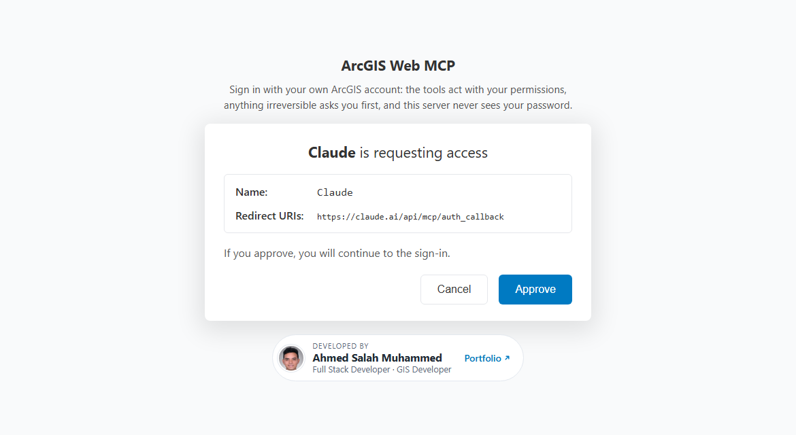
Figure 3 — The approval page, shown once per browser for 30 days
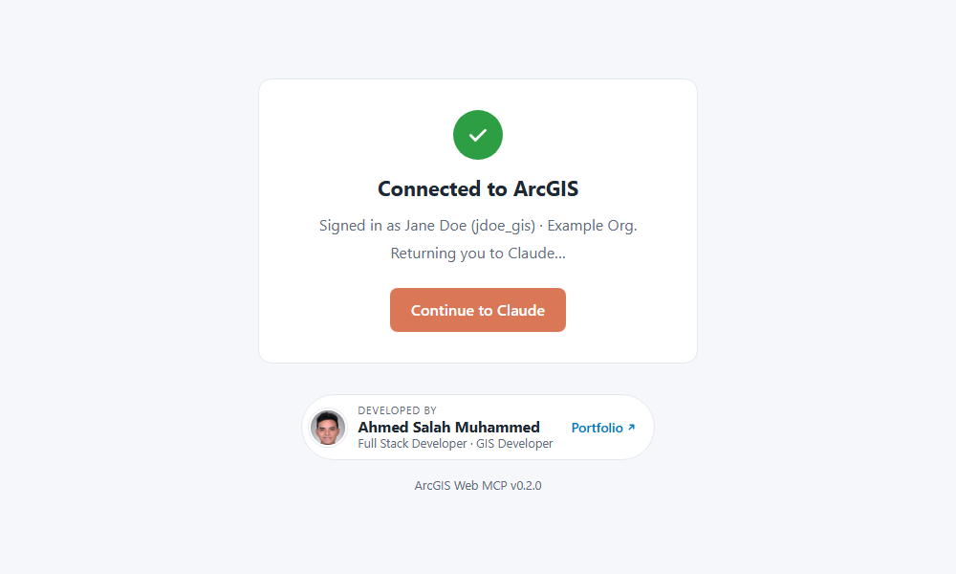
Figure 4 — After the ArcGIS sign-in; the button is orange for Claude and blue for other clients
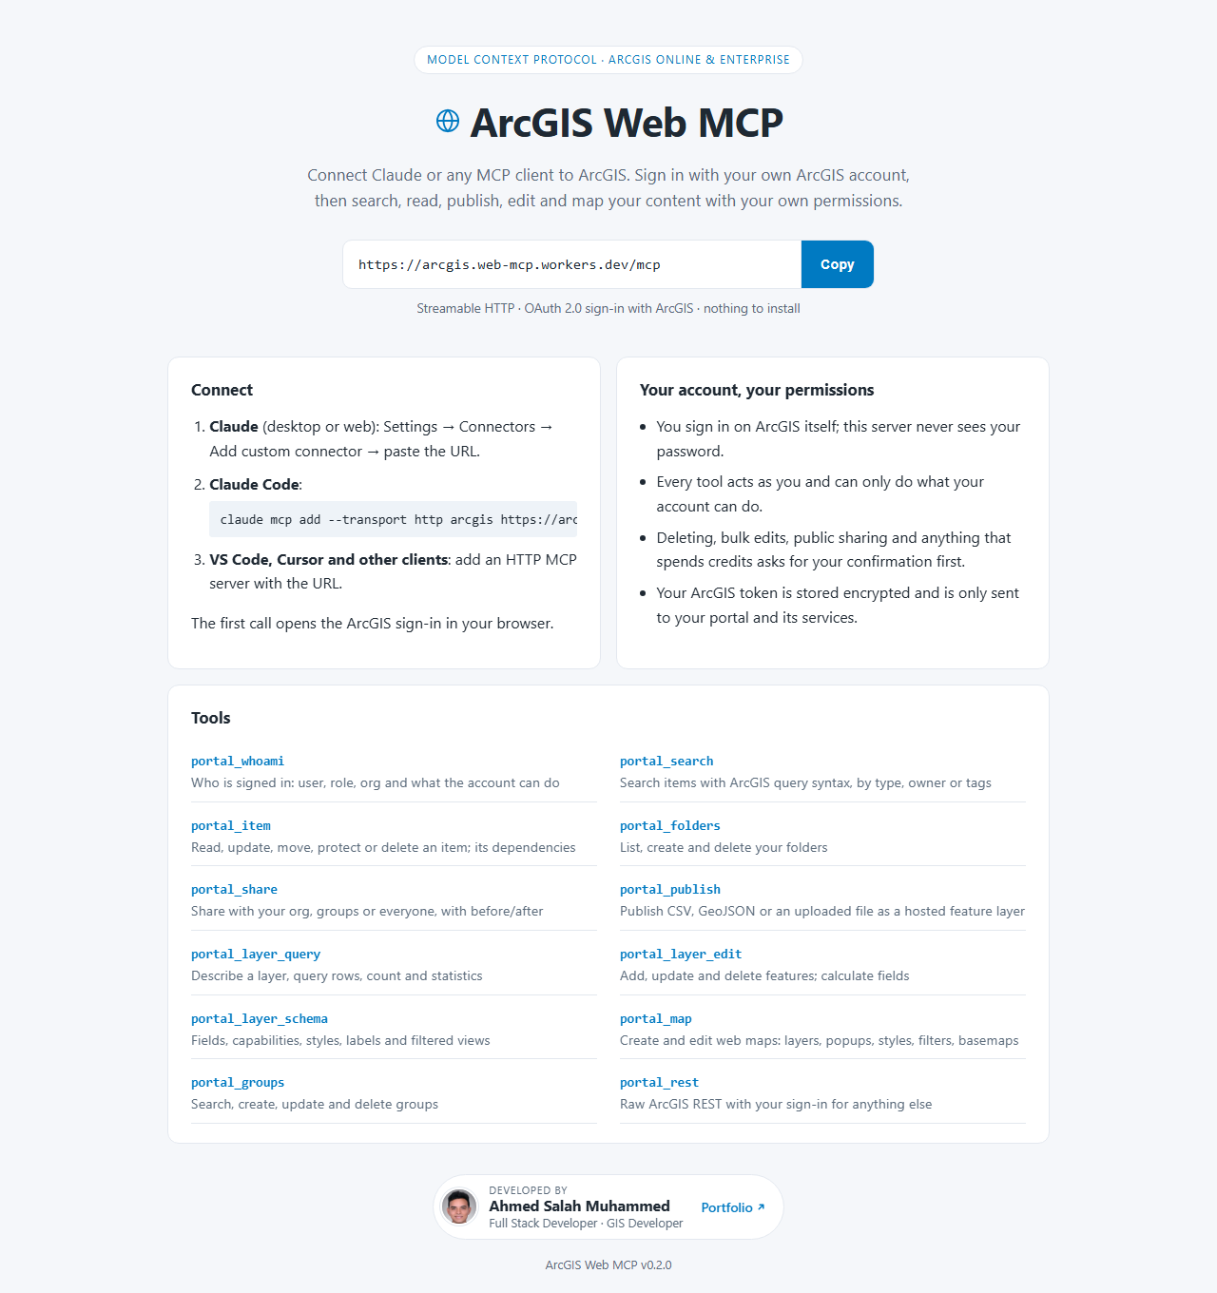
Figure 5 — The home page at https://arcgis.web-mcp.workers.dev

10. Security model
- Every tool runs with the signed-in user's own ArcGIS permissions. There is no shared account, and the password is only ever typed on ArcGIS.
- PKCE S256 is used with both the MCP client and ArcGIS; plain PKCE is disabled (allowPlainPKCE: false).
- The approval form has a CSRF token. The sign-in state is bound to the browser with a hashed cookie, lives 10 minutes, and is deleted after use, like the PKCE verifier.
- ArcGIS tokens exist only inside the encrypted grant. They are never returned to clients or logged, are scrubbed from error messages, and travel in request bodies or the Authorization header, never in URLs.
- Host allowlist: the token is only sent to the portal, ArcGIS Online's service hosts and ARCGIS_EXTRA_HOSTS. global_fetch_strictly_public limits outbound requests to public hosts.
- Irreversible, bulk, public and credit-spending actions need confirmation; protected items are refused.
- Every write leaves an audit line in the Worker logs, which the deployment's owner can read.
- The pages load nothing external and send a Content-Security-Policy, X-Frame-Options: DENY and Referrer-Policy: no-referrer; the Connected page is no-store.
- Secrets live only in .dev.vars (gitignored) and Cloudflare secrets, never in the repository, and production uses its own cookie key.

11. Limits and quotas
Limit | Value
Cloudflare free plan | 100,000 requests a day; 10 ms of CPU per request (time spent waiting for ArcGIS does not count); 50 subrequests per request
portal_layer_query | At most 1,000 rows per call (50 by default); no geometry unless asked; page with offset / next_offset
portal_layer_edit | At most 5,000 edits and 30 batches per call (batch_size 500 by default)
portal_publish | Up to 5 MB of CSV or GeoJSON text; waits about 60 seconds for the publish job, then returns its status
Long responses | data and portal_rest results are cut at max_chars (20,000 by default)
ArcGIS usage | Counts against the user's own organization, e.g. 0.04 credits per geocoded address on ArcGIS Online (estimated in the confirmation preview)

12. Troubleshooting
Symptom | Cause | Fix
ArcGIS shows "Invalid redirect_uri" (Error 400) | The Worker's /callback URL is not registered in the OAuth credentials | Add it exactly: https://<worker>.<subdomain>.workers.dev/callback (and http://localhost:8788/callback for local use)
"Invalid or expired state" | Approve was clicked twice, the sign-in took longer than 10 minutes, or the local server restarted | Start again from the client and click Approve once
/token answers "Invalid authorization code format" | A user id containing a colon (fixed in this version) | Already handled by grantUserId()
wrangler login times out | The approval was not completed in the browser that opened | npx wrangler login --device, then enter the code in any browser
wrangler login fails with ENOTFOUND | The internet connection dropped | Reconnect and log in again
"Could not detect a directory containing static files" | Wrangler ran outside the project folder | cd into the project folder first
Remove-Item cannot find ..\prod-secrets.env | The relative path was resolved from another folder | Use the right relative path or the full path
"Subdomain is unavailable" | workers.dev subdomains are unique across all accounts | Choose another name
"Account already has an associated subdomain" | The API only creates subdomains | Change it in the dashboard
The approval page does not appear | The approval is remembered for 30 days in that browser | Use a private window or clear the site's cookies
The client still shows old server info | It was read at the last connection | Disconnect and reconnect the connector
A tool answers confirm_required | By design: the action needs the user's approval | Read the preview; if the user agrees, the client calls again with confirm: true
Deleting a layer fails: "has a related Service item" | A view depends on the layer | Delete the views first

13. Customizing

13.1 Developer credit
The name, title, portfolio link and photo come from one place, AUTHOR in src/pages.ts. The server info, the instructions and all three pages read it:
export const AUTHOR = {
name: "Ahmed Salah Muhammed",
title: "Full Stack Developer · GIS Developer",
url: "https://ahmedsalah-portfolio.vercel.app/",
photo: AVATAR,
} satisfies Author;
The photo is src/avatar.ts: a square JPEG as base64. The steps to replace it are written at the top of that file.

13.2 ArcGIS Enterprise
- Set ARCGIS_PORTAL_URL in wrangler.jsonc, for example https://gis.example.com/portal.
- Register the OAuth credentials in that portal and use its Client ID.
- The portal must be reachable from the internet; list federated servers on other hosts in ARCGIS_EXTRA_HOSTS.

13.3 Running your own copy
- Change name in wrangler.jsonc and remove the KV id; the first deploy creates a new namespace.
- Use your own OAuth credentials and your own AUTHOR.

14. Next steps
- Test the sign-in with an account from another ArcGIS organization. Esri's documentation says users outside the organization can sign in to a registered OAuth app; whether the app item must be shared publicly has not been verified yet.
- Put the project under git and commit it, keeping .dev.vars and secret files out.
- Optionally, use a custom domain on Cloudflare instead of workers.dev.
- Optionally, bring more tools over from ArcGIS Pro Salah MCP.

Appendix A. Command cheat sheet
Task | Command
Install dependencies | npm install
Create the local secrets file | copy .dev.vars.example .dev.vars
Generate a random key | node -e "console.log(require('crypto').randomBytes(32).toString('hex'))"
Generate environment types | npx wrangler types
Run locally | npm run dev
Run the tests / type check | npm test / npm run type-check
MCP Inspector | npx @modelcontextprotocol/inspector
Log in to Cloudflare | npx wrangler login (or --device)
Show the account | npx wrangler whoami
First deploy, with secrets | npx wrangler deploy --secrets-file ..\prod-secrets.env
Later deploys | npx wrangler deploy
Live logs | npx wrangler tail
Deployments / rollback | npx wrangler deployments list / npx wrangler rollback
Delete the Worker | npx wrangler delete
Log out | npx wrangler logout

Appendix B. Configuration reference
Name | Kind | Purpose
ARCGIS_CLIENT_ID | Secret (required) | Client ID of your ArcGIS OAuth 2.0 credentials
COOKIE_ENCRYPTION_KEY | Secret (required) | Signs the cookie that remembers approved clients
ARCGIS_PORTAL_URL | Variable | The portal to sign in to; https://www.arcgis.com by default
ARCGIS_EXTRA_HOSTS | Variable | Comma-separated extra hosts allowed to receive the user's token
OAUTH_KV | KV binding | OAuth clients, grants, sign-in state, PKCE verifiers
compatibility_flags | Setting | nodejs_compat; global_fetch_strictly_public (outbound requests only to public hosts)
secrets.required | Setting | A deploy fails while a listed secret is missing
dev.port | Setting | 8788 for npm run dev

Appendix C. ArcGIS REST endpoints used
Paths are relative to <portal>/sharing/rest unless they start with a service or layer URL.
Purpose | Endpoint
Sign-in | oauth2/authorize, oauth2/token
User and organization | community/self, portals/self
Search | search
Read an item | content/items/<id>, content/items/<id>/data
Change an item | content/users/<owner>/items/<id>/update, move, protect, unprotect, delete
Dependencies | content/items/<id>/dependencies, …/dependencies/listDependentsTo
Folders | content/users/<me>/createFolder, content/users/<me>/<folderId>/delete
Sharing | content/users/<owner>/items/<id>/share, unshare, content/items/<id>/groups
Upload and publish | content/users/<me>/addItem (multipart), content/features/analyze, content/users/<me>/publish, content/users/<me>/items/<id>/status, portals/<orgId>/isServiceNameAvailable
Groups | community/groups, community/createGroup, community/groups/<id>/update, …/delete, …/users
Layer data | <layer>/query, <layer>/applyEdits, <layer>/calculate
Layer schema | <admin layer>/addToDefinition, deleteFromDefinition, updateDefinition, truncate
Views | content/users/<me>/createService (isView), then the admin view's addToDefinition and updateDefinition
Web maps | addItem with type Web Map and the map JSON as text; later changes through update

Appendix D. Glossary
Term | Meaning
MCP | Model Context Protocol: the standard way AI assistants call external tools
Streamable HTTP | The MCP transport for remote servers: JSON-RPC over HTTP POST
OAuth 2.0 | The standard that lets a user grant an app access without giving it their password
PKCE | Proof Key for Code Exchange: a one-time secret that ties the code to the app that asked for it, so no client secret is needed
Dynamic client registration | An MCP client registering itself with the server at /register before signing in
Grant | The record of one user's approval of one client, holding that user's encrypted ArcGIS tokens
Cloudflare Worker | Code that runs on Cloudflare's network, close to the user, without a server to manage
KV | Cloudflare's key-value store, used here for OAuth data
Wrangler | Cloudflare's command-line tool for Workers
Hosted feature layer | A feature service stored in ArcGIS Online or Enterprise
View | A layer that shows part of another layer (filtered rows or hidden fields) without copying the data

