CCP-CN-S2026 - Problem 2: ISP Network Failover
Week 2: Implementation, Connectivity, VLAN Note
Static Route Based ISP Network Failover
Implementation Note: GNS3 setup was completed, but the required Cisco IOS image was not available. Therefore, the same ISP failover design was implemented and validated in Cisco Packet Tracer using 3 routers and 2 PCs.

1. Implementation Summary
The topology was implemented in Cisco Packet Tracer with 3 Cisco 2911 routers and 2 PCs. The selected Problem 2 does not require VLANs; therefore, VLAN screenshots are not applicable.
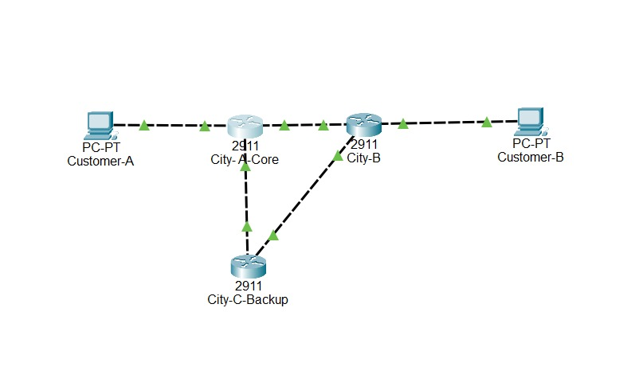
Final topology with all links green.

2. Router Configuration Summary

City-A-Core
- G0/0 = 192.168.10.1/24
- G0/1 = 10.0.12.1/30
- G0/2 = 10.0.13.1/30
- Primary route to 192.168.20.0/24 via 10.0.12.2
- Floating backup route to 192.168.20.0/24 via 10.0.13.2 AD 100

City-B
- G0/0 = 10.0.12.2/30
- G0/1 = 10.0.23.2/30
- G0/2 = 192.168.20.1/24
- Primary return route to 192.168.10.0/24 via 10.0.12.1
- Floating backup return route via 10.0.23.1 AD 100

City-C-Backup
- G0/0 = 10.0.13.2/30
- G0/1 = 10.0.23.1/30
- Route to Customer-A LAN via 10.0.13.1
- Route to Customer-B LAN via 10.0.23.2

3. Connectivity Tests
Test | Command/Evidence | Expected Result | Status
Normal ping before failure | normal-ping-before-failure.png | Customer-A reaches Customer-B | Pass
Routing table before failure | routing-table-before-failure.png | Route to 192.168.20.0/24 via 10.0.12.2 with AD 1 | Pass
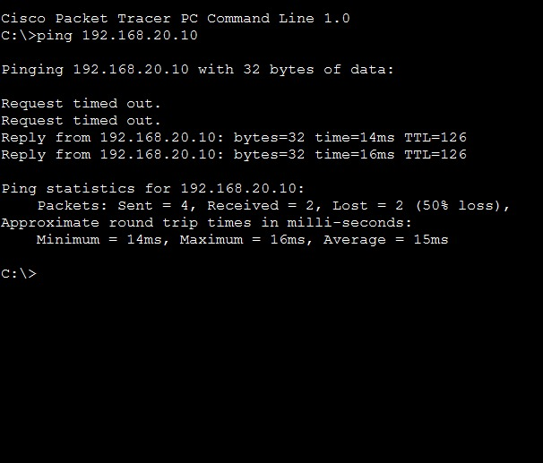
Customer-A successfully pinged Customer-B before failure.

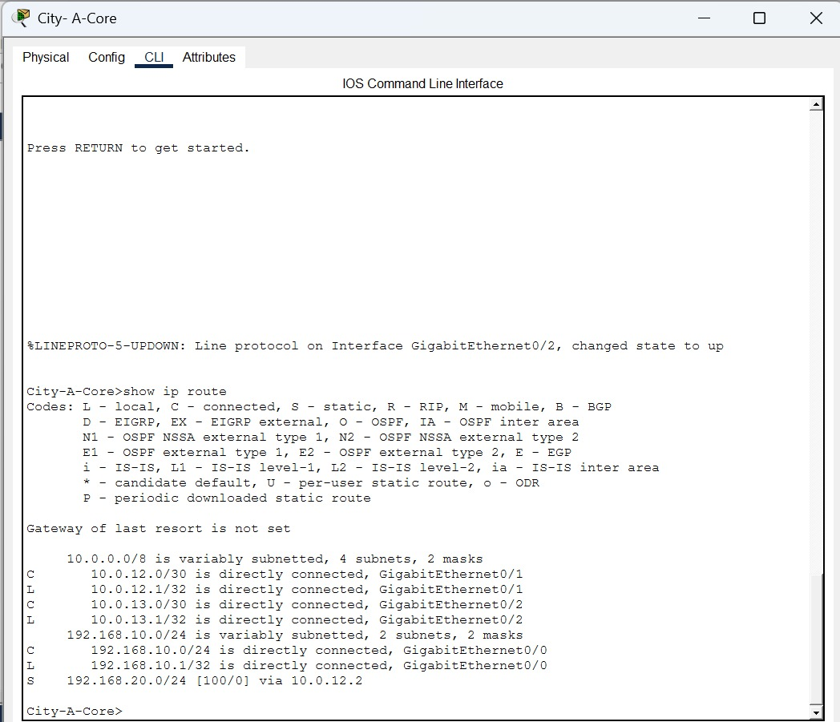

City-A-Core routing table before link failure. It shows primary static route via 10.0.12.2.

4. Running Config Evidence
- Attach City-A-Core running-config.
- Attach City-B running-config.
- Attach City-C-Backup running-config.

5. Week 2 Status Report
- Topology implemented.
- Router interfaces configured.
- Static and floating static routes configured.
- Normal connectivity verified.
- VLANs are not applicable for Problem 2.

