CCP-CN-S2026 - Problem 2: ISP Network Failover
Week 1: Topology, IP Plan, GitHub
Static Route Based ISP Network Failover
Implementation Note: GNS3 setup was completed, but the required Cisco IOS image was not available. Therefore, the same ISP failover design was implemented and validated in Cisco Packet Tracer using 3 routers and 2 PCs.

1. Problem Selection
Selected Problem: Problem 2 - ISP Network. The project designs a three-city ISP topology with a primary route and a backup route that activates when the primary link fails.

2. Team Charter
Member | Combined Role | Responsibilities
Member 1 | Network Architect + Testing Lead | Topology design, IP addressing, router configuration, ping tests, route verification
Member 1 | Documentation + Report Lead | Weekly reports, final report, evidence organization, screenshots placement
Member 1 | Project Manager + GitHub/Submission Lead | Repository/folder structure, file naming, submission checklist, video coordination

3. Logical Topology
- Customer-A connects to City-A-Core.
- City-A-Core connects directly to City-B through the primary link.
- City-A-Core connects to City-C-Backup through the backup link.
- City-C-Backup connects to City-B to complete the backup path.
- Customer-B connects to City-B.
Primary Path: Customer-A -> City-A-Core -> City-B -> Customer-B
Backup Path: Customer-A -> City-A-Core -> City-C-Backup -> City-B -> Customer-B
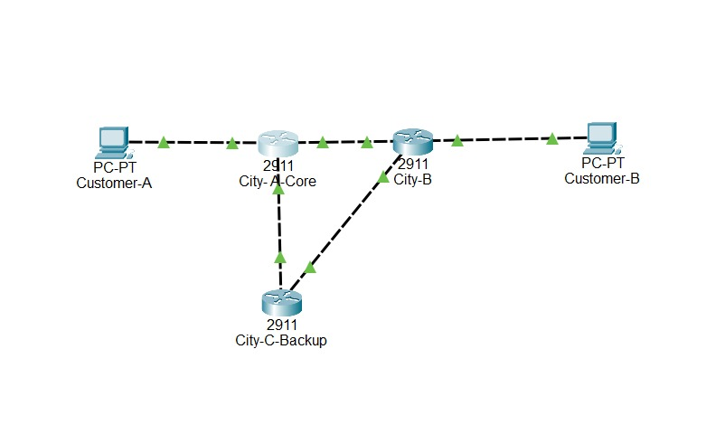
Use this as the final topology evidence after all links are restored and green.

4. IP Addressing Plan
Network/Link | Device | Interface | IP Address | Mask | Gateway/Next Hop | Purpose
Customer-A LAN | Customer-A PC | NIC | 192.168.10.10 | 255.255.255.0 | 192.168.10.1 | Source PC
Customer-A LAN | City-A-Core | G0/0 | 192.168.10.1 | 255.255.255.0 | - | Gateway
Primary Link | City-A-Core | G0/1 | 10.0.12.1 | 255.255.255.252 | 10.0.12.2 | Primary path
Primary Link | City-B | G0/0 | 10.0.12.2 | 255.255.255.252 | 10.0.12.1 | Primary path
Backup Link 1 | City-A-Core | G0/2 | 10.0.13.1 | 255.255.255.252 | 10.0.13.2 | Backup path
Backup Link 1 | City-C-Backup | G0/0 | 10.0.13.2 | 255.255.255.252 | 10.0.13.1 | Backup path
Backup Link 2 | City-C-Backup | G0/1 | 10.0.23.1 | 255.255.255.252 | 10.0.23.2 | Backup path
Backup Link 2 | City-B | G0/1 | 10.0.23.2 | 255.255.255.252 | 10.0.23.1 | Backup path
Customer-B LAN | City-B | G0/2 | 192.168.20.1 | 255.255.255.0 | - | Gateway
Customer-B LAN | Customer-B PC | NIC | 192.168.20.10 | 255.255.255.0 | 192.168.20.1 | Destination PC

5. GitHub Repository name:
CCP_ISP_Failover
https://github.com/Ahmed-sys-coder/CCP_ISP_Failover

6. Risk Assessment Matrix
Risk | Impact | Probability | Mitigation
Cisco IOS image unavailable in GNS3 | High | High | Equivalent implementation completed in Cisco Packet Tracer
Interface naming mismatch | Medium | Medium | Verified interfaces using show ip interface brief
Backup route not activating | High | Medium | Used floating static route with AD 100
Missing screenshots | Medium | Low | Captured normal, failure, backup, and restore evidence

7. Week 1 Status Report
- Problem selected and understood.
- Topology and IP plan prepared.
- Roles assigned for a member group.
- Risk matrix completed.
- Practical implementation planned for Packet Tracer because Cisco IOS image was not available for GNS3.

