CCP-CN-S2026 - Problem 2: ISP Network Failover
Week 3: Security, VPN, L2 Security Note + Failure Simulation
Static Route Based ISP Network Failover
Implementation Note: GNS3 setup was completed, but the required Cisco IOS image was not available. Therefore, the same ISP failover design was implemented and validated in Cisco Packet Tracer using 3 routers and 2 PCs.

1. Requirement Mapping
The LMS folder title mentions security, VPN, and L2 security. However, the selected Problem 2 is an ISP failover problem. It requires static routes, different administrative distances, and failure testing. VPN and L2 security are not part of this selected problem.

2. Controlled Failure Test
To simulate a primary link failure, the City-A-Core interface connected to City-B was shut down.
Device | Interface | Action | Purpose
City-A-Core | GigabitEthernet0/1 | shutdown | Simulate primary City-A to City-B link failure

3. Commands Used
enable
configure terminal
interface gigabitEthernet0/1
shutdown
end
show ip route

4. Expected and Actual Result
State | Route Expected | Evidence
After primary failure | S 192.168.20.0/24 [100/0] via 10.0.13.2 | after-failure-routing-table.png
Backup connectivity | Customer-A ping to 192.168.20.10 succeeds | backup-path-ping-success.png
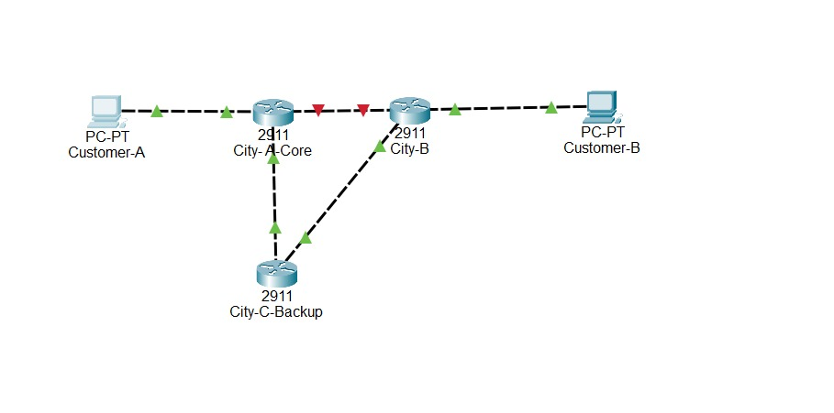
Topology evidence showing the primary link failure state.
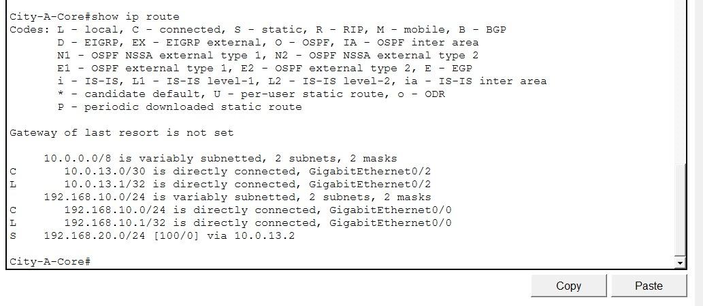
City-A-Core routing table after primary link failure. Backup route via 10.0.13.2 becomes active.
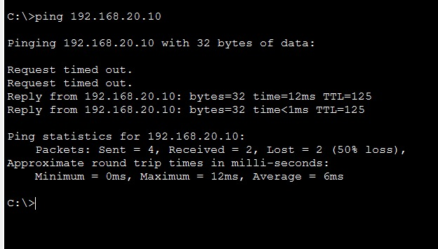
Ping success through backup path after primary failure.

5. Week 3 Status Report
- Primary link failure simulated.
- Backup route activated.
- Ping through backup path succeeded.
- Security/VPN/L2 items marked not applicable for selected Problem 2.

