CCP-CN-S2026 Final Project Report
Problem 2: ISP Network Failover
Static Route Based ISP Network Failover using Cisco Packet Tracer
Course: Computer Networks
Project Type: Complex Computing Problem (CCP)
Implementation Tool: Cisco Packet Tracer
Group Member | Role
Member | Network Architect + Testing Lead
Member | Documentation + Report Lead
Member | Project Manager + GitHub/Submission Lead

Submission: Week 6 Final Report, Video and Presentation

Abstract
This report presents the design, implementation, and validation of a three-city ISP network failover solution. The selected problem is Problem 2: ISP Network. The network uses a primary direct path between City-A-Core and City-B and a backup transit path through City-C-Backup. Static routes and floating static routes with different administrative distances are used to achieve automatic path selection during normal operation, primary link failure, and primary link restoration. The practical implementation was validated in Cisco Packet Tracer using 3 Cisco 2911 routers and 2 PCs.

Implementation Note
GNS3 Desktop and GNS3 VM setup were completed, but the required Cisco IOS image for the Cisco 7200 appliance was unavailable. Therefore, the same ISP failover design was implemented and validated in Cisco Packet Tracer. The topology, IP addressing, static routes, administrative distance behavior, failover testing, and evidence screenshots remain aligned with the selected ISP failover problem.

Table of Contents
1. Introduction
2. Problem Scenario
3. Project Objectives
4. Tools and Technologies
5. Network Topology Design
6. IP Addressing Plan
7. Routing Design and Configuration
8. Testing Methodology
9. Results and Evidence
10. Failure Response and Mitigation
11. Limitations
12. Conclusion
Appendix A: Router Configuration Summary

1. Introduction
Internet Service Provider networks require reliable connectivity even when a primary link fails. This project demonstrates a simple but effective ISP resilience design using static routes and floating static routes. The solution ensures that traffic between Customer-A and Customer-B normally follows the direct City-A-Core to City-B path, and automatically switches to a backup path through City-C-Backup when the direct link fails.

2. Problem Scenario
ConnectSphere ISP has three cities: City A, City B, and City C. City B customers experience connectivity loss when the direct primary link fails. The ISP requires a backup route so customer traffic can continue during the failure. The selected design uses City-C-Backup as an alternate transit router.
City / Node | Role in Network
Customer-A | Source end-user PC in the 192.168.10.0/24 LAN
City-A-Core | Core router and primary source-side gateway
City-B | Customer-B side router and destination gateway
City-C-Backup | Backup transit router used during primary link failure
Customer-B | Destination end-user PC in the 192.168.20.0/24 LAN

3. Project Objectives
- Design a three-router ISP topology with two customer LANs.
- Configure a direct primary path from City-A-Core to City-B.
- Configure a backup transit path through City-C-Backup.
- Use floating static routes with a higher administrative distance for failover.
- Validate normal connectivity, failure state, backup path operation, and primary route restoration.
- Capture evidence screenshots for final submission.

4. Tools and Technologies
Tool / Technology | Purpose
Cisco Packet Tracer | Network topology implementation and simulation
Cisco 2911 Routers | Routing between ISP city networks
PC-PT End Devices | Customer-A and Customer-B connectivity testing
Static Routing | Manual route control and path selection
Floating Static Routes | Backup routes using higher administrative distance
Ping | End-to-end reachability verification
show ip route | Routing table and failover verification

5. Network Topology Design
The topology contains two customer PCs and three routers. The primary path is Customer-A -> City-A-Core -> City-B -> Customer-B. The backup path is Customer-A -> City-A-Core -> City-C-Backup -> City-B -> Customer-B.
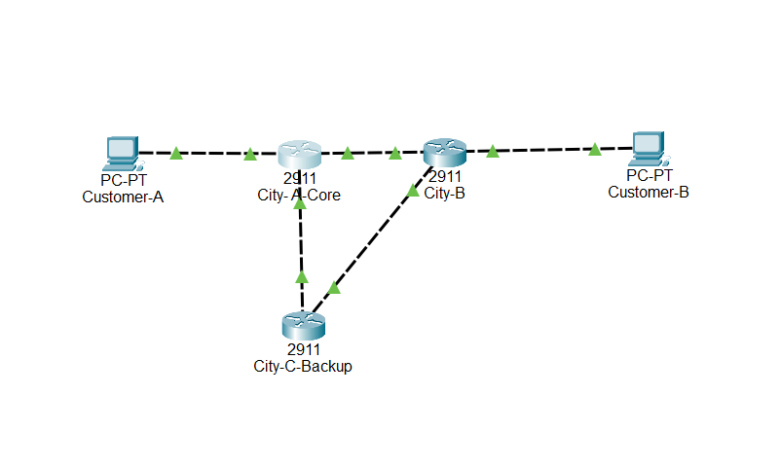
Figure 1: Final topology with all links restored and green.

6. IP Addressing Plan
Network | Device | Interface | IP Address | Subnet Mask | Gateway / Next Hop
Customer-A LAN | Customer-A PC | NIC | 192.168.10.10 | 255.255.255.0 | 192.168.10.1
Customer-A LAN | City-A-Core | G0/0 | 192.168.10.1 | 255.255.255.0 | -
Primary Link | City-A-Core | G0/1 | 10.0.12.1 | 255.255.255.252 | 10.0.12.2
Primary Link | City-B | G0/0 | 10.0.12.2 | 255.255.255.252 | 10.0.12.1
Backup Link 1 | City-A-Core | G0/2 | 10.0.13.1 | 255.255.255.252 | 10.0.13.2
Backup Link 1 | City-C-Backup | G0/0 | 10.0.13.2 | 255.255.255.252 | 10.0.13.1
Backup Link 2 | City-C-Backup | G0/1 | 10.0.23.1 | 255.255.255.252 | 10.0.23.2
Backup Link 2 | City-B | G0/1 | 10.0.23.2 | 255.255.255.252 | 10.0.23.1
Customer-B LAN | City-B | G0/2 | 192.168.20.1 | 255.255.255.0 | -
Customer-B LAN | Customer-B PC | NIC | 192.168.20.10 | 255.255.255.0 | 192.168.20.1

7. Routing Design and Configuration
The routing design uses a primary static route and a backup floating static route. The primary route uses the default administrative distance of 1, while the backup route uses administrative distance 100. This makes the primary path preferred during normal operation and the backup path active only when the primary route becomes unavailable.
Router | Route Purpose | Command Summary
City-A-Core | Primary route to Customer-B LAN | ip route 192.168.20.0 255.255.255.0 10.0.12.2
City-A-Core | Backup route to Customer-B LAN | ip route 192.168.20.0 255.255.255.0 10.0.13.2 100
City-B | Primary return route to Customer-A LAN | ip route 192.168.10.0 255.255.255.0 10.0.12.1
City-B | Backup return route to Customer-A LAN | ip route 192.168.10.0 255.255.255.0 10.0.23.1 100
City-C-Backup | Route to Customer-A LAN | ip route 192.168.10.0 255.255.255.0 10.0.13.1
City-C-Backup | Route to Customer-B LAN | ip route 192.168.20.0 255.255.255.0 10.0.23.2

8. Testing Methodology
Testing was performed in four major stages: normal operation, primary link failure, backup path verification, and primary link restoration.
Test ID | Test Description | Command / Evidence | Expected Result
T1 | Normal ping before failure | ping 192.168.20.10 | Customer-A reaches Customer-B
T2 | Route table before failure | show ip route on City-A-Core | Route via 10.0.12.2 with AD 1
T3 | Primary link shutdown | shutdown on G0/1 of City-A-Core | Primary link goes down
T4 | Route table after failure | show ip route on City-A-Core | Route via 10.0.13.2 with AD 100
T5 | Backup path ping | ping 192.168.20.10 | Ping succeeds through City-C-Backup
T6 | Primary link restore | no shutdown on G0/1 | Primary link restored
T7 | Final route and ping | show ip route and ping | Route returns to 10.0.12.2 and ping succeeds

9. Results and Evidence

9.1 Normal Connectivity Before Failure
Customer-A successfully pinged Customer-B during normal operation. Initial timeouts can occur due to ARP resolution, but replies confirm successful connectivity.
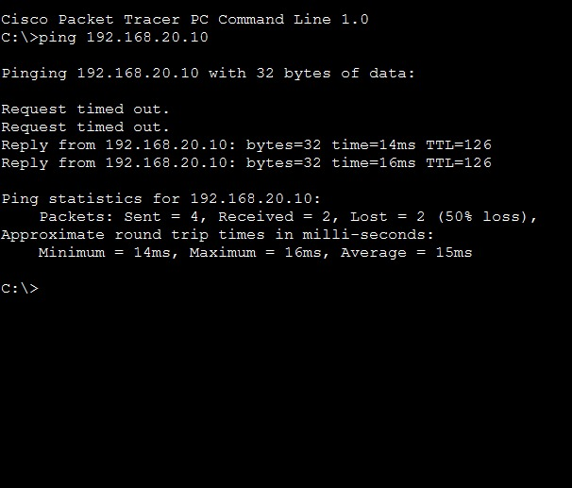
Figure 2: Normal ping before failure.
The routing table before failure shows the primary route to 192.168.20.0/24 through 10.0.12.2 with administrative distance 1.
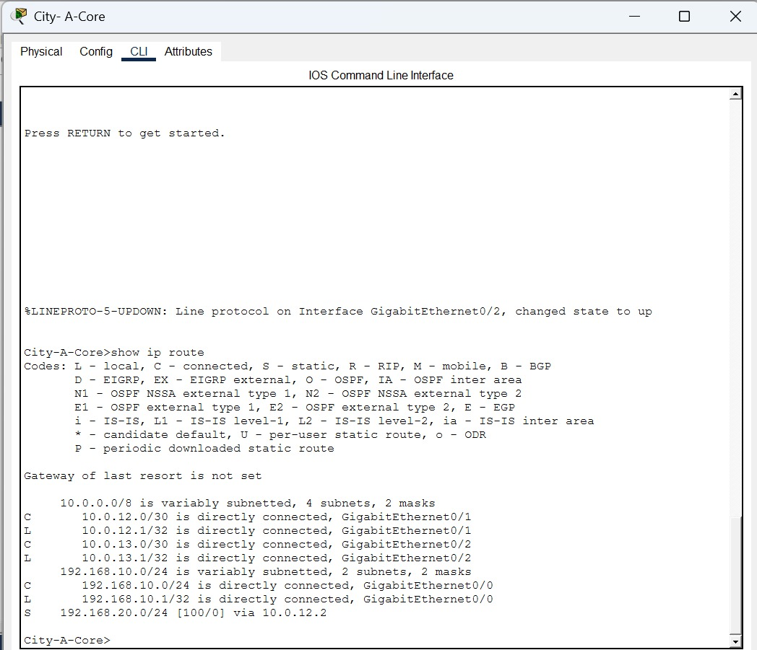
Figure 3: Routing table before failure - primary route via 10.0.12.2.

9.2 Primary Link Failure
The primary link between City-A-Core and City-B was administratively shut down to simulate link failure.
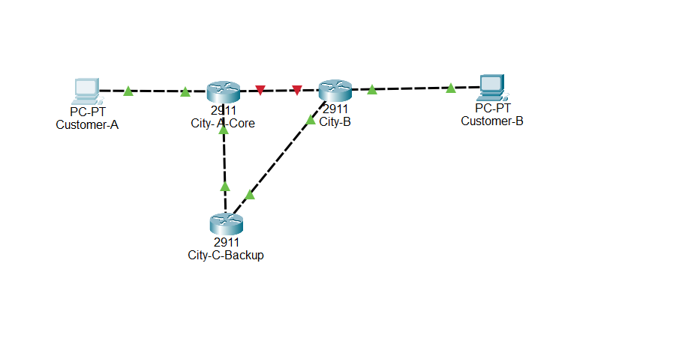
Figure 4: Primary link failure topology.
After failure, the routing table shows the floating static route through City-C-Backup with administrative distance 100.
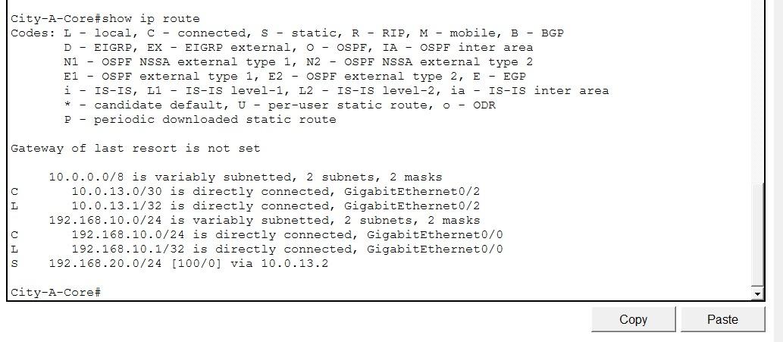
Figure 5: Routing table after failure - backup route via 10.0.13.2.

9.3 Backup Path Verification
After primary link failure, Customer-A was still able to reach Customer-B through the backup path. The increased TTL value confirms route behavior changed compared to the normal path.
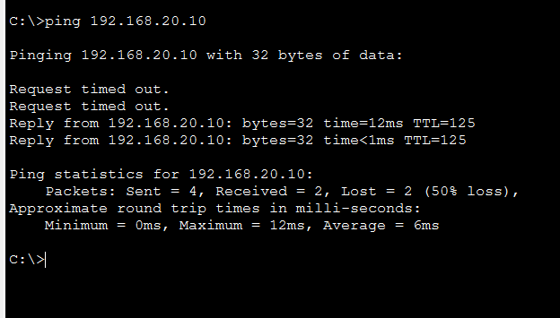
Figure 6: Backup path ping success.

9.4 Primary Link Restoration
After the primary interface was restored using no shutdown, the route table again preferred the primary path via 10.0.12.2 with administrative distance 1.
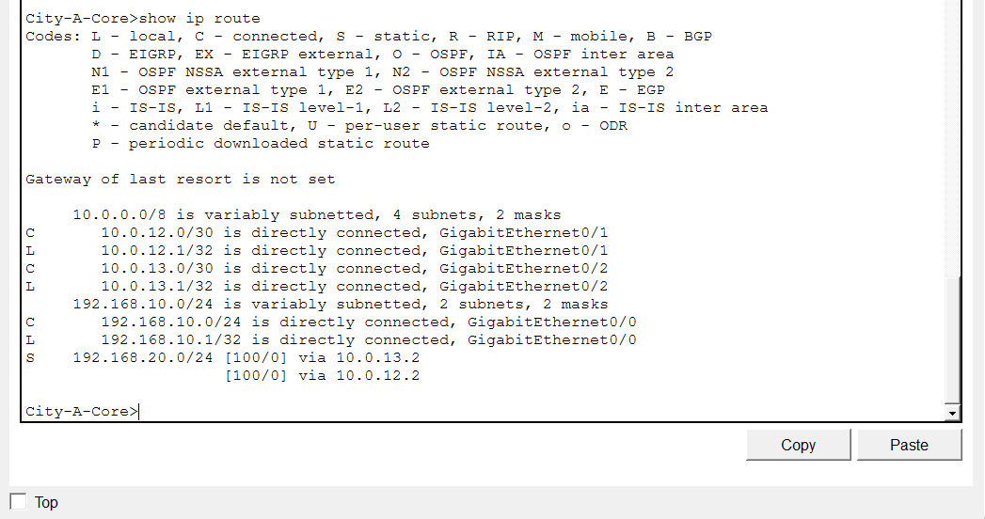
Figure 7: Routing table after primary link restore.
The final ping after restore confirms that end-to-end connectivity remained successful.
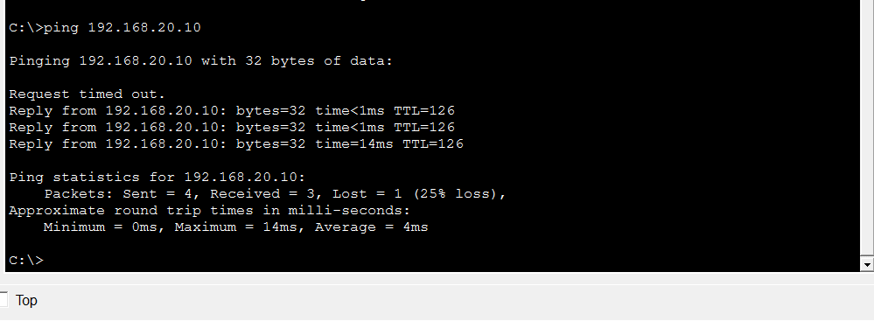
Figure 8: Final ping after primary route restoration.

10. Failure Response and Mitigation
Stage | Observation | Response / Mitigation
Normal State | Route via 10.0.12.2 is active. | Traffic uses direct City-A-Core to City-B link.
Failure State | Primary link is down and route via 10.0.12.2 is unavailable. | Floating static route via 10.0.13.2 becomes active.
Backup Operation | Ping succeeds through backup path. | City-C-Backup maintains service continuity.
Restoration | Primary route returns after no shutdown. | Traffic again uses the preferred direct route.

11. Limitations
- GNS3 Cisco IOS image was unavailable, so implementation was completed in Cisco Packet Tracer.
- QoS, VPN, L2 security, and attack tools were not applicable to the selected Problem 2 scenario.
- Monitoring was performed using ping and routing table verification, which are suitable for this static-route failover problem.

12. Conclusion
The project successfully demonstrates static route based ISP failover. During normal operation, Customer-A traffic to Customer-B uses the direct primary route via City-B. When the primary link fails, the router automatically selects the floating static backup route through City-C-Backup. After primary link restoration, the network returns to the preferred primary path. The evidence screenshots confirm successful connectivity, route change, backup operation, and recovery.

Appendix A: Router Configuration Summary
City-A-Core Configuration Summary
interface g0/0
ip address 192.168.10.1 255.255.255.0
no shutdown
interface g0/1
ip address 10.0.12.1 255.255.255.252
no shutdown
interface g0/2
ip address 10.0.13.1 255.255.255.252
no shutdown
ip route 192.168.20.0 255.255.255.0 10.0.12.2
ip route 192.168.20.0 255.255.255.0 10.0.13.2 100
City-B Configuration Summary
interface g0/0
ip address 10.0.12.2 255.255.255.252
no shutdown
interface g0/1
ip address 10.0.23.2 255.255.255.252
no shutdown
interface g0/2
ip address 192.168.20.1 255.255.255.0
no shutdown
ip route 192.168.10.0 255.255.255.0 10.0.12.1
ip route 192.168.10.0 255.255.255.0 10.0.23.1 100
City-C-Backup Configuration Summary
interface g0/0
ip address 10.0.13.2 255.255.255.252
no shutdown
interface g0/1
ip address 10.0.23.1 255.255.255.252
no shutdown
ip route 192.168.10.0 255.255.255.0 10.0.13.1
ip route 192.168.20.0 255.255.255.0 10.0.23.2

Week 6 Deliverable Addendum
Final Report, Video Demonstration Script, Presentation Outline and Submission Checklist

1. Final Report
The complete final project report has been included above. It covers the problem scenario, objectives, tools, topology design, IP addressing plan, routing configuration, testing methodology, results, failure response, limitations, conclusion, and router configuration summary.

2. Video Demonstration Script
1. Introduce the project: Static Route Based ISP Network Failover for CCP-CN-S2026, Problem 2: ISP Network.
2. Show the final Cisco Packet Tracer topology with Customer-A, City-A-Core, City-B, City-C-Backup, and Customer-B.
3. Explain the primary path: Customer-A -> City-A-Core -> City-B -> Customer-B.
4. Explain the backup path: Customer-A -> City-A-Core -> City-C-Backup -> City-B -> Customer-B.
5. Show Customer-A pinging Customer-B before failure using ping 192.168.20.10.
6. Show the City-A-Core routing table before failure using show ip route. Explain that the route is via 10.0.12.2 with administrative distance 1.
7. Simulate failure by shutting down City-A-Core GigabitEthernet0/1.
8. Show the routing table after failure. Explain that the backup floating static route is active via 10.0.13.2 with administrative distance 100.
9. Show backup path ping success from Customer-A to Customer-B.
10. Restore the primary interface using no shutdown.
11. Show the route after restore and the final ping after restore.
12. Conclude that failover and recovery were successful.

3. Presentation Outline
Slide | Title | Main Content
1 | Title | Static Route Based ISP Network Failover
2 | Problem Scenario | Three-city ISP network with primary link failure issue
3 | Objectives | Primary path, backup path, failover, and restore
4 | Topology | Show final topology with all links restored and green
5 | IP Addressing | Show Customer-A LAN, Customer-B LAN, primary link, and backup links
6 | Routing Design | Static route AD 1 and floating static route AD 100
7 | Normal Operation | Show normal ping and routing table before failure
8 | Failure Simulation | Show primary interface shutdown
9 | Backup Result | Show backup route via 10.0.13.2 and backup ping success
10 | Conclusion | Failover achieved successfully and primary path restored

4. Week 6 Final Submission Checklist

Video Link
https://drive.google.com/file/d/1wUaU75PZd0k4XRkTiDU9_LcpWfCz32uF/view?usp=sharing

PPT Presentation Link
https://docs.google.com/presentation/d/1A4JUvWLv1qdA_UxnblqtYyc74-GevidO/edit?usp=sharing&ouid=111565301925292724739&rtpof=true&sd=true

Github Link

https://github.com/Ahmed-sys-coder/CCP_ISP_Failover

