CCP-CN-S2026 - Problem 2: ISP Network Failover
Week 5: Attack, Response, Mitigation
Static Route Based ISP Network Failover
Implementation Note: GNS3 setup was completed, but the required Cisco IOS image was not available. Therefore, the same ISP failover design was implemented and validated in Cisco Packet Tracer using 3 routers and 2 PCs.

1. Week 5 Mapping
The LMS folder mentions attack, response, and mitigation. For Problem 2, the equivalent event is a primary ISP link failure, not a cybersecurity attack. The response and mitigation are backup route activation and traffic continuity.

2. Failure Response Report
Item | Explanation
Incident | Primary City-A-Core to City-B link was manually shut down.
Detection | City-A-Core routing table changed from primary route to floating backup route.
Response | Backup route via City-C-Backup became active.
Mitigation | Traffic continued to reach Customer-B through the backup path.
Recovery | Primary interface was restored using no shutdown; route returned to 10.0.12.2.

3. Evidence Files
Primary Link Failure Topology
- 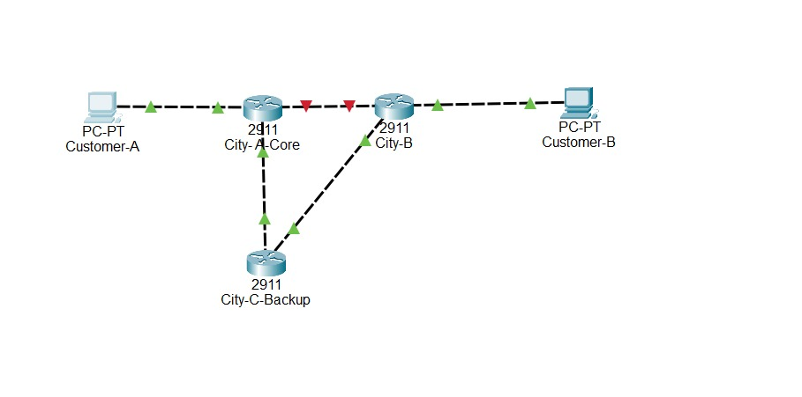
After Failure Routing Table
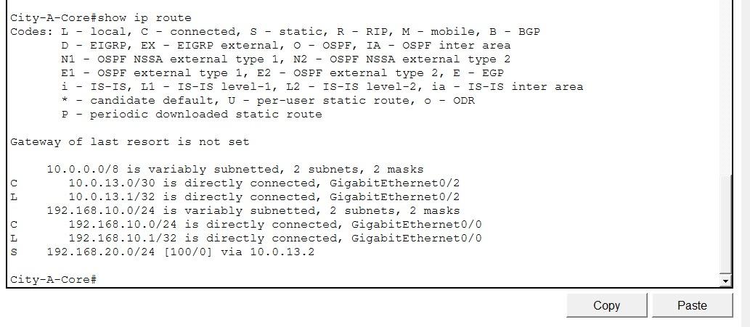
Backup Path Ping Success

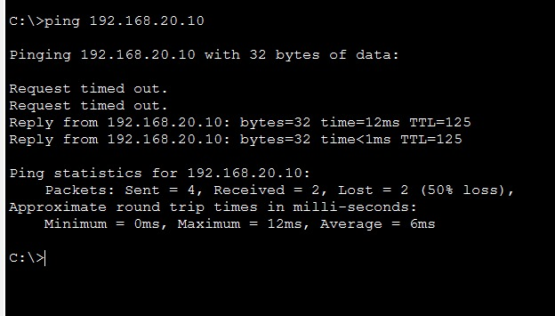
Routing Table After Primary Restore

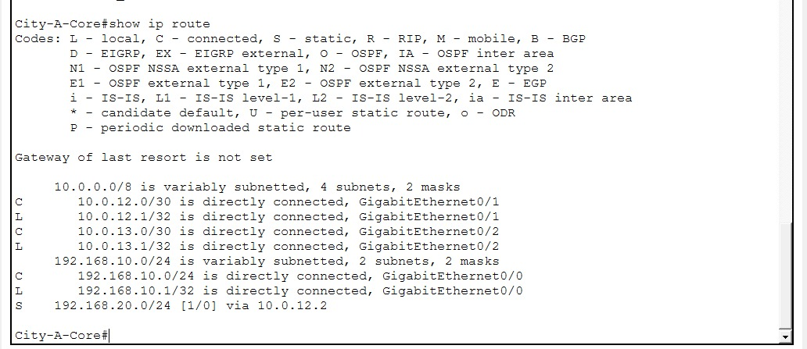

Final Ping After Restore
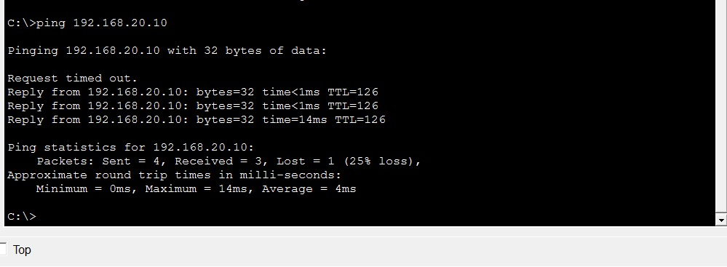

4. Week 5 Status Report
- Failure event simulated.
- Backup route response verified.
- Mitigation successful because traffic continued.
- Primary path restored successfully.

