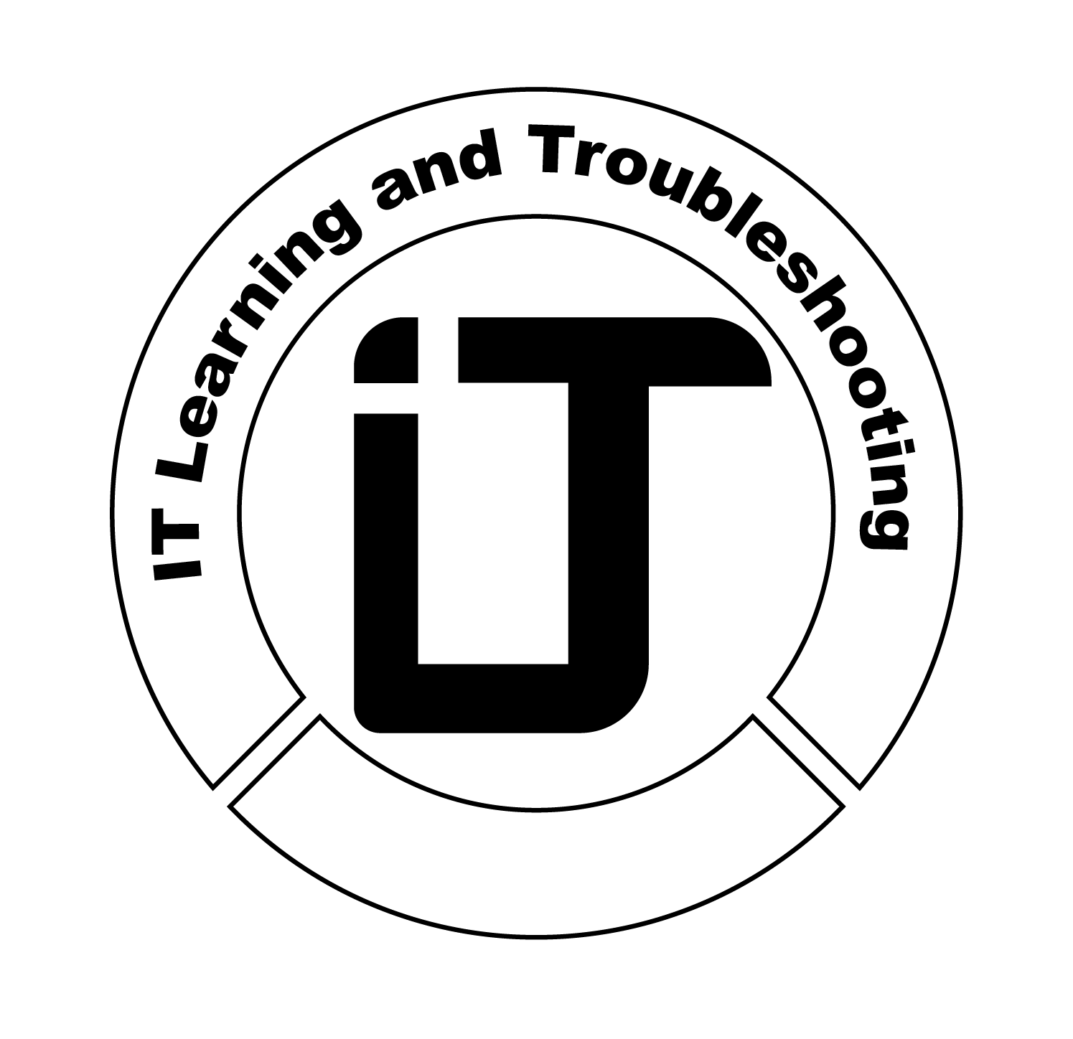
Professional Training
Assessment Report
Issued by IT Learning & Troubleshooting

Trainee Information
Full Name: __________________________
Report ID: ITR-TR-XXXX
Issue Date: ________________

Training Scope
Training coverage included theoretical assessments, hands-on practical tasks, and packet-level analysis, covering core CCNA domains such as networking fundamentals, IP addressing and subnetting, switching and routing technologies, network services, security fundamentals, NAT/WAN connectivity, troubleshooting, and Wireshark-based traffic analysis.

Task-Based Evaluation
Task No | Task Name | Description | Result | Grade
1 | ________________ | ________________ | Excellent | __ %
2 | ________________ | ________________ | Excellent | __ %
3 | ________________ | ________________ | Excellent | __ %
4 | ________________ | ________________ | Excellent | __ %
5 | ________________ | ________________ | Excellent | __ %

Executive Summary
The trainee demonstrated strong practical understanding and professional execution of enterprise-level networking concepts.

SIGNATURE

Mostafa Othman
Founder & Lead Instructor

