Task 1: ML Classification Project
Alfido Tech | Artificial Intelligence Internship
Internship domain: Artificial Intelligence
Name: EZAZ AHAMAD Candidate ID: BS/REG/127948

1. Links
- LinkedIn profile: https://www.linkedin.com/in/ezaz-ahamad-440416336
- GitHub repository: https://github.com/ahmed-web-oss-wj/alfido-task1-ml-classification
- Notebook: ml_classification.ipynb (in the repository root)
- README with environment setup and run commands: README.md (in the repository root)

2. Problem and dataset
The goal is to build and evaluate a supervised classification model that predicts whether a breast tumour is malignant or benign from measurements of cell nuclei. The dataset is the Breast Cancer Wisconsin (Diagnostic) dataset bundled with scikit-learn: 569 samples, 30 numeric features, no missing values and no duplicate rows. The classes are moderately imbalanced (62.7% benign, 37.3% malignant).

3. Approach
- Preprocessing: 80/20 stratified train/test split (455 train, 114 test) so both sets keep the class ratio.
- Scaling: StandardScaler placed inside a scikit-learn Pipeline, so it is fitted only on training folds and cannot leak test information.
- Cross-validation: 5-fold stratified CV on the training set for every model.
- Algorithms compared: Logistic Regression, Random Forest and Gradient Boosting.
- Tuning: GridSearchCV optimising ROC-AUC for Logistic Regression (C) and Random Forest (trees, depth, leaf size).
- Metrics: accuracy, precision, recall, F1 and ROC-AUC, all reported on the untouched test set.

4. Exploratory analysis
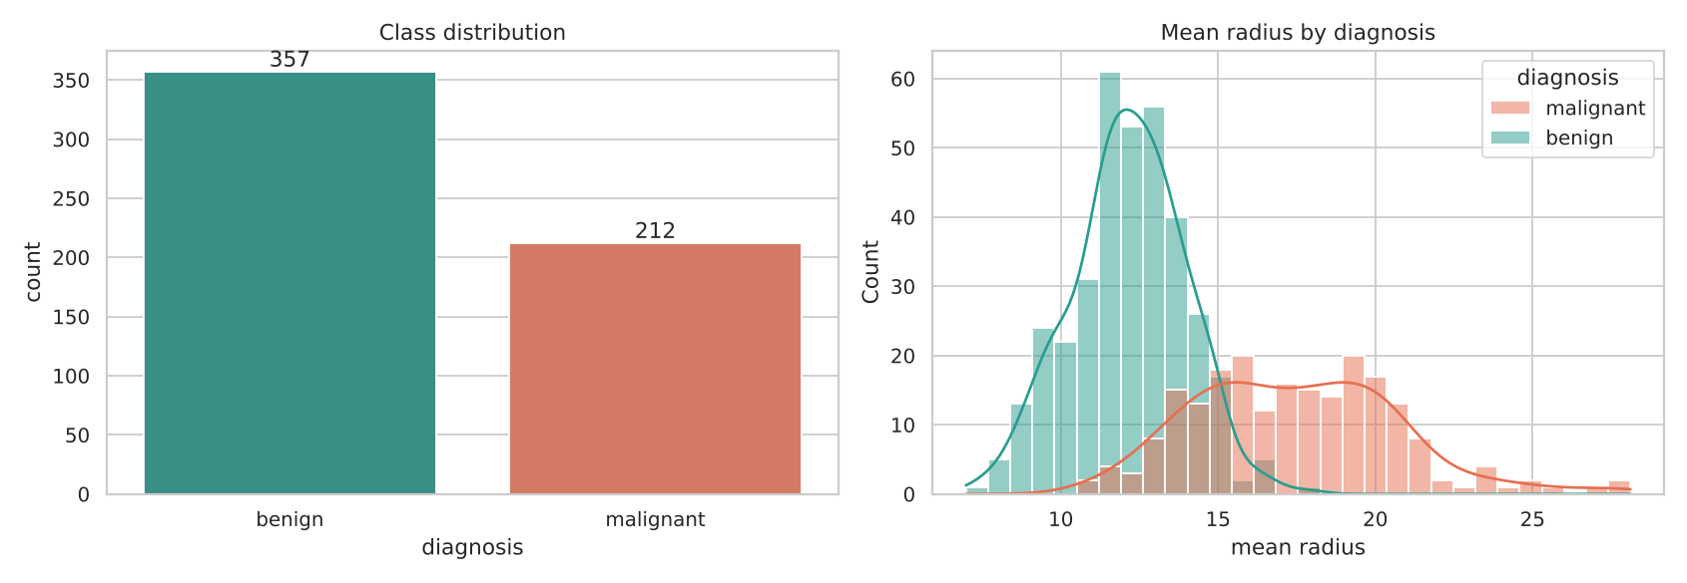
Figure 1: Class distribution and mean radius by diagnosis
Size and shape features such as radius, perimeter, area and concavity separate the two classes well, which is why even a linear model performs strongly.
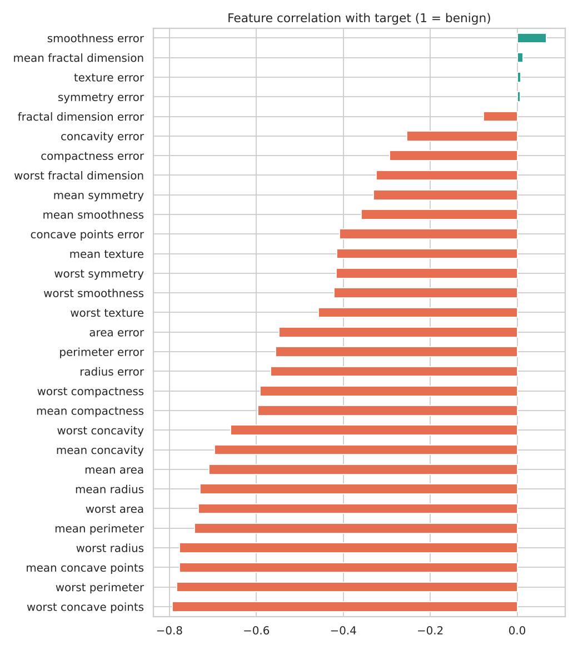
Figure 2: Correlation of each feature with the target

5. Results
Test-set performance of all models (114 held-out samples):
Model | Accuracy | Precision | Recall | F1 | ROC-AUC
Logistic Regression | 0.9825 | 0.9861 | 0.9861 | 0.9861 | 0.9954
Random Forest | 0.9474 | 0.9583 | 0.9583 | 0.9583 | 0.9937
Gradient Boosting | 0.9561 | 0.9467 | 0.9861 | 0.9660 | 0.9907
Logistic Regression (tuned) | 0.9825 | 0.9861 | 0.9861 | 0.9861 | 0.9954
Random Forest (tuned) | 0.9561 | 0.9589 | 0.9722 | 0.9655 | 0.9934

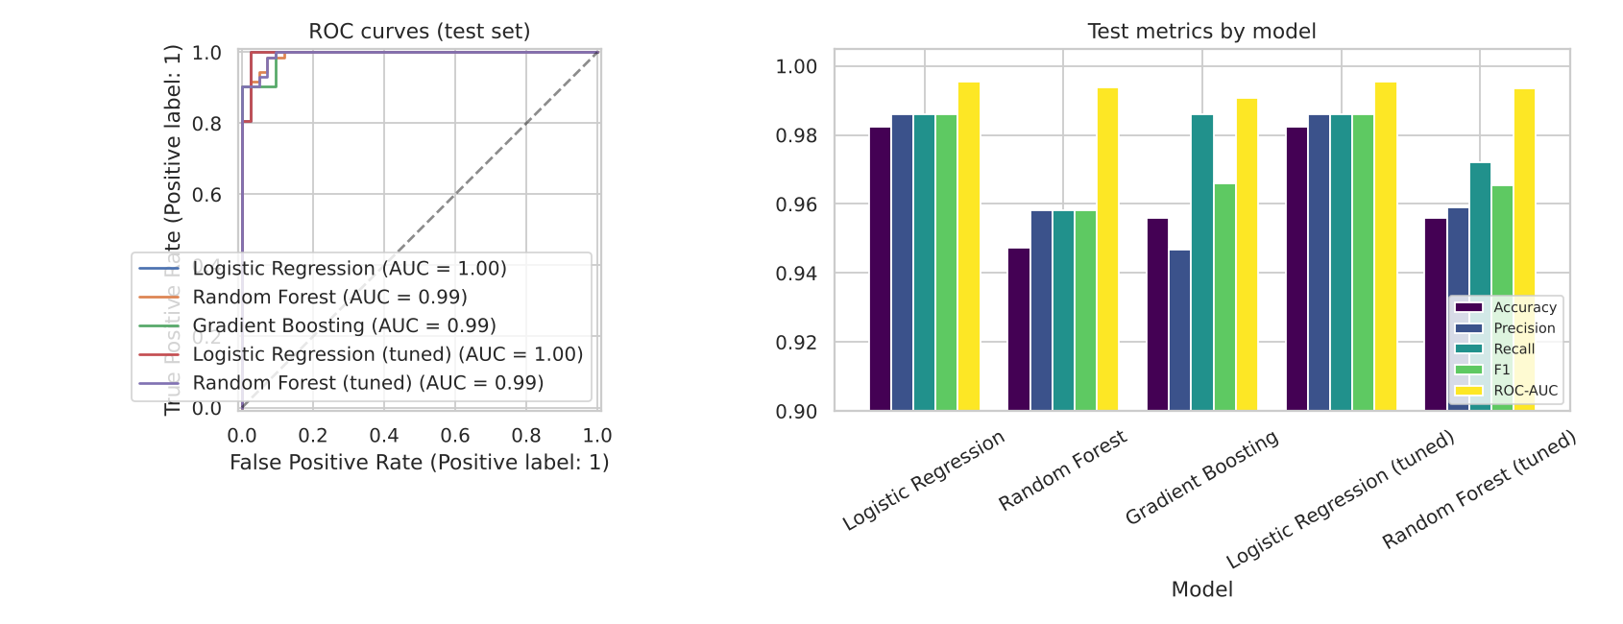
Figure 3: ROC curves and metric comparison on the test set

6. Model selection
Logistic Regression was selected. It scored the highest F1 (0.9861) and ROC-AUC (0.9954) on the test set and also had the best cross-validated ROC-AUC (about 0.996), so the result is not a lucky split. Tuning changed nothing for it (the default C=1 was already best), while tuning improved the Random Forest slightly (accuracy 0.9474 to 0.9561) but not enough to overtake the linear model. A simple, fast, interpretable model winning here is a common outcome on small, clean, well-separated tabular data.
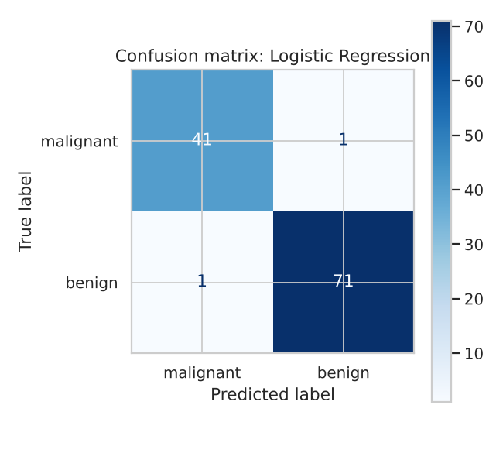
Figure 4: Confusion matrix of the selected model
Of 114 test samples the model made 2 errors: 1 malignant tumour predicted as benign (false negative) and 1 benign tumour predicted as malignant (false positive). Recall for the malignant class is 0.976.
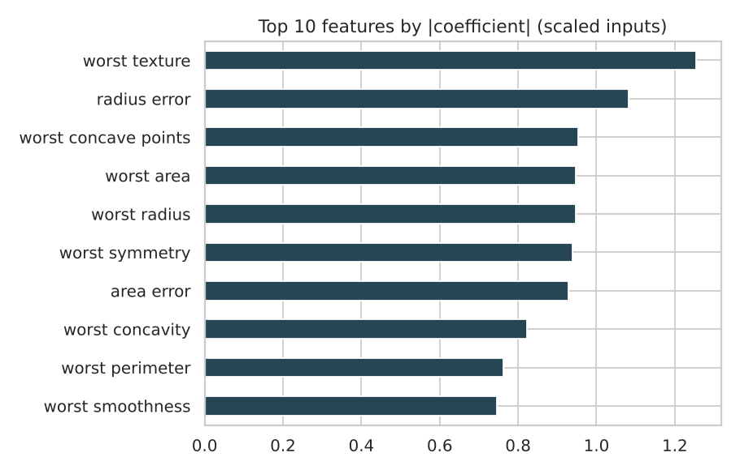
Figure 5: Most influential features

7. Conclusions and limitations
- All models reach roughly 95-98% accuracy and above 0.99 ROC-AUC; the differences between them are small.
- In medical screening a missed cancer (false negative) costs more than a false alarm, so recall on the malignant class is the metric to watch. A decision threshold below 0.5 could trade some precision for higher recall.
- The dataset is small (569 rows) and one 114-sample test set is noisy: a single extra error changes accuracy by about 0.9 points. Results would need external validation before any real use.
- Next steps: probability calibration, threshold tuning, and model interpretation with SHAP (covered in Task 4).

