Project OS

Name: Ahmed Mohamed Gaber

ID:19100683

# SJF: non_preemptive

We implement the SJF algorithm using C language

1. Asking the user for number of processes
2. Ask user for burst time of each burst but them in 2 array (copy,bst_time)
3. Sorting the processes according from smallest to largest
4. Comparing both array to find the processes number after sorting
5. Measuring both turn around, waiting time, average waiting and average turnaround using the rules
6. Printing all of them

# SJF:

We implement the SJF algorithm using C language

1. Asking the user for number of processes
2. Ask user for burst time of each burst but them in 2 array (copy,bst_time)
3. Sorting the processes according from largest to smallest
4. Comparing both arrays to find the processes number after sorting
5. Measuring both turn around, waiting time, average waiting and average turnaround using the rules
6. Printing all of them

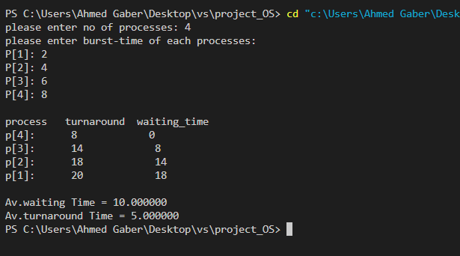

# Round Robbin algorithm:

We implement the SJF algorithm using C++ language

1. In this algorithm we tried to make it similar to the real world we are using a struct to make a queue named Queue, it includes all the function ( enqueue, dequeue and front)
2. In the main function we are asking user to enter number of process
3. Ask user for burst time of each process
4. We are assuming the quantum time to be 4
5. Making a while loop till the queue is empty
6. First we check if the process value is less than quantum time or not then dequeue it from queue
7. If it’s we are adding the value of process to completion time the subtract from its process time quantum number then dequeue it and enqueue it again
8. Else adding the quantum value to completion time
9. Each time process finish it puts it’s completion time in an array and number of this process in another array
10. Finally we are sorting them for printing and measuring of turnaround, waiting , average waiting and average turnaround.

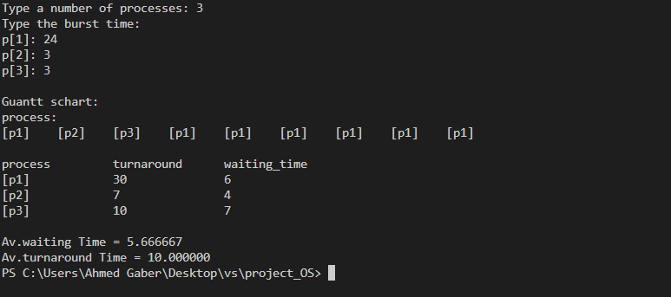

# Priority algorithm:

We implement the SJF algorithm using C++ language

1. Asking the user for number of processes
2. Ask user for burst time of each burst but them in 3 array (copy,bst_time,priority)
3. Sorting the processes according to their priority from largest to smallest
4. Comparing both arrays to find the processes number after sorting
5. Measuring both turn around, waiting time, average waiting and average turnaround using the rules
6. Printing all of them

