**Smart healthcare adopting MQTT**

1st Sara Walid Barbar  
*School of Engineering and Applied Sciences   
Nile University*Giza, Egypt  
Email: [Sar.walid@nu.edu.eg](mailto:Sar.walid@nu.edu.eg)

3rd Abdulrahman Mohsen Badran  
*School of Engineering and Applied Sciences*  
*Nile University*Giza, Egypt   
Email: ab.mohsen@nu.edu.eg2nd Hager Sayed Soliman  
 *School of Engineering and Applied Sciences   
Nile University*  
Giza, Egypt  
Email: Hag.sayed@nu.edu.eg

4th Ahmed Mohamed Gaber  
 *School of Engineering and Applied Sciences   
Nile University*  
Giza, Egypt  
Email: Ah.Gaber@@nu.edu.eg

# abstract

People live far away from cities suffer from poor medical care due to lack of medical resources. Coronavirus disease (COVID-19) altered the way of care giving and the new pandemic forced the health systems to adopt new treatment protocols in which remote follow-up is essential. This paper aims to provide better healthcare for people across developing a system for detecting human vital signs such as heart rate, body temperature and humidity of the surrounding environment based on the Internet of Things (IoT). The doctor could decide to give the patient remotely a specific medicine immediately according to the data taken from patient. Message queuing telemetry transport (MQTT) protocol was employed to transfer the measured data from the healthcare unit to the hospital server. An ESP32 MQTT client to publish MQTT messages on the server and to subscribe orders from MQTT topics. Multiple sensors have been integrated to measure and display the vital parameters of the patient simultaneously from anywhere and at any time. All collected data displayed in a scientific manner through a server and can be accessed by laptops or phones.

**Keywords— Internet of Things, Message Queuing Telemetry Transport, Publish/Subscribe**

# introduction

The gathering and analysis of data at any time and from any location is the main goal of the IOT concept. Devices in the healthcare industry might be used to monitor patients with chronic conditions, help them recover from injuries, or create comfortable assisted living surroundings. Smart mobile devices employ the idea of mobile health to develop efficient healthcare services and solutions.

In the coming years, the medical sector will rely more and more on IOT. The availability of portable medical equipment and mobile health care applications improves health care services. Additionally, the widespread use of cutting-edge technologies like robots, artificial intelligence, and the ability to upload medical data in real-time to the internet enable doctors to make more accurate diagnoses and produce better therapeutic outcomes, which boosts the effectiveness of healthcare services. By identifying cutting-edge therapeutic options, the combination of IOT with medical equipment improves patient care. A patient remote control system, as an example, enhanced the way Elderlies, diabetic patients, patients with heart diseases, and special needs patients are receiving the care they need with more suitable and comfortable ways for them.

A brand-new coronavirus spread quickly over the world in late 2019 and was identified as a pandemic by the World Health Organization in March. Most health systems, including those in developed nations, were forced to implement remote care procedures to handle mild cases in order to decrease the burden on the systems and preserve the priceless lives of the medical staff as a result of the rapid and steady rise in the number of confirmed cases. A healthcare provider will remotely supervise patients who have a positive COVID-19 test and just mild symptoms to keep an eye on their health and course of therapy. Each patient is given their own independent healthcare unit to monitor the most important vital signs and document the treatment's aftercare.

The aim of the paper is design and implement a healthcare system to monitor the patient’s life activities through a set of sensors that have been linked through a wireless network. This paper Provides a proposed system for detection of health problems and monitoring vital signs of patient, and this would be through two sections first by using IoT and the second one is by using MQTT protocol and they will be discussed more below:

## Internet of things

## The Internet of Things (IoT) is a new technology era that has been widely adopted and is connecting millions of smart devices, including machines, sensors, gadgets, and appliances. IoT systems utilize data that has been compiled by sensors and transmitted over a variety of communication methods, all of which are connected to a network. The dominance of IoT systems over every process and daily activity was made possible by the most recent technologies and tremendous advancements in information gathering, networking, communication, sensor manufacture, cloud computing, artificial intelligence, software, and algorithms [7]. The development and adoption of IoT technologies are revolutionized in 1970 by home monitoring [4].

## IoT-based devices are expected to number in the tens of billions by 2022, which highlights the crucial role they have in guiding information collection and decision-making to a new level. IoT-connected devices will account for 50% of all connections in 2023, Cisco forecasted in their annual internet report for the years 2018 through 2023 [4]. According to Cisco's whitepaper, out of the expected 14.7 billion IoT-connected devices, 735 million IoMT and smart health systems will be connected by 2023. accounting for approximately 5.6% of the estimated machine to machine (M2M) connection. Therefore, 2% of all internet-connected devices are IoT-based healthcare solutions.

## MQTT Protocol

Dozens of protocols at the application layer all work toward improving system performance. The message queue telemetry transport protocol and the limited application protocol are at the top of the list of application protocols. MQTT has high throughput, reduced latency, simplicity light weight, minimal battery and memory requirements, less bandwidth usage when compared to other protocols, and minimal protocol interchange [1]. MQTT is a great option for IoT systems due to the properties listed above which lessen the impact of network traffic. As it uses the Transmission Control Protocol (TCP), MQTT uses the Transport Layer Security (TLS) and Secure Sockets Layer (SSL) protocols to provide the necessary security levels.

The MQTT server, also known as a broker, act as a middleman between connected clients. Among linked clients, can publish, subscribe, unsubscribe, and disconnect processes. A session is a client-broker interaction during which data (application messages) are exchanged. A message from an application carries its topic (address) [5]. Due to its one-to-many and many-to-many architecture, which enables clients to subscribe to more than one topic at once, MQTT is appropriate for use in medical applications. The broker serves as the network's hub and is the only node through which data is exchanged, making the protocol space decoupled and lowering message overhead [6]. Although the nodal dependency is eliminated by the space decoupling, the entire protocol broker becomes reliant.

Figure 1 depicts an illustrated explanation of the MQTT quality of services. The temperature sensor sends its readings to the broker without the requirement for any acknowledgement or response, which is the only service quality that is shown in red. One or more service quality indicators are highlighted the broker who publishes the test results to the doctor is the patient. The doctor and the broker are each responding at least once [6].

Figure Publish/subscribe MQTT quality of service [1]

Quality of service levels: This protocol describes the Quality of Service (QoS) levels that are a deal within two parties of a message with respect to the assurance of distribution of data [2]. It supports three level of Quality of Services which are described below.

a) QoS0 (At most once): In these Quality levels of service, the message is sent at most once and it does not provide guarantee delivery of a message.

b) QoS1 (At least once): In these Quality levels of service, the data is sent at least once and it is possible to deliver a message more than once by setting the value of duplicate flag by 1.

c) QoS2 (Exactly once): In these Quality levels of service, the message is sent exactly once by using 4-way handshaking.

The selection of the QoS level depends on the system like if a system needs constant data delivery, adapts QoS2 for transmission of data even if there is a time delay [6].

# Literature Review

Many IoT-based healthcare applications have been developed with the help of numerous researchers. Researchers have developed an IoT implementation reference model. As an illustration, Y. Liao (2016) [7] In this paper, a 3D heterogeneous human body model is used to build an analytical and exact in to out (I2O) human body path loss (PL) model at 2.45 GHz under safety restrictions.

According to P. Salunke and R. Nerkar (2017) [8] in this paper, it is impossible for the sizable elderly population to adhere to the traditional healthcare system. This system is useful for doctors who are overburdened with patients and advantageous for rural patients who arrive to medical facilities the least frequently.

In this article, A. Mohammad Rahmani and N. Kumar Thanigaivelan (2015) [9] offered the idea of a Smart eHealth Gateway. The gateway acts as a connection point between IP-based networks and cloud computing infrastructure for medical sensors, home, hospital, and building automation products.

N. De Caro and W. Colitti (2013) [5] In this work, they have concentrated on CoAP and MQTT, two lightweight application protocols capable of meeting the performance needs of the majority of smartphone-based assembled sensing applications. Thus, they thoroughly examined and discussed these two treatments from both a qualitative and then a quantitative perspective.

proposed system uses ECG sensor that allows detecting the heart rate of a person using heartbeat sensing even if the person is at home. The sensor is then interfaced to Raspberry pi 3 that allows checking heart rate readings and transmitting them over internet [1].

MQTT has been utilized as part of many IoT gadgets and instant message delivery systems because it was intended to work on low-power machines as a light-weight protocol [2]

Broker controls the distribution of information and responsible for receiving all messages from publisher, filtering them, decide who is interested in it and then sending the messages to all subscribed clients. It can do the following things [4]

when a subscriber associates with the broker, clean session association is considered as permanent, if its value is false. In this task, consecutive messages which come out conveying a highest QoS assignment are reserved for delivery when the association is resumed [5]

IoT-based devices are expected to number in the tens of billions by 2022, which highlights the crucial role they have in guiding information collection and decision-making to a new level. IoT-connected devices will account for 50% of all connections in 2023[2].

##### PROPOSED SYSTEM ARCHITECTURE

If the patient has heart disease and symptoms appear for some time and disappear, the monitor standard cannot record of symptoms during a few minutes. In this case, the doctor should recommend a portable device that monitors the blood oxygen level, heart rate and body temperature which usually takes hours.

*Figure 2 System overview [5]*

The solution we proposed in Fig.2, which is by connecting a sensor to the patient's body then connect it to the microcontroller. A patient can carry the device in his pocket, or which is attached to a belt or shoulder strap. The device sends measuring results to the server over an internet connection using Wi-Fi technology. Using Wi-Fi gives patient ability to move without constraint Also, patient, doctor, and anyone interested in the patient's condition can access the server over the phone and view the patient's measured data. A system is configured to send and receive vital signs of the patient by communication using the MQTT protocol. Where the doctor can send a name of the drug for the symptoms according to the measured data. The patient may not be able to read or write so another solution was proposed is by put the drugs in a box with each has a led beside it. when the doctor needs the patient to take a specific drug, he will send a signal to the led to turn on, the patient will notice then he will take the drug at this moment.

Figure flowchart of sending and data transceiver

Fig.3 shows the flow chart of how the data received from the sensor is being send to ESP8266 then it’s sent to MQTT broker.

Figure flowchart of Gateway operation

Fig.4 shows the flow chart of how the data is being received from the MQTTLens server, then the ESP8266 received the data then depending on this data if the ESP8266 will send data to a topic or not.

##### IMPLEMENTATION DETAILS

An ESP8266 act as the control unit is used to send the data measured by the sensors to the server and receive commands from the doctor. The sensor used are temperature sensor LM35, pressure sensor, heart rate sensor which sends continuously the temperature of the patient. The ESP8266 is collecting the data from the sensor connected to it then it connects to a free server called Mosquitto which is an open source (EPL/EDL licensed) message broker that implements the MQTT protocol. By using free google support tool called MQTTLens which supports MQTT communications, where we can use it to send and watch the data from computer. To watch the data of nodes from mobile we used an application called MyMQTT a free android app which can publish or subscribe the topics.

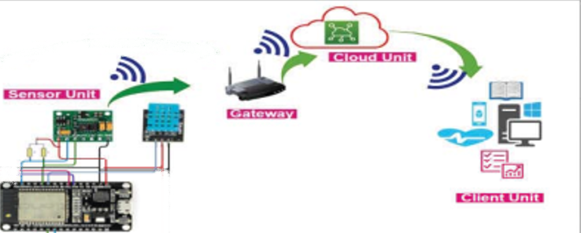

Figure schematic diagram of the proposed system

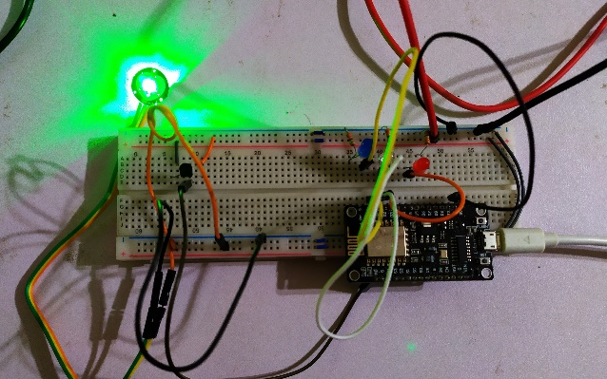

Figure components connection

##### Results

A program designed called MQTTLens to display the record data from the server which shows sensors values heart rate, body temperature, body pressure. The program allows the ability to access the measuring data from in place in the world via mobile or computer.

The circuit designed is sending the data continuously in real-time. The sensors are connected to the patient’s body its data is published to MQTT server/broker. Fig.7 shows the quantities measured for the person’s vital health on MQTTLens on Desktop. It shows the doctor publishing a specific drug according to the measured value.

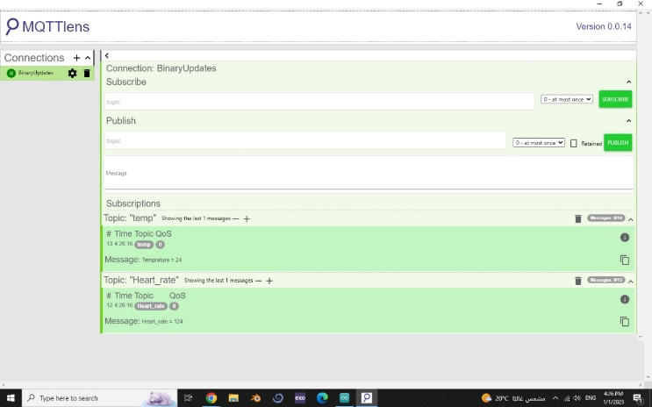

Figure measurements of the vital signs of the patient’s heart and temperature through desktop application.

Figure Measurements of patient on mobile application

##### CONCLUSION

This article proposed a smart health care monitoring system based on the MQTT protocol to publish and subscribe measured data. The proposed implementation of the system carried out using a prototype developed with ESP8266. The Mosquitto loT platform client application used to collect (heartbeat, body temperature, temperature, and humidity from the environment) and then publish data using MQTT broker. The results obtained experimentally from the proposed model displays on an application install on smart phone or computer. Also, the proposed system provides a reliable, flexible, and confidential approach to monitor the vital signs of the heart using loT technology. The End-user, a doctor or a medical technician can view the data of all devices connected to the intemet in realtime and from anyplace via subscribing to the identical MQTT topic.

##### FUTURE WORK

##### The work in this paper can be developed by using required hardware and software components to identify emergency vital signs that affect the patient's situation. These improvements will give proposed system ability to send urgent alarm in critical status through call, E-mail, or SMS notification.

##### References

1. “Remote web based ECG monitoring using MQTT protocol for IOT in ...” [Online]. Available: https://www.researchgate.net/profile/Ayaskanta-Mishra/publication/324686561_Remote_web_based_ECG_Monitoring_using_MQTT_Protocol_for_IoT_in_Healthcare/links/5adcadfb0f7e9b285940b8c0/Remote-web-based-ECG-Monitoring-using-MQTT-Protocol-for-IoT-in-Healthcare.pdf?origin=publication_detail. [Accessed: 29-Nov-2022].
2. Hwang, H. C., Park, J., & Shon, J. G. (2016). Design and implementation of a reliable message transmission system based on MQTT protocol in IoT. Wireless Personal Communications, 91(4), 1765-1777.
3. “Dipa Soni | charotar University of Science and ... - researchgate.” [Online]. Available: https://www.researchgate.net/profile/Dipa-Soni. [Accessed: 29-Nov-2022].
4. Banks, A., & Gupta, R. (2014). MQTT Version 3.1. 1. OASIS standard.
5. Lee, S., Kim, H., Hong, D. K., & Ju, H. (2013, January). Correlation analysis of MQTT loss and delay according to QoS level. In Information Networking (ICOIN), 2013 International Conference on (pp. 714717). IEEE.
6. Luzuriaga, J. E., Cano, J. C., Calafate, C., Manzoni, P., Perez, M., & Boronat, P. (2015, September). Handling mobility in IoT applications using the MQTT protocol. In Internet Technologies and Applications (ITA), 2015 (pp. 245-250). IEEE.
7. Y. Liao, M. S. Leeson, M. D. Higgins, and C. Bai, “Analysis of in-to-out wireless body area network systems: Towards QoS-aware Health Internet of Things Applications,” MDPI, 13-Jul-2016. [Online]. Available: https://www.mdpi.com/2079-9292/5/3/38. [Accessed: 29-Nov-2022].
8. P. Salunke and R. Nerkar, “IOT driven healthcare system for remote monitoring of patients,” Semantic Scholar, 01-Jan-1970. [Online]. Available: <https://www.semanticscholar.org/paper/IoT-Driven-Healthcare-System-for-Remote-Monitoring-Salunke->
9. A. Rahmani, N. K. Thanigaivelan, T. N. Gia, J. Granados, B. Negash, P. Liljeberg, and H. Tenhunen, “Smart e-health gateway: Bringing intelligence to internet-of-things based ubiquitous healthcare systems: Semantic scholar,” undefined, 01-Jan-1970. [Online]. Available: https://www.semanticscholar.org/paper/Smart-e-Health-Gateway%3A-Bringing-intelligence-to-Rahmani-Thanigaivelan/75d8c056f08307ead58ebe1ee59cb9269a682200. [Accessed: 30-Nov-2022].