

**“AZƏRBAYCAN HAVA YOLLARI” CJSC NATIONAL AVIATION ACADEMY**

**Individual Work № 7:**

**Topic: C program to get the device information**

**Subject: System software and Operating systems-2**

**Teacher: Mehemmed Shahmaliyev**

**Group: 1459i Student: Mammadov Ahmad**

**Date: Signature:M.A**

**Baku 2022**

**Getting System and Process Information Using C Programming**

Whenever you start a new process in Linux it creates a file in /proc/ folder with the same name as that of the process id of the process. In that folder, there is a file named “status” which has all the details of the process. We can get those **Process Information Through shell** as follows:

cat /proc/1/status

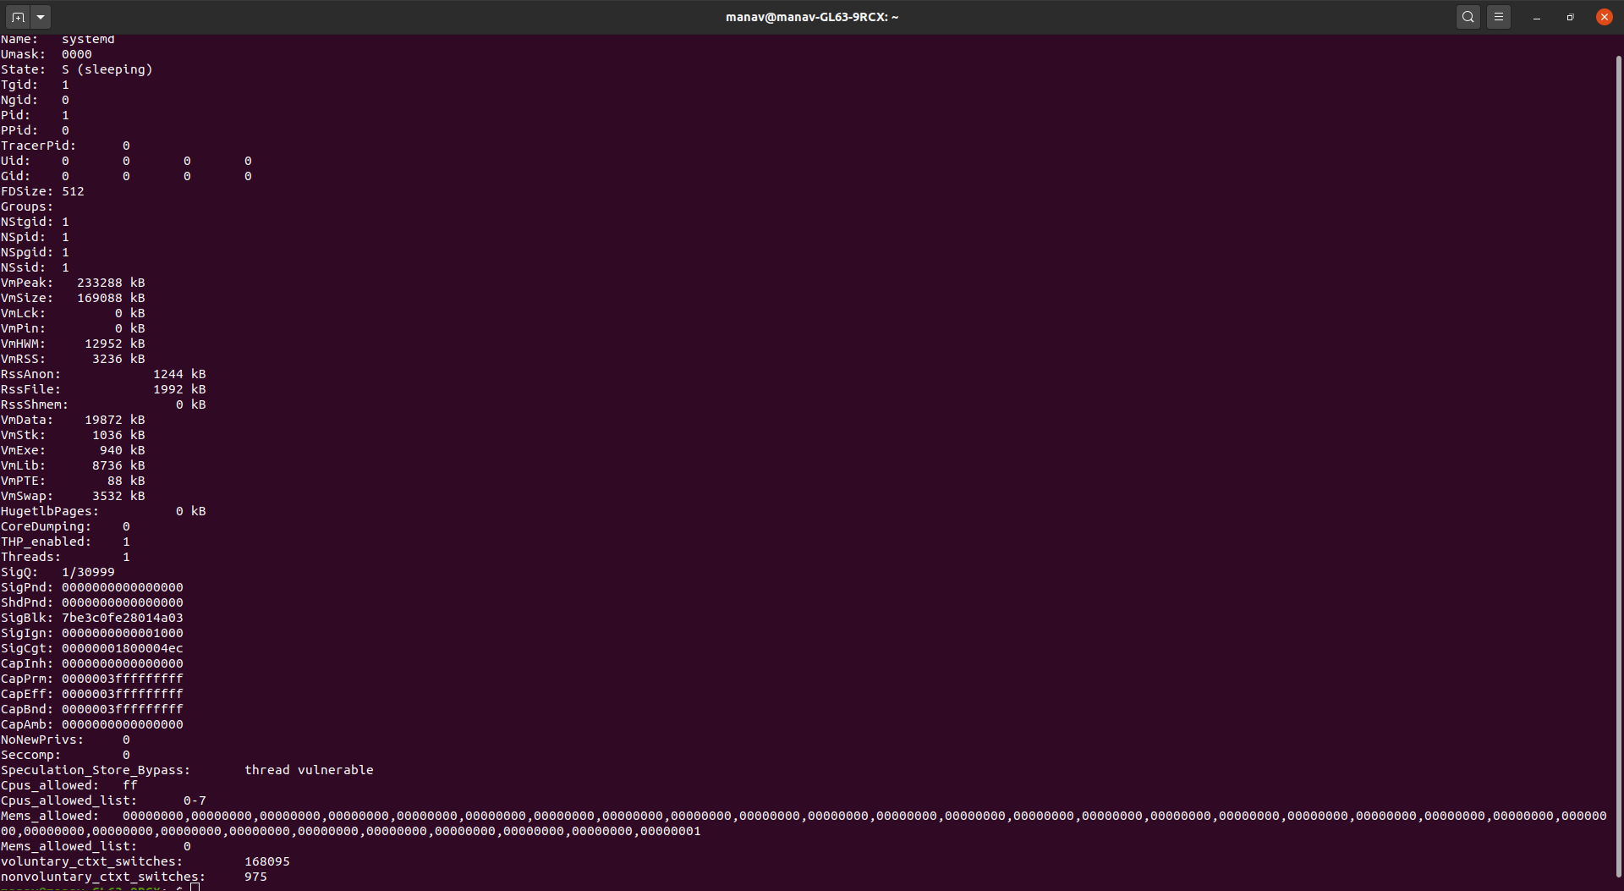

As can be seen, it displays most of the information about the process.

**Note:**, In this case, the process id is 1, it may be changed as per need.

You can get the **System Information through the shell**. The basic system information is stored in a file named os-release in /etc/ folder.

cat /etc/os-release

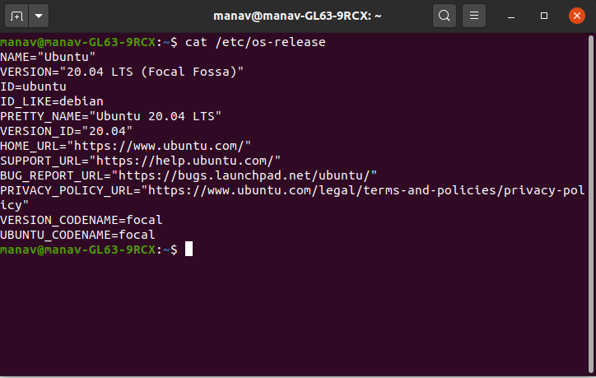

You can also get the **System Information using C programming**. The below code is used to get the details of the system. In this code, *utsname* maintains a structure that has the details of the system like sysname nodename, release, version, etc.

|  |
| --- |
| #include<stdio.h>  #include<stdlib.h>  #include<errno.h>  #include<sys/utsname.h>  int main()  {     struct utsname buf1;     errno =0;     if(uname(&buf1)!=0)     {        perror("uname doesn't return 0, so there is an error");        exit(EXIT_FAILURE);     }     printf("System Name = %s\n", buf1.sysname);     printf("Node Name = %s\n", buf1.nodename);     printf("Version = %s\n", buf1.version);     printf("Release = %s\n", buf1.release);     printf("Machine = %s\n", buf1.machine);  } |

On execution the above code will give the following output:

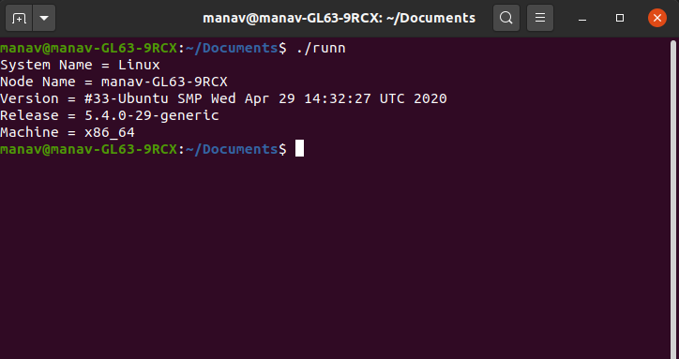

To get Process Information using C programming, use the below code. In this code, we execute the Linux command through a c program to get the details of the process.

|  |
| --- |
| #include<stdio.h>  #include<stdlib.h>  int main()  {     int r=system("cat /proc/1/status");  } |

On execution the above code will give the following output:

