Project 7 – Extreme Value Theory for Tail Risk
S&P 500, 1928–2026: Hill, GPD, McNeil–Frey and out-of-sample backtests — full report
Table of Contents

This report explains Project 7 from start to finish: what was done, why it was done that way rather than another way, how each step was checked, and what it showed. It is written so that someone who has never used extreme value theory can follow it from the first page, and so that it can be used to prepare for interviews for quantitative risk and portfolio risk roles.
Each step uses the same structure:
- What we did – the task, in plain words.
- Why this choice, and not the alternatives – the options we had and the reason we picked one.
- How – the method, the formula and the Python function that implements it.
- How we checked it – how we made sure the code was right before trusting its result.
- What we found – the numbers.
- In plain words – the takeaway in one or two sentences.
Definitions of every equation and variable, with worked examples, are in the separate document Project 7 – Theory Notes; equation numbers in this report refer to it. Chapter 2 explains the ten ideas you need before reading the steps. Chapter 5 gathers all the design choices and their alternatives in one table, and Chapter 9 contains 60 interview questions with short answers.
Conventions. A daily loss is $x_{t}=−100ln\left(S_{t}/S_{t−1}\right)$ in %, where $S_{t}$ is the S&P 500 close: a positive number is a fall of the index. VaR and ES are written as positive losses in %. “99.9% VaR” is the daily loss exceeded on 1 day in 1,000 — about once every four years of trading (252 days a year). Where a money amount helps, we use a USD 10m long position in the S&P 500 and convert the log loss back to a loss of value, $1−e^{−x/100}$. Every out-of-sample forecast for day t uses information up to day t − 1 only.

1. The Question

1.1 The business question
How large can a one-day loss on an S&P 500 position be at the 99.9% level and beyond — once in 10 or 100 years — and which model forecasts such losses reliably, day by day, out of sample?

1.2 Why it matters
Most risk models are built for the centre of the distribution, where there is a lot of data: a 95% or 99% VaR is exceeded 12 or 2–3 times a year, so a few years of history are enough to estimate and test it. But the losses that ruin a fund, break a margin call or wipe out a year of profits are much rarer: the 19 October 1987 crash (−20.5% in one day), the Covid crash of 16 March 2020 (−12.0%), the autumn of 2008. Risk committees, regulators and stress-test teams ask questions about these rare events:
- What is the 99.9% daily loss (once in four years)? Banks’ economic-capital models and many insurers’ models work at 99.9% or 99.5% over one year.
- What is the once-in-a-century daily loss, to size stress scenarios and the capital needed to survive them?
- How sure are we of these numbers?
The standard tools answer badly. A normal distribution makes a 10% daily fall of the S&P 500 a once-in-10¹⁴-years event, although it happened six times since 1928. Historical simulation cannot go beyond the worst loss in its window: with 1,000 days of history there is simply no 99.95% quantile to read. A Student-t has fat tails, but its tail shape is fixed by the fit to the whole distribution, mostly by the centre, so it can be too fat or too thin in the far tail.
Extreme value theory (EVT) is the branch of statistics built for this problem. It says that, whatever the distribution of daily losses, the far tail has a universal shape governed by one number, the tail index ξ. Estimate ξ from the largest losses only, and you can extrapolate the tail beyond the data in a disciplined way.

1.3 Where this project starts
- Projects 1–2: daily returns have fat tails and volatility clusters; GARCH-type models forecast volatility well.
- Project 3: filtered historical simulation (FHS) is the best VaR/ES method for an equity portfolio at 99%; the normal fails.
- Projects 4–6: correlations change; full revaluation beats approximations for bonds and options.
Every project so far worked at 95–99%. Project 7 asks what happens further out, where the data run out, and brings EVT into the out-of-sample framework of the earlier projects through the McNeil–Frey method (GARCH for the level of volatility, EVT for the shape of the tail).

1.4 The plan in one paragraph
We download the S&P 500 since 1927 and clean it (Section 1); measure how fat its tails are (Section 2); estimate the tail index with the Hill estimator (Section 3) and with the peaks-over-threshold method and the Generalized Pareto Distribution (Section 4); turn the tail into VaR and ES at 99–99.9% and into “once in N years” losses, against normal, Student-t and historical benchmarks (Section 5); measure the uncertainty of those numbers (Section 6); show that extremes cluster and remove the clustering with a GJR-GARCH filter (Section 7); run McNeil–Frey and five competitors out of sample from 1931 to 2026 (Section 8); and backtest every method, diagnose the failures and fix the main one (Section 9).

1.5 An analogy
Engineers who design a sea wall need the height of the once-in-a-century wave, but they have only 30 years of wave records. They do not take the highest wave seen (that is historical simulation), nor assume waves are normally distributed (that would make a large storm impossible). They fit a model to the largest waves only and extrapolate. EVT was developed for exactly these problems — floods, wind, insurance claims — and was brought to finance in the 1990s. The S&P 500 gives us 98 years of “wave records” and a few genuine storms.

2. Ten Ideas You Need First
1. VaR and ES (Equation 2). VaR at level q is the loss exceeded with probability 1 − q: VaR 99.9% is exceeded on 1 day in 1,000. ES at level q (Expected Shortfall) is the average loss on the days beyond VaR — “if things go badly, how badly on average”. ES looks into the tail, VaR only marks its entrance, which is why regulators moved from VaR to ES for capital (Basel FRTB, ES 97.5%).
2. A fat tail is a power-law tail (Equation 5). For many financial series, the probability of a loss larger than x falls like $x^{−α}$ for large x: doubling the loss divides its probability by $2^{α}$. The tail index $α$ (or its inverse ξ = 1/α) measures how fat the tail is: α = 3 (ξ = 0.33) is fatter than α = 5 (ξ = 0.2). A normal tail falls much faster than any power, so it corresponds to ξ = 0. A useful fact: moments of order α and above are infinite; with α ≈ 3–5 the variance exists but the higher moments may not.
3. The extreme value theorem (Equation 4). Just as the central limit theorem says that averages become normal whatever the data, the Fisher–Tippett–Gnedenko theorem says that the maximum of many observations, suitably scaled, can only follow one family, the Generalized Extreme Value distribution, with three shapes: ξ > 0 (fat, power-law tail: Fréchet — stock returns), ξ = 0 (thin, exponential tail: Gumbel — the normal), ξ < 0 (bounded tail: Weibull). This is why one number, ξ, describes the tail of almost any distribution.
4. Two ways to use EVT. Block maxima: take the largest loss of each month or year and fit the GEV. It wastes data (one point per block). Peaks over threshold (POT): take every loss above a high threshold u. The Pickands–Balkema–de Haan theorem (Equation 10) says that the excesses $x−u$ then follow a Generalized Pareto Distribution (GPD) with shape ξ and scale β. POT uses all the extreme data, so it is the standard in risk management and the main method of this project.
5. The Hill estimator (Equation 6) is the simplest estimate of ξ: the average of the log of the k largest losses relative to the (k+1)-th largest. It needs no optimisation. Its weakness is the choice of k: a small k uses only the far tail (little bias, much noise); a large k reaches into the body of the distribution (little noise, but biased).
6. The threshold is a bias–variance trade-off. Both Hill and POT require a choice of where “the tail” starts. Too low and the GPD/power law does not hold yet (bias); too high and only a handful of points remain (variance). Tools to choose it: the mean excess plot (linear above a good threshold, Equation 15) and parameter stability (ξ and β − ξu constant above a good threshold).
7. Extrapolation and return levels (Equations 13 and 16). Once ξ and β are known, the tail formula gives the VaR at any level, including levels beyond the data. The “once in N years” loss is the VaR at $q=1−1/\left(252N\right)$: the 10-year loss is the 99.96% VaR, the 100-year loss the 99.996% VaR.
8. Uncertainty grows fast in the tail. The further we extrapolate, the more a small error in ξ is amplified. Confidence intervals are therefore part of the answer: the delta method (fast, symmetric), the profile likelihood (asymmetric, more accurate for extreme quantiles) and the bootstrap (resampling, and with blocks of days, robust to dependence).
9. Extremes cluster, so filter first. EVT assumes independent observations, but large losses come in groups (1929, 2008, 2020). The extremal index θ (Equation 23) measures it: θ = 1 means no clustering, θ = 0.5 means extremes come in pairs on average. The McNeil–Frey method (Equations 24–26) removes the clustering with a GARCH model and applies EVT to the standardised residuals $z_{t}=\left(x_{t}−μ\right)/σ_{t}$: ${\text{VaR}}_{t}=μ+σ_{t} z_{q}^{EVT}$. GARCH sets the level of risk today; EVT sets the shape of the tail.
10. Backtesting rare events is hard (Equations 27–30). At 99.9% we expect 24 breaches in 23,818 days. Kupiec tests the breach count, Christoffersen tests that breaches do not cluster, the exact binomial test replaces Kupiec’s χ² approximation when breaches are few, and Acerbi–Székely Z2 tests whether the losses beyond VaR are as large as ES predicts (negative Z2 = ES too low). A model that passes all three is trustworthy; with so few breaches, the tests have little power, so a long history like ours is a real advantage.

3. Step by Step

Step 1 – Data: the S&P 500 since 1927, cleaned

1.1–1.2 Download
What we did. Downloaded the daily close of the S&P 500 price index (^GSPC) from Yahoo Finance, from 30 December 1927 to 27 October 2026: 24,823 closes, no missing values. The raw file is saved in data/raw/spx.csv and reloaded on later runs.
Why this choice, and not the alternatives.
- The longest free daily history. EVT needs many extremes; 98 years contain the 1929 crash, the Depression, the war, 1987, 2008 and 2020. A post-1990 sample would have a third of the extremes and no 1929.
- The price index, not total return. Daily dividends are about 0.01% a day; they matter for long-run performance, not for daily tail losses. The price index is also what index futures track.
- Yahoo rather than a paid source (CRSP, Bloomberg): free and reproducible; the cost is data quality in the early years, which Steps 1.3–1.5 and 7.4–7.5 deal with.
How. load_yahoo(ticker, start) uses yfinance (imported inside the function, so the package and its tests run without it), keeps the close, removes the time zone and drops missing values.
How we checked it. Known moves: −20.47% on 19 October 1987, −9.03% on 15 October 2008, −11.98% on 16 March 2020. All match.

1.3 Quality checks
What we did. Checked the calendar, stale prices and suspicious moves.
Why. In tail estimation, the data errors that matter are exactly the large ones: a single mistyped close creates two fake extremes (a fall and a rebound). The early data were typed by hand from newspapers.
What we found.
- Calendar. No Saturdays, although the NYSE traded on Saturdays until 1952: Yahoo’s history omits them (about 250 days a year throughout). The longest gaps are explained: 12 days in March 1933 (Roosevelt’s bank holiday), 7 days in September 2001 (markets closed after 9/11).
- Stale prices. 313 days with a zero change (1.3%), mostly in the 1940s (prices quoted in coarse fractions), longest run 3 days: no long stale periods.
- Reversals. 20 moves larger than 5% were almost fully reversed the next day. Most are known crisis days (October 1929, 1931–33, November 2008, March 2020). One stood out: 16 April 1935, −9.97% then +9.61%, in a quiet market — the 5th “largest loss” in the history of the index if it were real.

1.4 Data errors: a volatility-scaled rule
What we did. Measured each reversed move in units of the volatility of the previous 60 days: $z=r_{t}/σ_{t−1}$. A move is suspect if |z| > 6 and the next day undoes more than 80% of it (suspect_reversals).
Why this choice, and not the alternatives.
- An absolute threshold (“any reversed move above 8%”) cannot separate 16 April 1935 (−10% in a calm market) from 29 October 1929 (−10% in the middle of the crash). Volatility scaling does: the same move is ordinary in 1932 and impossible in a calm 1935.
- Removing all reversals would delete the real crisis days — the most important observations of the project.
- Comparing with a second source (e.g. CRSP) would be best, but is not free; the rule plus a look at the neighbouring closes is a transparent substitute.
What we found. Three suspects: 16 April 1935 (|z| = 7.9), 16 August 1935 (|z| = 7.7) and 16 September 1936 (|z| = 6.2). Each is one close out of line with both neighbours (e.g. 9.13 → 8.22 → 9.01). All real crisis reversals have |z| between 1.3 and 4.9, because volatility was already high.

1.5 Removing the bad closes
What we did. clean_closes drops the closes listed in BAD_CLOSES; the return across the gap becomes one correct return. The list has four dates: the three above and 17 April 1961, found later by the second pass (Step 7.5).
Why dropping, not correcting. We do not know the true close; inventing one (e.g. an average of the neighbours) would add a made-up number. Dropping one close merges two daily returns into one, which is exactly correct over the two days.
How we checked it. The joined returns are small (−1.31%, −1.04%, −0.38%); no suspect is left; the crisis days (1929, 1987, 2020) are unchanged. Clean series: 24,819 closes.

1.6 Losses
What we did. $x_{t}=−100ln\left(S_{t}/S_{t−1}\right)$ (Equation 1): 24,818 daily losses, 3 January 1928 to 27 October 2026.
Why log losses. They add up over time (the sum of daily losses equals the total log loss), treat rises and falls symmetrically, and are the standard in the EVT literature. The VaR in log terms is converted back to a loss of value at the end ($1−e^{−x/100}$): 22.90 (log) on 19 October 1987 is a fall of 20.47%.
How we checked it. Sum of losses = $−100ln\left(S_{last}/S_{first}\right)$ = −608.06 exactly.
In plain words. One free series, almost a century long, cleaned of four typing errors that would otherwise have been among the largest “crashes” in the sample.

Step 2 – The tails in the data

2.1 Tail statistics by era
What we did. For the full sample and three eras — 1928–45 (Depression and war), 1946–86 (the calm post-war decades), 1987–2026 (modern crashes) — computed the excess kurtosis, the 99% and 99.9% quantiles relative to a normal with the same standard deviation, and the number of days beyond 5 standard deviations, for losses and for gains (tail_table).
What we found.
 | Full sample | 1928–45 | 1946–86 | 1987–2026
Daily volatility (%) | 1.19 | 1.81 | 0.81 | 1.16
Excess kurtosis | 18.7 | 7.7 | 7.0 | 25.1
99.9% loss quantile / normal | 2.08 | 1.68 | 1.71 | 1.97
Days with a loss > 5 sd | 57 | 7 | 13 | 21
…expected under a normal | 0.007 | 0.001 | 0.003 | 0.003
Largest loss (sd) | 19.3 | 7.7 | 13.0 | 19.8
- The 99.9% quantile is twice the normal one; 57 days beyond 5 sd where a normal expects 0.007 — about 8,000 times too many.
- Every era is fat-tailed, including the calm 1946–86 (kurtosis 7, a 13-sd day on 26 September 1955).
- In 1987–2026 the loss tail is fatter than the gain tail (skew +1.13 for losses; 21 vs 13 days beyond 5 sd): crashes are larger than rallies. In 1928–45 the two tails were similar (the largest rallies of the Depression were as violent as the falls).

2.2 QQ plots
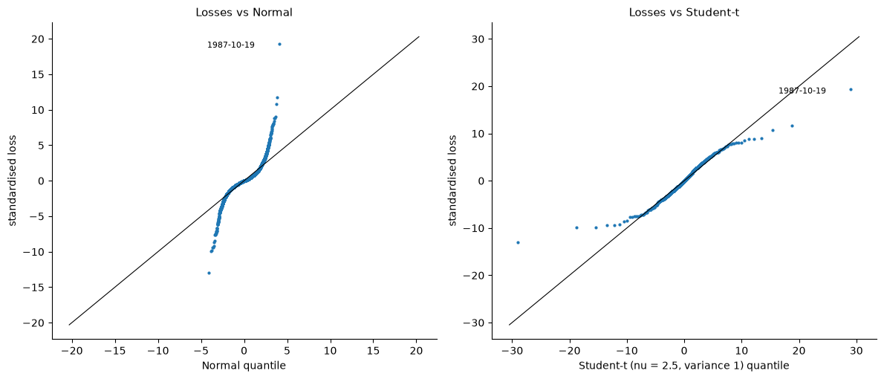
QQ plots of standardised losses against the normal (left) and a Student-t fitted to all days (right)
What we found. Against the normal, the points leave the 45° line from about 2.5 sd: the 99.9% quantile of standardised losses is 6.43 vs 3.09 for the normal. A Student-t fitted to all days needs ν = 2.5 degrees of freedom — barely a finite variance — and then follows the tail reasonably (6.19 at 99.9%), but its tail is dictated by the whole distribution, not by the extremes.
In plain words. The S&P 500’s tails are far from normal in every era. The question is no longer whether the tail is fat, but how fat, measured from the extremes themselves.

Step 3 – The Hill estimator

3.1 Implementation and validation
What we did. hill(x, k) computes ${\hat{ξ}}_{k}=\frac{1}{k}\sum_{i=1}^{k}{ln}X_{\left(i\right)}−lnX_{\left(k+1\right)}$ (Equation 6) for all k at once with a cumulative sum of the sorted logs, and its standard error $\hat{ξ}/\sqrt{k}$ (Equation 7).
Why Hill first. It is the classic tail-index estimator, needs no optimisation, and its Hill plot shows the bias–variance trade-off of the threshold choice that the GPD will face too.
How we checked it. The theory-note example gives ξ = 0.4234, se = 0.1893, as computed by hand. On 24,818 simulated points:
- Pareto (exact power law, ξ = 0.5): errors within about 1.5 se at every k from 50 to 2,500 — Hill is unbiased when the power law holds everywhere.
- Student-t(4) (ξ = 0.25, power law only far out): accurate for k ≤ 250, then biased upwards: error 4.3 se at k = 500, 8 se at k = 1,000, 21 se at k = 2,500.
This second result is the key lesson: for realistic distributions, Hill must use a small share of the data (around 1% or less here).

3.2–3.3 The Hill plot and eras
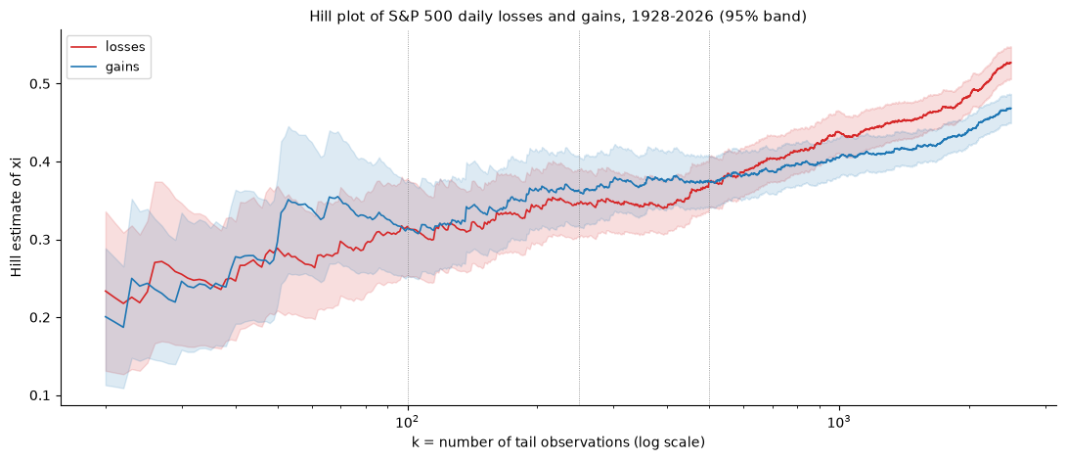
Hill estimate of ξ against k for losses and gains, with 95% bands
What we found. For S&P 500 losses, ξ ≈ 0.29–0.35 for k = 50–250 (α ≈ 3) and then rises steadily (0.44 at k = 1,000, 0.53 at k = 2,500) — the same upward drift as the Student-t simulation, so there is no clean plateau. Gains have almost the same tail (0.30–0.36). By era, at the same share of days, the modern era has the fattest loss tail (ξ ≈ 0.34–0.37) and 1946–86 the thinnest (0.26–0.31). Multiplying all losses by 2 leaves ξ unchanged (scale invariance).

3.4 Hill VaR and ES
What we did. The Weissman extrapolation ${\text{VaR}}_{q}=X_{\left(k+1\right)}{\left(\frac{k}{n\left(1−q\right)}\right)}^{ξ}$ and ES = VaR/(1 − ξ) (Equations 8–9).
How we checked it. On simulated Pareto data, the Hill VaR at 99.9% is 30.4 vs the true 31.6 (within the sampling error of 250 points).
What we found. With k = 150: VaR 99.9% = 7.44% (historical 7.60%, normal 3.64%), ES 99.9% = 10.86%. The VaR is stable for k = 100–250 (7.44–7.66%).
In plain words. Hill confirms a power-law tail with α around 3, and gives a sensible 99.9% VaR, but its tail index depends on k with no clear plateau. We need a method with a formal way to choose the threshold — the GPD.

Step 4 – Peaks over threshold: the GPD

4.1–4.2 The mean excess function
What we did. Computed the mean excess $e\left(u\right)=E\left[X−u∣X>u\right]$ over a grid of thresholds (mean_excess, Equation 15), with standard errors, and fitted a straight line by weighted least squares (weights 1/se).
Why. For a GPD, $e\left(u\right)=\left(β+ξu\right)/\left(1−ξ\right)$ is linear in u with slope ξ/(1 − ξ). So the plot shows where the GPD starts to hold (where the line becomes straight) and gives a first estimate of ξ = slope/(1 + slope). Weighting matters because the right end of the plot rests on very few points.
How we checked it. Exponential data (ξ = 0) give a flat e(u) ≈ 1.00; Pareto α = 2 gives e(u) ≈ u, as theory says.
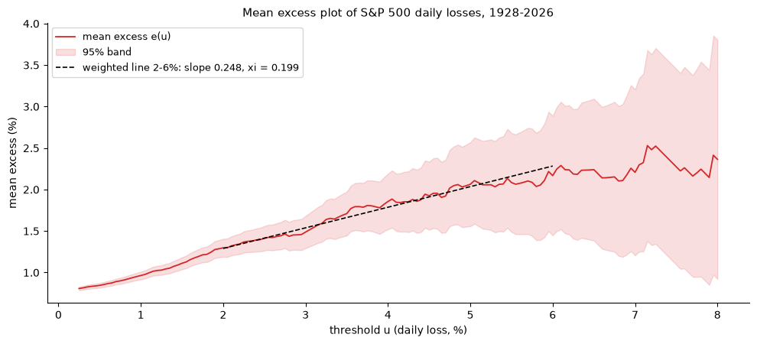
Mean excess plot of S&P 500 losses with a weighted straight line between 2% and 6%
What we found. e(u) rises from 0.85 at u = 0.5% to about 2.2 at 6–8%: an upward slope means ξ > 0. The weighted line from 2% to 6% has slope 0.248, so ξ ≈ 0.20, and the estimate barely changes when the start moves between 1.5% and 2.5%.

4.3 GPD maximum likelihood
What we did. fit_gpd(y) maximises the GPD log-likelihood of the excesses (Equation 11) with Nelder–Mead from method-of-moments starting values, and computes standard errors from the inverse of a numerical Hessian.
Why this choice, and not the alternatives.
- Maximum likelihood is efficient (lowest variance) for ξ > −0.5 and gives standard errors; probability-weighted moments are an alternative for small samples, but we have hundreds of excesses.
- Nelder–Mead needs no derivatives and handles the edge of the valid region (where 1 + ξy/β ≤ 0 the likelihood is −∞) safely; gradient methods can step outside it.
- Writing our own instead of calling scipy: we need the covariance matrix for the confidence intervals and full control of the exponential limit ξ → 0. scipy serves as the check.
How we checked it. On simulated GPD data (ξ = 0.25, β = 0.70), our estimates equal scipy.stats.genpareto.fit to 4 decimals, and the standard error is close to the theoretical $\left(1+ξ\right)/\sqrt{n}$ (0.0090 vs 0.0088 for 20,000 points).

4.4–4.5 Parameter stability and the choice of u
What we did. threshold_stability refits the GPD for every threshold from 1.0% to 4.5% and reports ξ and the modified scale β* = β − ξu, with standard errors.
Why β*. If a GPD holds above u₀ with shape ξ, it holds above any higher threshold with the same ξ and a scale that grows linearly with u; subtracting ξu removes that growth, so both ξ and β* should be flat above a valid threshold.
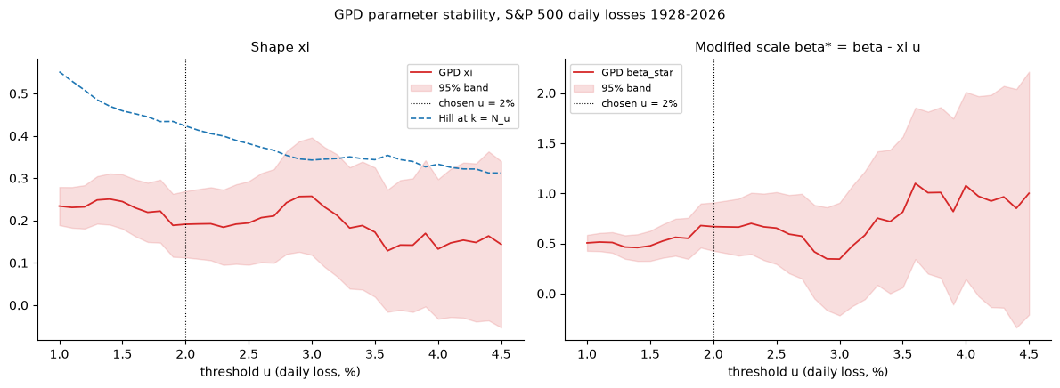
GPD shape ξ (with Hill at the same k) and modified scale β* against the threshold
What we found. ξ stays between about 0.13 and 0.26, inside its 95% band, from 1.0% to 4.4%; β* is flat within its band. We chose u = 2%: the lowest threshold where the mean excess is straight and the parameters are stable, so the most data without visible bias. At u = 2%: 886 exceedances (3.6% of days), ξ = 0.191 (se 0.040), β = 1.050 (se 0.054).
Hill at the same number of points (k = 887) gives 0.42, more than twice the GPD estimate. This is the bias seen on the t(4) simulation: Hill assumes an exact power law from the threshold, the GPD allows a gradual transition, so with a deep threshold the GPD is the more reliable of the two. The GPD’s α = 1/ξ ≈ 5 is therefore our estimate of the tail index, not Hill’s α ≈ 3.

4.6 Goodness of fit
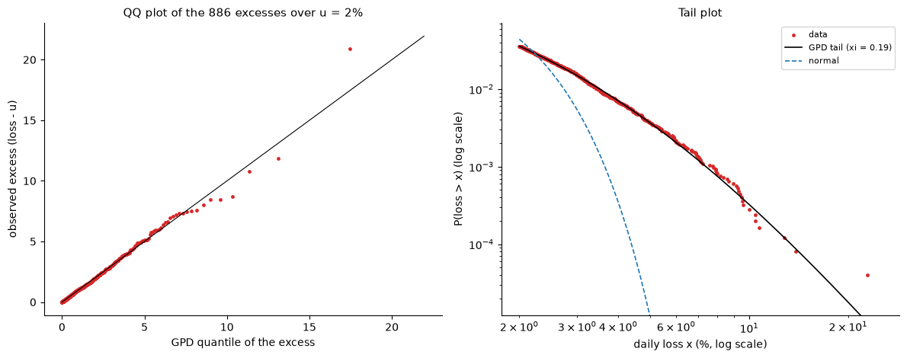
QQ plot of the 886 excesses against the GPD (left); tail plot P(loss > x) on log–log axes with the GPD and the normal (right)
What we found. The QQ plot lies on the 45° line up to excesses of about 8% (losses of 10%); above, there are only four points, with 1987 the largest. The tail plot follows the data over four orders of magnitude of probability, while the normal collapses after 3%.
Daily loss of at least | Days observed (98 years) | GPD: once every | Normal: once every
3% | 378 | 3 months | 9 months
5% | 90 | 1.1 years | 352 years
7.6% | 25 | 4.4 years | 62 million years
10% | 6 | 12 years | 3 × 10¹⁴ years
22.9% (1987) | 1 (the crash itself) | 411 years | 3 × 10⁸⁰ years
In plain words. Above a 2% daily loss, S&P 500 losses follow a GPD with ξ ≈ 0.19: a fat tail, but less fat than Hill or a Student-t suggests. Under this model, 1987 was a once-in-400-years day — extreme, but not impossible, whereas the normal calls it impossible many times over.

Step 5 – Extreme VaR and ES

5.1 GPD VaR and ES
What we did. gpd_var_es turns the tail into VaR and ES (Equations 13–14):
$${\text{VaR}}_{q}=u+\frac{β}{ξ}\left[{\left(\frac{n}{N_{u}}\left(1−q\right)\right)}^{−ξ}−1\right], {\text{ES}}_{q}=\frac{{\text{VaR}}_{q}+β−ξu}{1−ξ}.$$
How we checked it. On 1,000,000 simulated points with an exact GPD tail above 2%, the formulas match the empirical quantiles and tail means (e.g. VaR 99.9% 7.38 vs 7.53, ES 9.95 vs 9.99; the gap is the sampling error of 1,000 points beyond the quantile). In the limit ξ = 0, VaR = 2 + ln 100 = 6.6052, as the exponential formula says.
What we found. The GPD results are stable across thresholds: VaR 99.9% between 7.38% and 7.56% for u from 1.5% to 3%. At u = 2%: VaR 99.9% = 7.38%, ES 99.9% = 9.95% (USD 712k and 947k on a USD 10m position).

5.2–5.3 The benchmarks
What we did. fit_t fits a Student-t by maximum likelihood (L-BFGS-B, bounds ν ∈ [2.05, 200], starting from the median and the MAD); var_es_normal, var_es_t and var_es_hist give the benchmark VaR and ES (Equations 17–19).
How we checked it. fit_t equals scipy on simulated t(4) data and on the S&P 500; every formula matches 2,000,000 simulated draws to two decimals.
What we found. On the S&P 500, the t fit gives ν = 2.54, so its tail index is ξ = 1/ν = 0.39 — twice the GPD’s 0.19. The t has to be that fat to accommodate the high peak in the centre of the distribution, and that makes its far tail too fat.

5.4 Six models side by side
What we found (VaR and ES at 99.9%, % and error relative to historical simulation, which is a reliable reference inside the data):
Model | VaR 99.9% | vs historical | ES 99.9% | vs historical
Normal | 3.64 | −52% | 3.97 | −60%
Student-t (MLE, ν = 2.5) | 8.64 | +14% | 14.34 | +45%
Student-t, sample sd | 7.31 | −4% | 12.13 | +23%
Historical | 7.60 | – | 9.86 | –
Hill (k = 150) | 7.44 | −2% | 10.86 | +10%
GPD (u = 2%) | 7.38 | −3% | 9.95 | +1%
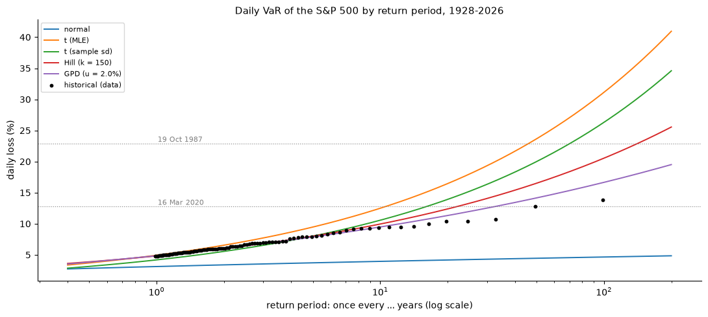
Daily VaR against the return period (log scale) for five models, with the 100 largest losses
Beyond the data, the models diverge widely:
Once every | 10 years | 50 years | 100 years
Normal | 3.95% | 4.45% | 4.65%
Student-t (MLE) | 12.50% | 23.67% | 31.14%
Hill (k = 150) | 9.96% | 16.52% | 20.55%
GPD | 9.49% | 14.16% | 16.66%
The chart shows why the GPD is the most credible: it passes through the empirical quantiles of the 100 largest losses (black dots) up to the 30-year level, while the t curves away above them and the normal stays flat below them. Beyond 30 years there are only two data points, 2020 and 1987, and the models are extrapolating.
In plain words. Inside the data, EVT (GPD and Hill) matches historical simulation within 3%; the normal halves the risk, the MLE Student-t overstates the ES by 45%. Beyond the data — where historical simulation has nothing to say — the once-in-100-years daily loss is about 17% (GPD), a 15% fall in value, or USD 1.5m on USD 10m.

Step 6 – How sure are we? Confidence intervals
A VaR estimated from 886 exceedances is a random number: another century of data would give another ξ. A risk number without its uncertainty invites false precision, and the uncertainty grows quickly as we extrapolate. This step measures it in three ways and then tests which way is honest.

6.1 Delta method
What we did. gpd_var_ci computes the standard error of VaR (or ES) as $\sqrt{∇^{T}\hat{Σ}∇}$ (Equation 20), where $\hat{Σ}$ is the covariance of $\left(\hat{ξ},\hat{β}\right)$ from the inverse Hessian and $∇$ the gradient of the VaR formula, taken numerically; the interval is estimate ± 1.96 se.
How we checked it. The numerical gradient gives se = 0.32630 for the 99.9% VaR, identical to the analytic derivative of Equation 13.
What we found.
 | VaR | 95% interval | width | ES | 95% interval | width
99% | 3.51 | 3.39–3.63 | 7% | 5.17 | 4.85–5.48 | 12%
99.9% | 7.38 | 6.75–8.02 | 17% | 9.95 | 8.53–11.38 | 29%
10 years | 9.49 | 8.32–10.65 | 25% | 12.55 | 10.22–14.89 | 37%
100 years | 16.66 | 12.73–20.59 | 47% | 21.42 | 14.80–28.04 | 62%
The relative width grows from 7% at 99% to almost 50% for the 100-year loss, and ES is always less certain than VaR (it depends on the tail beyond VaR).

6.2 Profile likelihood
What we did. gpd_var_profile_ci re-parametrises the GPD by (ξ, VaR) — solving Equation 13 for β — and for each candidate VaR maximises the likelihood over ξ. The interval keeps every VaR for which $2\left(ℓ_{max}−ℓ_{p}\right)≤3.84$, the 95% χ²(1) quantile (Equation 21); its two ends are found with brentq.
Why this, and not only the delta method. The delta method assumes the estimator is normal and the VaR a linear function of the parameters, so its interval is symmetric. For an extreme quantile neither is true: a slightly larger ξ raises the 100-year loss much more than a slightly smaller ξ lowers it, so the uncertainty is skewed upwards. The profile likelihood follows the actual shape of the likelihood.
What we found. The profile interval for the 99.9% VaR is 6.83–8.14% (1.35 times longer above the estimate than below); for the 100-year loss 13.56–21.84%, 1.67 times longer upwards. The delta method’s upper end (20.59%) is 1.3 points too low. A check: the profile at the estimate equals the maximum log-likelihood at every level.

6.3 Bootstrap: i.i.d. and blocks
What we did. bootstrap_var_es resamples the 24,818 losses 500 times, refits the GPD above 2% and recomputes VaR and ES (Equation 22): once with single days (i.i.d.) and once with moving blocks of 20 consecutive days.
Why blocks. Both previous methods assume independent excesses. Large losses cluster (Step 7), so the effective number of independent extremes is smaller than 886. Resampling blocks of 20 days keeps clusters together, so the spread of the bootstrap estimates includes the extra uncertainty that clustering creates.
What we found. The i.i.d. bootstrap agrees with the profile likelihood (99.9% VaR 6.76–8.05% vs 6.83–8.14%). Blocks widen the intervals by 20–90%: 6.51–8.47% for the 99.9% VaR and 12.78–22.35% for the 100-year loss. The bootstrap ξ ranges from 0.11 to 0.27.

6.4 Coverage: which interval can we trust?
What we did. Simulated 300 samples of 886 excesses from the fitted GPD (whose true VaR we know), computed both intervals on each, and counted how often they contained the truth.
Why. An interval method is only as good as its coverage; this is the only direct test.
What we found.
 | Coverage (target 95%) | Truth above the interval
99.9%, delta method | 96.3% | 2.7%
99.9%, profile | 95.7% | 2.0%
100 years, delta method | 94.0% | 6.0%
100 years, profile | 97.7% | 1.7%
At 99.9% both are fine. At 100 years the delta method misses too often on the dangerous side (the true loss above the interval in 6% of samples, against 2.5% for a balanced interval); the profile likelihood does not.
In plain words. The 99.9% VaR is known to about ±10% (7.4%, between 6.8% and 8.1%), but the 100-year loss only to about ±25% (17%, between 13.6% and 21.8%, wider still once clustering is allowed for). For long return periods use the profile likelihood or a block bootstrap, and report the interval, not only the point estimate.

Step 7 – Clustering of extremes and the GARCH filter

7.1 The extremal index
What we did. extremal_index_runs counts clusters of exceedances: a new cluster starts when more than r days separate two exceedances. θ = clusters / exceedances (Equation 23). We compared with the same losses shuffled, which keeps the distribution but destroys the time order.
Why compare with shuffled data. Even independent data give θ < 1 with the runs estimator (two independent exceedances can fall within r days by chance; θ ≈ ${\left(1−p\right)}^{r}$). The shuffled series shows the value that means “no clustering” for the same estimator.
What we found. At u = 2% and r = 5 days, θ = 0.51 against 0.85 shuffled: large losses come in clusters of about 2 (and 4 with r = 20). The clustering weakens only slowly as the threshold rises (θ = 0.63 at 5%). The largest clusters of losses above 4% are the crises: autumn 1929 (10 days), 1931 (7), 1932 (12), 1937 (9), September–December 2008 (15) and March 2020 (8).
In plain words. Extremes are not independent: one bad day makes another more likely. This breaks EVT’s i.i.d. assumption and, more importantly for risk management, means that the risk of an extreme loss tomorrow depends on today’s conditions. An unconditional 99.9% VaR is the same number in a calm summer and in October 2008.

7.2 GJR-GARCH by quasi-maximum likelihood
What we did. fit_gjr_qml fits a GJR-GARCH(1,1) to the losses (Equation 24):
$$σ_{t}^{2}=ω+\left(α+γ 1\left[x_{t−1}>μ\right]\right){\left(x_{t−1}−μ\right)}^{2}+β σ_{t−1}^{2},$$
by quasi-maximum likelihood (normal likelihood, Equation 25), with SLSQP, bounds and the stationarity constraint α + γ/2 + β < 1.
Why this choice, and not the alternatives.
- GJR rather than plain GARCH: the leverage term γ lets falls raise volatility more than rises (found in every earlier project).
- QML rather than a t likelihood: QML estimates the variance equation consistently whatever the true shock distribution (Bollerslev–Wooldridge). McNeil and Frey deliberately use it so that the tail of the shocks is not assumed but estimated afterwards by EVT. A t likelihood would impose a tail shape that EVT is supposed to measure.
- Our own code rather than arch: the rolling engine needs warm starts and 1,191 fast refits; arch is used as the check.
What we found. α = 0.034, γ = 0.098, β = 0.907, μ = −0.031 (a mean daily gain of 0.03%). Falls raise volatility about four times more than rises ((α + γ)/α ≈ 3.9). Persistence 0.990: a volatility shock halves in 69 trading days. Long-run volatility 17.5% a year. Identical to arch (log-likelihood −32,556.4 vs −32,555.1; the small difference most likely comes from how the first day’s variance is initialised).

7.3 The standardised residuals
What we did. Computed $z_{t}=\left(x_{t}−μ\right)/σ_{t}$ and tested: (1) Ljung–Box on $z^{2}$ (remaining volatility clustering), (2) the extremal index of z against shuffled z, (3) the tail of z.
What we found.
- Ljung–Box (20 lags) on squares: 12,200.8 for the losses, 25.1 for the residuals (p = 0.20, critical value 31.4): the volatility clustering is gone.
- θ of the residuals is close to the shuffled value (0.81 vs 0.85 at the 2% quantile; 0.94 vs 0.98 further out): the clustering of extremes is gone too.
- The tail is still fat: excess kurtosis 4.1, GPD ξ of the upper tail of z = 0.21 (se 0.04). The largest residual is +12.8 (26 September 1955).
In plain words. GARCH removes the clustering but not the fat tail. This is exactly the situation McNeil–Frey is designed for: the residuals are close to i.i.d. (so EVT applies) and fat-tailed (so a normal would be wrong).

7.4–7.6 A fourth data error
What we did. Listed the eight largest residuals with the next day’s move.
Why residuals are a better detector. A residual measures a move against the volatility of its own time. A 3.5% move is unremarkable in 2008 but a 7σ event in a quiet 1961.
What we found. The largest residuals are real events: 26 September 1955 (z = 12.8, the day after President Eisenhower’s heart attack), 13 October 1989 (10.5, the “mini-crash”), 19 October 1987 (8.9). Each is followed by an ordinary day. One date was suspicious: 17 April 1961, +3.48% then −3.61% at a volatility of 0.49% (|z| = 7.1, next day −7.3) with consistent neighbours — the signature of an error. Running the Step 1.4 rule again on moves above 3% (Step 7.5) flagged it and nothing else. It was added to BAD_CLOSES and everything was rerun.
Did it matter? For the GPD, hardly (Step 7.6): ξ 0.190 → 0.191, VaR 99.9% 7.384 → 7.385, 100-year loss 16.62 → 16.66 (all below 0.3%). For the GARCH fit it did: α 0.0365 → 0.0340 and the residual Ljung–Box statistic 30.1 → 25.1, because a fake +3.5%/−3.6% pair in a calm market inflates the estimated reaction to shocks. Lesson: data errors matter most for the models that look at every day (GARCH), less for the ones that look only at the tail; and one error can hide another, so a cleaning rule should be rerun until nothing new appears.

Step 8 – McNeil–Frey out of sample

8.1–8.2 The residual tail models
What we did. residual_var_es gives the standardised VaR and ES of a window of residuals under four models: McNeil–Frey (GPD on the top 10% of the residuals, i.e. 100 of 1,000), normal, Student-t (fitted by MLE) and empirical (FHS). The conditional VaR is then ${\text{VaR}}_{t}=μ+σ_{t} z_{q}$ (Equation 26).
Why the top 10%. McNeil and Frey’s choice: with only 1,000 residuals in a window, a 10% threshold leaves 100 excesses — enough to estimate two GPD parameters — while staying in the tail.
How we checked it (200 simulated windows of 1,000 standardised t(5) residuals, true 99.9% quantile 4.57):
Model | Bias at 99.9% | RMSE at 99.9%
McNeil–Frey (GPD) | −3.4% | 17.1%
Normal | −32.3% | 32.3%
Student-t | −0.3% | 9.2%
Empirical (FHS) | −8.4% | 20.1%
The normal is useless at 99.9%. The t wins here only because the simulated truth is a t — a fair benchmark, not a real-world advantage. The GPD has little bias but a large RMSE: with 1,000 residuals, the 99.9% quantile is uncertain whichever method is used — the first hint of the problem found in Step 9.
On the S&P 500 residuals (full sample), the 99.9% multiplier is 4.73 for McNeil–Frey, 4.18 for the t, 4.63 empirical and 3.09 normal.

8.3–8.5 The rolling engine
What we did. rolling_tail_var produces, for every day from 30 December 1931 to 27 October 2026 (23,818 days), VaR and ES at 97.5%, 99%, 99.5% and 99.9% for six methods:
Method | Volatility | Tail of the shocks
McNeil–Frey | GJR-GARCH | GPD on residuals
GARCH-normal | GJR-GARCH | normal
GARCH-t | GJR-GARCH | Student-t
FHS | GJR-GARCH | empirical residuals
EVT unconditional | none | GPD on raw losses
HS | none | empirical losses
Every 20 days the GJR model is re-estimated on the previous 1,000 days (warm-started from the previous fit) and the four residual models are refitted; σ_t is updated every day with the loss of the day before.
Why this design.
- 1,000-day window: the McNeil–Frey standard; long enough for GARCH, short enough to adapt to regime changes.
- Refit every 20 days, update σ daily: parameters change slowly, σ_t changes daily. Refitting 23,818 times would take hours; this takes 4 minutes with the same forecasts to within noise.
How we checked it.
- Hand check: on 6 January 1932 the engine’s σ (3.93100) and GARCH-normal VaR 99% (9.10145) equal the values recomputed by hand from the block’s parameters.
- Look-ahead test: a fake 30% loss placed on 22 January 1948 leaves every forecast up to and including that day unchanged, and changes only the following days (VaR 99.9% jumps from 5.9% to 63.7% the next day).
- No missing values; 1,191 GJR fits, all converged.
What we found (first look, 99.9% breaches, expected 23.8): McNeil–Frey 45, GARCH-t 47, EVT unconditional 55, FHS 64, HS 72, GARCH-normal 140.

Step 9 – Backtests, diagnosis and the fix

9.1 The tests
What we did. Implemented and checked the four tests:
- Kupiec (Equation 27): likelihood ratio of the observed breach rate against p, χ²(1).
- Christoffersen (Equation 28): adds a test that a breach today does not make a breach tomorrow more likely (Markov chain), χ²(2).
- Exact binomial (Equation 30): with 24 expected breaches the χ² approximation is rough, so the exact binomial p-value is reported too.
- Acerbi–Székely Z2 (Equation 29), written for losses: Z2=1−1Tt​xt 1xt>VaRtp ESt. Zero if ES is right, negative if the losses beyond VaR are larger than ES says. Its 5% critical value is simulated for each level (−0.069, −0.108, −0.160, −0.356 at 99.9%).
How we checked them. 1% hits evenly spaced: Kupiec p = 0.96. 3% hits: everything rejects. 1% hits in pairs: Kupiec accepts (p = 0.91), Christoffersen rejects (p = 0.000) — exactly what each test is for. At 99.9%, 45 hits give p = 0.0001. Z2 with correct normal VaR/ES is +0.02; with losses doubled, −7.5.

9.2 The full table
Level (expected) | McNeil–Frey | GARCH-normal | GARCH-t | FHS | EVT uncond. | HS
97.5% (595.5) | 599 | 751 | 728 | 614 | 652 | 684
99% (238.2) | 258 | 429 | 322 | 287 | 295 | 330
99.5% (119.1) | 137 | 290 | 178 | 161 | 181 | 191
99.9% (23.8) | 45 | 140 | 47 | 64 | 55 | 72
- McNeil–Frey is the best method at every level and passes Kupiec at 97.5%, 99% and 99.5% (p = 0.88, 0.20, 0.11) and Christoffersen at 99.5%. Its Z2 passes at 97.5% but falls below the critical value at 99% and 99.5% (−0.27 vs −0.16 at 99.5%): the ES is somewhat too low.
- The unconditional methods (EVT, HS) have many consecutive breaches (69 and 78 at 97.5%): they cannot react to a crisis.
- GARCH-normal fails everywhere: 5.9 times too many breaches at 99.9%.
- At 99.9% every method fails, McNeil–Frey included (45 breaches, ratio 1.9).

9.3 Diagnosis: why does McNeil–Frey fail at 99.9%?
What we did. Broke the breaches down by era, listed the 45 breach days with the loss in units of σ, σ itself and the GARCH persistence of their window, and measured the share of breaches in windows with unstable GARCH fits (persistence below 0.9).
What we found.
- The failure is not one era: breach ratio 1.15 in 1932–45, 2.04 in 1946–86, 1.99 in 1987–2026.
- The breaches happen in calm markets: median σ on breach days 0.74%, below the median of all days (0.81%); the losses are 3 to 16 σ (1955: 12.7σ; 1987: 16.2σ; 2007-02-27: 7.3σ; 2016-06-24, the Brexit vote: 6.6σ).
- Unstable GARCH windows are not the cause: they hold 14.6% of the days and 13.3% of the breaches.
The cause. In a calm decade, the 1,000-day window (four years) of residuals contains no extreme shock, so the GPD fitted to its top 100 residuals has a thin tail: the median 99.9% multiplier $\left(\text{VaR}−μ\right)/σ$ is only 3.73σ in 1946–86. When a 5σ shock arrives — and the full-sample residuals show they do arrive, about once every few years — the VaR is breached. Volatility is a short-memory quantity (a 1,000-day window estimates it well); the tail shape of the shocks is a long-memory quantity (it takes decades of data to see the rare ones). The rolling window treats both the same way.

9.4 The fix: rolling volatility, expanding residual tail
What we did. expanding_tail_var keeps σ_t and μ from the rolling GJR, but fits the residual tail (GPD and empirical) on all residuals available before day t: the first window’s residuals plus every out-of-sample residual since. It is refitted every 20 days.
Why this, and not the alternatives.
- A longer rolling window (e.g. 5,000 days) would also help the tail, but would make the GARCH parameters slow to adapt; the fix separates the two memories.
- A fatter fixed tail (e.g. imposing ξ = 0.2) uses information from the future of the sample — the full-sample ξ — and so is not a valid out-of-sample test.
- Expanding residuals use only past data, and the residuals are standardised by their own day’s σ, so old and new residuals are comparable.
How we checked it. On the first block the expanding pool equals the rolling window, and the forecasts are identical. Multiplying all losses after 3 January 2000 by 3 leaves every forecast up to that day unchanged (no look-ahead).
What we found. The 99.9% multiplier rises from 3.73σ to 4.95σ in 1946–86 (and from 4.49 to 4.79 in 1987–2026); the backtests:
 | Breaches (expected) | Kupiec p | Christoffersen p | Z2 (critical) | Pass all
97.5%, MF expanding | 573 (595.5) | 0.35 | 0.18 | +0.030 (−0.069) | yes
99%, MF expanding | 213 (238.2) | 0.10 | 0.04 | +0.066 (−0.108) | no (independence)
99.5%, MF expanding | 100 (119.1) | 0.07 | 0.04 | +0.077 (−0.160) | no (independence)
99.9%, MF expanding | 29 (23.8) | 0.30 | 0.57 | −0.376 (−0.356) | borderline (ES)
99.9%, FHS expanding | 30 (23.8) | 0.22 | 0.046 | −0.352 (−0.356) | no (independence, narrowly)
At 99.9%, breaches fall from 45 to 29: Kupiec and Christoffersen pass; Z2 is just below its critical value, so the ES is still slightly too low. At 99–99.5% the expanding version is slightly conservative (ratios 0.84–0.89) and fails Christoffersen narrowly (p = 0.04): the remaining breaches come a little too often in pairs. FHS expanding passes all tests at 97.5% and 99.5%.

9.5 Summary chart
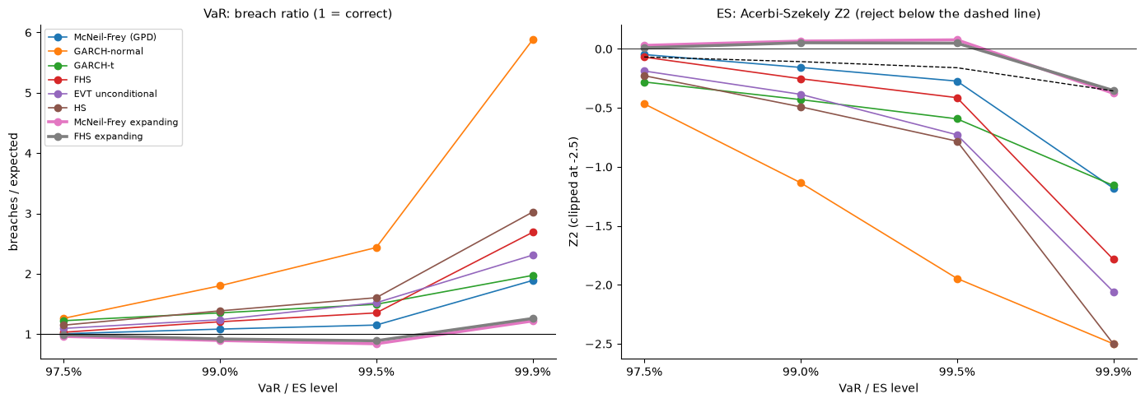
Breach ratio (left) and ES test Z2 (right) by level for the eight methods; expanding methods drawn thick
The left panel shows the rolling methods drifting away from 1 as the level rises, while the two expanding methods stay close to 1 at every level. The right panel shows the same for ES: the expanding methods sit at or above the critical line up to 99.5% and on it at 99.9%.

9.6 Through three crises
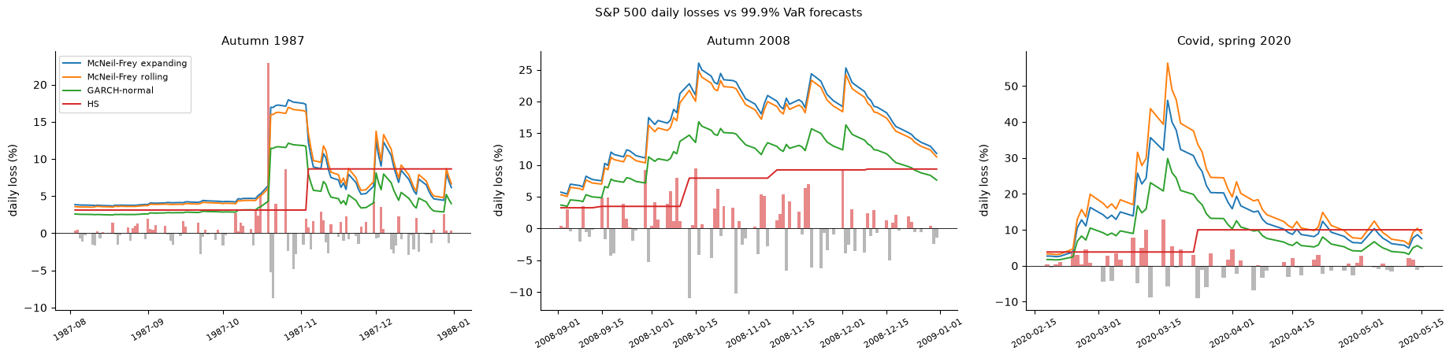
Daily losses (bars) against four 99.9% VaR forecasts in autumn 1987, autumn 2008 and spring 2020
99.9% breaches | Days | MF expanding | MF rolling | GARCH-normal | HS
Autumn 1987 | 106 | 1 | 2 | 3 | 4
Autumn 2008 | 85 | 0 | 0 | 1 | 11
Covid, spring 2020 | 63 | 0 | 0 | 1 | 7
The only expanding breach is 19 October 1987 itself, a 16σ day that no model forecasts. In 2008 and 2020 the GARCH-based forecasts rise within days of the first shock (to 25% in October 2008, over 40% in March 2020), while historical simulation stays flat for weeks and is breached 11 and 7 times.
In plain words. McNeil–Frey is the right idea, but at 99.9% its tail must be estimated from much more data than its volatility. With volatility from the last four years and the tail from the whole past, it passes the coverage and independence tests at 99.9% over 95 years, and is never breached in 2008 or 2020.

4. Conclusions and Recommendation

4.1 Scorecard
Question | Answer
How fat is the tail of S&P 500 daily losses? | GPD above 2%: ξ = 0.19 ± 0.08 (α ≈ 5); Hill 0.29–0.35 but biased upwards
VaR / ES 99.9% (unconditional) | 7.4% / 10.0% (USD 712k / 947k on USD 10m); 95% interval for VaR 6.8–8.1%
Once-in-100-years daily loss | 16.7% (95% interval 13.6–21.8%); 1987 is a once-in-400-years day
How wrong is the normal at 99.9%? | VaR −52%, ES −60%
How wrong is the MLE Student-t at 99.9%? | VaR +14%, ES +45%
Do extremes cluster? | Yes: θ = 0.5 (vs 0.85 if independent); GJR-GARCH removes it
Best out-of-sample method up to 99.5% | McNeil–Frey (rolling): passes Kupiec at 97.5–99.5%
At 99.9% | Every rolling method fails; McNeil–Frey with an expanding residual tail passes Kupiec and Christoffersen, ES borderline

4.2 Main findings
- The tail is fat, but less than simple estimators suggest. The GPD gives ξ ≈ 0.19; Hill and a Student-t fitted by MLE give ξ ≈ 0.3–0.4 because they are pulled by the body of the distribution. The difference matters only beyond the data — inside the data all fat-tailed models agree within 15% for VaR.
- EVT matches history inside the data and extrapolates beyond it. GPD VaR/ES at 99.9% are within 3% of historical simulation; the normal halves them.
- The uncertainty of a 100-year loss is large and skewed upwards (±25%, more with clustering). A single number is misleading; the interval is the answer.
- Extremes cluster, and a GARCH filter removes the clustering but not the fat tail — the premise of McNeil–Frey, confirmed on 98 years of data.
- McNeil–Frey is the best conditional method, but its tail needs long memory. With a 1,000-day window it fails at 99.9% because calm windows contain no extreme shocks. Estimating the residual tail on all past data fixes the breach count (45 → 29, expected 23.8).
- Data quality is a tail-risk issue. Four mistyped closes would have been among the largest daily moves in history; one of them noticeably biased the GARCH fit.

4.3 Recommendation to the risk committee
- Daily VaR/ES at 99–99.9%: McNeil–Frey — GJR-GARCH volatility re-estimated on a rolling window, residual tail (GPD) estimated on all available history. Monitor the 99.9% ES (Z2 borderline).
- Stress testing and capital beyond the data (10–100 years): the unconditional GPD, reported with profile-likelihood or block-bootstrap intervals; plan for the upper end of the interval (about 22% for the 100-year daily loss), not the point estimate.
- Never use the normal for tail risk; avoid a Student-t fitted by MLE for ES at 99.9% (45% too high) and historical simulation in a crisis (11 breaches at 99.9% in autumn 2008).
- Clean the data with a volatility-scaled rule, and rerun it after every correction.

5. The Design Choices and Their Alternatives
Choice | What we did | Main alternatives | Why our choice
Data | S&P 500 price index since 1927 | Post-1990 only; total-return index | Most extremes; daily dividends irrelevant for tail losses
Data errors | Volatility-scaled reversal rule, two passes, drop the bad close | Absolute threshold; interpolate; second data source | Separates errors from crisis days; invents no data
Loss definition | Log loss in % | Simple return | Additive, standard in EVT; converted back at the end
Tail estimator | POT with GPD (main), Hill (comparison) | Block maxima (GEV); Hill only | Uses all extremes; formal threshold diagnostics
Threshold | u = 2% (886 exceedances) | Fixed share (e.g. 5%); automated rules | Lowest threshold with linear mean excess and stable ξ, β*
GPD estimation | MLE, Nelder–Mead, numerical Hessian | Probability-weighted moments; scipy | Efficient, gives covariance; scipy as check
Benchmarks | Normal, t (MLE), historical, Hill | Skewed t; Cornish–Fisher | Standard competitors used by practitioners
Confidence intervals | Delta, profile likelihood, block bootstrap, coverage test | Delta only | Delta is biased for long return periods; coverage shows it
Clustering | Runs extremal index vs shuffled data | Blocks estimator; intervals estimator | Simple, interpretable; shuffling removes estimator bias
Volatility filter | GJR-GARCH(1,1) by QML | GARCH-t likelihood; EWMA | Leverage; QML leaves the tail to EVT
Conditional EVT | McNeil–Frey, top 10% of 1,000 residuals | Fixed threshold in σ units | The published method
Window | 1,000 days, refit every 20 days, σ daily | Daily refit; longer window | Same forecasts, 4 minutes instead of hours
The fix | Rolling σ + expanding residual tail | Longer window; imposed ξ | Separates short-memory volatility from long-memory tail; no look-ahead
Backtests | Kupiec, Christoffersen, exact binomial, Z2 with simulated critical values | Basel traffic light; Z1, Z3 | Coverage, independence and ES size; exact test for few breaches

6. Limitations and Next Steps
- One index. A portfolio needs the dependence between assets in the tail (tail dependence, copulas, multivariate EVT). Next step: apply McNeil–Frey to each asset of a portfolio with FHS of the joint residuals.
- The threshold is a judgement. Results are stable between 1.5% and 3%, but an automated rule would make the choice reproducible.
- The 99.9% ES is borderline (Z2 −0.376 vs −0.356). A slightly lower threshold for the residual GPD, or a bias correction of ξ, could fix it.
- Christoffersen fails narrowly at 99–99.5% for the expanding method: some breaches still come in pairs, so volatility reacts a little too slowly after a first shock (a daily refit or a realised-volatility input could help).
- Data quality. Old data may contain further, smaller errors; a second source (CRSP) would settle it.
- Price index only; dividends ignored; one-day horizon only (a 10-day 99.9% VaR would need simulation of GARCH paths with EVT shocks, as in Project 6).
- Basel traffic light (250-day windows) was not reported; the four tests on 23,818 days are stronger evidence.

7. How the Code Is Organised
evt-tail-risk/
├── src/tailrisk/
│ ├── data.py load_yahoo, BAD_CLOSES, suspect_reversals, clean_closes, losses
│ ├── descriptive.py ERAS, tail_stats, tail_table, ljung_box
│ ├── evt.py hill, hill_var_es, mean_excess, fit_gpd, threshold_stability,
│ │ gpd_var_es, gpd_var_ci, gpd_var_profile_ci, bootstrap_var_es,
│ │ extremal_index_runs
│ ├── benchmarks.py fit_t, var_es_normal, var_es_t, var_es_hist
│ ├── garch.py gjr_variance, fit_gjr_qml, standardised_residuals
│ ├── engine.py LEVELS, METHODS, residual_var_es, rolling_tail_var, expanding_tail_var
│ ├── backtest.py kupiec_test, christoffersen_test, binomial_pvalue,
│ │ acerbi_szekely_z2, z2_critical, backtest_table
│ └── plots.py 8 chart functions, each returning a Figure
├── tests/test_tailrisk.py 32 unit tests on synthetic data with known answers
├── notebooks/01_tail_risk.ipynb 43 numbered steps, 5 questions each, findings per section
├── notes/theory.md theory notes (Equations 1–30)
├── reports/ this report, the theory notes, figures/
└── data/raw, data/processed downloads and saved results (not committed)
Design rules: every function has a docstring with parameters and returns; the notebook only calls functions and prints checks; every chart comes from plots.py and is saved to reports/figures before it is shown; long computations (the out-of-sample run, the bootstrap, the coverage simulation) are saved to data/processed and reloaded. The 32 unit tests check every estimator against a known answer (hand examples, scipy, closed forms, simulation) and the two engines against look-ahead.

8. Glossary
α (tail index). The power of the tail: P(loss > x) falls like $x^{−α}$. Smaller α = fatter tail. α = 1/ξ.
Acerbi–Székely Z2. Backtest of Expected Shortfall: compares the losses beyond VaR with the ES forecast. 0 = correct, negative = ES too low.
Backtest. Comparing out-of-sample forecasts with what actually happened.
β (GPD scale). The scale of the excesses over the threshold, in % of loss. β* = β − ξu is the scale corrected for the threshold, constant above a valid threshold.
Block bootstrap. Resampling blocks of consecutive days rather than single days, so that clusters of extremes stay together.
Block maxima. The EVT approach that fits the GEV to the largest loss of each block (month, year). Wastes data compared with POT.
Breach (exception, hit). A day on which the loss exceeded the VaR forecast.
Christoffersen test. Tests that breaches are independent (a breach today does not make one tomorrow more likely) together with the correct breach rate.
Delta method. Approximate standard error of a function of estimated parameters: $\sqrt{∇^{T}Σ∇}$. Gives symmetric intervals.
Excess. The amount by which a loss exceeds the threshold: y = x − u.
Expected Shortfall (ES). The average loss on the days beyond VaR.
Exponential limit. The GPD with ξ = 0: an exponential (thin) tail, like the normal’s.
Extremal index (θ). Between 0 and 1: the reciprocal of the mean cluster size of extremes. θ = 1 means no clustering.
Extreme value theory (EVT). The statistics of the tails: the maximum, or the excesses over a high threshold, follow universal distributions (GEV, GPD) whatever the underlying distribution.
FHS (filtered historical simulation). Historical simulation of GARCH-standardised residuals, rescaled by today’s volatility.
Fisher–Tippett–Gnedenko theorem. The scaled maximum of i.i.d. observations converges to a GEV distribution.
GEV (Generalized Extreme Value distribution). The limit distribution of maxima: Fréchet (ξ > 0), Gumbel (ξ = 0), Weibull (ξ < 0).
GJR-GARCH. A GARCH model where a fall (here, a loss above its mean) raises the next day’s variance by more than a rise of the same size (γ, the leverage term).
GPD (Generalized Pareto Distribution). The limit distribution of excesses over a high threshold (Pickands–Balkema–de Haan), with shape ξ and scale β.
Hill estimator. The average log of the k largest losses relative to the (k+1)-th: an estimate of ξ that assumes an exact power law above the threshold.
Hill plot. ξ_k against k; a flat region suggests a good k.
i.i.d. Independent and identically distributed: the assumption behind basic EVT.
Kupiec test. Likelihood-ratio test that the breach rate equals 1 − q.
Leverage effect. Volatility rises more after falls than after rises.
Look-ahead bias. Using information from day t or later in a forecast for day t. Our engines are tested against it.
McNeil–Frey. Conditional EVT: GARCH by QML, then GPD on the standardised residuals; VaR_t = μ + σ_t z_q.
Mean excess function. e(u) = average excess over u; linear in u for a GPD.
Moving window / expanding window. A rolling window uses the last N days; an expanding window uses every day since the start.
Peaks over threshold (POT). EVT on every loss above a threshold u, with the GPD.
Persistence. α + γ/2 + β in GJR: how slowly a volatility shock fades. Half-life = ln 0.5 / ln(persistence).
Profile likelihood. The likelihood maximised over the other parameters for each value of the parameter of interest (here VaR); gives asymmetric confidence intervals.
QML (quasi-maximum likelihood). Estimation with a normal likelihood even if the shocks are not normal; consistent for the variance equation.
Return level. The loss exceeded on average once every N years: VaR at $q=1−1/\left(252N\right)$.
Runs estimator. Estimates θ by counting clusters separated by more than r days without an exceedance.
Standardised residual. z_t = (x_t − μ)/σ_t: the shock with volatility removed.
Threshold (u). The loss above which the tail model applies.
Weissman estimator. The Hill-based extrapolation of a quantile beyond the data.
ξ (shape, tail index). The single parameter that governs the far tail: ξ > 0 fat (power law), 0 exponential, < 0 bounded.

9. Interview Preparation: 60 Questions with Short Answers

A. The project in two minutes
1. Describe this project in 30 seconds. I estimated the extreme tail of S&P 500 daily losses over 98 years with extreme value theory — Hill and peaks-over-threshold with a GPD — and compared it with normal, Student-t and historical models. Then I ran McNeil–Frey (GARCH plus EVT on the residuals) out of sample from 1931 to 2026 and backtested it. It works up to 99.5%, fails at 99.9% with a rolling window, and passes when the residual tail is estimated on an expanding window.
2. What is your main result? Unconditional 99.9% daily VaR of 7.4% and ES of 10%; a once-in-100-years daily loss of about 17% with a 95% interval of 13.6–21.8%. Out of sample, McNeil–Frey with rolling volatility and an expanding residual tail brings the 99.9% breaches from 45 to 29 against 23.8 expected, passing Kupiec and Christoffersen.
3. What was the most interesting thing you found? That the failure at 99.9% was not the volatility model but the memory of the tail estimate. Volatility needs a short window; the shape of the shock distribution needs decades. Separating the two fixed the backtest.
4. What would you do differently? Automate the threshold choice, add a second data source to check the early data, and extend to a portfolio with tail dependence between assets.

B. Extreme value theory
5. Why not just use the normal distribution? Because it makes extreme losses essentially impossible: a 10% daily fall would happen once in 10¹⁴ years, yet the S&P 500 had six in 98 years. At 99.9% the normal VaR is half the true one and the ES 60% too low.
6. Why not just use historical simulation? Inside the data it is fine, but it cannot go beyond the worst loss in the window: no 100-year loss from a 4-year window. It also reacts slowly in crises — 11 breaches at 99.9% in autumn 2008.
7. What does EVT say, in one sentence? Whatever the distribution of daily losses, the excesses over a high threshold follow a Generalized Pareto Distribution, whose shape ξ alone determines how fat the tail is.
8. Explain ξ. The tail index. ξ > 0 means a power-law tail where the probability of a loss above x falls like $x^{−1/ξ}$; ξ = 0 is an exponential tail like the normal; ξ < 0 a bounded tail. For the S&P 500, ξ ≈ 0.19, so α = 1/ξ ≈ 5.
9. Block maxima or peaks over threshold? POT: it uses every extreme above the threshold rather than one per block, so it has much lower variance for the same data.
10. How does the Hill estimator work and what is its weakness? It averages the log of the k largest losses relative to the (k+1)-th. It assumes an exact power law above the threshold, so when k is large it picks up the body of the distribution and is biased — upwards for the S&P 500 (0.42 at k = 887 vs 0.19 for the GPD).
11. How did you choose the threshold? With the mean excess plot (linear above a good threshold) and parameter stability (ξ and β − ξu constant above it). I took the lowest threshold where both held: 2%, 886 exceedances, 3.6% of the days. I also showed the VaR is stable for thresholds from 1.5% to 3%.
12. Why is the mean excess function linear for a GPD? Because the excess distribution of a GPD over a higher threshold is again a GPD with the same ξ and a scale that grows linearly with the threshold; its mean, (β + ξu)/(1 − ξ), is therefore linear in u.
13. How did you fit the GPD? Maximum likelihood with Nelder–Mead from method-of-moments starting values, standard errors from the inverse numerical Hessian, checked against scipy to 4 decimals.
14. Why Nelder–Mead? The likelihood is −∞ outside the region 1 + ξy/β > 0, and Nelder–Mead needs no derivatives, so it handles that boundary safely.
15. Give the GPD VaR formula and explain it. ${\text{VaR}}_{q}=u+\frac{β}{ξ}\left[{\left(\frac{n}{N_{u}}\left(1−q\right)\right)}^{−ξ}−1\right]$. N_u/n is the probability of exceeding u; the bracket rescales the GPD quantile for the conditional probability (1 − q)/(N_u/n).
16. And ES? ${\text{ES}}_{q}=\left({\text{VaR}}_{q}+β−ξu\right)/\left(1−ξ\right)$, finite only if ξ < 1.
17. What does ξ ≈ 0.19 imply about moments? Moments of order below 1/ξ ≈ 5 exist: mean, variance, skewness and kurtosis are finite, but the fifth moment is not. Hill’s α ≈ 3 would make the kurtosis infinite — one reason sample kurtosis (18.7 here) is such an unstable number.
18. Why does the Student-t fitted by MLE overstate ES? The MLE fits the whole distribution; to match the sharp peak of daily returns it needs ν ≈ 2.5, which implies ξ = 0.4 in the tail. The far tail is then too fat: ES 99.9% 45% too high.
19. What is a return level? The loss exceeded once every N years on average: the VaR at q = 1 − 1/(252N). The 10-year loss is the 99.96% VaR, the 100-year loss the 99.996% VaR.
20. Was the 1987 crash an outlier? Under the GPD it is a once-in-400-years event: extreme but within the model. Under the normal it is impossible (10⁸⁰ years). Its standardised residual is 16σ, so no conditional model forecasts it either.

C. Uncertainty
21. How confident are you in the 100-year loss? Point estimate 16.7%, profile-likelihood 95% interval 13.6–21.8%; with a block bootstrap 12.8–22.4%. I would plan for the upper end.
22. Why is the profile likelihood better than the delta method there? The delta method assumes a linear, normal approximation, so its interval is symmetric. For extreme quantiles the uncertainty is skewed upwards. My coverage simulation showed it: at 100 years the delta method missed the truth on the high side 6% of the time, the profile likelihood 1.7%.
23. How does the profile likelihood interval work? Re-parametrise the GPD by its VaR, maximise the likelihood over ξ for each candidate VaR, and keep the VaRs whose likelihood is within χ²(1)/2 = 1.92 of the maximum.
24. Why a block bootstrap? Extremes cluster, so the 886 exceedances are not independent and the effective sample is smaller. Resampling 20-day blocks keeps the clusters together; the intervals widen by 20–90%.
25. How did you check your intervals? By simulation: 300 samples from the fitted GPD, where the true VaR is known, and counting how often each interval contains it.

D. Clustering and McNeil–Frey
26. What is the extremal index? θ between 0 and 1, the inverse of the mean cluster size of extremes. I estimated 0.51 at a 2% threshold, against 0.85 for the same losses shuffled — extremes come in pairs or more.
27. Why compare with shuffled data? The runs estimator gives θ < 1 even for independent data. Shuffling keeps the distribution and removes time dependence, so it shows the value that means “no clustering”.
28. Why is clustering a problem for EVT? EVT assumes i.i.d. data; with clustering, the standard errors are too small, and the unconditional VaR ignores that the risk tomorrow depends on today.
29. Explain McNeil–Frey. Fit a GARCH model by QML, standardise the losses by the GARCH volatility, fit a GPD to the upper tail of the standardised residuals, and forecast VaR_t = μ + σ_t z_q^{GPD}. GARCH gives the level of risk today; EVT gives the shape of the tail.
30. Why QML and not a GARCH-t likelihood? QML estimates the variance equation consistently whatever the shock distribution. Using a t likelihood would impose a tail shape that EVT is supposed to estimate.
31. Why GJR and not plain GARCH? The leverage effect: falls raise volatility about four times more than rises in this sample (γ = 0.098 vs α = 0.034).
32. How do you know the GARCH filter worked? Ljung–Box on squared values fell from 12,201 to 25.1 (p = 0.20), and the extremal index of the residuals is close to that of shuffled residuals. But the residuals still have kurtosis 4 and ξ = 0.21 — the tail survives, which is why EVT is still needed.
33. Why the top 10% of residuals in each window? It is McNeil and Frey’s choice: 100 excesses out of 1,000 residuals is enough to fit two parameters while staying in the tail.
34. What is the half-life of a volatility shock? ln 0.5 / ln(0.990) ≈ 69 trading days, about three months.

E. The engine and the backtests
35. How does your out-of-sample engine work? For each day from 1931, the previous 1,000 days are the window; GJR is refitted every 20 days with a warm start; σ_t is updated every day with yesterday’s loss; six methods produce VaR and ES at four levels. 23,818 forecast days, 1,191 fits, about 4 minutes.
36. How did you make sure there was no look-ahead bias? A fake 30% loss inserted on one day must not change any forecast up to and including that day. I tested that, and the same for the expanding engine by tripling all losses after 2000.
37. Why refit every 20 days instead of every day? The parameters change slowly; σ_t, which changes daily, is still updated daily. Daily refits would take hours for no visible gain.
38. Which tests did you use and why four? Kupiec (breach rate), Christoffersen (independence), the exact binomial test (because 24 expected breaches is too few for the χ² approximation) and Acerbi–Székely Z2 (whether ES is large enough). Each catches a different failure.
39. How do you get the critical value of Z2? By simulation under a correct model for the same number of days and level: −0.356 at 99.9% for 23,818 days.
40. What did the backtest show? Rolling McNeil–Frey was the best method at every level and passed Kupiec at 97.5–99.5%. At 99.9% everything failed — McNeil–Frey had 45 breaches against 23.8.
41. How did you diagnose the 99.9% failure? By looking at when and where the breaches happened: across all eras, on calm days (median σ below average), as 3–16σ shocks, and not in windows with unstable GARCH fits. The 99.9% multiplier was only 3.7σ in the calm 1946–86 window: four calm years contain no extreme residual.
42. What was the fix? Keep the rolling GARCH for volatility but estimate the residual tail on all past residuals. Volatility is short-memory, tail shape is long-memory. Breaches fell to 29, Kupiec p = 0.30, Christoffersen p = 0.57.
43. Isn’t the expanding window cheating? No: it uses only residuals before day t, and the look-ahead test confirms it. Imposing the full-sample ξ would be cheating.
44. What still fails? Z2 at 99.9% is just below its critical value (−0.376 vs −0.356), so the ES is slightly too low; and at 99–99.5% Christoffersen rejects narrowly (p = 0.04) — some breaches still come in pairs.
45. How did the models do in 2008 and 2020? The expanding McNeil–Frey had zero 99.9% breaches in both; historical simulation had 11 and 7. Its only breach in autumn 1987 was the crash day itself.
46. Why do unconditional methods fail even when their breach rate looks close? Their breaches cluster in crises (69–78 consecutive breaches at 97.5%), which Christoffersen rejects; their VaR is the same in a calm summer and in October 2008.

F. Data and practice
47. How did you clean the data? A volatility-scaled reversal rule: a move larger than 6 times the previous 60-day volatility and reversed by more than 80% the next day, with consistent neighbours, is a data error. It found four closes (1935, 1935, 1936, 1961), which I dropped rather than corrected.
48. Why not remove every large reversal? Real crisis days are often reversed (October 1929, March 2020); they are the most important data in a tail-risk study. Scaling by volatility separates “large in a crisis” from “impossible in a calm market”.
49. Did the data errors matter? For the GPD hardly (below 0.3%), but for the GARCH fit yes: the 1961 error raised α from 0.034 to 0.037 and the residual Ljung–Box statistic from 25 to 30. In a tail study, a mistyped close becomes one of the largest moves in history.
50. Why log losses? They add up over time, treat both tails symmetrically and are standard in EVT; I convert back to a loss of value for reporting: a 7.38 log loss is a 7.1% fall in value.
51. How would you present the 99.9% VaR to a risk committee? “On a USD 10m S&P 500 position, a one-day loss of about USD 710k is exceeded about once every four years; when it is exceeded, the average loss is about USD 950k. The model has been tested over 95 years of daily data.” Then the stress number with its interval.
52. How would you use this for stress testing? The 100-year daily loss of 17% (up to 22% at the upper end of the interval) is a statistically grounded severe-but-plausible scenario, to sit next to historical scenarios like 1987 and 2008.
53. How does this relate to regulation? Basel FRTB uses ES at 97.5% over 10 days with stressed calibration; economic capital and Solvency II work at 99.5–99.9% over one year. EVT is the standard tool for the far tail in both, and the backtests here are the same as the regulatory ones (plus Z2).
54. How would you extend this to a portfolio? Filter each asset with GARCH, model the joint residuals (FHS of residual vectors, or a copula with EVT margins), then aggregate. The key extra ingredient is tail dependence.
55. What about a 10-day horizon? Square-root-of-time scaling is wrong with fat tails and GARCH. I would simulate GARCH paths with shocks drawn from the EVT residual distribution (as in Project 6’s 10-day engine).

G. Your judgement
56. Which method would you put into production? McNeil–Frey with rolling GJR volatility and an expanding GPD residual tail for daily VaR/ES; unconditional GPD with profile-likelihood intervals for stress and capital.
57. What is the biggest weakness of EVT? The threshold choice and the extrapolation uncertainty. Beyond the data the model is the only source of information, so the interval must be reported.
58. When would EVT give a wrong answer? If the future tail differs from the past one (structural change, a new market structure), if the data contain errors in the tail, or if the threshold is too low. And it says nothing about when an extreme happens unless combined with a conditional model.
59. Why is a 99.9% backtest hard? With 24 expected breaches, the tests have little power; a few years of data would contain 1 or 2 breaches. Our 95 years of out-of-sample data are what make the test meaningful.
60. What did this project teach you as a risk manager? That the tail must be measured from the tail; that a model’s memory should match what it estimates; that uncertainty grows fast beyond the data and must be reported; and that data quality is a tail-risk issue.

