Project 4 – Multivariate Volatility: Rolling, EWMA, CCC and DCC
Final Report: what was done, how and why — with 45 interview questions
Table of Contents

How to Read This Report
This report explains Project 4 from start to finish: what was done, why it was done, how each step was checked, and what it showed. It is written so that someone who has never built a multivariate volatility model can follow it, and so that it can be used to prepare for interviews.
Each step uses the same structure:
- What we did – the task, in plain words.
- Why – the reason for the choice.
- How – the method and the Python function that implements it.
- How we checked it – how we made sure the code was right before trusting the result.
- What we found – the numbers.
- In plain words – the takeaway in one or two sentences.
Definitions of every equation and variable, with worked examples, are in the separate document Project 4 – Theory Notes; equation numbers in this report refer to it. At the end you will find a glossary and 45 interview questions with short answers.

1. The Question

1.1 The business question
How should a buy-side risk team forecast the covariance matrix of a multi-asset portfolio, and does a dynamic-correlation model give better risk numbers and better portfolios than constant or rolling correlations?

1.2 Why it matters
A portfolio’s risk is not the sum of its assets’ risks: it depends on how they move together. For a portfolio with weights $w$ and covariance matrix $H$,
$$σ_{p}^{2}=w′Hw.$$
Every portfolio VaR, every hedge ratio and every optimised allocation is built on $H$. If the correlations in $H$ are wrong, the risk number is wrong even when every single volatility is right.
Example from the theory notes: a 60/40 stock–bond portfolio has a 99% VaR of EUR 160k on EUR 10m if the stock–bond correlation is −0.3, and EUR 187k if it is +0.3. Same positions, 17% more risk, only because one correlation changed sign — which is exactly what happened in 2022 and again in 2026.

1.3 Where this project starts
- Projects 1–2: volatility clusters; GJR-GARCH with Student-t shocks is the best volatility model.
- Project 3: filtered historical simulation (FHS) is the best VaR/ES method — but risk was measured one series at a time, and separately estimated ES were not even consistent (the portfolio ES exceeded the sum of its parts on 18 days). Diversification collapsed when correlations jumped.
Project 4 builds one joint model for several assets and asks whether making correlations dynamic is worth it.

1.4 The portfolio
A European buy-side investor holding five assets, all measured in EUR: CAC 40, DAX, S&P 500, German government bonds (Bunds, 5.5–10.5 years) and gold. The main portfolio is a classic balanced 60/30/10: 20% in each equity index, 30% Bunds, 10% gold, rebalanced daily. We also build, every day, the minimum-variance portfolio implied by each model.

1.5 An analogy
A covariance forecast is like a weather map for a fleet of ships. Each ship’s own risk (volatility) matters, but so does whether storms hit them at the same time (correlation). A fleet that spreads its ships across regions is safe only if the regions don’t get storms together — and in a big storm, they often do.

2. Six Ideas You Need First
1. The covariance matrix = volatilities × correlations. $H_{t}=D_{t}R_{t}D_{t}$, where $D_{t}$ holds the volatilities and $R_{t}$ the correlations. CCC and DCC model the two parts separately.
2. A covariance matrix must be positive definite. No combination of assets can have zero or negative variance. A matrix that is nearly singular (smallest eigenvalue close to 0) suggests a combination that looks almost risk-free — usually an illusion created by estimation noise.
3. Correlations can change, and even change sign. The stock–bond correlation was strongly negative in 2008–2012 and positive in 2026. A constant correlation cannot describe this.
4. DCC is a GARCH for correlations. $Q_{t}=\left(1−a−b\right)\overset{‾}{Q}+a ε_{t−1}ε_{t−1}′+b Q_{t−1}$: a reaction to yesterday’s joint shock ($a$), persistence ($b$), and a pull back to the long-run level ($\overset{‾}{Q}$). Two parameters for all pairs.
5. The true covariance is never observed. Forecasts are judged against the noisy proxy $y_{t}y_{t}′$ with a loss function (QLIKE) that still ranks models correctly.
6. Out of sample, no look-ahead. Every forecast for day $t$ uses data up to $t−1$; models are estimated on a 1,000-day window and judged on the following days: 3,602 days, January 2012 – October 2026.

3. Step by Step

Step 1 – Data

1.1 Downloading and choosing the series
What we did. Downloaded from scratch the three equity indices, two candidate bond ETFs (US Treasuries IEF; German Bunds EXHD and EXHA), two gold series (the GLD ETF and COMEX futures GC=F), both the traded price (Close) and the price adjusted for payouts (Adj Close), and EUR/USD from the Federal Reserve (FRED). Everything is saved, so later runs do not depend on the internet.
Why these choices.
- Bond: German Bunds, not US Treasuries. A European fund holds euro government bonds. US Treasuries converted into EUR become mostly a currency bet: EUR/USD is more volatile than the bond itself (IEF: 6.8% a year in USD). The cost is history: Yahoo’s Bund ETF series starts in January 2008.
- Gold: GLD, not futures. Futures jump on contract-roll days; these jumps are not real returns. GLD holds physical gold, has no rolls, and starts in 2004 — earlier than the Bund, so the futures’ longer history adds nothing.
- Why both prices? A bond ETF’s return is mostly its coupons, which only the adjusted price includes. Comparing Adj Close with Close at the first date shows how much the adjustment adds (Bund ETFs 0.83–0.86, IEF 0.49; indices and gold exactly 1, as expected).

1.2 Quality checks and the Bund problem
What we did. For each series: share of zero returns (stale prices), longest run of unchanged prices, worst and best day with dates.
What we found. Equities and gold were clean, with extremes on known dates (12 March 2020, 13 October 2008, the Lehman week for gold). Gold’s −10.27% on 30 January 2026 was confirmed by the futures (−10.78% the same day). But the four largest Bund moves were all in mid-May (2009–2012, −2.6% to −3.5%). Market crashes don’t happen every May.
Diagnosis.
- Yahoo’s payout history for this ETF starts only in 2013. From 2013, the adjustment is exactly right: on every ex-date, adjusted return − close return = payout yield (0.599 vs 0.600, 0.545 vs 0.545, …).
- Before 2013, Adj Close was just Close × 0.826: the annual May payouts (about 3% when Bund yields were about 3%) were not adjusted, and looked like crashes.
- A systematic search found 8 unadjusted payouts: February and May 2008, May 2009–2011, and May, August and November 2012 (when the fund switched to quarterly payouts).
The fix (total_return). We rebuilt the total return ourselves: $R_{t}=\left(P_{t}+D_{t}\right)/P_{t−1}−1$, using Yahoo’s payouts from 2013 and, for the 8 missing ones, the price drop on the ex-date (so the return on those days is set to 0%). The error of this estimate is at most one normal day’s move (about 0.3%), against a 2–3.5% fake drop.
How we checked it.
- From 2013 our series equals Yahoo’s adjusted return (to 0.003%, Yahoo’s rounding).
- The implied yearly payout yield follows Bund yields: 3.3–3.7% in 2008–2011, falling to 1.4% by 2016 (4.5% in 2012, a transition year with annual and quarterly payouts).
- After the fix, every extreme Bund day is a real event: 5 March 2025 (−2.08%, the German fiscal package), 18 March 2020 (−1.72%, Covid “dash for cash”), 15 March 2023 (+2.56%, SVB / Credit Suisse).
What we found. Bund volatility fell from 5.37% to 5.11%: 8 fake days out of 4,778 added 5% of the measured risk.
In plain words. “Adjusted” data from a free source can be wrong for years. Checking extremes against known events is the first job of any model validation.

1.3 Returns in EUR on a common calendar
What we did (return_index, eur_returns). Turned the Bund’s total return into a price index, kept only days on which all five prices and the FX rate exist, computed simple returns between those days, and converted the S&P 500 and gold into EUR: $R^{EUR}=\left(1+R\right)/\left(1+R_{X}\right)−1$.
Why. A covariance matrix needs every return to cover the same time interval. Filling holidays with the last price would create fake 0% returns that lower both volatility and correlation.
How we checked it. The Bund index reproduces the total return to 2e-14; with a constant exchange rate, the EUR return equals the USD return exactly.
What we found. 4,602 common days, 3 January 2008 – 16 October 2026.
 | CAC 40 | DAX | S&P 500 (EUR) | Bund | Gold (EUR)
Annual volatility | 21.9% | 21.7% | 20.5% | 5.2% | 17.9%
Correlation with CAC 40 | 1 | 0.92 | 0.48 | −0.29 | −0.09
Two details: the S&P 500’s correlation with the Bund is only −0.09, because in EUR it also carries the dollar move and because the US closes 4.5 hours after Europe; and the famous 13 October 2008 rally appears on 14 October, because FRED publishes no EUR/USD rate on Columbus Day.

1.4 The portfolio and the first sign of changing correlations
What we did. Built the 60/30/10 portfolio (portfolio_returns) and computed the stock–Bund correlation calendar year by calendar year.
What we found.
- Portfolio volatility 11.05% a year, against 16.18% if everything moved together: diversification removes 32% of the risk (12% in Project 3 with equities only).
- The yearly stock–Bund correlation: −0.70 in 2011, about −0.25 in 2013–2021, about 0 in 2022, and +0.62 in 2026.
The 2026 value was checked three ways because it is extreme: the other Bund ETF gives +0.64; without the 10 biggest equity days it is still +0.57; and month by month it is +0.41 to +0.84 from March to September 2026, after −0.52 in February. It is a real regime change.
In plain words. The “safe” asset hedged equities for 14 years, stopped hedging in 2022, and added to risk in 2026. Any model with a fixed correlation is wrong for part of the sample.

Step 2 – Covariance basics and rolling correlations
What we did (portfolio_variance, rolling_cov, cov_to_corr, pair_series). Wrote the basic tools for stacks of daily matrices: $w′Hw$, the rolling-window covariance forecast (average of $yy′$ over the previous 250 or 60 days), and correlations.
How we checked it.
- $w′Hw$ = 0.472 against 0.47216 on 1 million simulated returns.
- The rolling forecast equals a direct matrix product to 1e-15.
- An exact identity: the rolling $w′H_{t}w$ equals the rolling mean of the portfolio’s squared returns (1e-15).
- Every correlation matrix is symmetric, has ones on the diagonal and is positive definite.
What we found.
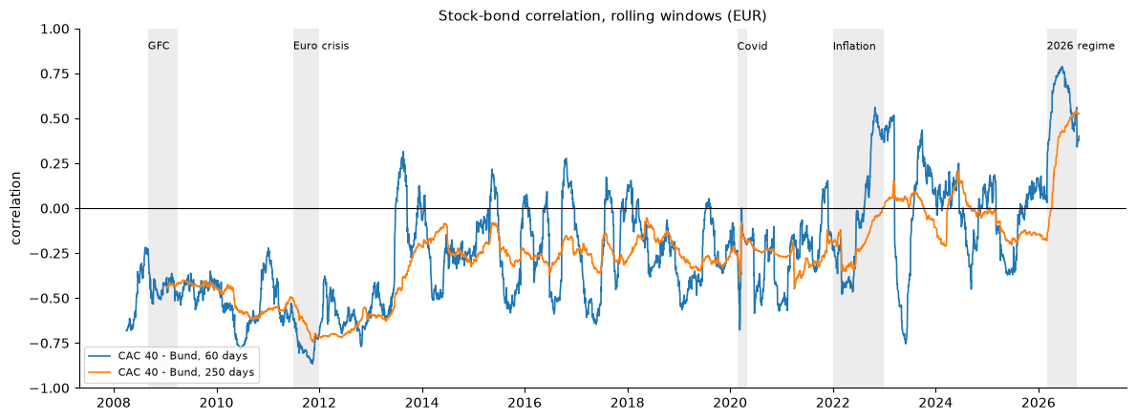
Stock-bond correlation, rolling windows
- The stock–bond correlation ranges from −0.87 (November 2011) to +0.79 (June 2026) on 60 days; −0.75 to +0.55 on 250 days.
- The 250-day window is late: in March 2026 the 60-day correlation had crossed zero while the 250-day one was still −0.17; it only peaked in September.
- Correlation can flip within weeks: in March 2023 (SVB) the 60-day value fell from +0.5 to −0.75.
- The smallest eigenvalue is only 0.029: CAC 40 and DAX are almost the same asset, so “long CAC, short DAX” looks almost risk-free. This becomes important for portfolio construction (Step 10).
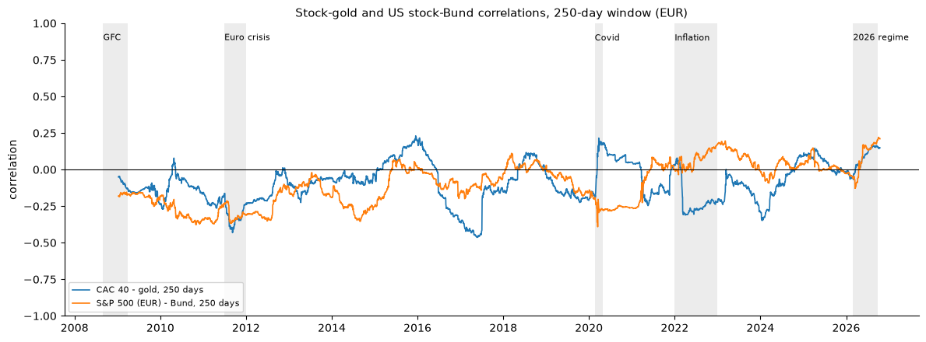
Stock-gold and US stock-Bund correlations
The CAC–gold correlation shows the ghost effect: it jumps in March 2020 (gold was sold with stocks in the dash for cash) and drops back exactly one year later, when those days leave the window — nothing happened in March 2021.

Step 3 – EWMA covariance (RiskMetrics)
What we did (ewma_cov). $H_{t}=\left(1−λ\right) y_{t−1}y_{t−1}′+λH_{t−1}$ with λ = 0.94 (half-life of a day’s weight: about 11 days).
Why. Old days fade gradually instead of dropping out on one date: no ghost effect, fast reaction, no estimation.
How we checked it. Each element equals pandas’ ewm on the cross-products (1.5e-14); one day computed by hand gives exactly the same matrix; every matrix is positive definite.
What we found.
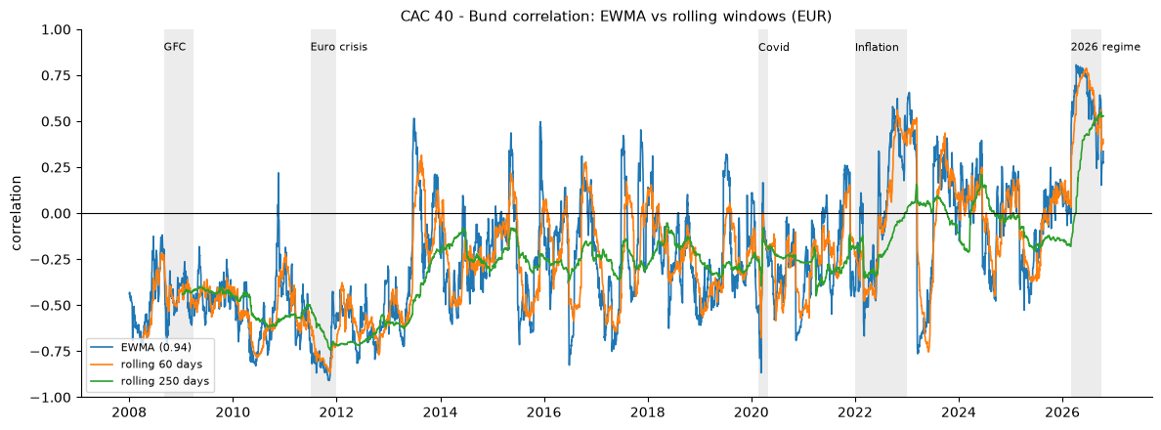
EWMA vs rolling windows
 | First positive day after 1 March 2026 | Average daily change of the correlation
EWMA | 3 March | 0.032
Rolling 60 days | 2 March | 0.016
Rolling 250 days | 2 April | 0.004
- Speed costs noise: EWMA is as fast as the 60-day window but twice as noisy, and 8 times noisier than the 250-day one.
- EWMA has the lowest smallest eigenvalue of all models (0.0065, August 2021): a short memory makes calm-period matrices nearly singular.
- (The date we first chose to show the ghost effect, 16 March 2021, missed the step; the chart shows it in March 2024, when the SVB days left the 250-day window.)
In plain words. A faster forecast is a noisier forecast. DCC tries to get the speed with less noise by estimating the right speed from the data.

Step 4 – One volatility model per asset, and constant correlation (CCC)

4.1 GJR-GARCH Student-t per asset
What we did (fit_gjr_t, gjr_variance). Estimated, for each asset, $σ_{t}^{2}=ω+\left(α+γI_{t−1}\right)y_{t−1}^{2}+βσ_{t−1}^{2}$ with Student-t shocks — written fresh for this project.
How we checked it. Our γ and ν equal those of the arch package to 3–4 decimals for all five assets; all fits converge; the standardised residuals have variance 0.99–1.01.
What we found.
 | α | γ | Half-life | Reading
CAC 40 | 0.000 | 0.228 | 55 days | volatility reacts only to falls
DAX | 0.000 | 0.199 | 49 days | same
S&P 500 (EUR) | 0.004 | 0.205 | 26 days | same, forgets faster
Bund | 0.045 | 0.005 | 214 days | symmetric, long volatility regimes
Gold | 0.077 | −0.024 | 62 days | inverse leverage; ν = 5.6, fattest tails
In plain words. Each asset has its own volatility personality. EWMA’s single 11-day half-life is wrong for all of them.

4.2 CCC
What we did (qbar, ccc_cov). CCC uses each asset’s GJR volatility and one constant correlation matrix $\overset{‾}{R}$: the correlation of the standardised residuals. $H_{t}=D_{t}\overset{‾}{R}D_{t}$.
How we checked it. $\overset{‾}{R}$ is a valid correlation matrix; the diagonal of every $H_{t}$ equals the GJR variances (1e-14); the correlations of every $H_{t}$ equal $\overset{‾}{R}$ (4e-16).
What we found. The residual correlations are slightly lower than the raw ones for equity pairs and less negative for stock–Bund (by about 0.02–0.04): part of what looks like correlation in crises is really volatility — when everything moves a lot, everything seems more related. But CCC’s stock–Bund correlation is −0.24 on every day, in 2011 (real −0.70) and in 2026 (real +0.62).

Step 5 – DCC: dynamic conditional correlation

5.1 The recursion
What we did (dcc_correlations). Equations 10–11: $Q_{t}=\left(1−a−b\right)\overset{‾}{Q}+a ε_{t−1}ε_{t−1}′+b Q_{t−1}$, rescaled to an exact correlation matrix $R_{t}$.
How we checked it.
- The theory-note example: after a joint crash day (shocks −3 and −2.5), the correlation rises from 0.50 to 0.639, exactly.
- With $a=b=0$, DCC equals CCC exactly (CCC is nested in DCC).
- Every $R_{t}$ is a valid correlation matrix on our data.

5.2 Likelihood and estimation
What we did (dcc_loglik, fit_dcc). The second step of the two-step estimation maximises the correlation part of the Gaussian log-likelihood, ℓC=−12t​lnRt+εt′Rt−1εt−εt′εt, over $\left(a,b\right)$.
How we checked it.
- Our likelihood equals scipy’s multivariate normal log-density, up to a known constant, to 6 decimals.
- Simulation: on DCC data generated with $a=0.05$, $b=0.93$, the estimation recovers 0.052 and 0.928.

5.3 Results on the five assets
What we found (full sample, 2008–2026).
- a = 0.031, b = 0.945, half-life of a correlation shock 28 days. The data ask for slower, mean-reverting correlation dynamics than RiskMetrics (11 days, no long-run level).
- Correlations are not constant: LR = 888.8 (log-likelihood 5,229.8 for DCC vs 4,785.4 for CCC), p ≈ 10⁻¹⁹³. Two extra parameters improve the fit by 444 log-points.
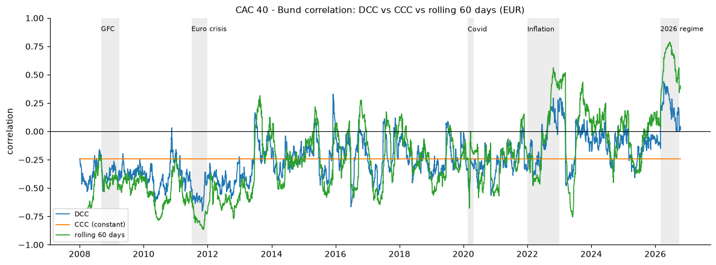
DCC vs CCC vs rolling
- DCC’s stock–bond correlation goes from −0.70 (November 2011) to +0.44 (9 April 2026), with half of EWMA’s noise (0.018 a day) and no ghost effects.
- But DCC is “muted”: in 2026 it peaks at +0.44 while the 60-day window reaches +0.79, and by October it is back near 0. Two reasons: it always pulls correlations back towards their long-run level (−0.24), and one $\left(a,b\right)$ must fit all 10 pairs, including CAC–DAX, which barely moves.
In plain words. DCC sees a regime change quickly but doesn’t believe it will last.

Step 6 – Correlations and portfolio risk in crises (in-sample)
What we did (dcc_cov). Averaged the DCC correlations and the forecast portfolio volatilities (DCC and CCC) over calm days and five stress periods, and compared them with the realised volatility.
What we found.
Average DCC correlation | Calm | GFC | Euro crisis | Covid | 2022 | 2026
CAC–S&P | 0.45 | 0.49 | 0.46 | 0.64 | 0.41 | 0.38
CAC–Bund | −0.25 | −0.38 | −0.57 | −0.36 | −0.08 | +0.23
CAC–gold | −0.08 | −0.13 | −0.22 | +0.08 | −0.04 | +0.09

Portfolio vol (60/30/10) | Realised | DCC | CCC
Calm | 8.92% | 8.93% | 8.94%
GFC | 27.63% | 24.20% | 24.34%
Euro crisis | 16.40% | 15.74% | 16.74%
Covid | 34.78% | 30.81% | 29.00%
2022 | 12.04% | 11.67% | 11.36%
2026 | 10.27% | 9.38% | 8.48%
- Equities move together in crashes; Bunds hedged the old crises but not the new regimes; gold hedged the GFC and euro crisis, not Covid.
- In calm markets the correlation model barely matters. In four of five stress periods DCC is closer to the realised volatility; in 2026 CCC is 17% too low, DCC 9%. The exception is the euro crisis, where DCC was too optimistic about the Bund hedge.
- Every model is too low in every crisis: forecasts react only after the first big days.

Step 7 – Out-of-sample forecasts
What we did (rolling_ccc_dcc). For each 20-day block: estimate the five GJR models and DCC on the previous 1,000 days only (with $\overset{‾}{Q}$ and $\overset{‾}{R}$ from the window), run the recursions through the block, and keep the block’s forecasts. Rolling-window and EWMA forecasts need no estimation and were cut to the same days.
How we checked it.
- Look-ahead test: a fake −20% day leaves every forecast up to and including its own day exactly unchanged, and changes the next day’s.
- Shapes and dates; CCC and DCC share identical variances.
What we found. 3,602 days (23 January 2012 – 16 October 2026), 181 re-estimations, all converged (5.9 minutes), every matrix positive definite. DCC parameters move across windows: $a$ from 0.021 to 0.045, $b$ from 0.87 to 0.946.

Step 8 – Which covariance forecast is best?
What we did (qlike_matrix, qlike_portfolio, diebold_mariano).
- Matrix QLIKE $ln\left|H_{t}\right|+y_{t}′H_{t}^{−1}y_{t}$: judges every direction, including all correlations.
- Portfolio QLIKE: judges only the 60/30/10 portfolio.
- Diebold–Mariano with Newey–West standard errors (10 lags).
How we checked it. For one asset, matrix QLIKE equals the univariate QLIKE; $−\frac{1}{2}\left(L_{t}+Nln2π\right)$ equals scipy’s log-density (1e-13); a model against itself plus noise gives an insignificant DM.
What we found.
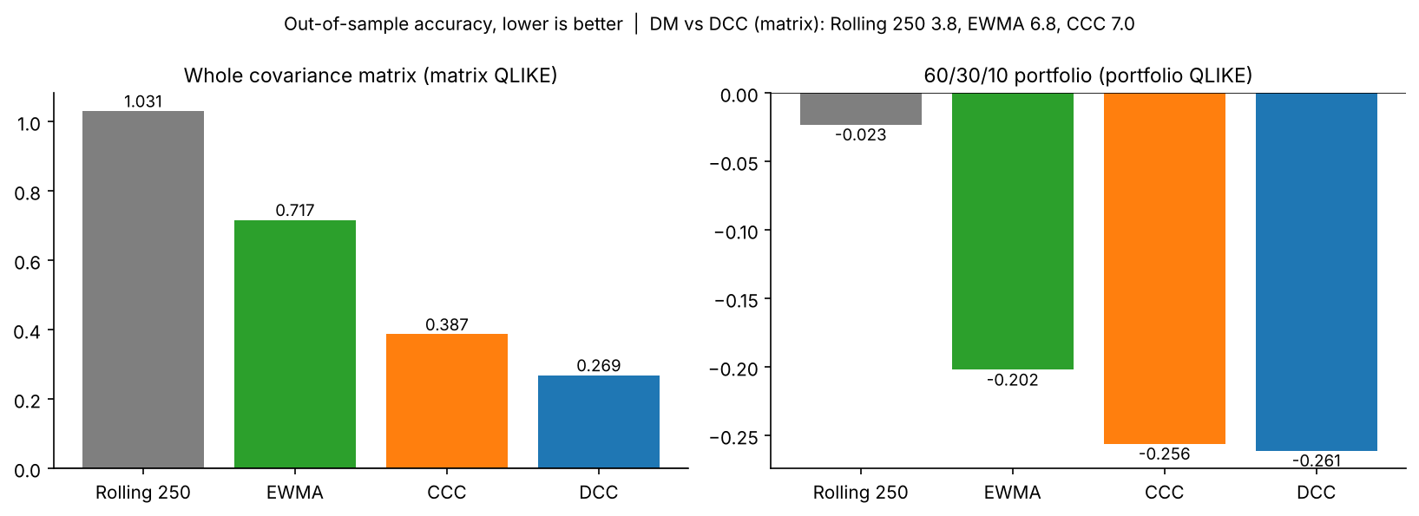
Out-of-sample scores
 | Rolling 250 | EWMA | CCC | DCC
Matrix QLIKE | 1.031 | 0.717 | 0.387 | 0.269
DM vs DCC | 3.8 | 6.8 | 7.0 | –
Portfolio QLIKE | −0.023 | −0.202 | −0.256 | −0.261
DM vs DCC | 3.4 | 3.9 | 1.85 (n.s.) | –
- For the whole matrix, DCC wins clearly, significantly against every model.
- For the 60/30/10 portfolio, DCC and CCC are tied: the GJR volatilities do most of the work for one balanced portfolio; correlation dynamics matter for other directions (hedges, long–short positions, minimum variance).
- By period: DCC best on calm days, in Covid and in 2022. In 2026, EWMA (1.488) ≈ DCC (1.499) and CCC is worst (1.769): a lasting new regime favours fast forgetting.

Step 9 – Portfolio VaR and ES
What we did (var_es_normal, var_es_fhs, backtests). For each model, $σ_{p,t}=\sqrt{w′H_{t}w}$, then VaR 99% and ES 97.5% with normal tails, or with FHS on each model’s own past standardised portfolio residuals (at least 250). Backtested on 3,352 days (February 2013 – October 2026) with Kupiec, Christoffersen and Acerbi–Szekely, rewritten for this project.
How we checked it. Normal multipliers 2.3263 and 2.3378; FHS converges to them on simulated normal data; a fake extreme residual does not change its own day’s VaR.
What we found.
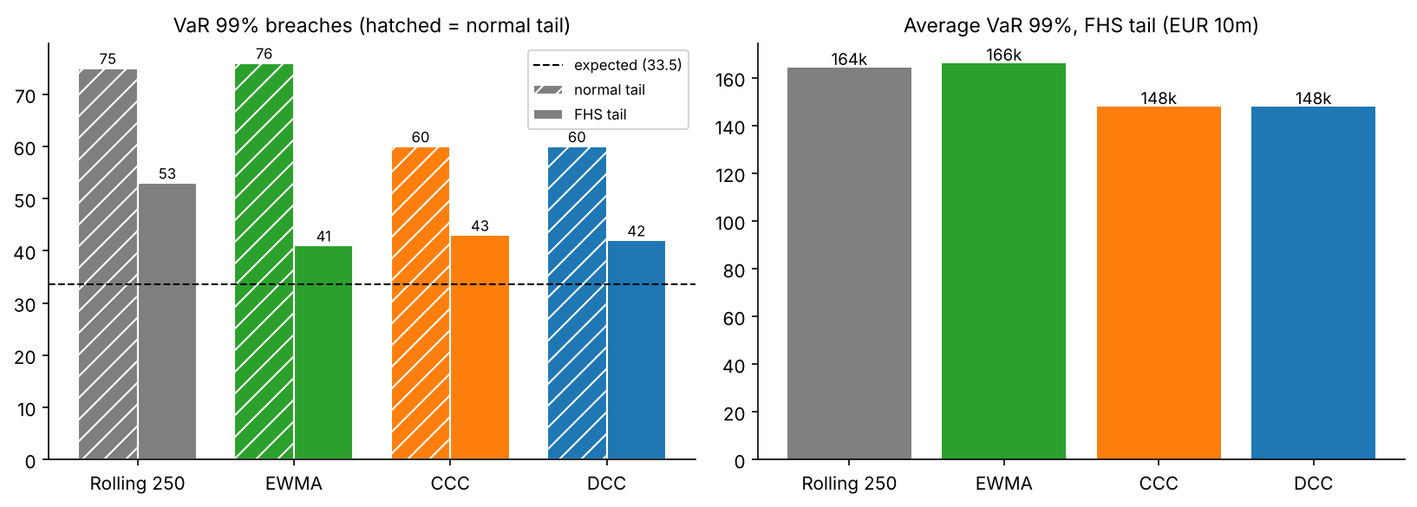
VaR backtest
FHS tails | Breaches 99% (33.5) | Consecutive | $p_{cc}$ | Breaches 97.5% (83.8) | Z₂ | Avg VaR 99%
Rolling 250 | 53 | 11 | 0.000 ✗ | 114 | −0.45 | EUR 164k
EWMA | 41 | 2 | 0.12 | 88 | −0.10 | EUR 166k
CCC | 43 | 1 | 0.25 | 94 | −0.14 | EUR 148k
DCC | 42 | 1 | 0.31 | 96 | −0.16 | EUR 148k
- Normal tails fail with every covariance model (60–76 breaches; Z₂ −0.44 to −0.70): the lesson of Project 3 again.
- The rolling window fails even with FHS: its slow volatility produces streaks of breaches. No tail correction fixes bad timing.
- CCC and DCC pass with 11% less VaR than EWMA: noisier volatility forecasts give noisier residuals and bigger FHS multipliers. A better covariance model makes the same safety cheaper.
- DCC’s Z₂ (−0.16) is close to the approximate critical value (−0.17); on ES, DCC, CCC and EWMA cannot be separated without simulated p-values.

Step 10 – Minimum-variance portfolios
What we did (min_variance_weights, turnover). Every day, each model builds the minimum-variance portfolio $w_{t}=H_{t}^{−1}1/\left(1′H_{t}^{−1}1\right)$ (fully invested, shorts allowed). We measured its realised volatility, its turnover, a Diebold–Mariano test on squared returns (Engle–Colacito), and returns net of trading costs of 2, 5 and 10 basis points.
Why. The minimum-variance portfolio depends only on the covariance and uses every correlation through $H^{−1}$: the test where correlation quality matters most — and where estimation noise turns into extreme positions.
How we checked it. Two-asset weights equal the closed form (21% stocks, 79% bonds); weights sum to 1 every day; the minimum-variance portfolio always has a lower forecast variance than 60/30/10.
What we found.
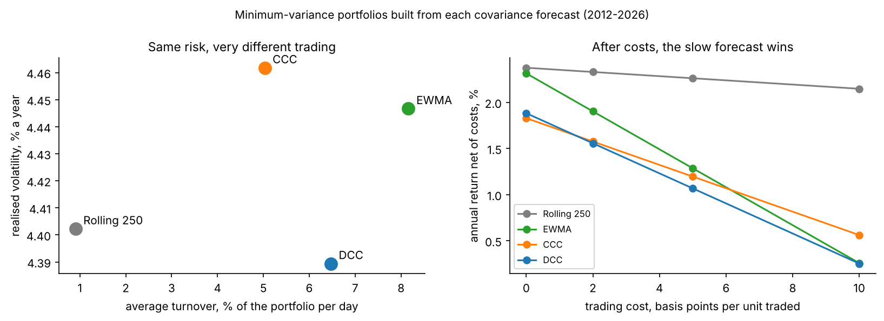
Minimum-variance trade-off
 | Rolling 250 | EWMA | CCC | DCC
Realised volatility | 4.40% | 4.45% | 4.46% | 4.39%
DM vs DCC (squared returns) | 0.25 (n.s.) | 1.15 (n.s.) | 3.38 | –
Turnover per day | 0.9% | 8.2% | 5.0% | 6.5%
Largest position | 1.05 | 1.25 | 1.01 | 1.02
Net return at 5 bp | 2.26% | 1.29% | 1.20% | 1.07%
Net return at 10 bp | 2.15% | 0.26% | 0.56% | 0.25%
- Every model halves the risk (about 4.4% against 9.72% for 60/30/10), mostly by holding Bunds. (The chart’s volatility axis is zoomed: the whole range is 0.07 points.)
- DCC builds the least volatile portfolio, significantly better than CCC — here the moving correlations clearly matter — but not significantly better than the rolling window or EWMA.
- Turnover decides. EWMA trades 8.2% of the portfolio a day and takes positions up to 125% in one asset: the near-singular CAC/DAX bets predicted by its eigenvalues (“error maximisation”). DCC trades 6.5%, the rolling window 0.9%.
- After costs, the slow rolling window is best: at 5 bp, DCC loses 0.82% a year to trading, the rolling window 0.11%.
In plain words. A better forecast is not automatically a better portfolio once you trade on it every day.

4. Conclusions and Recommendation

4.1 Scorecard
 | Rolling 250 | EWMA | CCC | DCC
Matrix QLIKE (rank) | 1.031 (4) | 0.717 (3) | 0.387 (2) | 0.269 (1)
Portfolio QLIKE | −0.023 | −0.202 | −0.256 | −0.261
VaR 99%, FHS (33.5 exp.) | 53 ✗ | 41 | 43 | 42
Avg VaR 99%, FHS | 164k | 166k | 148k | 148k
Min-variance realised vol | 4.40% | 4.45% | 4.46% | 4.39%
Min-variance turnover / day | 0.9% | 8.2% | 5.0% | 6.5%
Min-variance net return, 5 bp | 2.26% | 1.29% | 1.20% | 1.07%

4.2 Main findings
- Data quality first: Yahoo’s adjusted Bund prices missed 8 coupon payouts before 2013; the total return was rebuilt.
- Correlations are not constant (stock–Bund from −0.87 to +0.79; LR = 889 against constant correlation), and equity correlations rise in crashes.
- The hedge can disappear: Bunds hedged the GFC and the euro crisis, not 2022, and added to risk in 2026.
- DCC is the most accurate covariance forecast out of sample (DM 3.8–7.0 against every model). Its weakness is a lasting new regime, where its pull to the long-run average makes it trail EWMA.
- For one balanced portfolio, the volatility models do most of the work: DCC and CCC give the same VaR and both pass the backtests with FHS, at 11% less VaR than EWMA.
- For portfolio construction, turnover decides: after realistic costs, the slow rolling window beats DCC.

4.3 Recommendation to the risk committee
- Risk measurement (VaR, ES, limits): DCC-GJR covariance with FHS tails, re-estimated monthly; monitor the stock–bond correlation as a key risk indicator.
- Portfolio construction: do not trade on raw daily DCC forecasts; use a smoothed covariance — rolling window, shrinkage, DCC with trading bands or a turnover penalty.
- Stress testing: always include scenarios with a positive stock–bond correlation (2022, 2026).

5. Limitations and Next Steps
- One (a, b) for all 10 pairs: pair-specific or flexible DCC would let the stock–bond correlation move faster than CAC–DAX.
- Symmetric DCC: asymmetric DCC (ADCC) lets correlations rise more after joint falls.
- Gaussian quasi-likelihood for correlations: fat tails are handled in the univariate step and through FHS, not jointly (a multivariate Student-t or copula would).
- Non-synchronous closes between Europe, New York, Xetra and the FX fixing lower measured daily correlations.
- Bund history from 2008 only, with 8 payouts estimated before 2013.
- Minimum variance with shorts and linear costs: long-only, turnover-penalised and shrinkage portfolios are natural extensions (and the subject of covariance cleaning).
- Next project (5): bond portfolio risk — where the stock–bond correlation and rate risk meet.

6. How the Code Is Organised
multivariate-volatility-dcc/
├── data/raw/ downloads (Yahoo, FRED), cleaned Bund total return
├── data/processed/ EUR returns, out-of-sample forecasts, DCC parameters
├── notebooks/01_multivariate.ipynb the analysis, Sections 1-11
├── notes/theory.md theory notes (Equations 1-18)
├── reports/figures/ charts
├── src/covforecast/ the package
└── tests/test_covforecast.py 26 unit tests
Module | Functions | Role
data.py | total_return, return_index, eur_returns, portfolio_returns | Bund total return, EUR returns on a common calendar, portfolio
covariance.py | portfolio_variance, rolling_cov, ewma_cov, cov_to_corr, pair_series | basic tools and benchmark forecasts
univariate.py | gjr_variance, gjr_t_loglik, fit_gjr_t | volatility per asset
mgarch.py | qbar, ccc_cov, dcc_correlations, dcc_cov, dcc_loglik, fit_dcc, rolling_ccc_dcc | CCC, DCC, out-of-sample forecasts
evaluation.py | qlike_matrix, qlike_portfolio, diebold_mariano | forecast accuracy
risk.py | var_es_normal, var_es_fhs, kupiec_test, christoffersen_test, acerbi_szekely_z2 | portfolio VaR/ES and backtests
portfolio.py | min_variance_weights, turnover | minimum-variance portfolios
plots.py | plot_correlations, plot_scores, plot_var_backtest, plot_mv_tradeoff | every chart
Validation strategy. Every function was checked before use against an independent answer — closed forms, scipy, pandas, the arch package, hand-worked examples, or simulations with known parameters — and the checks are kept in the notebook and in 26 unit tests (pytest -v). Downloads and the 6-minute out-of-sample run are saved and reloaded, so the notebook reruns in about a minute.

7. Glossary
Cholesky factor – a lower-triangular matrix $L$ with $LL′=H$; used to simulate correlated shocks.
CCC (constant conditional correlation) – multivariate GARCH with time-varying volatilities and one constant correlation matrix.
Correlation targeting – fixing DCC’s long-run level $\overset{‾}{Q}$ at the sample covariance of the residuals, leaving only $a$ and $b$ to estimate.
Covariance matrix – the $N×N$ matrix of variances (diagonal) and covariances (off-diagonal).
DCC (dynamic conditional correlation) – multivariate GARCH where correlations follow a GARCH-like recursion with reaction $a$ and persistence $b$.
Diebold–Mariano test – tests whether the average loss difference between two forecasts is significant.
Error maximisation – optimisers put the largest weights where the covariance estimate is most wrong.
EWMA covariance – exponentially weighted covariance; RiskMetrics uses λ = 0.94.
Flight to quality – investors sell risky assets and buy safe ones (Bunds, gold) in a crisis; it makes the stock–bond correlation negative.
Ghost effect – the jump in a rolling-window estimate when an extreme day leaves the window.
Minimum-variance portfolio – the fully invested portfolio with the lowest forecast variance; depends only on the covariance.
Non-synchronous trading – markets closing at different times, so the same news appears on different dates.
Positive definite – $w′Hw>0$ for every non-zero $w$; all eigenvalues positive.
QLIKE (matrix) – $ln\left|H_{t}\right|+y_{t}′H_{t}^{−1}y_{t}$; a loss that ranks covariance forecasts correctly with a noisy proxy.
Standardised residual – the return divided by its forecast volatility; the input of CCC and DCC.
Total return – price change plus payouts (dividends, coupons).
Turnover – i​wi,t−wi,t−1: the share of the portfolio traded; a proxy for trading costs.
Two-step estimation – estimate the univariate volatility models first, then the correlation parameters on their residuals.

8. Interview Preparation: 45 Questions with Short Answers

A. Covariance and correlation basics
1. How do you compute a portfolio’s variance from a covariance matrix? σp2=w′Hw=i​j​wiwjhij. In a 60/40 example, changing the stock–bond correlation from −0.3 to +0.3 raises the 99% VaR by 17%.
2. Why must a covariance matrix be positive definite, and what happens if it isn’t? No portfolio can have zero or negative variance. A non-positive-definite matrix can produce a negative portfolio variance, an impossible VaR, or an optimiser that finds a “risk-free” combination of risky assets.
3. What does a small smallest eigenvalue tell you? That some combination of assets looks almost riskless. Here it was CAC vs DAX (correlation 0.92). Usually it is estimation noise, and optimisers exploit it with large long–short positions.
4. Why use simple rather than log returns for a portfolio? Simple returns add up across assets with fixed weights ($R_{p}=∑w_{i}R_{i}$ exactly); log returns add up over time, not across assets.
5. Why keep only common trading days? So each return covers the same interval for every asset. Filling holidays with the last price creates fake zero returns that lower volatility and correlation.
6. Why did the S&P 500 in EUR have a correlation of only −0.09 with Bunds? In EUR it also carries the dollar move, and the US closes 4.5 hours after Europe, so part of each US move appears in Europe the next day (non-synchronous trading).

B. Models
7. Describe the rolling-window covariance. Pros and cons? The average of $yy′$ over the last W days. Simple and stable, but slow (the 250-day stock–bond correlation turned positive a month late in 2026) and with ghost effects.
8. How does EWMA covariance work? $H_{t}=\left(1−λ\right)y_{t−1}y_{t−1}′+λH_{t−1}$, λ = 0.94: fast, no estimation, no ghost effect; but one speed for every asset, no long-run level, noisy, and close to singular in calm periods.
9. What is CCC-GARCH? Each asset gets its own GARCH volatility; correlations are one constant matrix, the correlation of the standardised residuals: $H_{t}=D_{t}\overset{‾}{R}D_{t}$.
10. What is DCC? Write the equations. $Q_{t}=\left(1−a−b\right)\overset{‾}{Q}+a ε_{t−1}ε_{t−1}′+bQ_{t−1}$; $R_{t}=\text{diag}{\left(Q_{t}\right)}^{−1/2}Q_{t}\text{diag}{\left(Q_{t}\right)}^{−1/2}$; $H_{t}=D_{t}R_{t}D_{t}$.
11. Why rescale $Q_{t}$? $Q_{t}$ does not have exact ones on its diagonal; dividing by $\sqrt{q_{ii}q_{jj}}$ gives an exact correlation matrix.
12. Why is DCC always positive definite? $Q_{t}$ is a positive combination of a positive definite target, a positive semi-definite outer product and the previous positive definite $Q_{t−1}$; rescaling preserves positive definiteness.
13. What are the advantages of DCC over full multivariate GARCH (VECH, BEKK)? Only two correlation parameters whatever N, estimable in two easy steps, and positive definite by construction.
14. What did your DCC estimates mean? a = 0.031, b = 0.945: a joint shock moves correlations by about 3% of its size, and a correlation shock halves in about 28 days — slower and mean-reverting compared with RiskMetrics’ 11-day half-life.
15. What are DCC’s limitations? One (a, b) for all pairs; symmetric response; mean reversion to a fixed long-run level, which made it “muted” in the 2026 regime; two-step estimation less efficient; Gaussian quasi-likelihood for correlations.
16. Why did you write the GJR model again instead of reusing a library? To control every detail and verify it: the estimates matched the arch package to 3–4 decimals, so the library was used as an independent check.
17. What did the univariate models show? Equities react only to falls (γ ≈ 0.2); the Bund is symmetric with a 214-day half-life; gold has inverse leverage (γ = −0.024) and the fattest tails (ν = 5.6).

C. Estimation and testing
18. Explain two-step DCC estimation. The Gaussian log-likelihood splits into a volatility part (one GARCH per asset) and a correlation part depending only on (a, b) given the residuals. Estimate step 1, then maximise the correlation part.
19. Write the correlation log-likelihood. ℓC=−12t​lnRt+εt′Rt−1εt−εt′εt.
20. How did you verify the DCC code? The likelihood equals scipy’s multivariate normal density up to a constant; a = b = 0 reproduces CCC exactly; simulated data with a = 0.05, b = 0.93 gave estimates of 0.052 and 0.928.
21. How do you test whether correlations are constant? Likelihood ratio DCC vs CCC (CCC = DCC with a = b = 0): LR = 888.8. Because a = 0 is on the boundary, χ²(2) is conservative, but the result is overwhelming.
22. What is correlation targeting? Setting $\overset{‾}{Q}$ to the sample covariance of the residuals, so only a and b are estimated; out of sample, $\overset{‾}{Q}$ must come from the estimation window only.
23. How did you guarantee no look-ahead out of sample? Parameters are estimated on the 1,000 days before each block; $\overset{‾}{Q}$ comes from the window; recursions use yesterday’s values. A fake −20% day left every earlier forecast unchanged.

D. Evaluating covariance forecasts
24. How do you evaluate a covariance forecast if the true covariance is unobservable? Use the noisy but unbiased proxy $y_{t}y_{t}′$ with a robust loss such as QLIKE, which ranks models correctly even with a noisy proxy (Patton, 2011).
25. Write the matrix QLIKE. $L_{t}=ln\left|H_{t}\right|+y_{t}′H_{t}^{−1}y_{t}$ — minus twice the Gaussian log-likelihood up to a constant.
26. Why use both matrix and portfolio QLIKE? The matrix version judges every direction; the portfolio version judges only what the investor holds. Here DCC won the matrix clearly but tied with CCC on the 60/30/10 portfolio.
27. What was the out-of-sample ranking? DCC (0.269) < CCC (0.387) < EWMA (0.717) < rolling (1.031), DCC significantly better than all (DM 3.8–7.0).
28. Where did DCC not win? In the 2026 regime, EWMA was as good (1.488 vs 1.499): a lasting regime change favours fast forgetting, and DCC’s mean reversion holds it back.
29. Why use Newey–West in the Diebold–Mariano test? Daily loss differences are autocorrelated because volatility clusters; a plain standard error would overstate significance.

E. Risk and portfolios
30. How do you get portfolio VaR from a covariance forecast? $σ_{p,t}=\sqrt{w′H_{t}w}$, times a multiplier: normal, Student-t, or the empirical quantile of past standardised portfolio residuals (FHS).
31. Which models passed the VaR backtests? With FHS tails: EWMA, CCC and DCC (41–43 breaches vs 33.5; no clustering). The rolling window failed (11 consecutive breaches). Normal tails failed for every model.
32. Why did CCC and DCC need less VaR than EWMA to pass? Noisier volatility forecasts give noisier standardised residuals with fatter tails, so EWMA’s FHS needs bigger multipliers: EUR 166k vs 148k.
33. Explain the minimum-variance portfolio and why it tests correlations. $w=H^{−1}1/\left(1′H^{−1}1\right)$; it depends only on $H$ and uses every correlation through the inverse, so correlation errors become wrong positions.
34. What is error maximisation? Optimisers put the most weight where the estimate is most wrong — e.g. EWMA’s near-singular matrices produced positions up to 125% in one asset.
35. Which model built the best minimum-variance portfolio? DCC had the lowest realised volatility (4.389%), significantly better than CCC but not than rolling or EWMA; after costs, the rolling window was best.
36. How do trading costs change the conclusion? DCC trades 6.5% of the portfolio a day, the rolling window 0.9%. At 5 bp, DCC loses 0.82% a year, rolling 0.11%, so rolling earns 2.26% net vs 1.07%.
37. How would you reduce turnover while keeping a good forecast? Trading bands, smoothing weights over several days, a turnover penalty in the optimiser, covariance shrinkage, or a smoothed DCC.
38. What is the Engle–Colacito approach? Evaluating covariance forecasts by the realised variance of the portfolios they produce — an economic rather than statistical loss.

F. Your project
39. Walk me through the project in two minutes. I built a joint risk model for a EUR multi-asset portfolio (equities, Bunds, gold), cleaned the data (including 8 missing Bund coupon payouts in Yahoo’s data), and compared rolling, EWMA, CCC and DCC out of sample over 2012–2026. DCC was the most accurate forecast and passed the VaR backtests with less capital; but for building portfolios, its turnover meant a slower forecast was better after costs.
40. What happened to the stock–bond correlation, and why does it matter? It was strongly negative in 2008–2012 (Bunds hedged equities), about zero in 2022 (inflation hit both) and +0.62 in 2026. A portfolio that assumes a fixed hedge underestimates risk exactly when rates drive both markets.
41. What data problem did you find? Yahoo’s adjusted price for the Bund ETF missed 8 coupon payouts before 2013, creating fake −2% to −3.5% crashes. I detected them from the dates of extremes, confirmed them against the payout history, and rebuilt the total return.
42. Why German Bunds and not US Treasuries? For a EUR investor, unhedged Treasuries are mostly a currency bet (EUR/USD is more volatile than the bond); Bunds are what a EUR fund actually holds.
43. What would you do next? Asymmetric and pair-specific DCC, a multivariate Student-t or copula for joint tails, shrinkage and long-only minimum-variance portfolios with a turnover penalty, and adding duration risk (Project 5).
44. What surprised you most? That the best forecast was not the best portfolio: DCC won every statistical test but lost to a simple rolling window once trading costs were included.
45. How does this project connect to portfolio management? Every allocation, hedge and risk limit uses a covariance matrix. Knowing when correlations break, how to measure it, and how to avoid trading on estimation noise is the core of a portfolio risk role.

