**Homework 2 : Student Records**

                                                                                                Student Name:Manasa Kavuru

                                                                                                Student ID: 01567661

I have implemented this project using structures. I initially started off with a student class and student name, id, year and gender as the data members of the class and other actions as member methods. However, I realized implementing this project with structures is better and easier and proceeded with using structures.

I have implemented the program using Qt creator(as recommended) on a ubuntu running on a VMware workstation. I have included hw2.pro  and main.cpp files in the submission. I made sure that program builds and runs successfully without any issues. Please follow the following instructions to build and run the project

1. Open hw2.pro project in Qt creator.
2. Build(Ctrl+B) the project( I made sure that project builds without any issues)
3. Run the project. You should be able to see the menu with different options displayed on the console.

**Menu driven student database management system:**

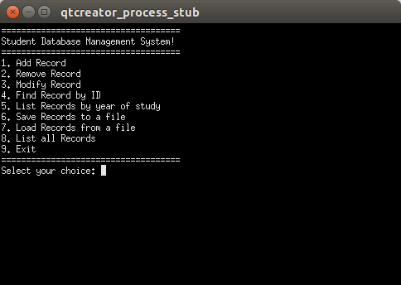

I have used a file named “databaseFile.txt” (temporary file)to write records and read the records in each session. Apart from this file, users can save and load records by entering desired filename.

Enter a menu choice to perform an action. For saving records to a file and loading records from a file, filename would be taken as input from user. Following are the common workflows with different menu choices

1.Add record: User is prompted to enter student name(first and last as two different inputs), student id, year of study and gender as input and the corresponding record would be added to the database. Since one of the requirements is student id has to be unique, if the id entered by the user already exists in the database, then a message would be displayed specifying this to the user. This record won't be added to the database.

2. Remove record:User is prompted to enter student ID. This ID is used to identify corresponding student among the existing records. When this ID is found in the database, corresponding student would be removed from the records.

3. Modify record: User is prompted to enter student ID. This ID is used to identify corresponding student among the existing records. If the student with the corresponding ID is found, user is prompted to enter all the details of this student and database would be updated with the modified information

4.Find record(print all data on a student ID): User is prompted to enter student ID.This ID is used to identify corresponding student among the existing records. If the student with the corresponding ID is found, details of that student(name,id,year of study and gender) would be printed in the console.

5.Print names and  IDs by year of study: User is prompted to enter year of study. Then student names and ids with this year of study are printed

6.Save to a file: User is prompted to provide filename( along with the extension eg: filename.txt) and student records in that session would be written and saved to the filename provided by the user.

7.Load from a file:User is prompted to provide filepath(along with the extension eg:filename.txt) . In any given session, students records from the corresponding file would be loaded and printed in the console

8. List all records: This option displays all the student records in any given session.

9.Exit: This option lets user to exit from the program

While implementing this project, I learnt a lot in C++. Also, I learnt about incremental development.

After implementing each choice, I spent some time testing to make sure the program works as expected. After the implementation of all the requirements, I spent some more time testing whole application.

I would like to acknowledge following online resources that helped me to gain valuable insights in completing this project

1.[www.cplusplus.com](http://www.cplusplus.com)

2. [www.stackoverflow.com](http://www.stackoverflow.com)

3. [www.learncpp.com](http://www.learncpp.com)

And instructor’s tutorial greatly helped to install VMware, ubuntu and Qt creator and setup the environment to implement the project, I am thankful for that.