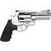 Finish Day 03 work before coming any closer 😊

Day 04 & Day 05 & Bonus

Working with MySQL

Welcome to the OS39  glasses shop

* We will work for this shop for 2 days !!!! so please check the images in the images folder which includes the images of it’s products and the SQL file which includes it’s items data you should have both before the Lab a
* Finally, get the DbHandler interface which you should implements

Now Your Mission in Day 04 & Day 05 and Bonus if you finish both :

**Day 04:**

1. Create the Database of the shop from the sql dump file in the resources folder, make sure the DB is fine
2. In the config file define constants for the following issues :
   1. Connection parameters
      1. Host
      2. User name
      3. Password
      4. Db name
   2. Number of records to be displayed in a single page make it 5 records
   3. A Debug mode (we will use it later)

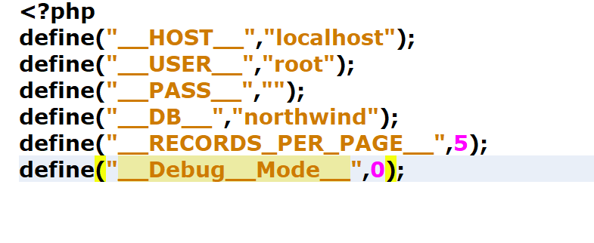

1. Implement the DbHandler interface given to you to encapsulate all the DB communication and querying functions in a MYSQLHandler class , start with empty implementation just not to get an error, then work in the functions one by one it’s a good idea to test the connection function from the index see if it’s really connecting .

|  |  |  |
| --- | --- | --- |
| Function | Use | Remarks |
| Connect() | Just open a connection to MYSQL | It should return boolean (false if connection is failed) |
| Disconnect() | Close a connection to mysql if one is opened |  |
| Get_data() | Should sent a select query to the Db that gets the records per page raws starting from a certain index | If the fields array is given only columns in this array will be returned , if an empty array is given all columns will be returned |
| Gat_record | Will get all fields of a certain record by id |  |

1. Notes :
   1. When the debug mode is set to 1 , your SQL queries should be displayed on the screen so please add this feature in your class
   2. You can use other private methods in your class
   3. After finishing the class and get approval of it please make a view for displaying the first 5 items in the table as in the following image

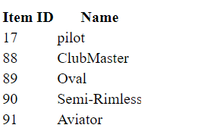

**Day 05**

1. Create a paggination that can get Next and Previous items

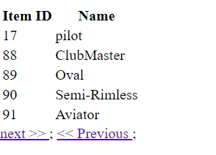

1. Add a 3rd column for more when clicking on it it should display the item details in a new page

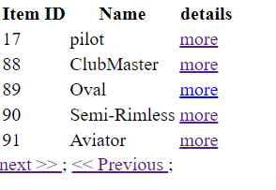

1. When clicking on the details link “more” it should display the clicked product description as shown

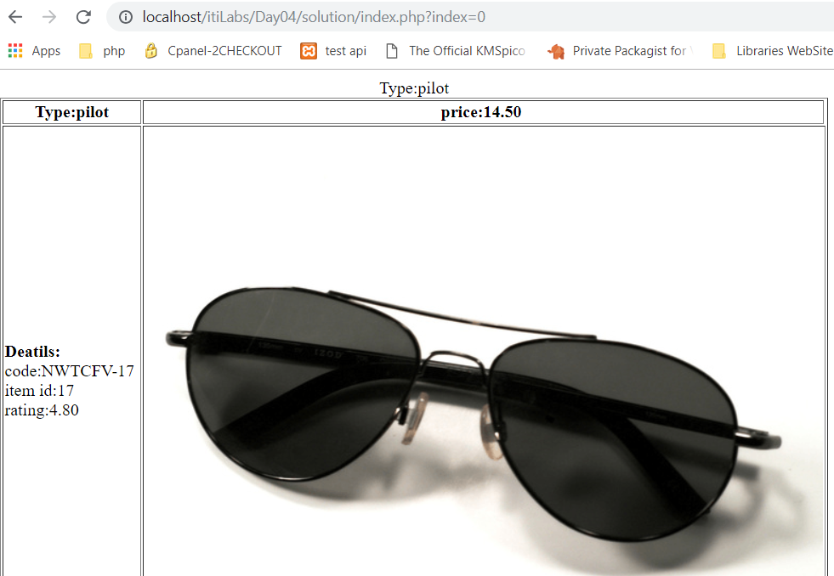

**Bonus work**

1. Add a function in the interface and class for searching , the function should search a key word in certain column
2. Use the function which you add to add a search box in the top of the page which lists all products .
3. Don’t forget a button to show all records

Notes and Remarks:

* Don’t forget the $this
* The results is a two dimentional array don’t forget that
* You can pass the table name which you need to work on the constructor of your MySQLHandler class, so you don’t need to pass it on every function
* If many functions share some common logic in your MYSQL Handler add it in a private function
* You will need this class in your project so do it well and document every method.
* Use array_change_key_case($row) so all columns be lowercase in the results otherwise you will need to remember the case of each column.
* Don’t forget to use the autoload.