Whole scale Newspaper &Magazine Distribution System
Name | ID | Section
Ahmed Khaled Moawad Gharib | 2017170575 | 1
Ahmed Mohamed Ali Hassan | 2016170047 | 3
Ahmed Adel Imam Abbas | 2015170031 | 2
Mohamed Adel Abd  el-Khalek Abd el-Samad | 2015170341 | 14
Ehab Yahya Goda Abdel Salam | 2015170108 | 5

Whole scale Newspaper&Magazine Distribution System
Ain Shams university
computer and information science
Date: 4/3/2020
Document Version: 1.0

1. Introduction
- 1.1 Purpose of this document
The Purpose of This System is To Delivery Newspaper & Magazine to Customers At The Places That They Want In Specific Line To Help Us To Reach The Newspapers By Delivery Boy,
The Intended Audience Is Everyone Interesting in Newspapers & Magazines
- 1.2 Scope of this document
In this document we will talk about the system of distribution of newspapers and magazines,
How Workers deal with customers, how to deliver newspapers and magazines to customers,
How to deal with lines, different addresses
- 1.3 Overview
A Magazine is a periodically published publication that contains many different articles. Magazines provide a variety of information, opinions, and entertainment.
The Newspaper is usually issued on a daily basis; sometimes some newspapers rely on the weekly issue, Including Journalists, Photographers, Writers, and others.
- 1.4 Business Context
The College of Computers and Information is the sponsoring organization for this product
Its goals are that newspapers and magazines contain all kinds of types that satisfy the community, such as sports, art, news, etc.

2. General Description
- 2.1 Product Functions
The general function of this project is making a good structured system that make a good connection between suppliers and customer and delivery stuff,
the system components are:
- Customers
- Suppliers
- Delivery Addresses
- Products
- Lines
- Delivery Stuff.
(Names of use cases)
(use case diagram should be included here)

ــــــــــــــــــــــــــــــــــــــــــــــــــــــــــــــــــــــــــــــــــــــــــــــــــــــــــــــــــــــــــــــــــــــــــــــــــــــــــــــــــــــــــــــــــــــــــــــــــــــــــــــــــــــــــــــــــــــــــــــــــــــــــــــــــــــــــــــــــــــــــــــــــــــــــــــــــــــــــــــــــــــــــــــــــــــــــــــــــــــــــــــــــــــــــــــــــــــــــــــــــــــــــــــــــــــــــــــــــــــــــــــــــــــــــــــــــــــــــــــــــــــــــــــــــــــــــــــــــــــــــــــــــــــــــــــــــــــــــــــــــــــــــــــــــــــــــــــــــــــــــــــــــــــــــــــــــــــــــــــــــــــــــــــــــــــــــــــــــــــــــــــــــــــــــ

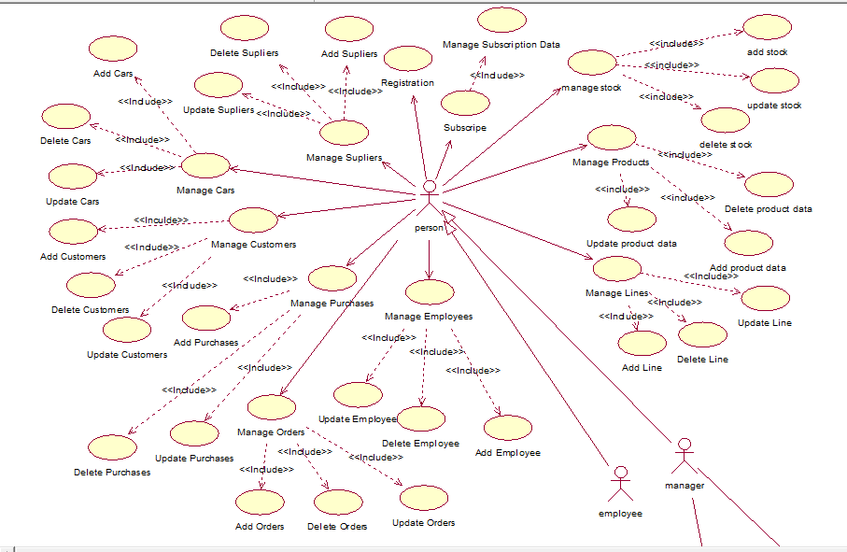
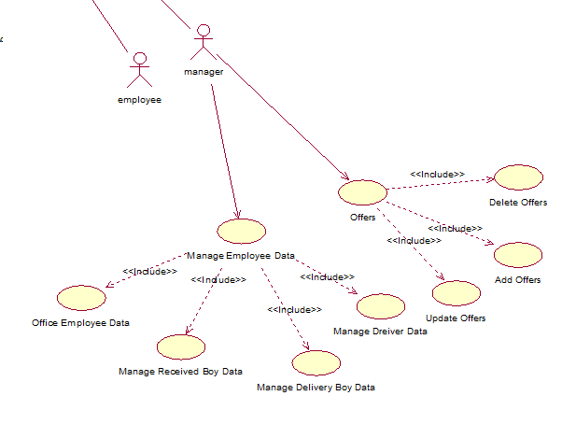
- 2.2 Similar System Information
Our System have some related Functionality like this Systems “Pressreader” and “Amazon” Both Of Them deal with Magazines and Newspapers as we have the same , we will deliver Our Products to the Customer Address , make some offers , deal with much Suppliers to have different Category of the Products like the Sites we refer to it in the first of text.
- This product is stand-alone product, related with suppliers' manufacturing system to give products enough information about them (Writers, Categories, etc.)
- 2.3 User Characteristics
Each kind of user should be able to access some level of the distribution the products
Suppliers can access suppliers' functions
Customers can access customers' functions,
And administrators can access both functions,
Supplier Functions' features:
- Make a new product
- Access their own existed products
Customer functions' will allow to:
1-Order Product
2-Cancel an existed order
3-View his orders history
Administrators will be able to:
1-View all products
2-Add/Delete orders
3-Add/Delete Supplier
4-Update entire system information

- 2.4 User Problem Statement
The essential problem that this system tries to solve is being many suppliers with their many products and the customer(s) will find some problem to gain specific product from specific supplier manually
So here we try to collect all possible supply with customer in the same software product
- 2.5 User Objectives
Among the wishes of users that we try to achieve:
- The journal or newspaper should arrive at the required time and in the specified quantity
- The product must be in excellent condition
- The product must maintain quality stability.
- 2.6 General Constraints
- The global schema, fragmentation schema, and allocation schema.
- SQL commands for above queries/applications
- How the response for application 1 and 2 will be generated. Assuming these are global queries. Explain how various fragments will be combined to do so.
- Implement the database at least using a centralized database management system.

3. Functional Requirements

A- System Requirements
1- All data shall connect with the centralize data base
2- The system will be active on server connected with other devices
B- Customer Requirements
1- Order a product
Discerption: allow customer to order from list of existed products
Input: user shall be allowed to use these features as a customer only
Output: after customer selects his order it will be added to his current orders list and the delivery stuff will receive notification about this order and customer's address
Wrong input: the system will return you to the order screen with warning massage "Unexcited Product"
2-View his orders list
Discerption: allow user to view his existed orders list and update them
Input: customer should enter order' id to be able to update it
Output: after show the order customer can update his address on order or delete it Not change the product and it will be updated
Wrong Input: if user enter unexcited order's id then system will show to "Order new product screen to user"

C-Suppler Requirements
1-Update a new product
Discerption: allow supplier to insert new product to his own existed product which customers can order from it
Input: Supplier should enter the entire information about new product (Id will generate automatically)
Output: when supplier finish the product will insert and update database
Wrong Input: if supplier enter existed product id it will show him the list of his existed products

2-Update his existed products' list
Discerption: allow supplier(s) to update/ delete their existed products
Input: supplier should insert product id
Output: the product is shown with many options (Update / delete) and it will update in database
Wrong Input: if supplier insert unexcited id the "new product " screen will be shown

4. Interface Requirements
- Not set yet

5. Performance Requirements
The System must respond quickly as it can to reduce the time of orders to can serve much customer as can, have a perfect deal with the huge amount of data ,and reduced the data redundancy and grouped the Similar data to make the work is easy.

6. Design Constraints
- 6.1 no one out the scoop of the work environment can see the real data of the system
- 6.2 High level of security and privacy for data
- 6.3 the size of memory is 2GB and 1GB hard disk and core i3 processor.

7. Other non-functional attributes
- 7.1 High level of security on the system data
- 7.2 Binary Compatibility between our system and Suppliers systems
- 7.3 Pass many performance tests
- 7.4 It was built on the foundations of OOP to be easy in Maintenance
- 7.5 It was built with perfect design and algorithms to serve for a very long time
- 7.6 pieces of our code we write before in oldest projects have the similar idea
- 7.7 have some related with “Pressreader” and “Amazon”
- 7.8 the Employee’s laptop
- 7.9 the System must have a guideline to the end users
- 7.10 give all employee who will react with system train about how to use it

