Cairo University  
Faculty of Computers and Information



**CS251**

**Software Engineering I**

Project Name

Software Design

Team Names

Month & Year

Contents

Instructions [To be removed] 3

Team 3

Document Purpose and Audience 3

System Models 3

I. Class diagrams 3

Important Algorithm 5

II. Sequence diagrams 5

Class - Sequence Usage Table 7

Ownership Report 8

Policy Regarding Plagiarism: 8

References 8

Authors 8

# Team

|  |  |  |  |
| --- | --- | --- | --- |
| **ID** | **Name** | **Email** | **Mobile** |
| 20110058 | Ahmed Saber Ahmed | Ahmedzoro016@gmail.com |  |
| 20090340 | Mena Mounir Reda |  |  |
| 20110521 | Mohamed Mahmoud Mohamed |  |  |
| 20110090 | Ahmed Mohamed Ghoniem |  |  |

# Document Purpose and Audience

* **the document is describe a website that teach a students solving problems throw games playing and help a teacher to develop and create games pattern, a children people is expected to see this games.**
* **(student , children people, programmers, developers ,games companies )**

# System Models

## I. Class diagrams

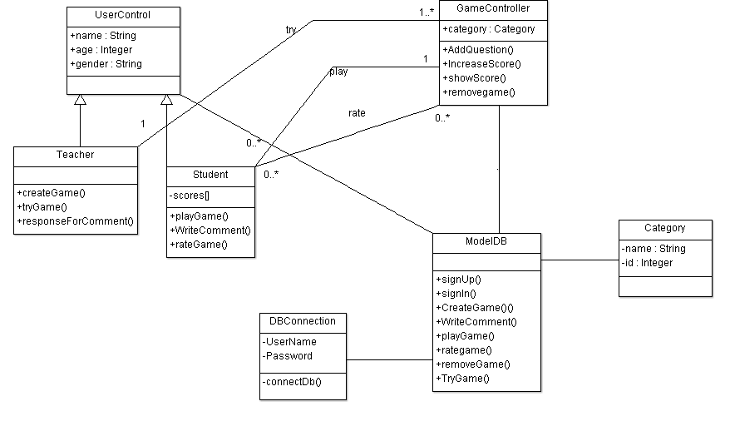

| **Class ID** | **Class Name** | **Description & Responsibility** |
| --- | --- | --- |
| **1** | **UserControl** | Class Which Contain basic info about teacher and student, parent of them. |
| **2** | **Teacher** | Class Which responsible for create, try game and reply for comment from users. |
| **3** | **Student** | Class which responsible for play games, rate and write comments. |
| **4** | **GameController** | Contain categories for games and let teachers to add questions ,increase score, show scores, and remove games that created. |
| **5** | **ModelDB** | Include all function in classes and store in DB mysql. |
| **6** | **DBConnection** | Class that make a connection between java and DB |
| **7** | **Category** | Class give name and id for each game to arrange them. |

## 

## II. Sequence diagrams

**ID : 1**

**Name : Have an account**

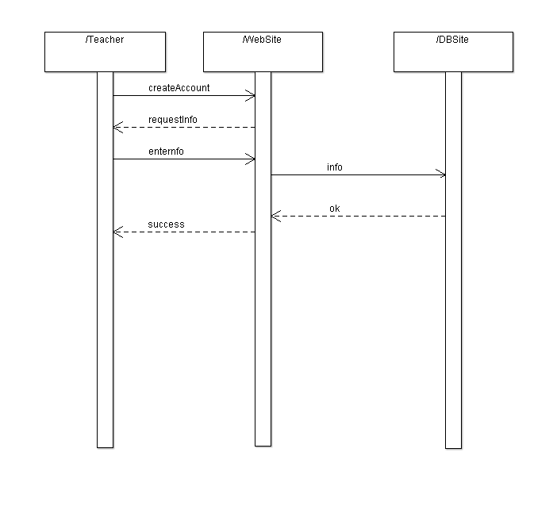

### ID : 2

### Name : Create Game

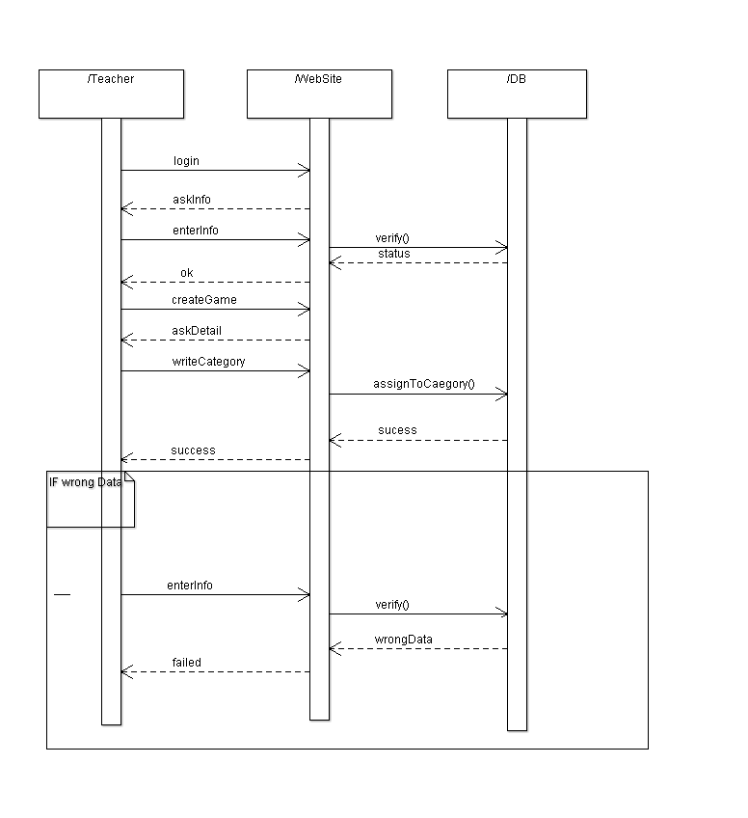

### ID : 3

**Name : Try Game**

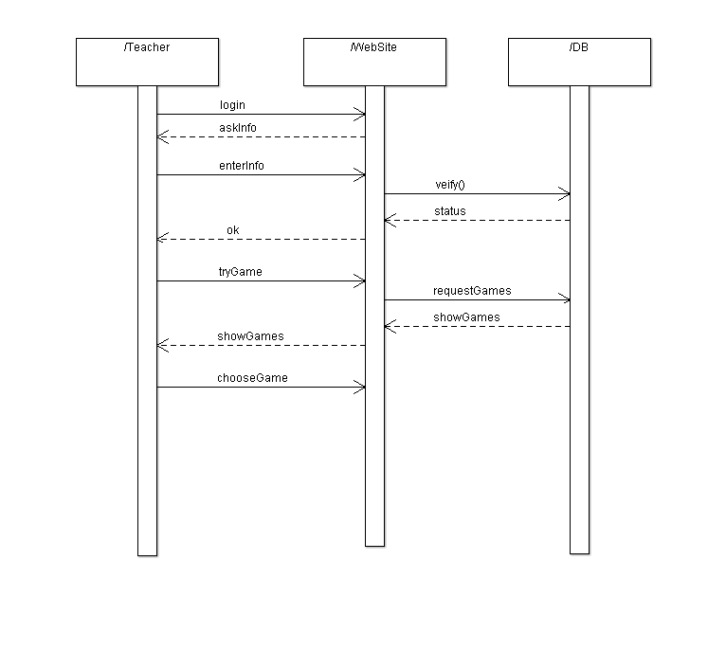

### ID : 4

### Name : Edit or remove Game

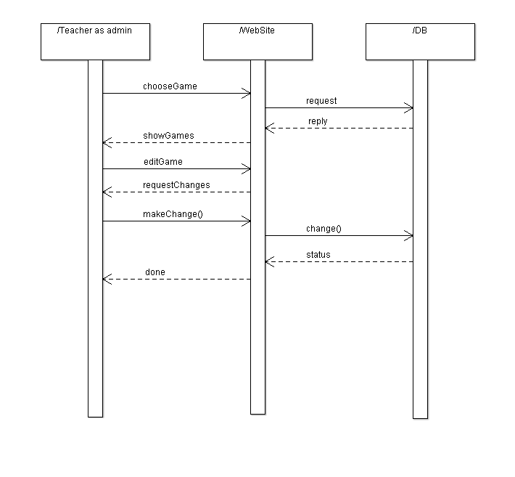

### ID : 5

### Name : Respond for Comments

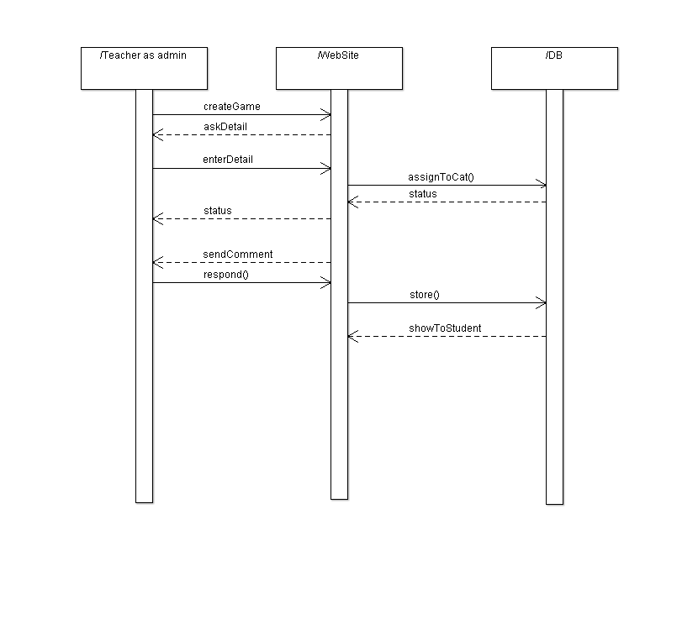

### ID : 6

**Name : Have an account**

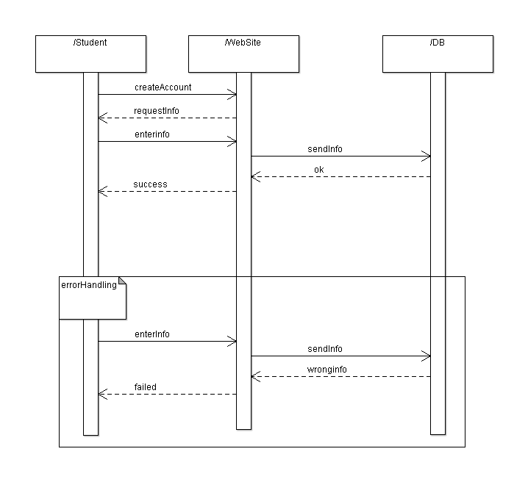

### ID : 7

### Name : Play a Game

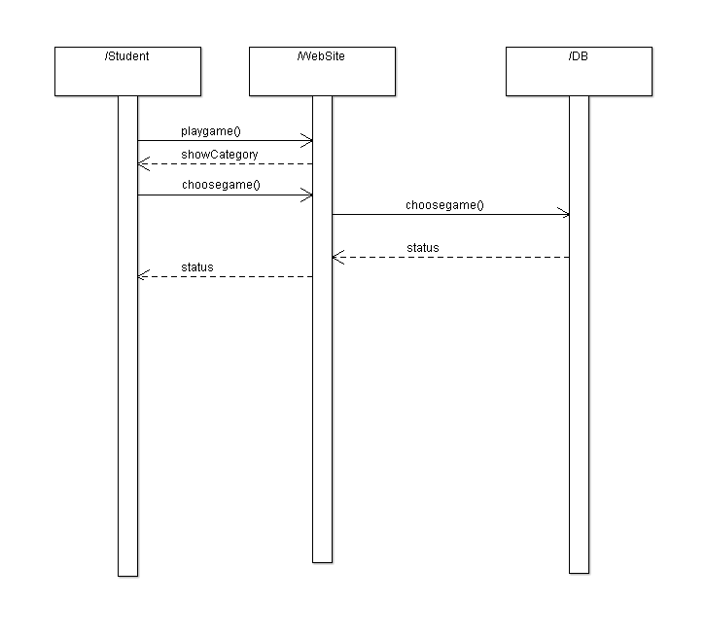

### ID : 8

**Name : Rate a Game**

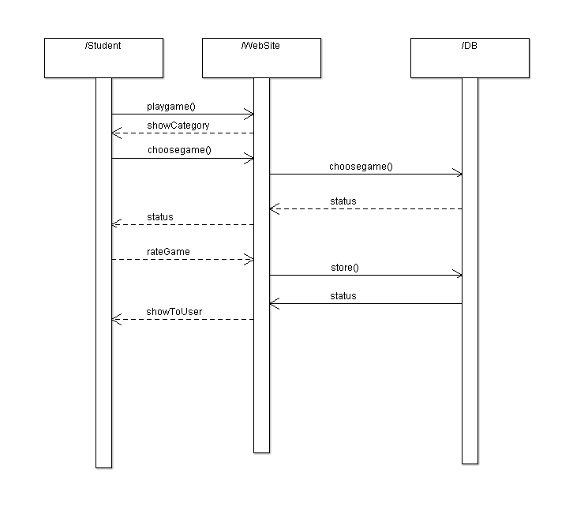

### ID : 9

**Name : Write Comments**

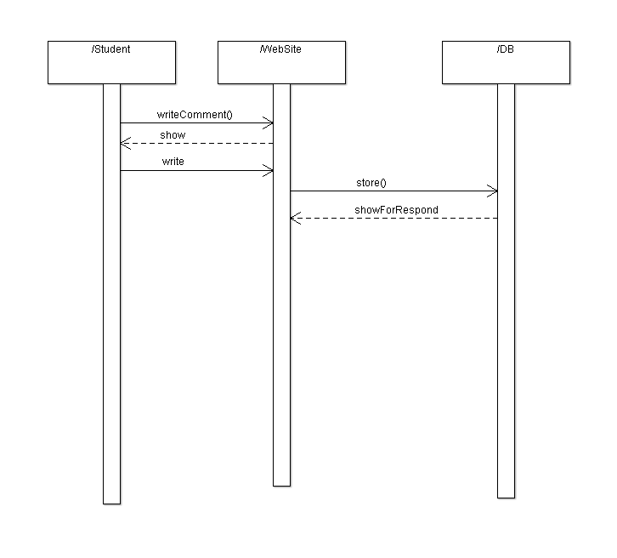

### Class - Sequence Usage Table

### 

| **Class Name** | **Sequence Diagrams** |
| --- | --- |
| UserControl | all |
| Teacher | 1,2,3,4,5 |
| Student | 6,7,8,9 |
| GameController | 3,4,5,7,8 |
| ModelDB | All function for all sequences |
| DBConnection |  |
| Category | 7 |

# Ownership Report

|  |  |
| --- | --- |
| **Item** | **Owners** |
| Class Diagram | *Ahmed & Mohammed* |
| Sequence Diagram | *Mena& Ghonien* |

# Policy Regarding Plagiarism:

**Students have collective ownership and responsibility of their project. Any violation of academic honesty will have severe consequences and punishment for ALL team members.**

1. تشجع الكلية على مناقشة الأفكار و تبادل المعلومات و مناقشات الطلاب حيث يعتبر هذا جوهريا لعملية تعليمية سليمة
2. ساعد زملاءك على قدر ما تستطيع و حل لهم مشاكلهم فى الكود و لكن تبادل الحلول غير مقبول و يعتبر غشا.
3. أى حل يتشابه مع أى حل آخر بدرجة تقطع بأنهما منقولان من نفس المصدر سيعتبر أن صاحبيهما قد قاما بالغش.
4. قد توجد على النت برامج مشابهة لما نكتبه هنا أى نسخ من على النت يعتبر غشا يحاسب عليه صاحبه.
5. إذا لم تكن متأكدا أن فعلا ما يعد غشا فلتسأل المعيد أو أستاذ المادة.
6. فى حالة ثبوت الغش سيأخذ الطالب سالب درجة المسألة ، و فى حالة تكرار الغش سيرسب الطالب فى المقرر.

# Repo Link In Github

https://github.com/Ahmed11111111/SDSTemplatePhase2

# References

* http://www.mhhe.com/engcs/compsci/pressman/graphics/Pressman5sepa/common/cs1/design.pdf

# Authors

* Mostafa Saad and Mohammad El-Ramly (Edited by Mohamed Samir)