Cairo University  
Faculty of Computers and Information



**CS251**

**Software Engineering I**

Project Name

Software Design

Team Names

Month & Year

Contents

Instructions [To be removed] 3

Team 3

Document Purpose and Audience 3

System Models 3

I. Class diagrams 3

Important Algorithm 5

II. Sequence diagrams 5

Class - Sequence Usage Table 7

Ownership Report 8

Policy Regarding Plagiarism: 8

References 8

Authors 8

# Team

|  |  |  |  |
| --- | --- | --- | --- |
| **ID** | **Name** | **Email** | **Mobile** |
| 20110058 | Ahmed Saber Ahmed | Ahmedzoro016@gmail.com |  |
| 20090340 | Mena Mounir Reda |  |  |
| 20110521 | Mohamed Mahmoud Mohamed |  |  |
| 20110090 | Ahmed Mohamed Ghoniem |  |  |

# Document Purpose and Audience

* **the document is describe a website that teach a students solving problems throw games playing and help a teacher to develop and create games pattern, a children people is expected to see this games.**
* **(student , children people, programmers, developers ,games companies )**

# System Models

## I. Class diagrams

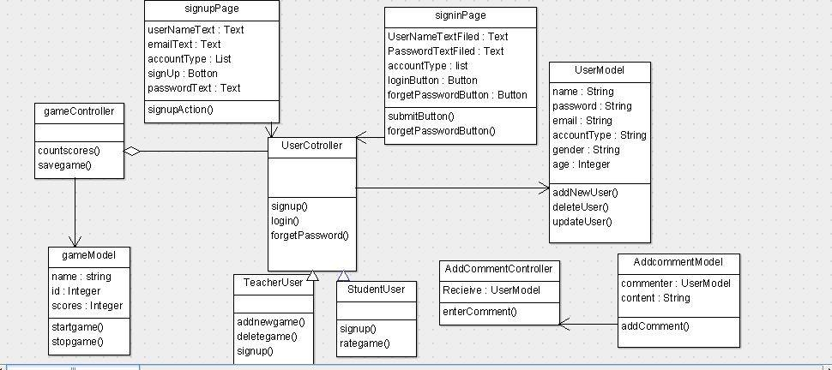

| **Class ID** | **Class Name** | **Description & Responsibility** |
| --- | --- | --- |
| 1 | SignUpPage | This class responsible for sign up which contain basic information to sign up |
| 2 | SignInPage | This class responsible for sign in to the website |
| 3 | userModel | This class contains basic information about user and basic functions : delete used and add user and update user |
| 4 | userController | Responsible for basic functions signup ,signin , forgetPassword |
| 5 | StudentUser | This class is user from type student and has functions :sign up , rate game. |
| 6 | teacherUser | This class is user from type teacher and hasfunction sign up and private functions : add new game , delete game |
| 7 | GameModel | This class has basic information about the game and basic function for game. |
| 8 | GameController | This class has afunction to count scores and to save game and the relation between game and user |
| 9 | AddCommentModel | This class to add comment |
| 10 | AddCommentController | This class responsible for addcomment model and relation between user mosel and addcomment model. |

## 

## II. Sequence diagrams

**ID : 1**

**Name : Have an account**

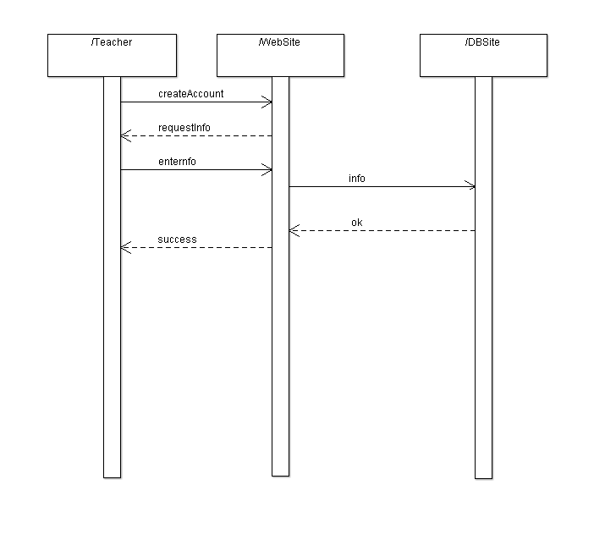

### ID : 2

### Name : Create Game

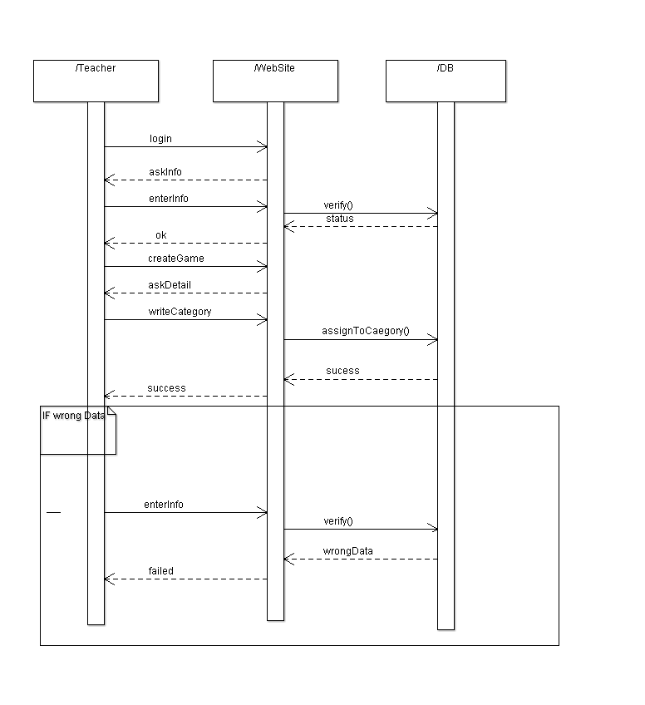

### ID : 3

**Name : Try Game**

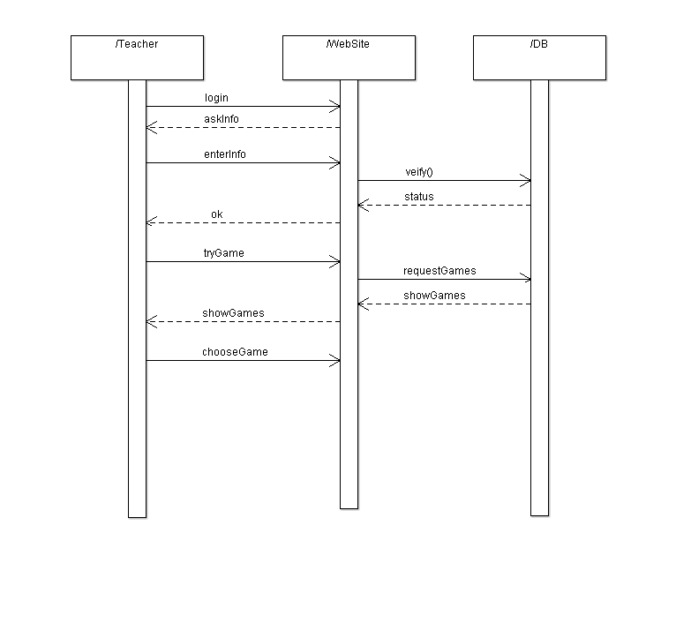

### ID : 4

### Name : Edit or remove Game

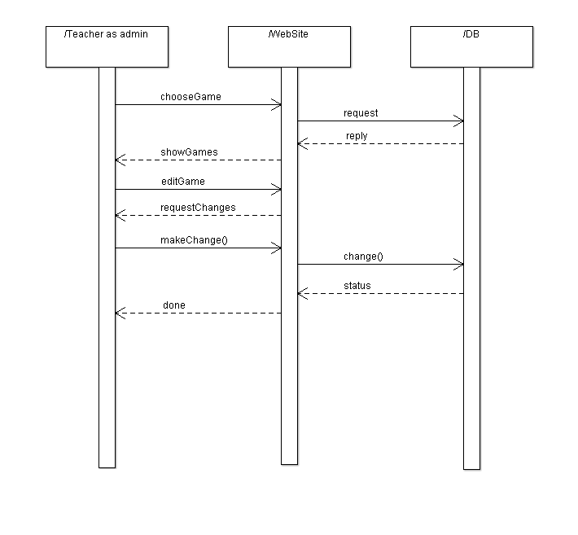

### ID : 5

### Name : Respond for Comments

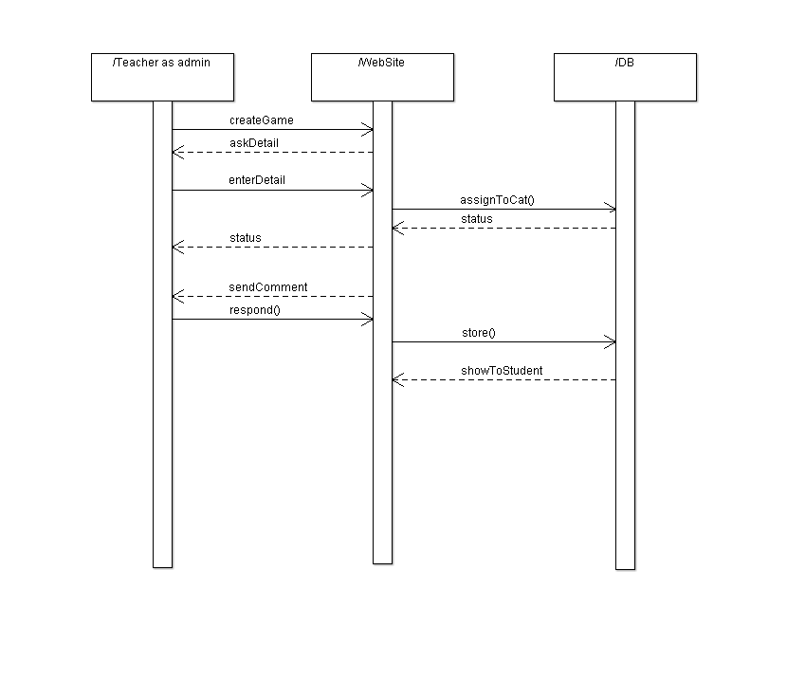

### ID : 6

**Name : Have an account**

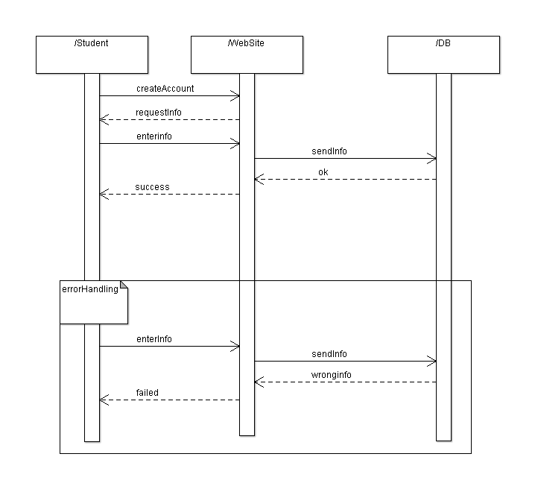

### ID : 7

### Name : Play a Game

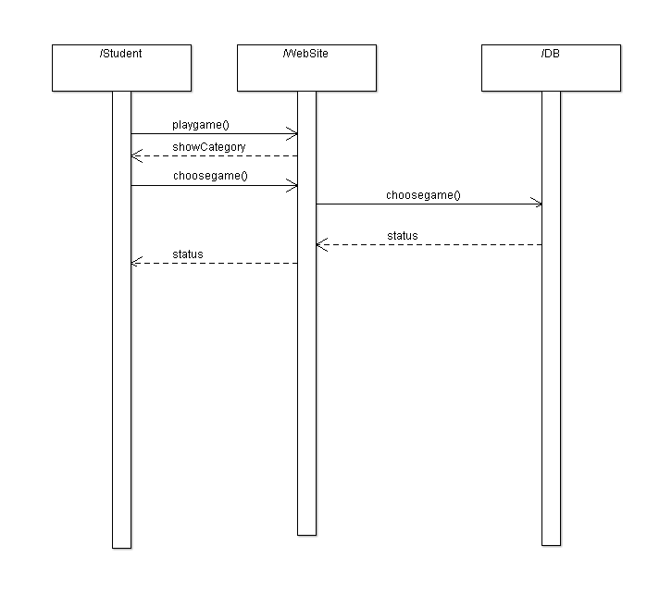

### ID : 8

**Name : Rate a Game**

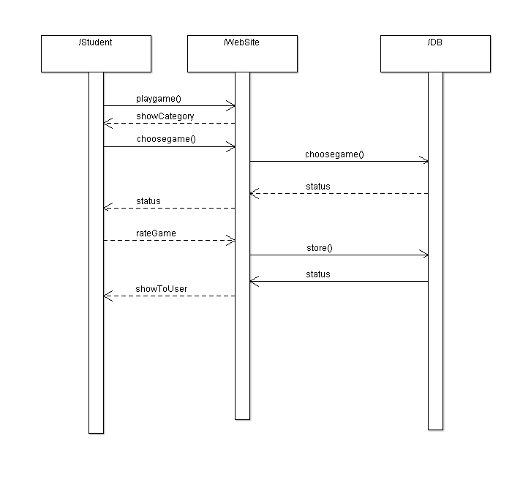

### ID : 9

**Name : Write Comments**

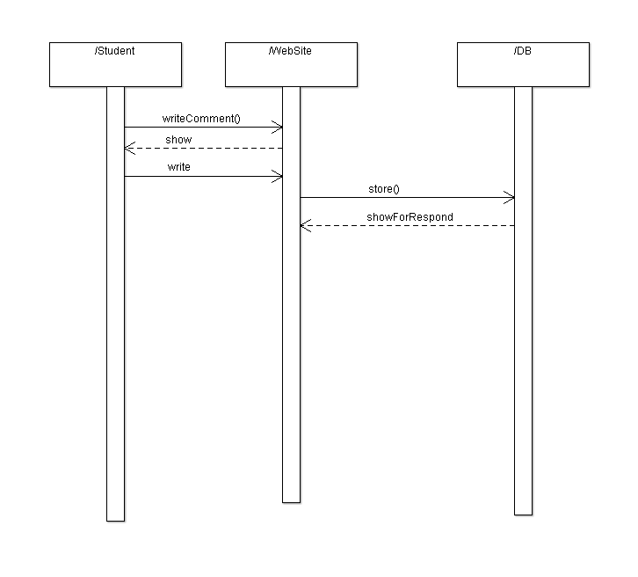

### Class - Sequence Usage Table

### 

| **Class Name** | **Sequence Diagrams** | **Overall used methods** |
| --- | --- | --- |
| SignUpPage | 1,6 | signupAction() |
| SignInPage | 1,6 | Submitbutton()  forgetPassButton() |
| UserModel | 1,6 | Addnewuser()  deleteUser()  updateUser() |
| UserController | 1,6 | signUp()  Login()  forgetPass() |
| StudentUser | 6 | Signup()  rateGame() |
| TeacherUser | 1 | SignUp()  addnewGame()  deletegame() |
| GameModel | 2,3,5,7,8 | startGame()  StopGame() |
| GameController | 2,3,5,7,8 | countScores()  SaveGame() |
| AddCommentModel | 9 | addComment() |
| AddComment Controller | 9 | enterComment() |

# Ownership Report

|  |  |
| --- | --- |
| **Item** | **Owners** |
| Class Diagram | *Mohamed & Mena* |
| Sequence Diagram | *Ahmed & Mena* |

# Policy Regarding Plagiarism:

**Students have collective ownership and responsibility of their project. Any violation of academic honesty will have severe consequences and punishment for ALL team members.**

1. تشجع الكلية على مناقشة الأفكار و تبادل المعلومات و مناقشات الطلاب حيث يعتبر هذا جوهريا لعملية تعليمية سليمة
2. ساعد زملاءك على قدر ما تستطيع و حل لهم مشاكلهم فى الكود و لكن تبادل الحلول غير مقبول و يعتبر غشا.
3. أى حل يتشابه مع أى حل آخر بدرجة تقطع بأنهما منقولان من نفس المصدر سيعتبر أن صاحبيهما قد قاما بالغش.
4. قد توجد على النت برامج مشابهة لما نكتبه هنا أى نسخ من على النت يعتبر غشا يحاسب عليه صاحبه.
5. إذا لم تكن متأكدا أن فعلا ما يعد غشا فلتسأل المعيد أو أستاذ المادة.
6. فى حالة ثبوت الغش سيأخذ الطالب سالب درجة المسألة ، و فى حالة تكرار الغش سيرسب الطالب فى المقرر.

# Repo Link In Github

# References

* http://www.mhhe.com/engcs/compsci/pressman/graphics/Pressman5sepa/common/cs1/design.pdf

# Authors

* Mostafa Saad and Mohammad El-Ramly (Edited by Mohamed Samir)