**Department of Electronics and Electrical**

**Communications Engineering**

**Faculty of Engineering**

**Cairo University**

**[DFT & OFDM system project]**

4th Year

1st Semester – Academic year 2024/2025

Presented by

|  |  |  |  |
| --- | --- | --- | --- |
| **Name** | **SEC** | **BN** | **ID** |
| **أحمد عادل يونس سيد** | **1** | **17** | **9213073** |
| **كريم أيمن محمد فخر الدين** | **3** | **22** | **9210836** |

Under supervision of

**Prof. Mohamed Khairy**

**Eng / Mohamed Nady**

* **Problem 1: Execution time of DFT and FFT**
* A mathematical equation with a number of letters

  Description automatically generatedIn this section, it is required to compare between the execution time of Discrete Fourier Transform (DFT) and Fast Fourier Transform (FFT) where the discrete Fourier transform X(k) represented by this equation:

|  |
| --- |
|  |

* After simulating the code, we found that the execution time of DFT function is **much higher** than FFT built-in function as shown in figure (1). Therefore, FFT offers superior performance with respect to the execution time.

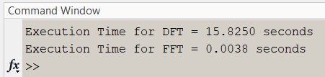

Figure (1): Simulation result

* **Problem 2: Bit-error rate performance for BPSK & QPSK & 16-QAM over Rayleigh flat fading channel**

|  |
| --- |
|  |

* The above code explains the steps of BER calculation over Rayleigh fading channel:

1. Generate Random Bit stream .
2. Generate BPSK symbols based on the bit stream

and generate the QPSK & 16-QAM symbols based on their constellation.

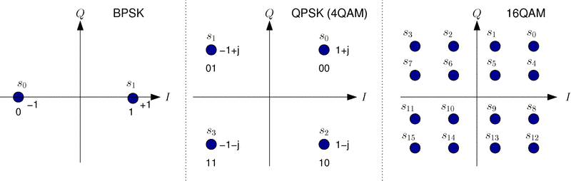

Figure (2): Constellation diagram for BPSK, QPSK, 16-QAM

1. Generate the complex channel vector and complex noise vector

based on the distributions explained above.

1. Compute the received symbol vector as follows:

1. Compensate for the channel gain at the receiver (assuming the channel is **known** at the receiver), apply correlator and make hard decision decoding to estimate the transmitted bit stream ().
2. Compute the bit-error rate (BER) for each SNR value [].
3. Plot the BER against SNR.
4. Repeat the above steps using a rate 1/3 repetition code. This is done by transmitting every “1” as three “1’s” and every “0” as three “0’s”.

* After simulating the code, we produce BER graph for each modulation scheme (BPSK, QPSK, 16-QAM) where each graph compares certain modulation scheme without any channel coding vs with channel coding (repetition 3 coding).

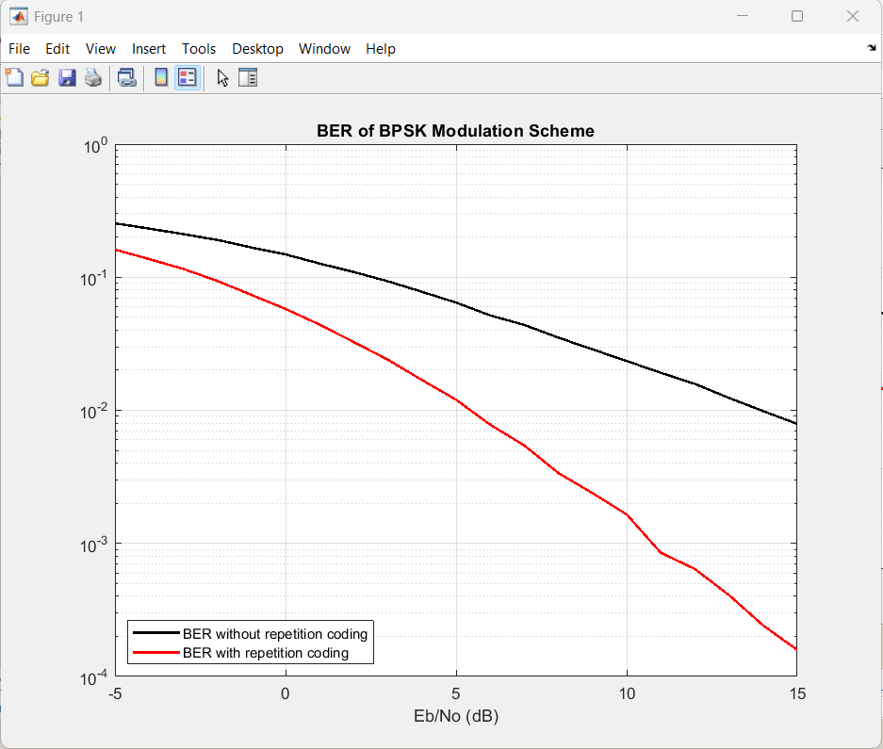

Figure (3): BER vs SNR for BPSK modulation scheme

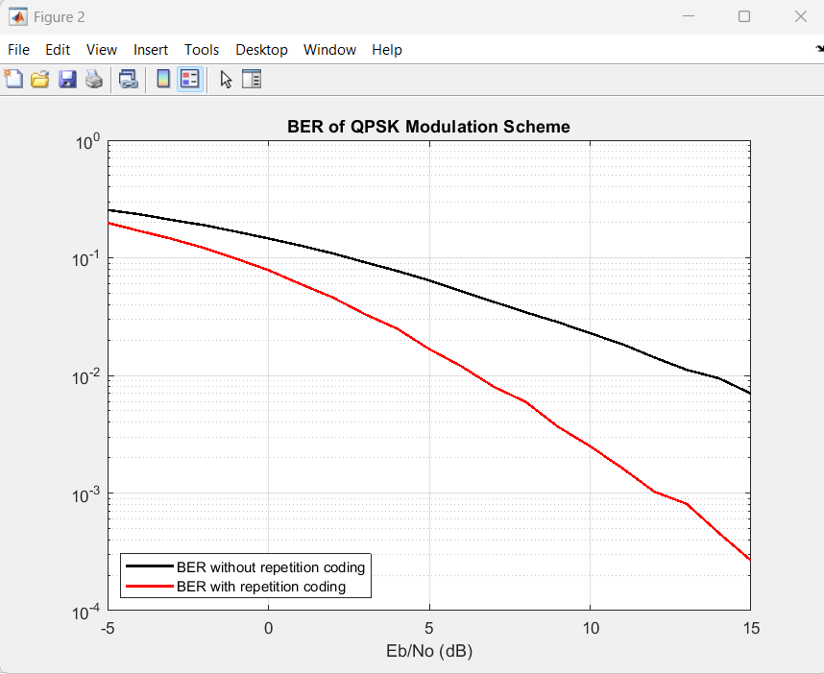

Figure (4): BER vs SNR for QPSK modulation scheme

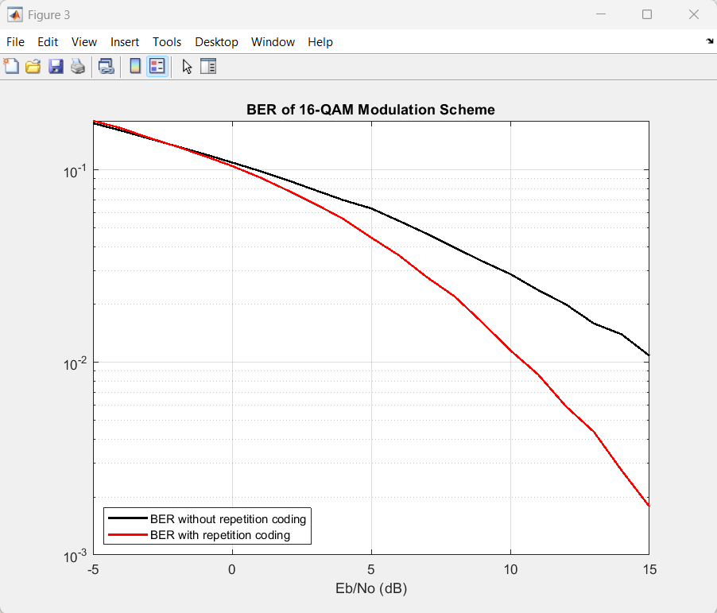

Figure (5): BER vs SNR for 16-QAM modulation scheme

* From the above graphs we notice that:

1. The BER in case of repetition coding is **better than** BER with no coding and this is what we expect as in repetition coding, each bit is transmitted multiple times (e.g., three times for 3-repetition coding) so, the receiver uses majority decoding logic to decide the bit value.  
   single-bit error in any of the three bits still results in correct decoding using majority logic.
2. BER for BPSK is very close to BER for QPSK and the reason behind that is the theoretical value of the BER for BPSK **equal to** that of QPSK

* **Problem 3: OFDM system simulation**

**Channel**

**Add Cyclic extension**

**128-IFFT block**

**Mapper block**

**Interleave block**

**Coding block**

**Decyclic extension**

**128-FFT block**

**Demapper block**

**Deinterleave block**

**Decoding block**

Figure (6): OFDM system block diagram

**Data bits**

* Role of each block in brief:

1. **Coding block** 🡪 The input to the system is a stream of binary data bits is coded first (for channel coding “repetition” only). This coding can be applied to the data bits to improve BER.
2. **Interleave block** 🡪 The data bits are interleaved to spread the impact of burst errors caused by channel fading. In our case we use interleaver with size (16*16) for QPSK, and the size of the interleaver is (32*16) for 16-QAM.
3. **Mapper block** 🡪 The interleaved bits are mapped to complex symbols (e.g., QPSK, 16-QAM) using a constellation mapping scheme mentioned above in figure (2).
4. **IFFT block** 🡪 The mapped symbols are grouped into blocks of 128 symbols and transformed into the time domain using an Inverse Fast Fourier Transform function ifft ().
5. **Cyclic extension block** 🡪 The last part of the IFFT output is appended to the beginning of the OFDM symbol, creating a cyclic prefix. Where the length of cyclic prefix = 25% of IFFT length (in our case cyclic prefix length = 32). This process helps mitigate Inter-Symbol Interference (ISI) caused by channel delay spread.
6. **Channel 🡪** The OFDM symbols are transmitted through the channel. Two channel models are considered, which are Rayleigh Flat Fading & Frequency Selective Fading.
7. **Receiver blocks** 🡪 All blocks at the Rx perform the reverse operation performed by the transmitter blocks mentioned before.

|  |
| --- |
|  |

* After simulating the above code, we produce 4 curves as we have four possibilities (QPSK with flat channel, QPSK with frequency selective channel, 16-QAM with flat channel, 16-QAM with frequency selective channel)

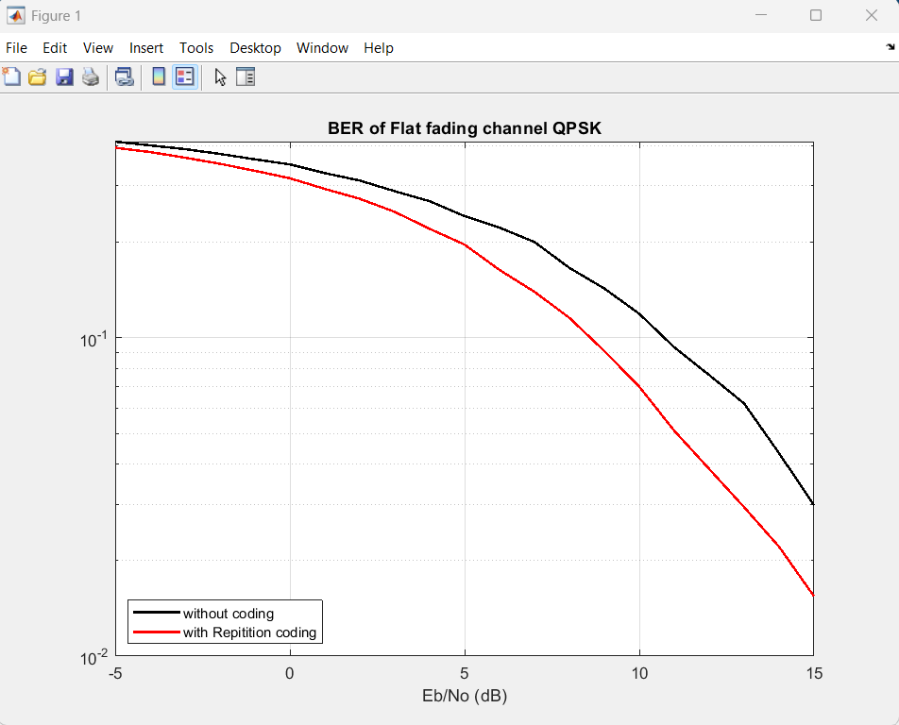

Figure (7): BER of flat fading channel for QPSK modulation

Figure (8): BER of frequency selective fading channel for QPSK modulation

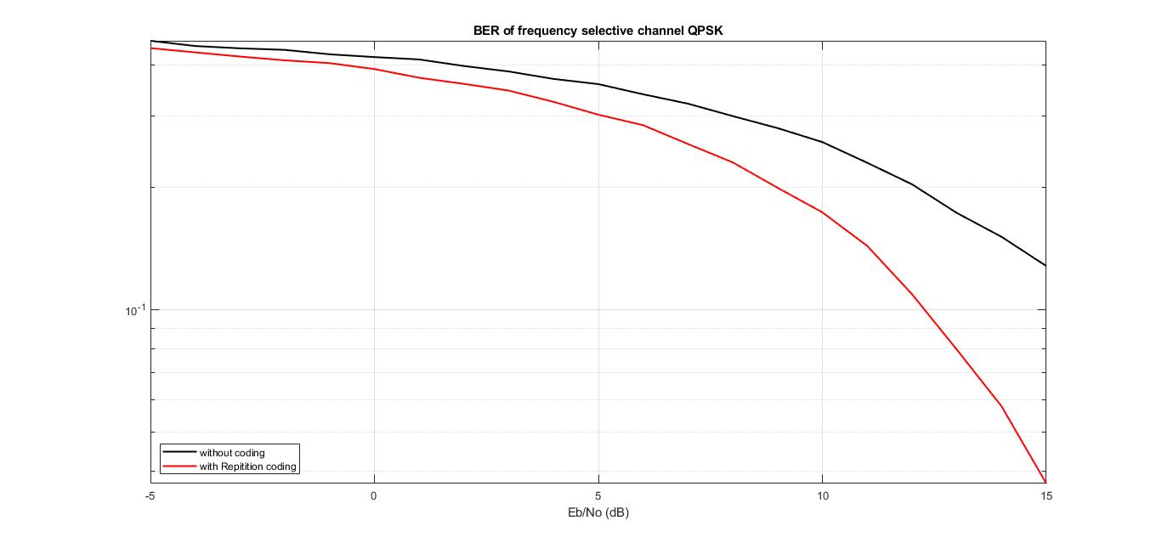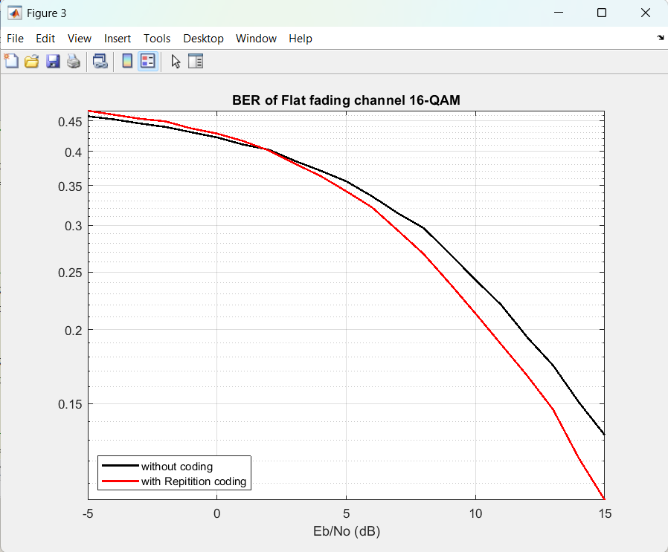

Figure (9): BER of flat fading channel for 16-QAM modulation

Figure (10): BER of frequency selective fading channel for 16-QAM modulation

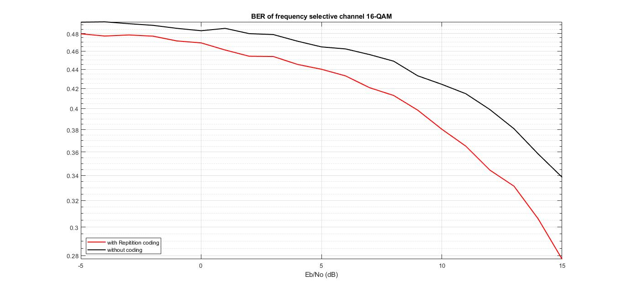

* From the above graphs we notice that:

1. **Channel vs. Modulation Scheme:**

Flat Fading Channel: For both QPSK and 16-QAM, the flat fading channel performs better overall compared to the frequency-selective channel. This is expected as flat fading introduces uniform distortion across all frequencies, which is easier to equalize.

Frequency-Selective Channel: This channel shows a more significant degradation in BER, especially for higher-order modulation (16-QAM). Frequency selectivity causes varying interference across different frequency components, making equalization harder and increasing BER.

1. **Effect of Coding with the Modulation Scheme on BER:**

QPSK: Repetition coding demonstrates noticeable improvement in BER for both flat and frequency-selective channels. This shows the resilience of lower-order modulation when combined with simple error correction techniques like repetition coding.

16-QAM: Repetition coding still improves the BER, but the improvement is less pronounced compared to QPSK. This reflects the inherent vulnerability of higher-order modulation to noise and fading, which limits the coding gain.

1. **Insights on Modulation and Coding:**

Higher-Order Modulation: As seen in 16-QAM, while it provides higher data rates, it is more sensitive to noise and fading. This trade-off makes it less effective in harsh channel conditions, even with coding.

Error-Correcting Codes: Simple coding techniques like repetition coding offer significant BER improvements, particularly for robust modulation schemes like QPSK. However, advanced coding methods may be needed for higher-order schemes to maximize performance gains.

1. **General Observations:**

QPSK offers better BER under challenging conditions, 16-QAM provides higher data rates but demands more sophisticated error-correction strategies.