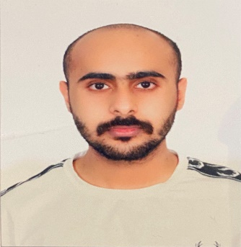**Appendix 1: Curriculum Vitae**

**Al-Gabri, Ahmed Hussein**

52 Leonila hill, Baguio city

**Personal Information:**

Contact No: 09563916034

Date Of Birth: April 6, 2000

Sex: Male

Citizenship: Yemeni

Civil Status: Single

Language Spoken: Arabic, English

**Education:**

**Tertiary:**

University of Baguio

Bachelor of Science in Computer Science

**Secondary:**

Emad Dean Senki High School

**Primary:**

King Abdo Al-Azzeiz Elementary School

**Skills:**

Computer and Technology Skills Hardware Troubleshooting /

Diagnosis Essential Knowledge on Microsoft & Google Applications

Installation of Operating System Format and Partition of Hard Disk