

12/19/2019

Car Rental System

Supervised By: Dr. Amr Ali Saad

Submitted By:

Ahmed Abdelgawad Abdelhady

Ahmed Hesham

Ahmed Mohamed Ahmed

Safinaz Hamdy

Youssef Yasser

Contents

**1.** **Proposal** 2

**1.1** **Introduction:** 2

**1.2** **Users of the system:** 2

**1.3** **Problem Statement:** 2

**1.4** **Objectives:** 3

**2.** **Development plan** 3

**3.1** **Task Descriptions** 3

**3.2** **Deliverables and Milestones** 4

**3.3** **Project Schedule** 5

**3.** **Entity Relationship Diagram** 6

**4.** **Unified Modeling Language** 7

# **Proposal**

## **Introduction:**

This system has been created for the role of car rental to act as an intermediary between two clients; namely the car owner and the renter. Anyone who has the interest to rent will not have to register, he or she can have a full access to this system. We are here to give the best service to our clients and make ensure they get their things to happen as they wanted.

As an owner of a car, you need to register your car that you want to rent out with the company. During the registration, all the details or information about the car will be fully given.

As a renter, you also need to register and then search for the desired car you want to rent and the system will check for the available car with the same match.

## **Users of the system:**

* Admin
* Car owner
* Customer (renter)

## **Problem Statement:**

As people mostly use the manual process to do their rental services, it was not the perfect as they wanted.

The clients of our car rental system faced these problems:

1. In order to offer cars for rent, a car owner normally have to come to the nearest branch office to register car to be rent out.
2. To rent car, a prospective renter who is interested in renting a car must first go to the nearest branch office to register as a client with us.
3. Cars that provide difficulties to rent out are normally advertised in local or national newspaper.it involves a lot of paper work and consumes time.

## **Objectives:**

Before we developed this system, there were a lot of problems people are facing from the old system. In order to overcome, our car rental system has been established.

The main objectives:

* To create a system that will allow car owner to register their cars for rent
* To establish a system that will allow renters to register and rent cars
* To create a system that can advertise cars for rent
* To create a system that will reduce paper work and consumes less time

# **Development plan**



## **Task Descriptions**

**Stakeholder Meetings**

The stakeholders and the software engineering team conducts meetings in order to get the full grasp of the problem at hand, obtaining any and all information needed. Conflicts and negotiations would be conducted during this time and any time throughout the project process flow.

**Design Models and Mockups**

Designing the models and mockups help to ensure clarity in view of the project as well as how it works. Stakeholders are to sit through this process as drawings are created.

**Database Creation**

A database is created using the models to provide storage for customer information, vehicle information, and payment reports. Testing of the database is ensured at this point.

**Employee Software Creation**

The software that is to be used by the employees will be designed using Visual Basic using the guide of the mockups, requirements, and models. The software will act as a simple and easy to understand user interface to ‘browse’ and among other functions the database – the information stored including customer information, vehicle information, and payment reports.

**Desktop Application Creation**

The desktop application will be designed using Java language using the guide of the mockups, requirements, and models. The desktop application will be implemented using high-quality design techniques. It should allow for users to immediately see the rental cars that are available. They can also have the ability to search for a certain vehicle they desire. Once they select, they can register or log in to store any private information they are about to give to the company in order to obtain their vehicle, although registering is not required.

**Testing**

Testing will be implemented on both the website and software. Test cases may be used to guide and understand the basic actions of both customers and employees. Any bugs or errors that occur will be identified and resolved.

**Finalization and Reports**

All testing and function processes are finalized at this stage. Reports will be created to ensure all information and functionality is clear in order to make the user manual and to help ensure employees can use the software with ease.

## **Deliverables and Milestones**

We had four major Milestones in this project:

1. Completion of Requirements Gathering.
2. Completion of Design and code.
3. Completion of Testing.
4. Completion of Demonstration.

These milestones were all completed on schedule and yielded a Deliverable at the end of each.

Our four corresponding deliverables (respectively) in this project were as follows:

1. A completed list of all stakeholders needs to be met.
2. A finished and easily navigational GUI (Graphical user interface).
3. Satisfied stakeholders and customers after demonstration and launch of software.

## **Project Schedule**

The first month of the project start date (September) was used mainly for requirements setting and Intel gathering. This took (over the course of four weeks) roughly 37-man hours. Through the last two weeks of September and part of October, we were able to begin designing, which took 35 hours. Around the same time, testing began and continued throughout the remainder of the project. This total time was about 70 hours. We then wrote out the user manual, and gave a final report of the software. The time this took was about 24 hours. We then had a minor period for demonstration and final adjustments which totaled 10 hours. We finished the project in late November. The percentage breakdown was as follows:

Requirements: 37 hours – 21.02%

Design and code: 35 hours – 19.88%

Testing: 70 hours – 39.77%

Manual and Final Report: 24 hours – 13.63%

Demonstration and Adjustments: 10 hours – 5.68%

Total: 176 hours - 100%

# **Entity Relationship Diagram**

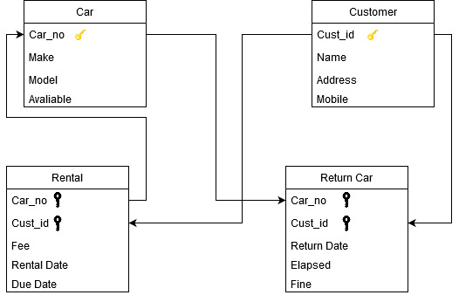

# **Unified Modeling Language**

