1. Create a new SQL database with name students.
2. Change database name from Student to students.
3. Drop an existing database in SQL schema with name Exam.
4. Create a new table with query statement has two columns ID as primary key, and Gender.
5. Show all data from table tblperson.
6. Write query for add foreign key for table tblperson with column GenderId with table tblGender.
7. Table tblperson with column ID,Name,Email insert the following two rows :

(5,'Sam','s@s.com')

(6, 'd@d.com','Dan')

1. As the below table tblEmployee Write query show this result

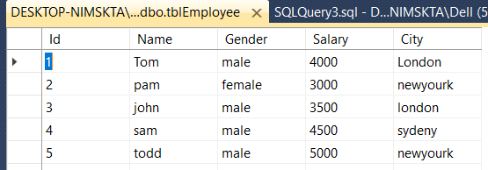 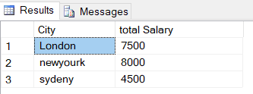

1. As the below table tblEmployee and tblDepartement Write query show this result

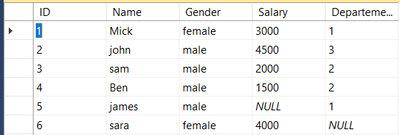 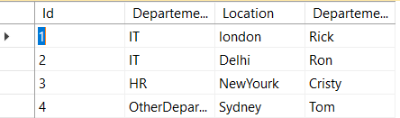

1. Result one

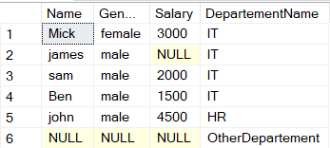

1. Result two

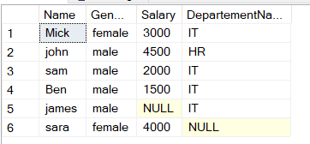

1. As the below table tblIndiaCustomers and tblUKCustomers Write query show this result

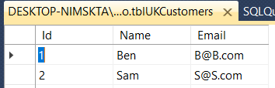 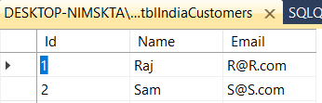

1. Result one

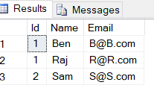

1. Result two

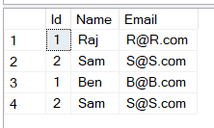

1. As the below table tblEmployee Write stored procedure show this result

 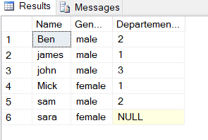

1. Create view from tblEmployee and tblDepartement show this result

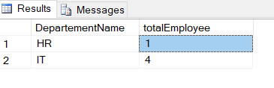

1. Create trigger for insert into tblEmployee as below result

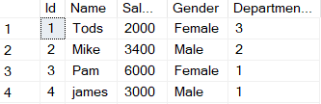 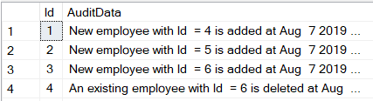

1. Create trigger for delete into tblEmployee as below result

 