Add Resources project

1-app folder :

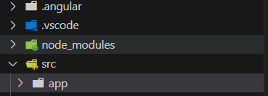

The main folder in application which contain all components and modules , services etc.

2-nav component:



Contain The header of application which contain the language and other actions

3- modules :

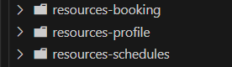

-- resource-profile module :

Contain the profile component (html , css , ts ) files contain the

profile logic .

--resource-booking module :

Contain the booking component (html , css , ts ) files contain the

booking logic .

--resource-schedule module :

Contain the schedule component (html , css , ts ) files contain the

schedule logic.

--shared module :



Contain the critical components and services , modules .

--app module :

The main module in application contain the components and services

-app component :

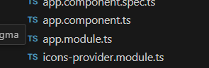

The main component in project which contain all components (parent component)

4- shared folder (store):

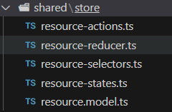

Contain store folder which contain [store-states ,store-reducers,store-actions,store-selectors ,store-interfaces].

5-services folder :

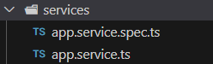

Contain all services in application

6-environments folder :

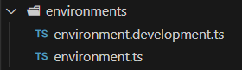

Which contain the environment variables and base urls and production url.

7-assets folder :

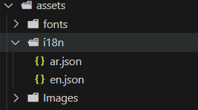

Which contain all resources in application like images , fonts , languages (i18n)