1. Phase 1: Soft launch used car / Spare part – buy and sell used cars (anyone will post add he will get free post in Bahrain showroom Instagram
2. Phase 2: add the new car section/ finance / insurance / car Alert / car services like workshops accessories / roadside assistance / rent a car /

Home page: the look it will be like Instagram photo size with brand name -model – price – phone number.

Upper menu: used cars – new cars – spare part -more options.

Post used car ad.

1. Brand Name
2. Model
3. Model year.
4. Cat category (Sport – Sedan – SUV- pickup – Bus )
5. Price
6. Phone number.
7. More information

Search page used cars.

1. Brand name
2. Model
3. Model year.
4. Car category (sport – sedan – SUV- pickup – Bus)
5. Price ranges from to

Spare parts inquiry:

Spare part name:

Car brand:

Model year:

Upload your car card or spare part photo (optional)

Name:

Phone number:

1. Phase 1 (used car / Spare part – buy and sell used cars and spare part

Home page: the look it will be like Instagram photo size with brand name -model – price – phone number.

Upper menu: used cars – new cars – spare part -more options.

Down menu: profile/ + add post / search / home.

1. When the user opens the app, he will see the latest ads by scrolling down.
2. Post used car ad.

-Brand Name

-Model

-Model year.

-Cat category (Sport – Sedan – SUV- pickup – Bus)

-Price

-Phone number.

-More information (will give him free space to wright whatever he wants)

Search page used cars.

1. Brand name
2. Model
3. Model year.
4. Car category (sport – sedan – SUV- pickup – Bus)
5. Price ranges from to

Spare parts inquiry:

Spare part name:

Car brand:

Model year:

Upload your car card or spare part photo (optional)

Name:

Phone number:

Search page:

Search page for cars.

1. Brand name
2. Model
3. Model year.
4. Price ranges from to

Or by category:

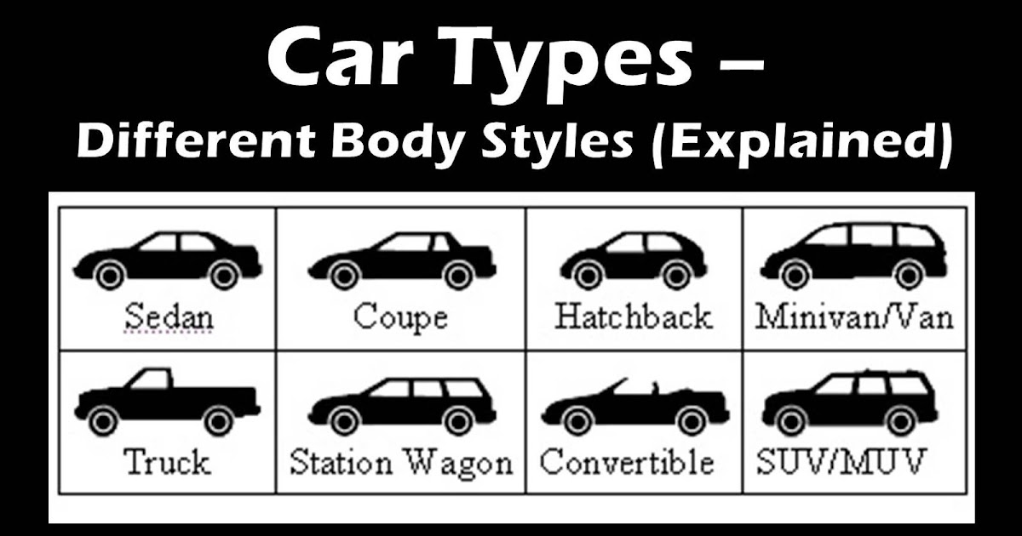

Search spare part.

Brand:

Car model:

Model year from – to

Spare part category

Ai things:

Post your photo and the Ai will identify the car brand model color.

Use algorithm to understand the user behaver and suggest him the cars he likes

User appeltey:

Post ad , Like, comment, save ad , chat option in the application share the add in WhatsApp

List your self as a freelancer photographer .