Architectural Overview and Comparative Analysis of Deep Learning Image Classification Models

model architectures

Inception V1 (GoogLeNet) - Transfer Learning Implementation

Overview: For this model, we utilized a Transfer Learning approach based on the Inception V1 (GoogLeNet) architecture. Instead of training a deep Convolutional Neural Network (CNN) from scratch, we leveraged pre-trained weights from the ImageNet dataset to extract high-level features, followed by a custom classification head designed for our A-Z handwritten dataset (26 classes).
Detailed Pipeline:
- Input Adaptation & Preprocessing:

- Challenge: Our dataset consists of small, grayscale images (28x28x1), but the Inception V1 model expects large, color images (224x224x3).

- Solution: We implemented an on-GPU preprocessing block within the model:

- Resizing: A Resizing layer scales the images up to 224x224.

- Channel Expansion: A Lambda layer converts the grayscale (1 channel) input to RGB (3 channels) by repeating the image across the channel dimension (tf.image.grayscale_to_rgb).

- Feature Extraction (The Base):

- We imported the Inception V1 feature vector from TensorFlow Hub (tfhub).

- Configuration: The weights were frozen (trainable=False). This ensures that the pre-learned patterns (edges, textures, shapes) from ImageNet are preserved and not destroyed during the initial training of our classifier.

- Key highlights of the architecture:

- Input Layer: Accepts a 224×224 RGB image as input.
- Initial Convolutions and Pooling: Applies a series of standard convolutional and max pooling layers to down sample the input and extract low-level features.

- Local Response Normalization (LRN): Normalizes the feature maps early in the network to improve generalization.

- Inception Modules: Each module processes the input through 1×1, 3×3, and 5×5 convolutions, as well as 3×3 max pooling, all in parallel. The outputs are concatenated along the depth dimension, allowing the network to capture both fine and coarse features.

- Final Layers: Uses global average pooling (7×7) to reduce each feature map to a single value.

- Classification Head (The Top):

- Since the base model outputs a flat feature vector, we attached a custom Multi-Layer Perceptron (MLP) for classification:

- Dense Layer 1: 512 neurons with ReLU activation to learn complex non-linear combinations of the extracted features.

- Dropout 1: A rate of 0.5 was applied to prevent overfitting by randomly dropping 50% of the connections during training.

- Dense Layer 2: 128 neurons with ReLU activation for further dimensionality reduction.

- Dropout 2: A rate of 0.3 for additional regularization.

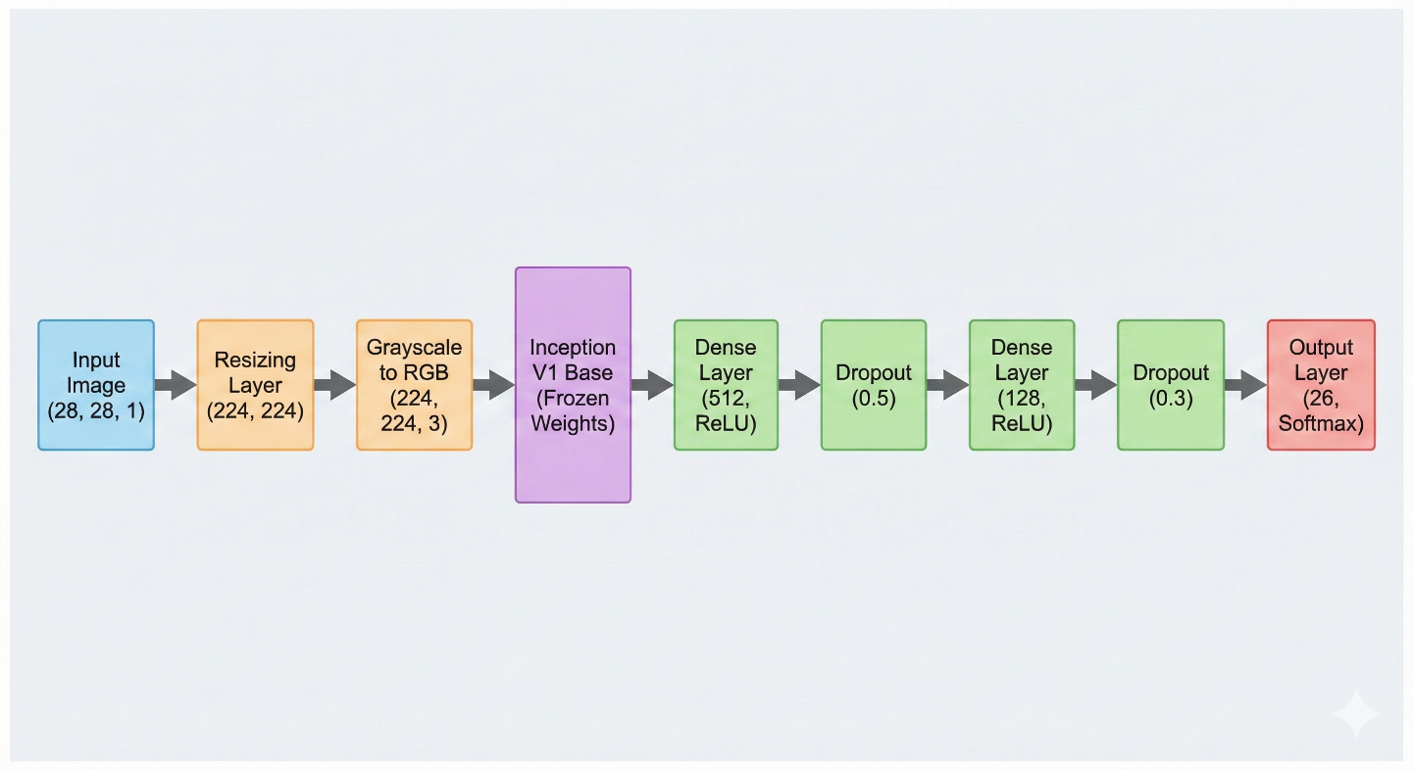
Architecture Diagram

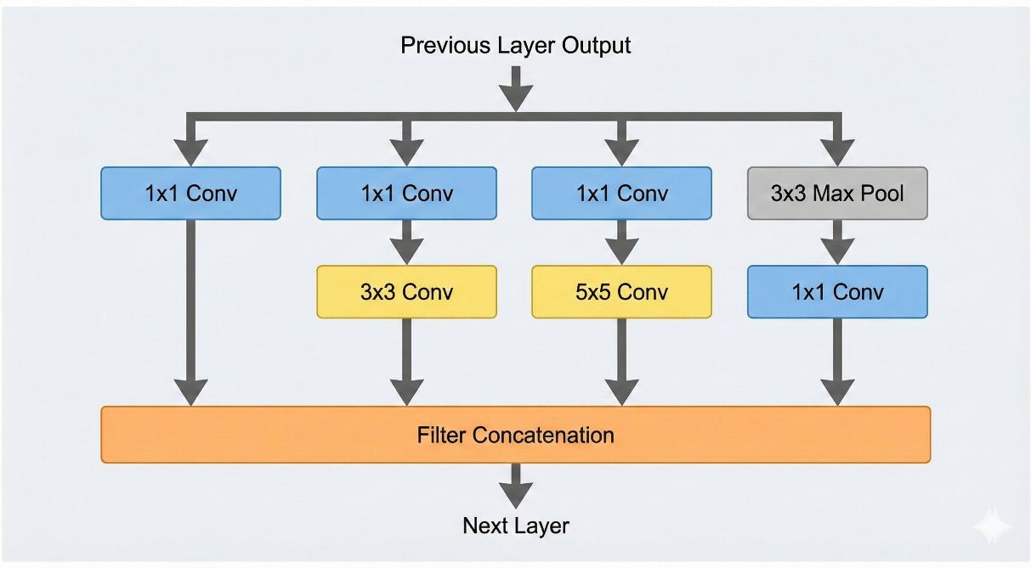
Inception V1 Module

References:
- Academic Papers

- Szegedy, C., Liu, W., Jia, Y., Sermanet, P., Reed, S., Anguelov, D., ... & Rabinovich, A. (2015). Going deeper with convolutions. In Proceedings of the IEEE conference on computer vision and pattern recognition (pp. 1-9).

- Technical Resources & Documentation

- GeeksforGeeks. (2023). "Understanding GoogLeNet Model - CNN Architecture". GeeksforGeeks.org. Available at: https://www.geeksforgeeks.org/understanding-googlenet-model-cnn-architecture/ [Accessed: Nov. 26, 2025].

