**What Are Wind Turbine Brakes For?**

Wind turbine brakes are important for

* Maintenance
* Emergencies
* Protecting investment in the case of high wind speeds.

**Main brake system types:**

There are two major different types of wind turbine brakes:

* Electrical Brakes
* Mechanical Brakes

**Types of brakes in wind turbine:**

* Rotor Brakes
* Yaw Brakes
* Pitch braking

1. **Main rotor braking systems:**

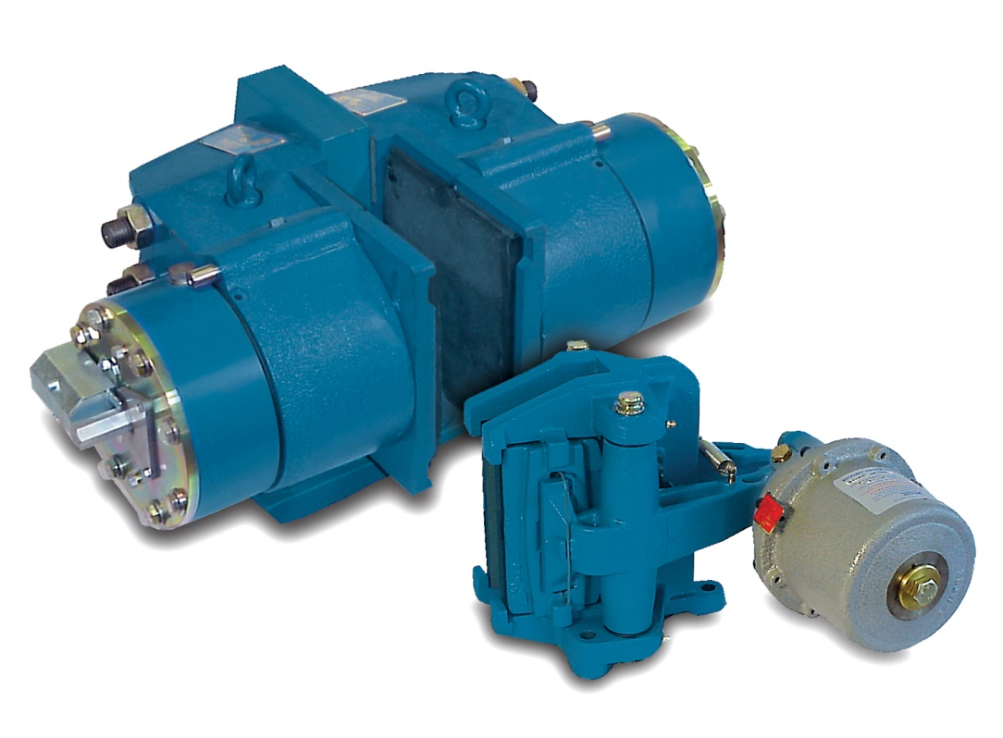

* Rotor brakes control overspeed, and provide parking and emergency braking.
* These brakes can be mounted on the **rotor** (low-speed shaft), or on the **generator** (high-speed shaft), and in some cases on **both shafts**.
* The most cost-effective position is on the **high-speed shaft** between the **gearbox** and the **generator**.
* The high increase ratios of wind turbine gearboxes produce a large reduction in output torque.
* A further consideration regarding brake position is the possibility of gear tooth damage.

**Braking torque for rotor brakes**

* The **maximum** permissible braking torque on the rotor shaft is usually imposed by the **blades**, or their anchorage to the gearbox input shaft.
* High-speed shaft braking is usually related to the maximum permissible gear-tooth loading.
* A **minimum** level of braking torque also exists, below which the variable nature of the frictional forces under different operating conditions could place the turbine rotors at risk. It is therefore important to allow an **adequate window of safety**, to ensure that the brakes will always operate effectively and under all climatic conditions.

Other factors affect the achievable friction level:

• Bedding and conditioning of the liners

• Dirt on the braking surfaces

• Condensation

• Oil on the braking surfaces

• Rubbing speed and pressure

• Disc temperature

• Disc surface finish and hardness

• Wear debris on liner surfaces

**Types of rotor brakes for wind turbine:**

* ABS 75 FC
* ABS 120 FC
* ABT 75 G-R
* ABT 90 G-R
* ABT 75 S-R
* ABT 90 S-R

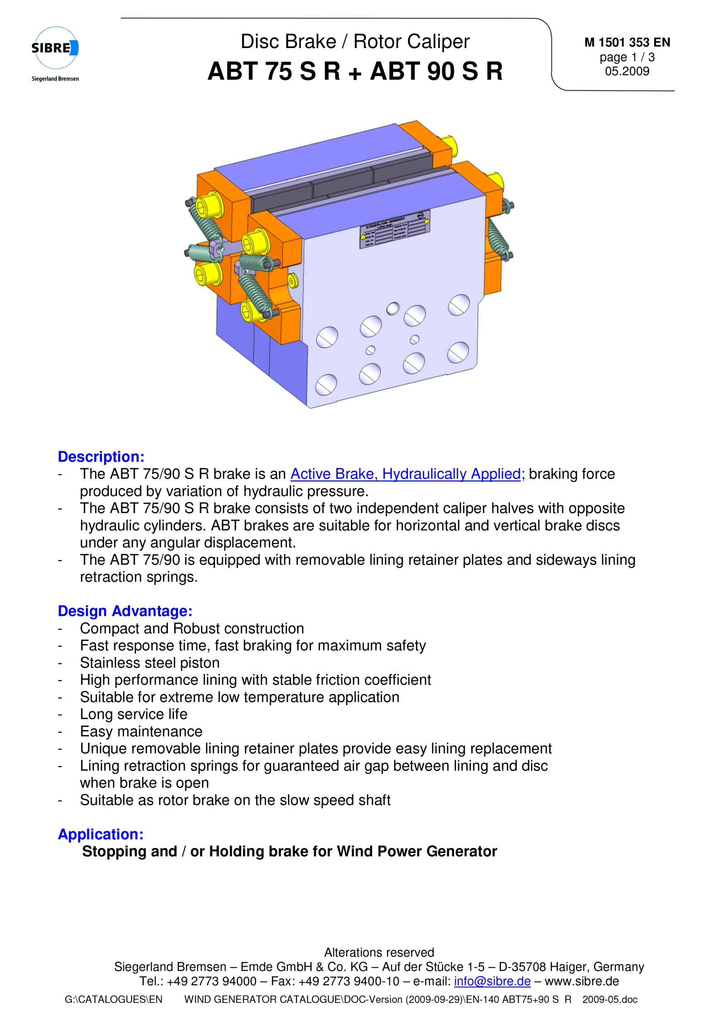

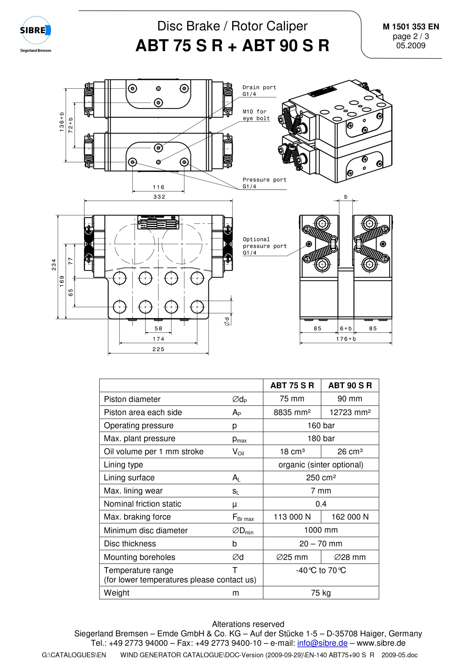

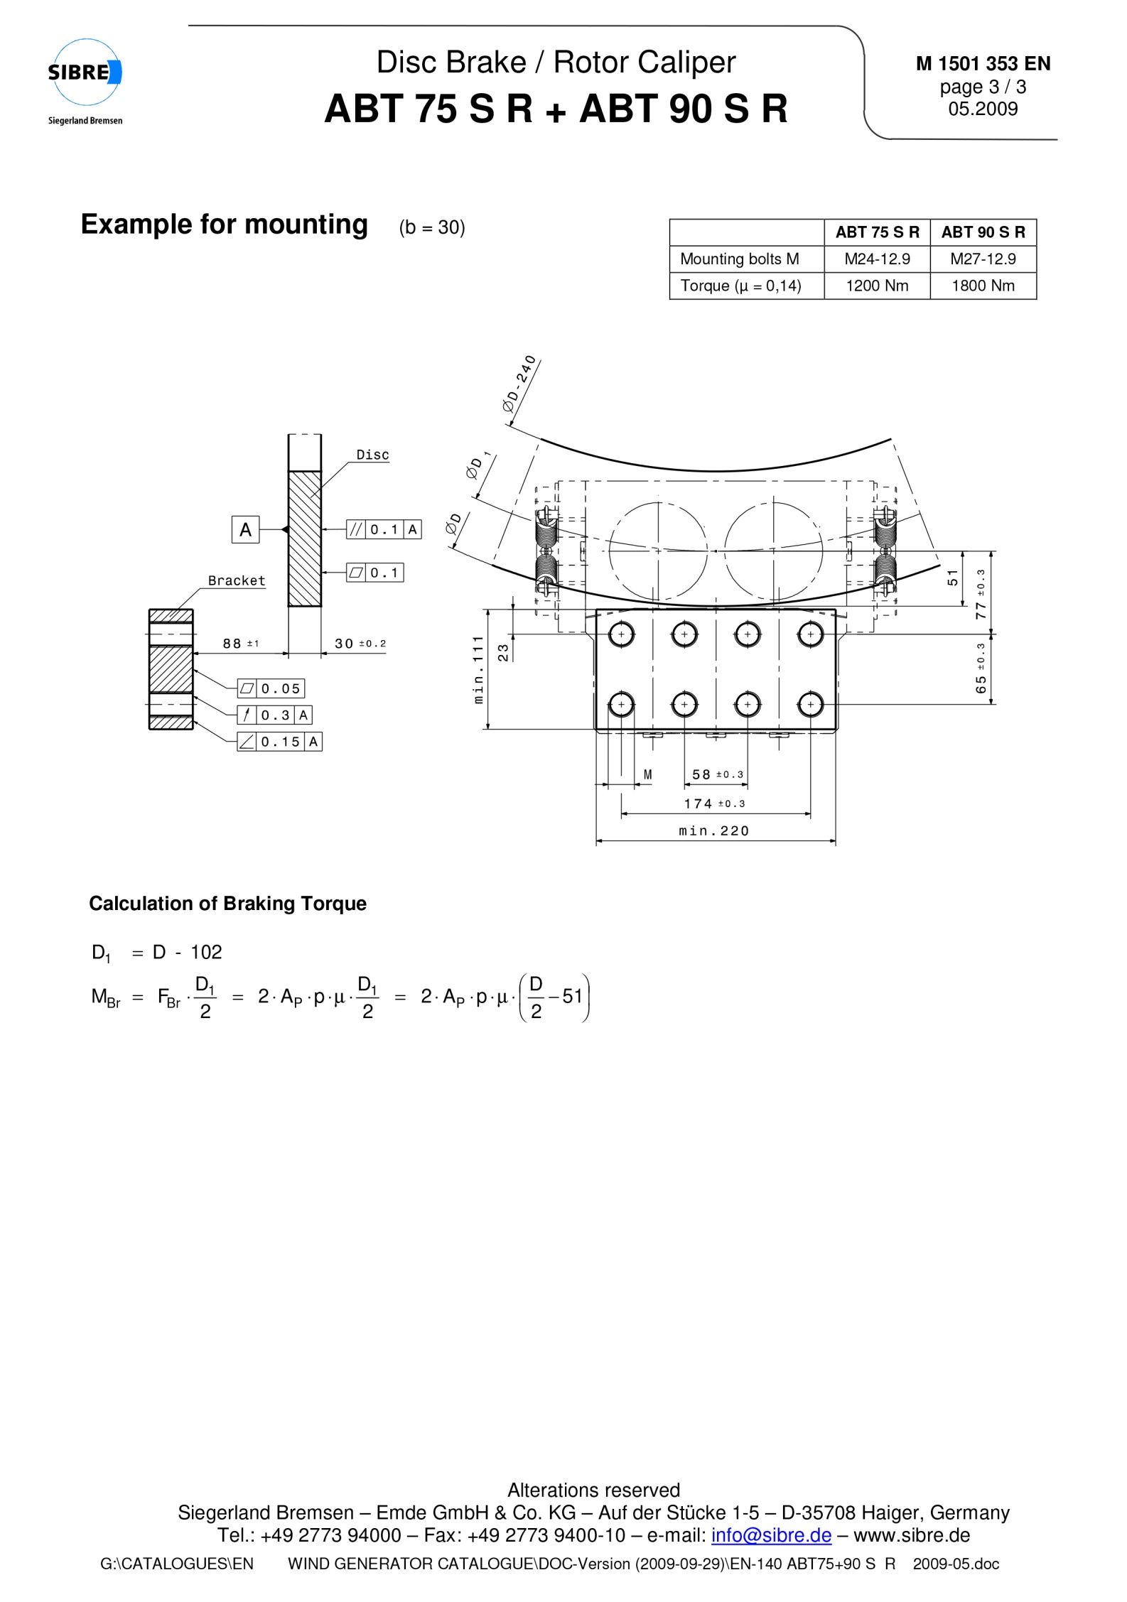

1. **Brakes for yaw control:**

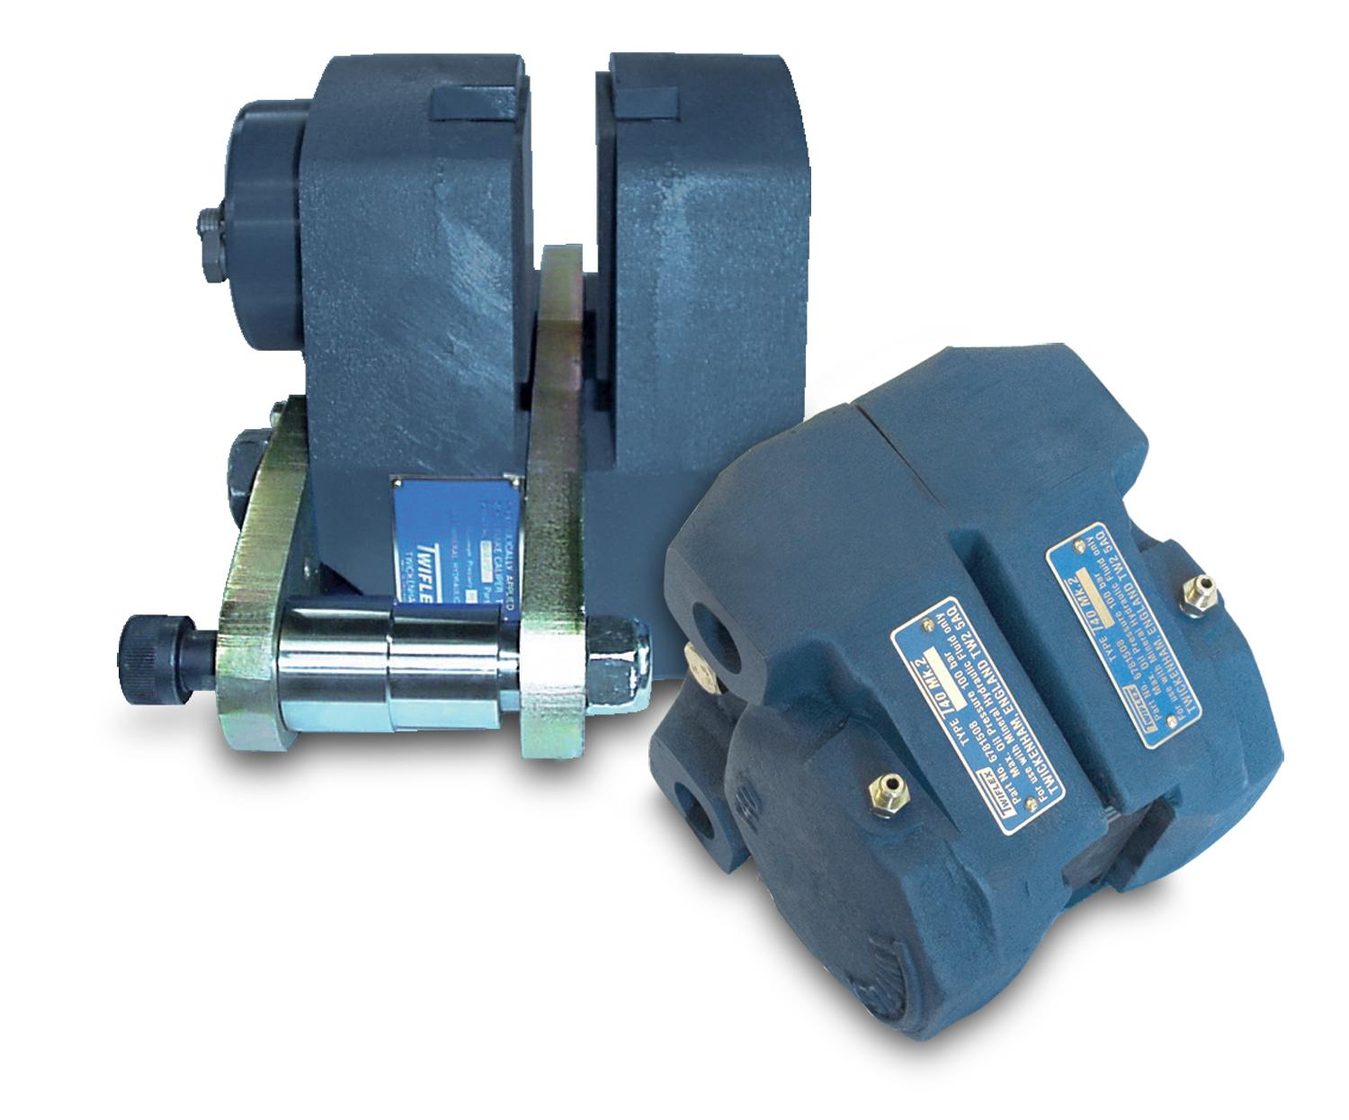

* Yaw brakes provide an effective means of smoothly controlling a wind turbine nacelle as it rotates “up wind” or yaws. They are usually installed as drag brakes and operate by controlling back pressure, which in turn controls the degree of spring force and therefore braking torques.
* An anemometer signals a change in wind direction which energizes the motor driving the gear ring on the yawing system.

Wind-turbine engineers agree that a mechanical disc brake is the best solution in terms of reliability, simplicity of manufacture, ease of servicing and initial cost.

**Types of yaw brakes for wind turbine:**

* ABT 75 G
* ABT 90 G
* ABT 75 S
* ABT 90 S
* ABT 120 G

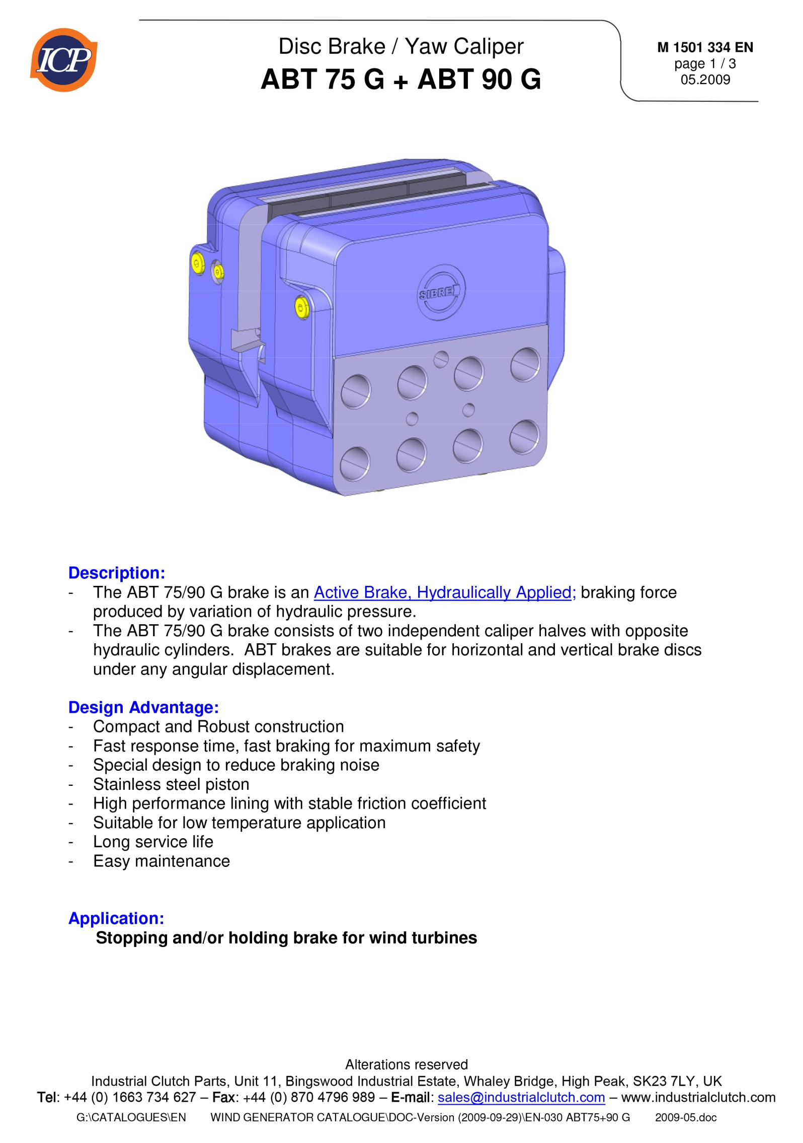

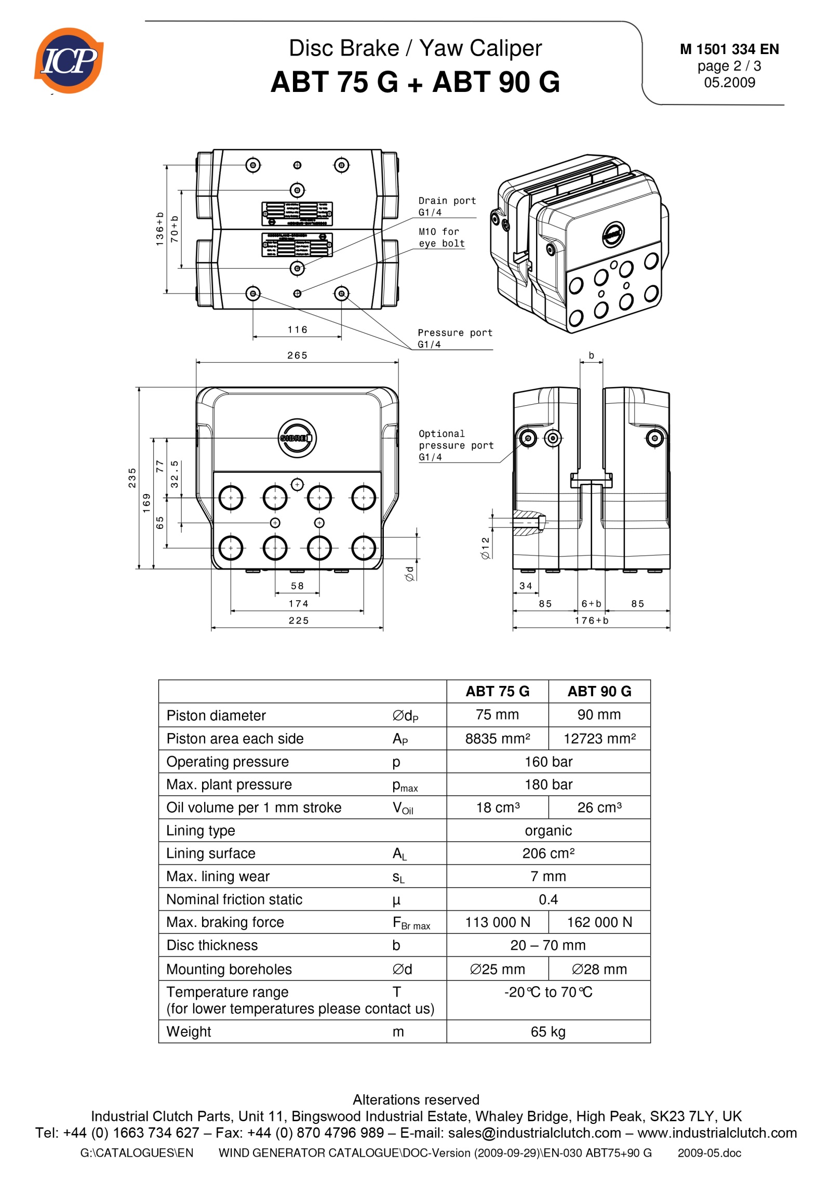

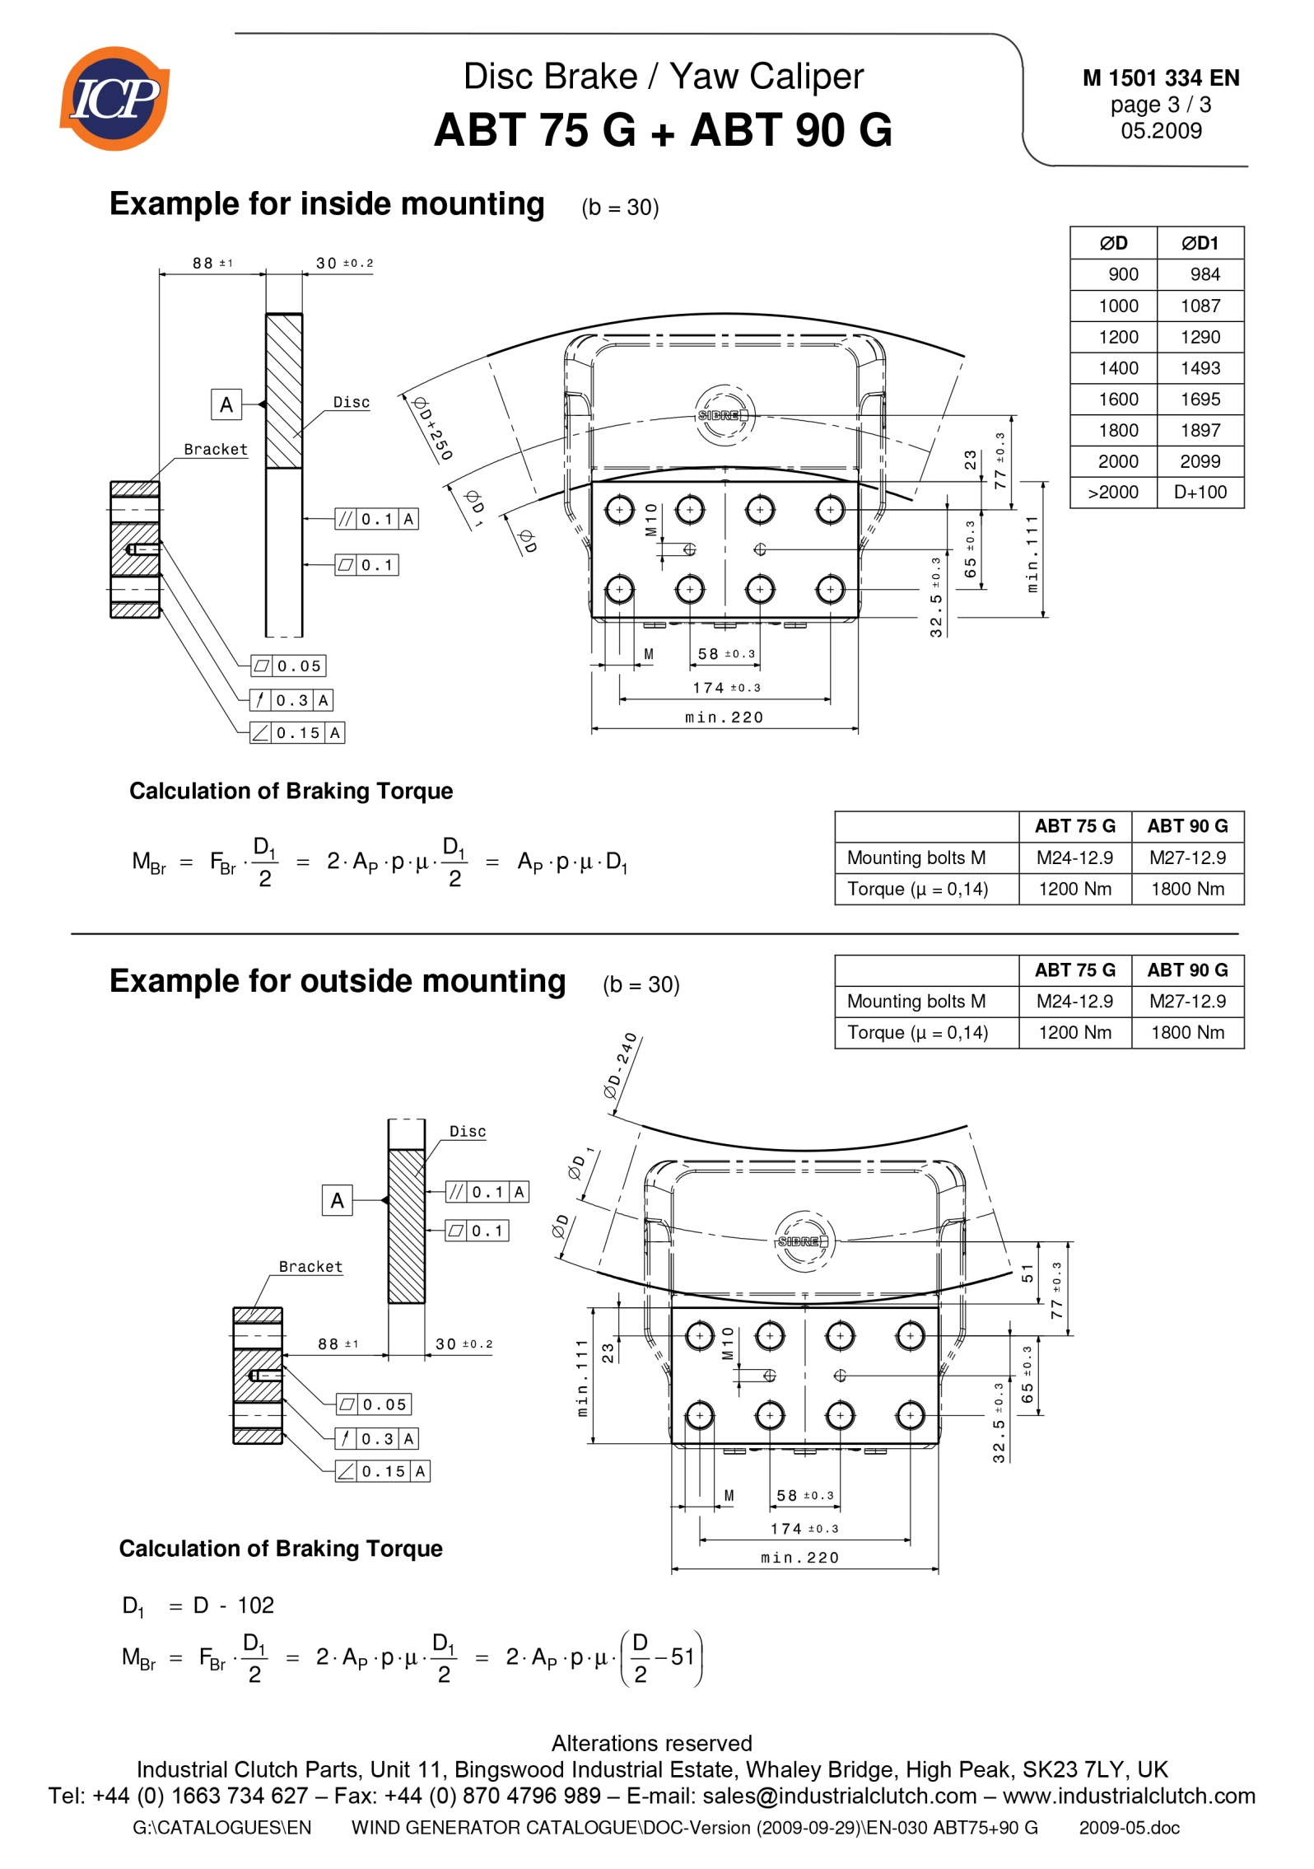

1. **Blade pitch control braking considerations:**

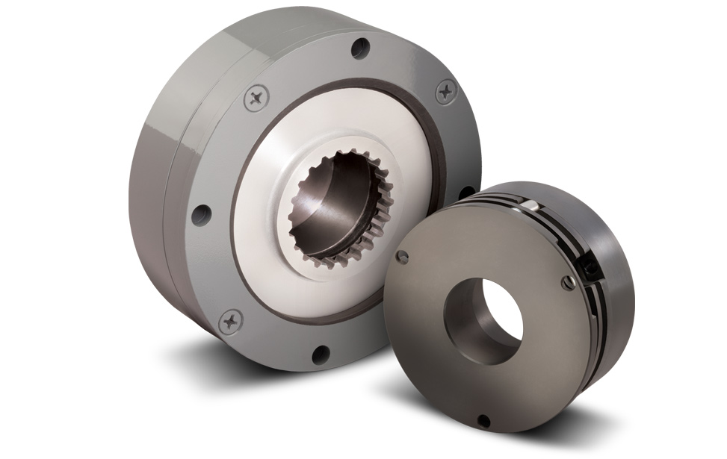

* Large horizontal axis wind turbines “pitch” or angle their rotor blades for best efficiency.
* The rotor blades are also pitched or feathered to minimize rotation in high winds and for turbine maintenance.
* Pitch drives can be driven electrically or hydraulically, but electrical is more common.