**Meeting Template**

Meeting Chairperson: A.Essam

Date: 11/20/2018

Meeting Points:

**Or**

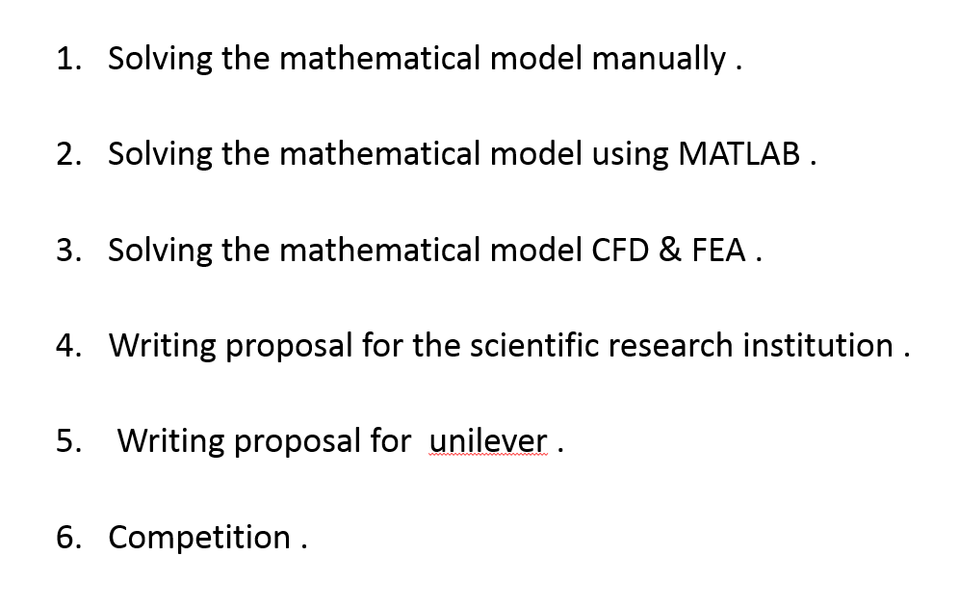

Prof. Notes:

**Or**



Tasks:

|  |  |  |
| --- | --- | --- |
| Ali | 1-solving mathematical equations manully.  2-revsion on CFD. | Deadline: 11/24/2018 |
| Omar | 1-solving mathematical equations manully.  2-revsion on CFD. | Deadline: 11/24/2018 |
| Tarek | 1-solving mathematical equations manully.  2-revsion on CFD. | Deadline: 11/24/2018 |
| A.Essam | 1-solving mathematical equations manully.  2-revsion on CFD. | Deadline: 11/24/2018 |
| Mayar | 1-writing the MATLAB code. | Deadline: 11/24/2018 |
| Asser | 1-proposal. | Deadline: 11/24/2018 |
| Mayada | 1-proposal. | Deadline: 11/24/2018 |

Incoming Meeting Chairperson: Tarek