**Meeting Template**

Meeting Chairperson: Tarek

Date: 11/25/2018

Meeting Points:

**Or**



Prof. Notes:

**Or**

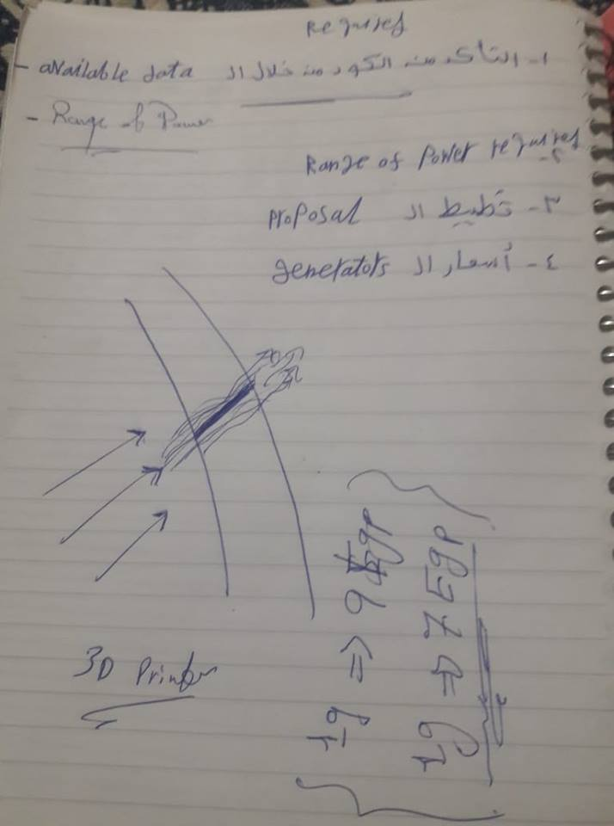

Tasks:

|  |  |  |
| --- | --- | --- |
| Asser | 1-Editing proposal.  2-Asking any member of team to help you getting any data needed for propsal.  3-Airfoil application(if you have time). | Deadline: 11/29/2018 |
| Mayada | 1-Editing proposal.  2-Asking any member of team to help you getting any data needed for propsal. | Deadline: 11/29/2018 |
| Mayar | 1-Editing proposal.  2-Learn MATLAB . | Deadline: 11/29/2018 |
| Tarek | 1-Helping Asser & Mayada, if they asked.  2- CFD & FEA revision. | Deadline: 11/29/2018 |
| Ali | 1-Helping Asser & Mayada, if they asked.  2- CFD & FEA revision. | Deadline: 11/29/2018 |
| Omar | 1-Helping Asser & Mayada, if they asked.  2- CFD & FEA revision. | Deadline: 11/29/2018 |
| A.Essam | 1-Helping Asser & Mayada, if they asked.  2- CFD & FEA revision.  3-Editing Gantt chart. | Deadline: 11/29/2018 |

Notes:

1-Please be restricted to deadline, as we almost have no time to submit our proposal.

2-Check your github folder(it may taked some time to fetch, don't worry).

3-Mayar put the matlab code you have written on the github(calculations folder).

4-Asser or Mayada put the edited proposal on the github(written work folder).

5-Check this file on github(Meetings) folder for further updates.

Incoming Meeting Chairperson: Choose a name