Text Stroke is the cool, nice-looking effect where black text characters are displayed on a white surrounding to increase readability on a non-uniform coloured background. For example text on Google Maps is displayed that way, just have a look at the place names in the banner of this page. A way to have this effect on an image is to use the Glow effect in Photoshop.



**Document Layout Analysis** is a part of [Computer Vision](http://en.wikipedia.org/wiki/Computer_Vision) indicating the process of identifying and categorizing the [regions of interest](http://en.wikipedia.org/wiki/Region_of_interest) in a document image, e.g. a scanned page. A reading system requires the segmentation of text zones from non-textual ones and the arrangement in their correct reading order [[2]](http://en.wikipedia.org/wiki/Document_Layout_Analysis#cite_note-1). Detection and labeling of the different zones (or blocks) as text body, picture, [math symbols](http://en.wikipedia.org/wiki/Mathematical_notation), and table embedded in a document is called Geometric layout analysis. But text zones play different logical roles inside the document (title, caption, footnote...) and this kind of semantic labeling is the scope of the Logical layout analysis. Document layout analysis is the union of geometric and logical labeling It is typically performed before a document image is sent to an [OCR](http://en.wikipedia.org/wiki/Optical_character_recognition) engine, but it can be used also to detect duplicate copies of the same document in large archives, or to index documents by their structure or pictorial content.

For document images, 300 dpi is commonplace and normal character (12 points) occupy an area as large as 40x40 pixel. Video frame are often digitized at 352x240 pixels with text rendered as small as 10x10 pixels, resulting in no output from OCR software, even though text is clearly human readable

Several changes

1. Text is usually embedded in complex backgrounds, make extraction and recognition difficult

2. The video image is usually digitized or subsampled at an extremely low resolution, and as a result, text can not be recognized by most commercial OCR software

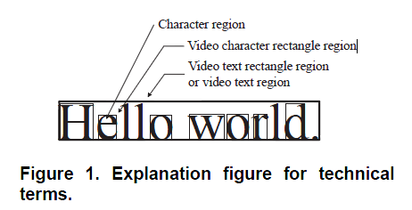

1999-A video text extraction method for character recognition , Hori, O.; Document Analysis and Recognition, 1999. ICDAR '99. Proceedings of the Fifth International Conference on

Figure 2 describes the flow of video character segmentation

from the background. The intensity distribution of

characters in a video is precisely estimated to extract only

character regions from the background. The first process is

to eliminate the background and roughly estimate the character

regions by image processing. In this process, a Sobel

filter for edge detection is applied to the video text region to

emphasize edges located on character contours. The edges

are extracted and dilated to roughly estimate character regions.

The dilated edge area mainly consists of character

regions, contours, and a part of the background(See Figure

3). An intensity histogram is calculated from the region and

segmented into three parts by the Otsu automatic threshold

selection method[4]. The Otsu method is well known

as an automatic binarization threshold selection algorithm

using an intensity histogram. This method can be easily extended

to a multiple segmentation method. The segmented

high-intensity part of the histogram presumably comes from

character regions. An intensity distribution of character regions

is computed from the part. This result, however, is not

precise because this roughly estimated high-intensity part

includes outliers coming from the background or contours.

A robust estimation is introduced to increase the accuracy

of the distribution estimation. Video characters have highintensity

and are surrounded by low intensity contours in

general. At first, very high-intensity parts are detected in

the character regions based on the estimated average and

then very high-intensity parts are expanded to the contours

based on the estimated variance.



1999-Textfinder: an automatic system to detect and recognize text in images, Wu, V.; Manmatha, R.; Riseman, E.M.; Pattern Analysis and Machine Intelligence, IEEE Transactions on