**CMP6210**

**Cloud Computing 2020–2021**

Web-application report

Grocery shopping application

BSc (Hons) Computer Science

Ahmed Mohamed – 18124225

Arslan Badar – 18117505

Archibald Makotose – 18149741

Contents

Aim 3

Objectives 3

Design database 3

Create Accounts 3

Add Products 3

Permissions 4

AWS infrastructure diagram 4

EC2 4

# Introduction

This report demonstrates the implementation of a grocery shopping application deployed using cloud services (Amazon Web Services). The application allows users to register on the site and add grocery shopping items to their basket. The information needed for these items shall be stored in a MySQL database where the storage and retrieval of these items have been handled through the usage of SQL queries. The web requests and scripts have been managed using PHP, which allows for the server and database to communicate and share information. The cloud-based application makes use of several Amazon Web Service features, including – virtual private cloud (VPC), elastic compute cloud (EC2), Amazon relational database service (RDS) and more. The Amazon Simple Storage Service (S3) was used to store the images of the grocery items, by creating an S3 bucket which allowed for the storage of all the images.

# Aim

To implement a grocery shopping application to allow users to add items to their basket.

Objectives

. To create a database containing names of items, images and prices.

. Implement a feature where users can create accounts.

. To allow users to add items to the basket.

# Design database

Firstly, a server will be needed on AWS. This is to allow client requests to be handled. The database shall make use of tables – a table for products and a table for users.

|  |  |  |  |  |  |  |
| --- | --- | --- | --- | --- | --- | --- |
| (Int)ID | (String)Name | (Currency)Price | (String)Image | (String)Category | (Int)Ratings ( /5) | (String)Description |
| 1 | Apple | 50p | … | Fruit&Veg | 4 | Ingredients/Allergies |
|  |  |  |  |  |  |  |
|  |  |  |  |  |  |  |
|  |  |  |  |  |  |  |

|  |  |  |  |  |
| --- | --- | --- | --- | --- |
| (Int)ID | (String)Username | (String)Password | (String)Email | (Int)Phone No. |
| 1 | Admin | Oiejt48t | Admin@ | 0121 3459699 |
|  |  |  |  |  |
|  |  |  |  |  |

## Create Accounts

Click ‘signup’ (Transitions to signup page) – Enter Username – Enter Email – Enter Password – Enter phone number - Click ‘create account’(Transitions to ‘home’ page).

## Add Products

Only the admin can add products to the database.

(Same login process as users) After logging in, transitions to admin page with admin options such as adding products – Click ‘Add Products’ – Form appears to enter product details – Click ‘submit product’.

## Permissions

|  |  |
| --- | --- |
| User | Admin |
| Can add items to cart | Can add items to cart |
| Remove items from cart | Remove items from cart |
| Sign in/out | Sign in/out |
| View products | View products |
| Option to checkout | Option to checkout |
| Update account details | Update account details |
| Contact admin/store | Add/remove users |
| Choose payment method | Add/remove products |
|  | View user details |
|  | Update product details |

# AWS infrastructure diagram

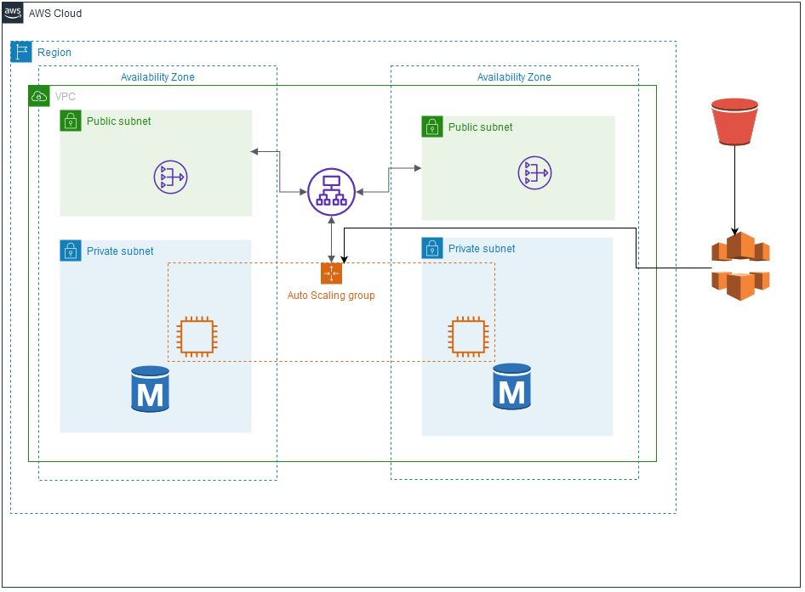

# VPC

To begin, we first need to create our Virtual Private Cloud. According to AWS (2021):

*Amazon Virtual Private Cloud (Amazon VPC) is a service that lets you launch AWS resources in a logically isolated virtual network that you define. You have complete control over your virtual networking environment, including selection of your own IP address range, creation of subnets, and configuration of route tables and network gateways.*

This shall be named *Shopping Website VPC* with a CIDR block of *10.0.0.0/16* as seen below.

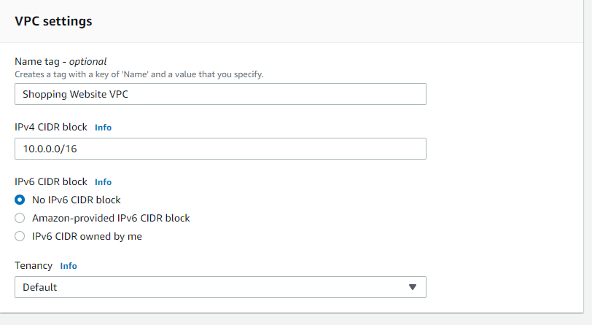

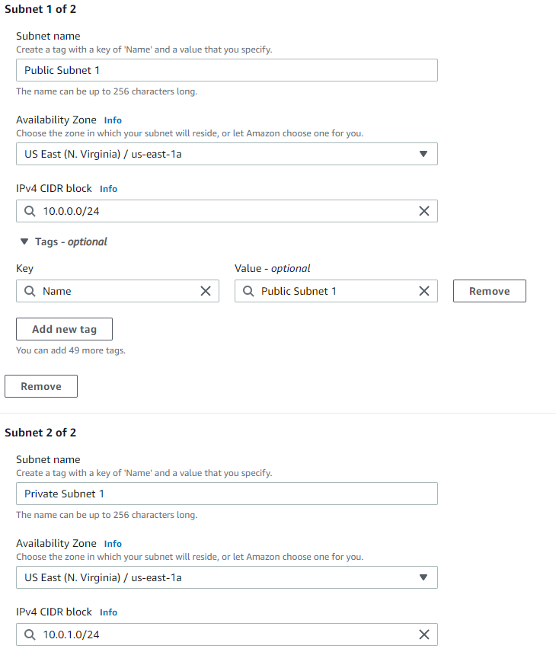A set of Public and Private subnets shall be created and assigned for two separate availability zones ‘US-East-1a’ and ‘US-East-1b’. The subnets shall be assigned a CIDR block of 10.0.**x**.0/24 (where x is a chosen digit).

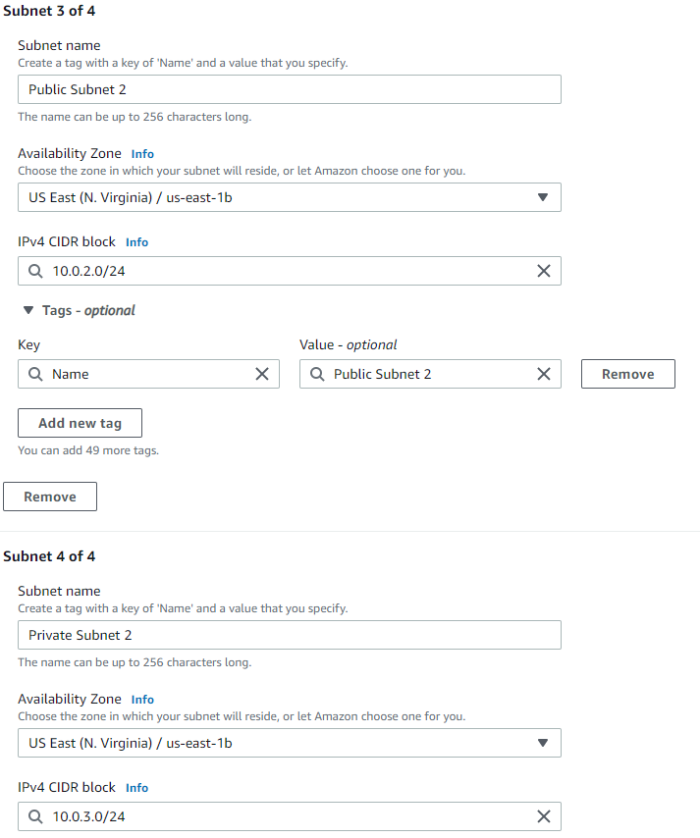

Here is a list of all the created subnets:

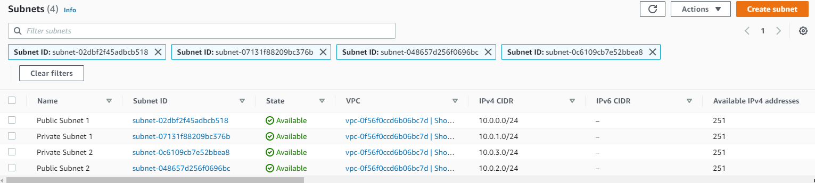

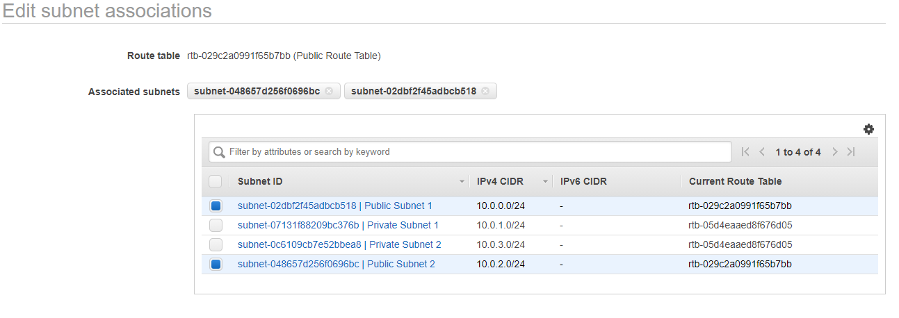Next, we’ll be editing the subnet associations for the public and private subnets. A public route table and a private route table will be created to accommodate this.

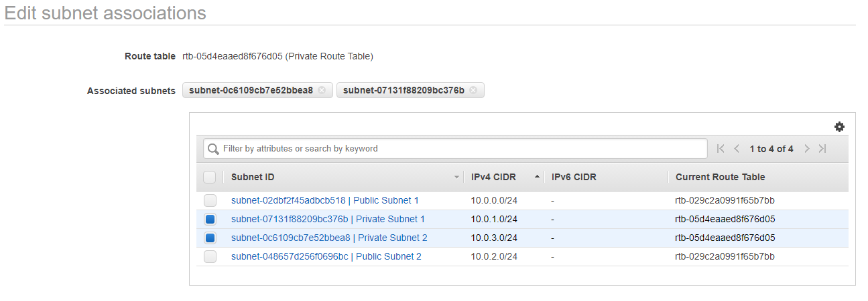

# EC2

According to Wigmore (2014), the Amazon elastic compute cloud (EC2) is a virtual server that allows for the running of applications on Amazon’s web services infrastructure. The creation of an instance will allow for unique configurations for the virtual server which the shopping website will run on.

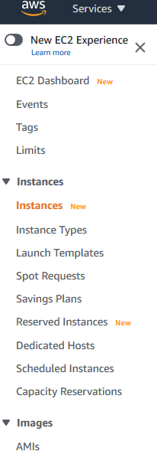

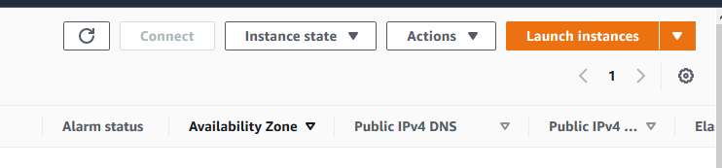

For this project, the Amazon Linux 2 AMI will be used. The instance type ‘micro’ shall be used since it is free.

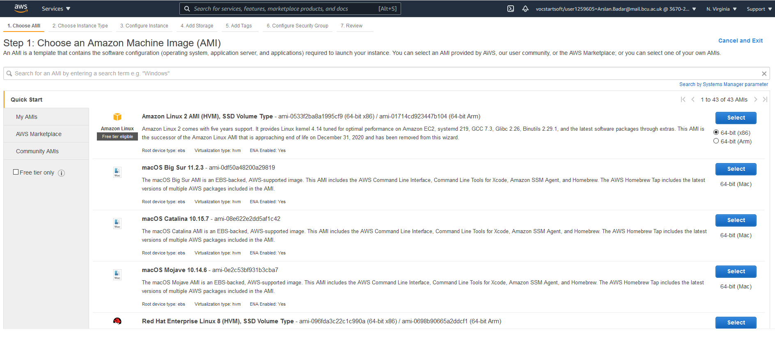

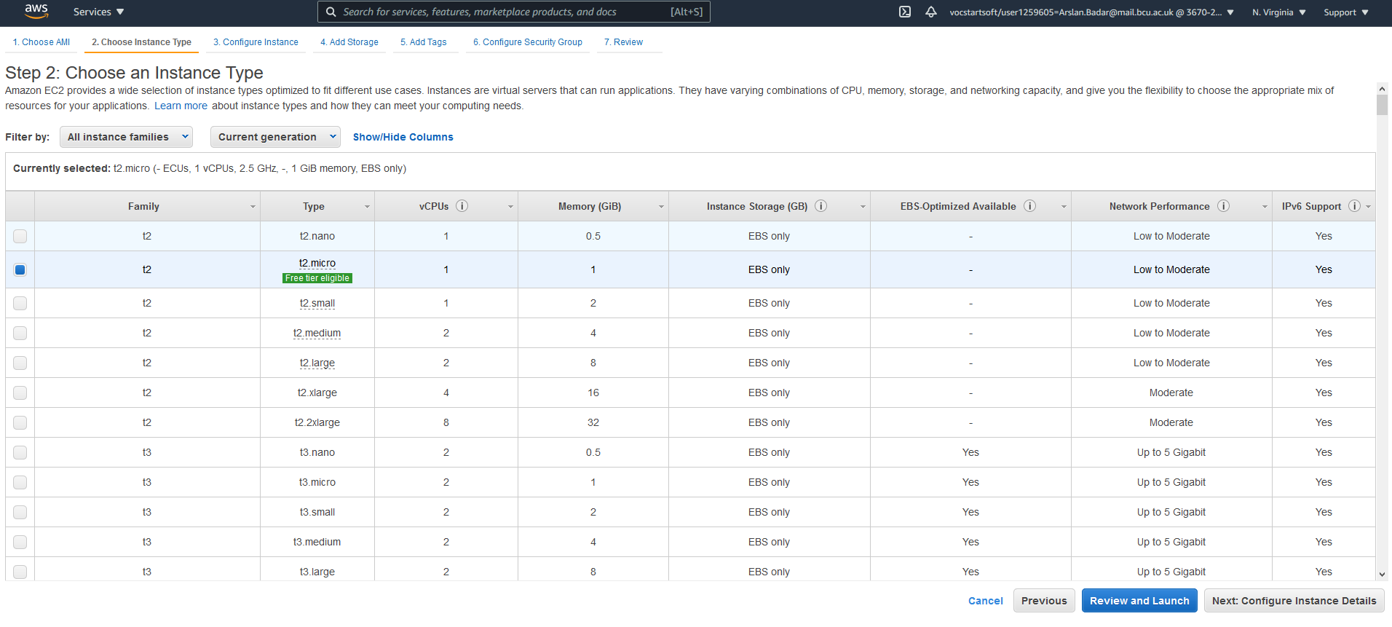

One instance shall be created, which will utilise the ‘Shopping Website VPC’ VPC previously created

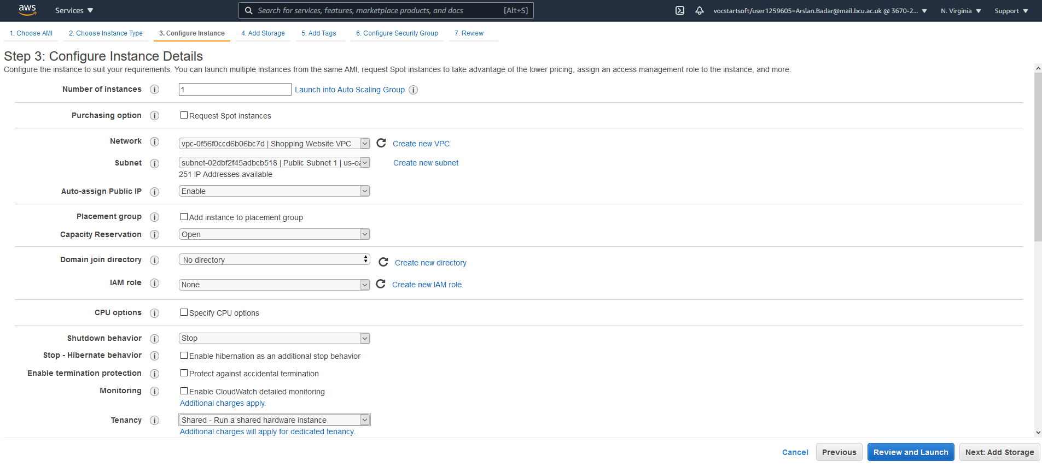

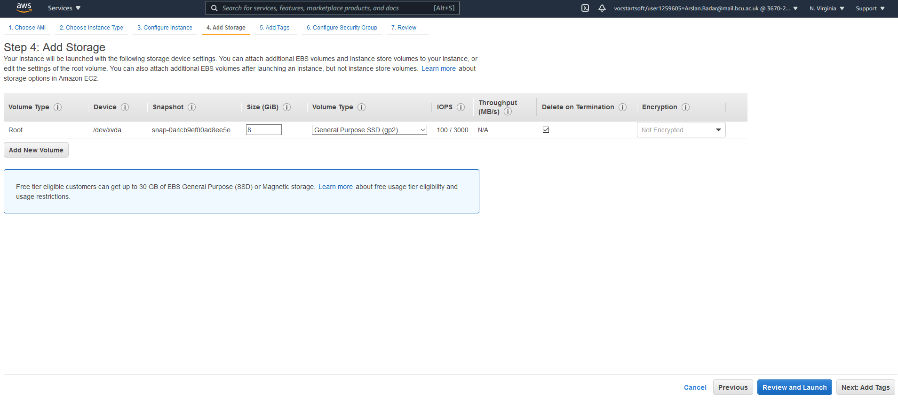

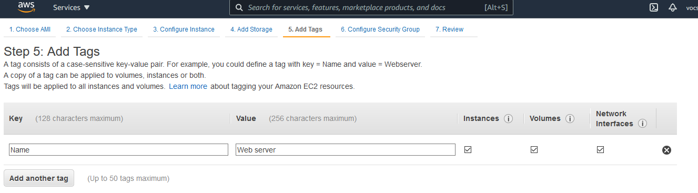

A security group for the website shall be created, titled ‘Shopping Website Security Group’. Enabling HTTP access will allow for HTTP inbound rules to be added.

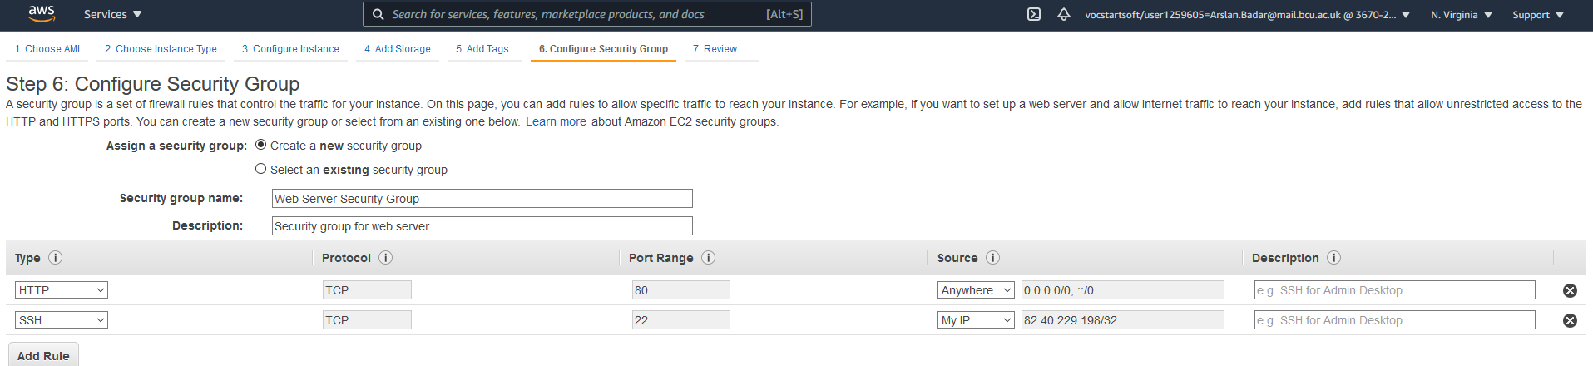

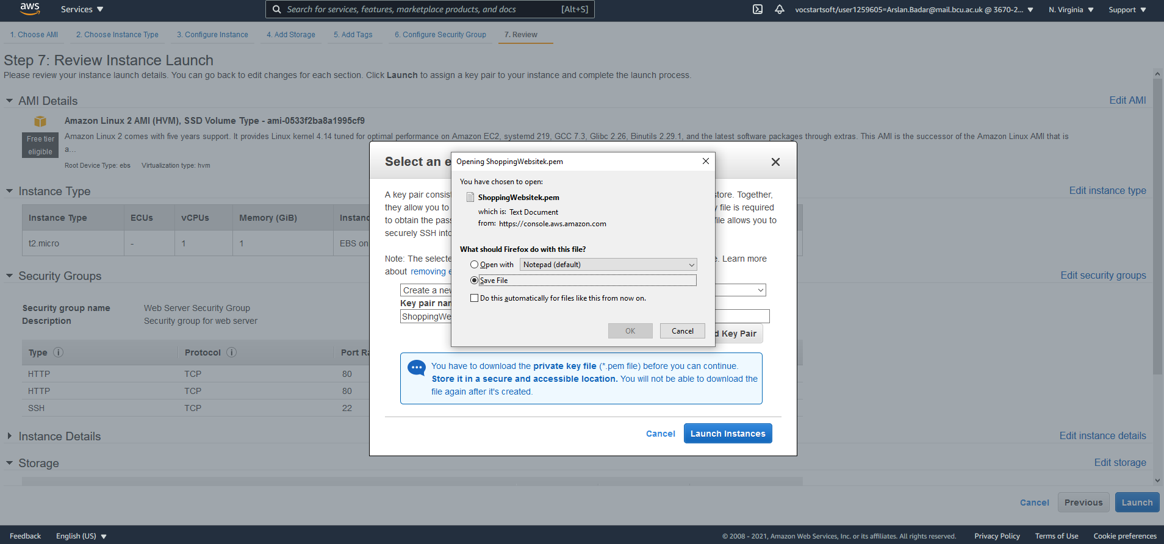

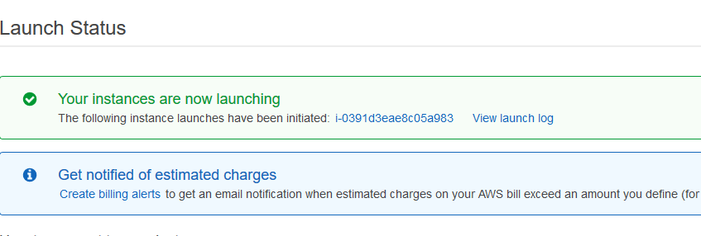

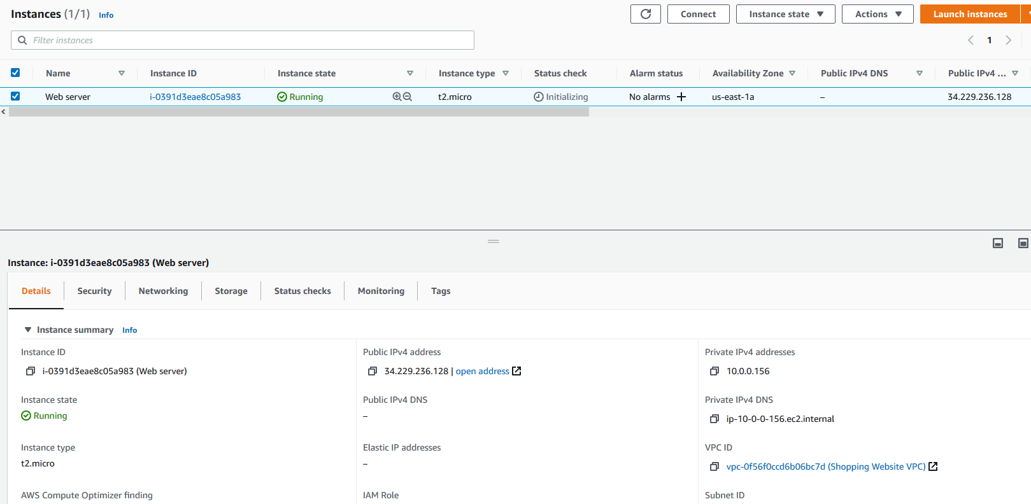

Load Balancer

According to the official AWS documentation (2021):

*Elastic Load Balancing automatically distributes incoming application traffic across multiple targets, such as Amazon EC2 instances, containers, IP addresses, Lambda functions, and virtual appliances.*

This means that if there are multiple target instances and there is a sudden increase in traffic, the distribution of the load can be handled by multiple instances instead of only one. The benefit of this is that it allows more people to access the application at once and if an instance fails, there is another instance which can be used as a backup.

The name of the load balancer shall be *‘LoadBalancer’*. It’ll operate on the HTTP Protocol and shall be running on port 80.

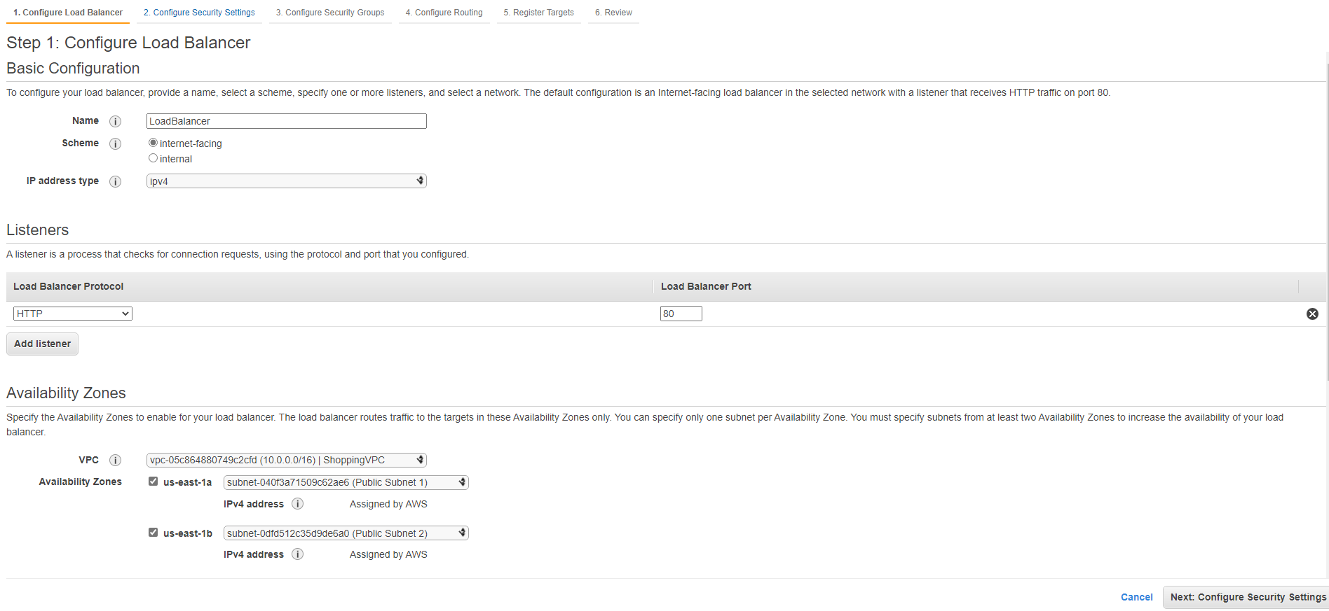

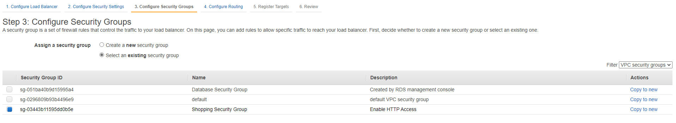

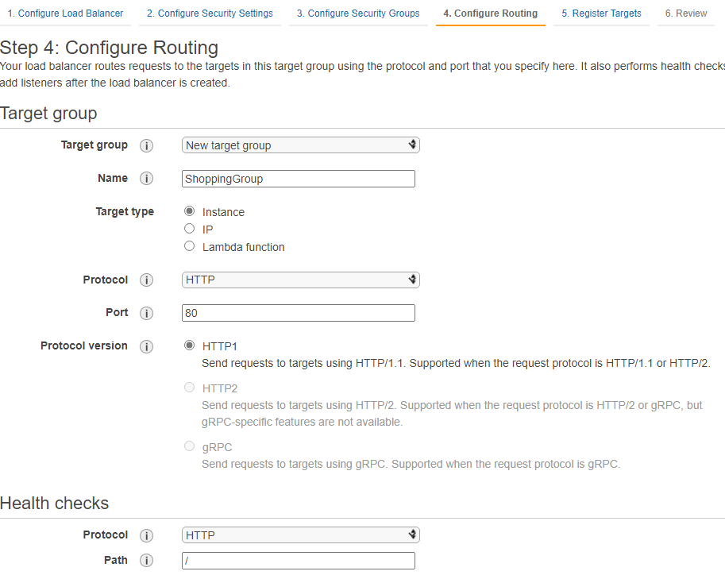

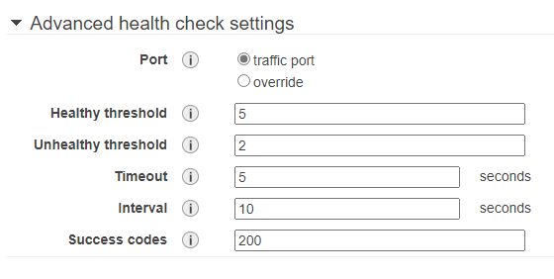

Here, both the instances have been registered as targets so that multiple instances can be used for handling the application requests.

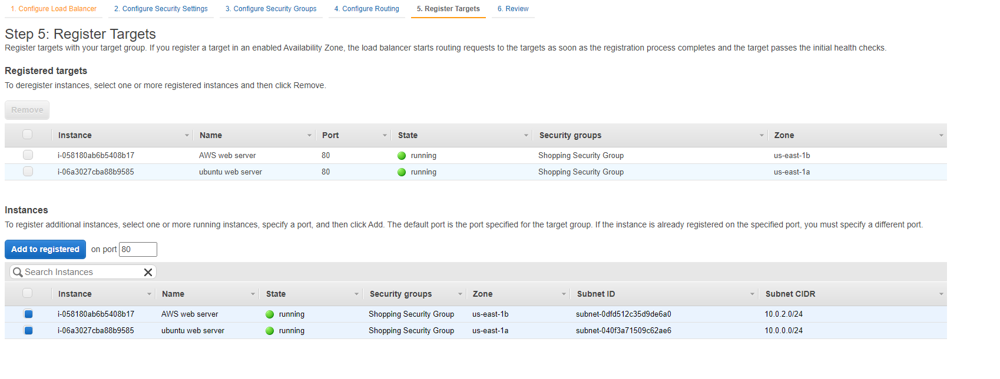

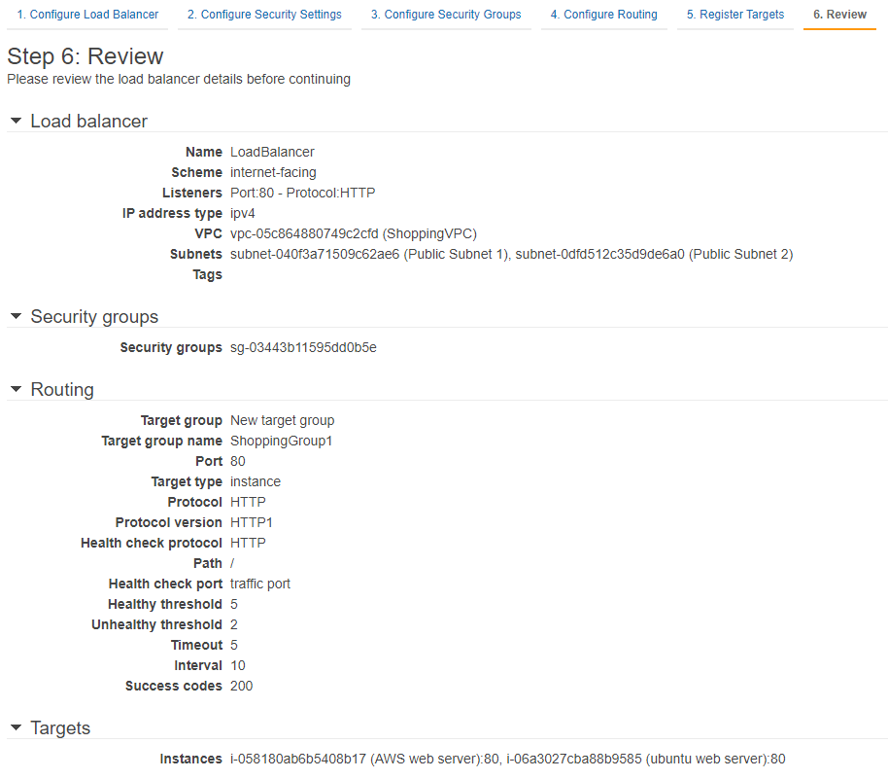

Here is the list of overall configurations for the details of the load balancer. This is to ensure that the settings are as needed, but many settings such as the allocated security group can still be changed later if necessary.

References

AWS. (2021)*Amazon Virtual Private Cloud* Available at: [Amazon Virtual Private Cloud (VPC)](https://aws.amazon.com/vpc/?vpc-blogs.sort-by=item.additionalFields.createdDate&vpc-blogs.sort-order=desc) (Accessed: 2nd April 2021)

Wigmore, I. (2014) *Amazon EC2 instance* Available at: [What is Amazon EC2 instance? - Definition from WhatIs.com (techtarget.com)](https://searchaws.techtarget.com/definition/Amazon-EC2-instances#:~:text=An%20EC2%20instance%20is%20a,programs%20in%20the%20computing%20environment.) (Accessed: 5th April 2021)

AWS. (2021)*What is Amazon EC2?* Available at: [What is Amazon EC2? - Amazon Elastic Compute Cloud](https://docs.aws.amazon.com/AWSEC2/latest/UserGuide/concepts.html) (Accessed: 5th April 2021)

AWS. (2021)*Elastic Load Balancing?* Available at: [Elastic Load Balancing - Amazon Web Services](https://aws.amazon.com/elasticloadbalancing/?whats-new-cards-elb.sort-by=item.additionalFields.postDateTime&whats-new-cards-elb.sort-order=desc) (Accessed: 8th April 2021)